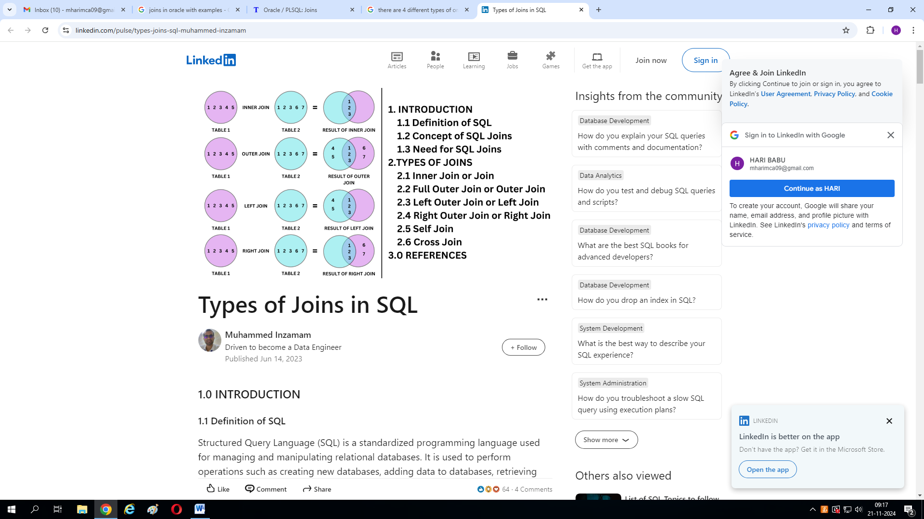

CREATE TABLE Course (

CourseId INT PRIMARY KEY,

CourseName VARCHAR(15),

CourseFee INT

);

INSERT INTO Course VALUES (10, 'Oracle', 3500);

INSERT INTO Course VALUES (20, 'MySQL', 3000);

INSERT INTO Course VALUES (30, 'SQL Server', 4500);

CREATE TABLE Student (

StudentId INT PRIMARY KEY,

StudentName VARCHAR(15),

CourseId INT

);

INSERT INTO Student VALUES (1001, 'James', 10);

INSERT INTO Student VALUES (1002, 'Smith', 20);

INSERT INTO Student VALUES (1003, 'Warner', 30);

INSERT INTO Student VALUES (1004, 'Sara', 10);

INSERT INTO Student VALUES (1005, 'Pam', 20);

**INNER JOIN**

SELECT * FROM Student

INNER JOIN Course

ON Student.CourseId = Course.CourseId;

**LEFT OUTER JOIN**

**SELECT * FROM Student S**

**LEFT OUTER JOIN Course C**

**ON S.CourseId =C.CourseId;**

**SELECT * FROM Student**

**LEFT OUTER JOIN Course**

**ON Student.CourseId =Course.CourseId;**

**RIGHT OUTER JOIN**

SELECT * FROM Student S

RIGHT OUTER JOIN Course C

ON S.CourseId =C.CourseId;

**FULL OUTER JOIN**

SELECT * FROM Student S

FULL OUTER JOIN Course C

ON S.CourseId =C.CourseId;