INSTALLING CLOUDWATCH AGENT THROUGH ANSIBLE
- Launch the ec2s
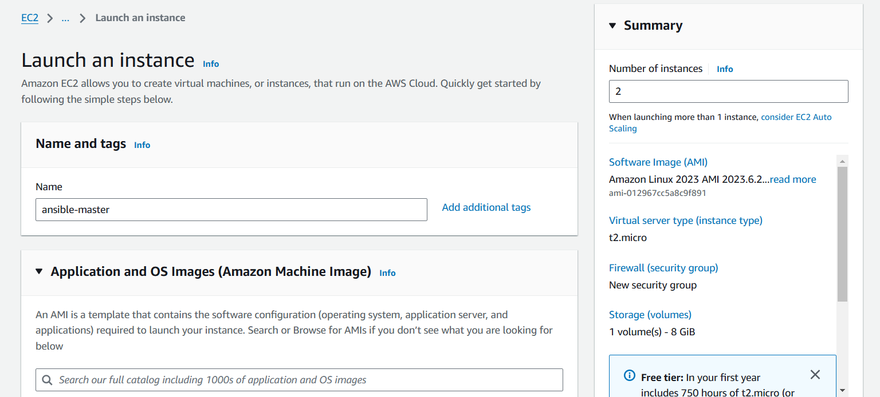

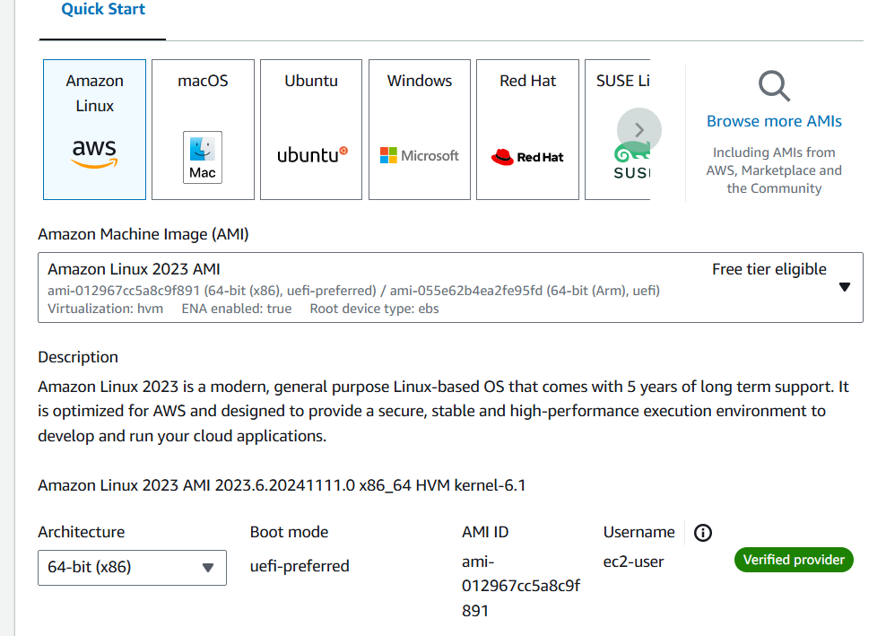

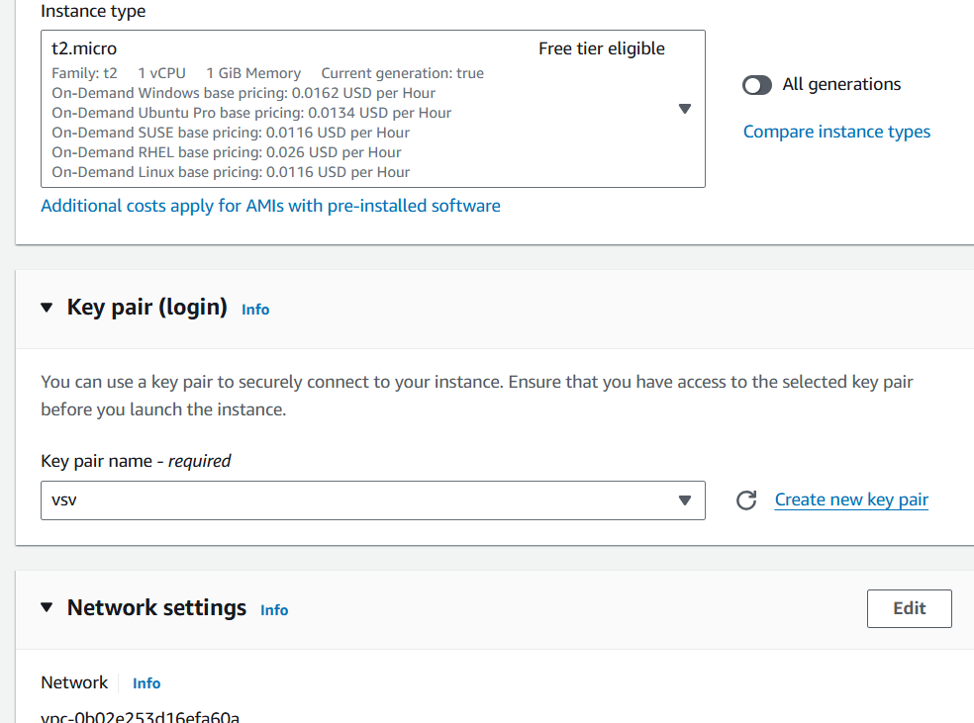

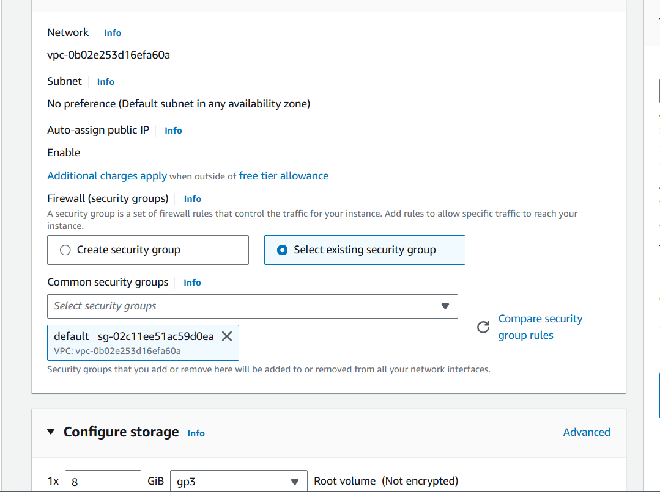

- In number of instances select 2 one for node another is master
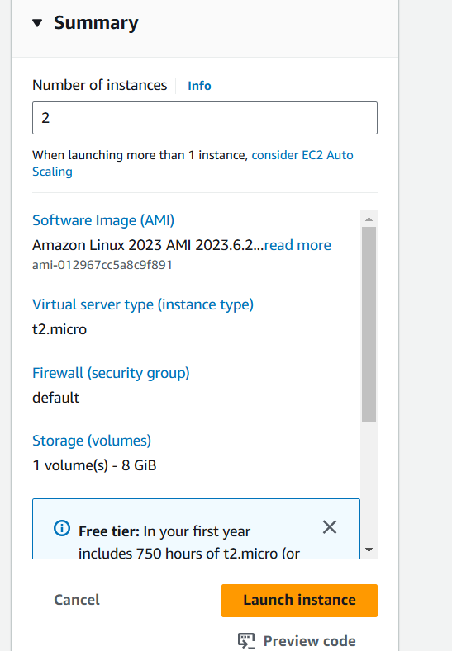
- Change the one instance name to ansible node
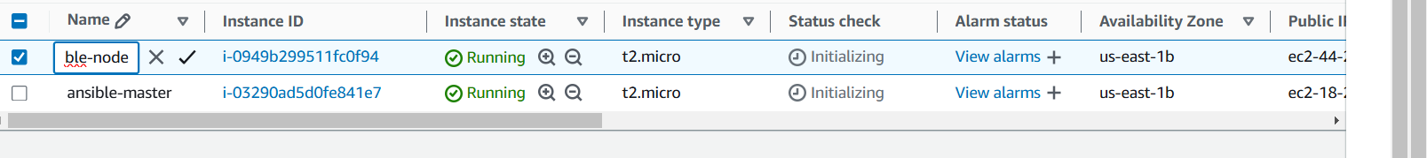

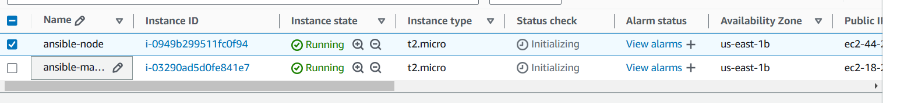
- Crete iam role for ansible node
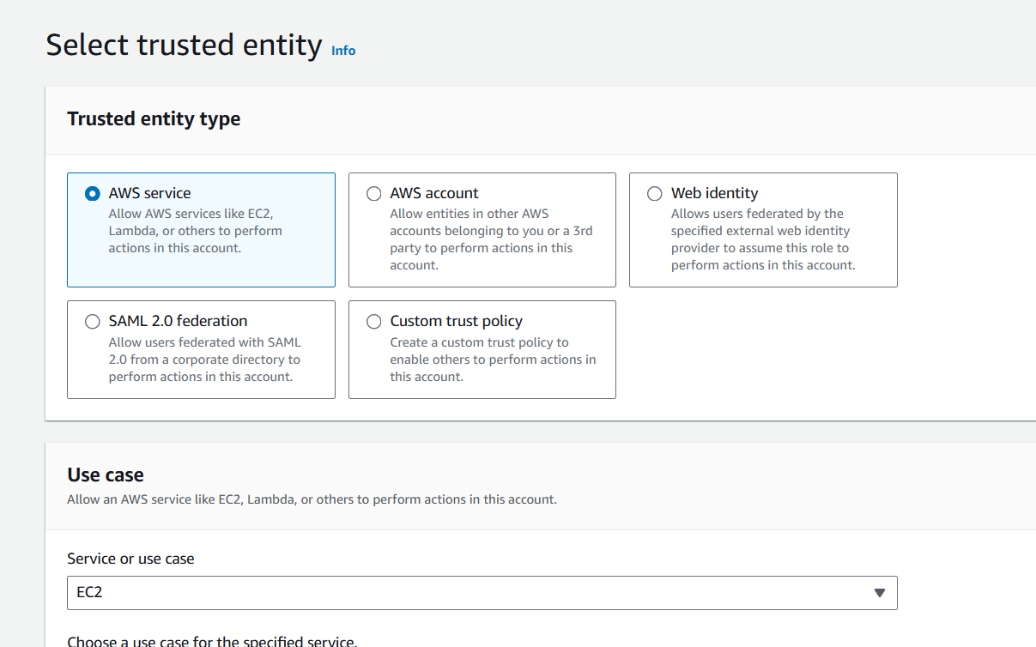

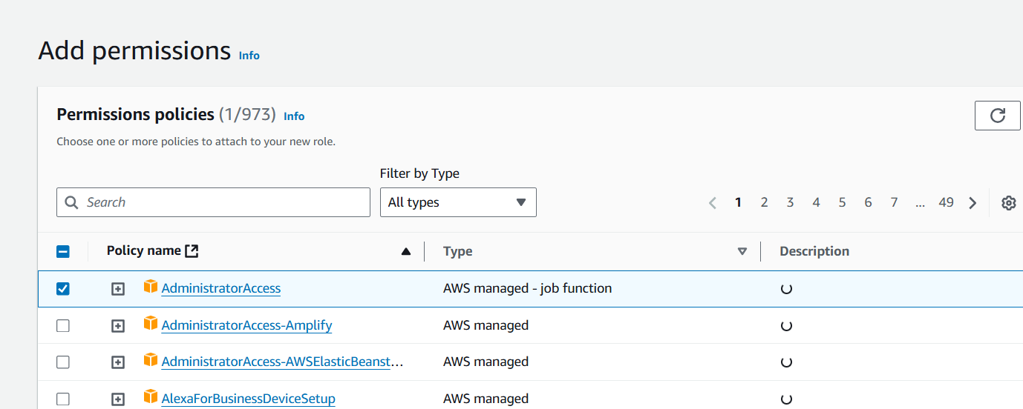

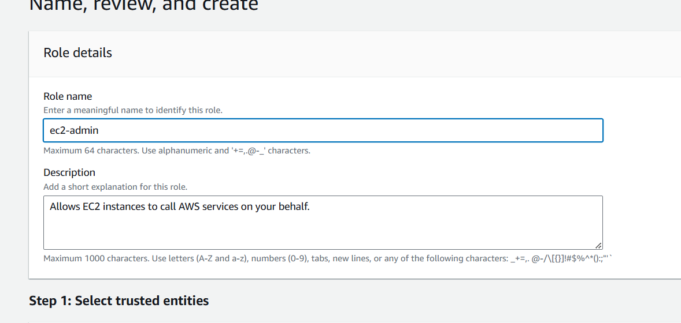
- Attach role to ansible node
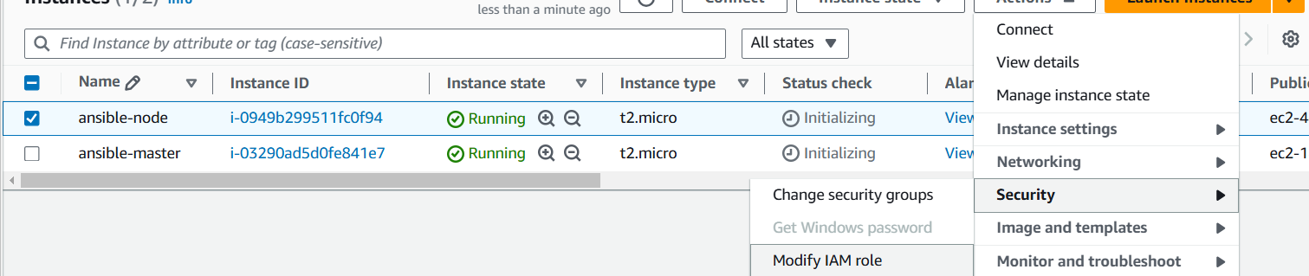
-- ansible ec2 want to communicate with to cloudwatch
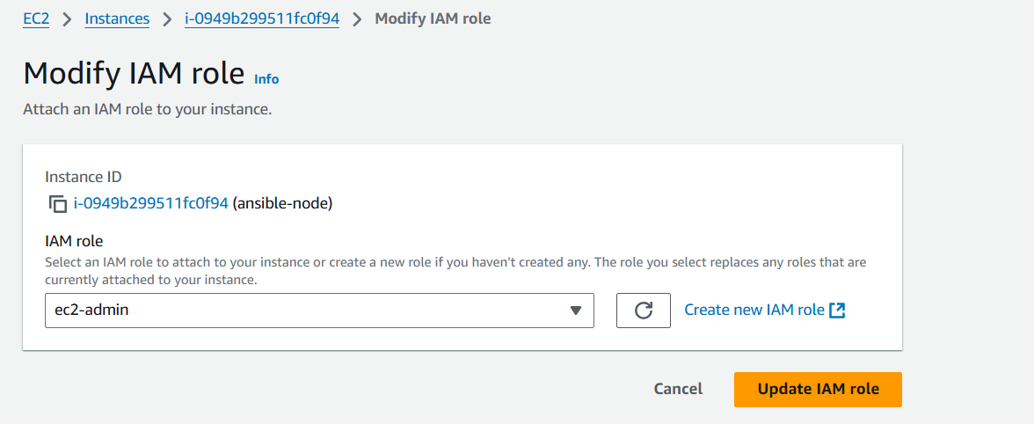

- Connect to ansible master install ansible
sudo yum install ansible -y
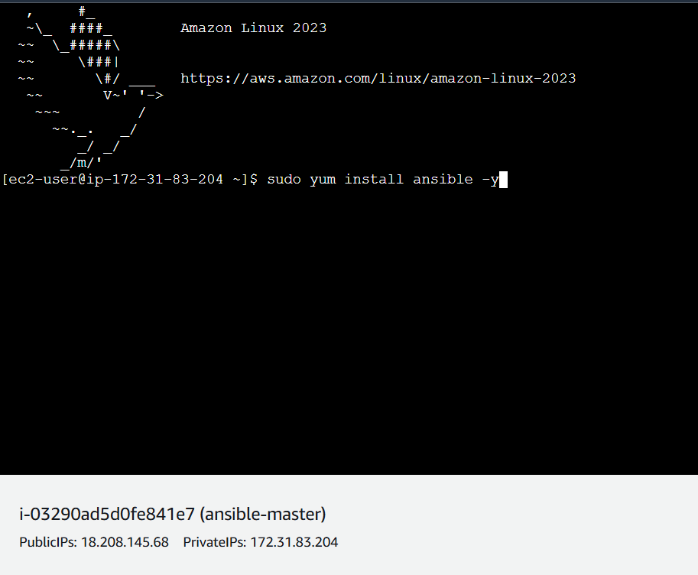
- Connect to ansible node install ansible
sudo yum install ansible -y
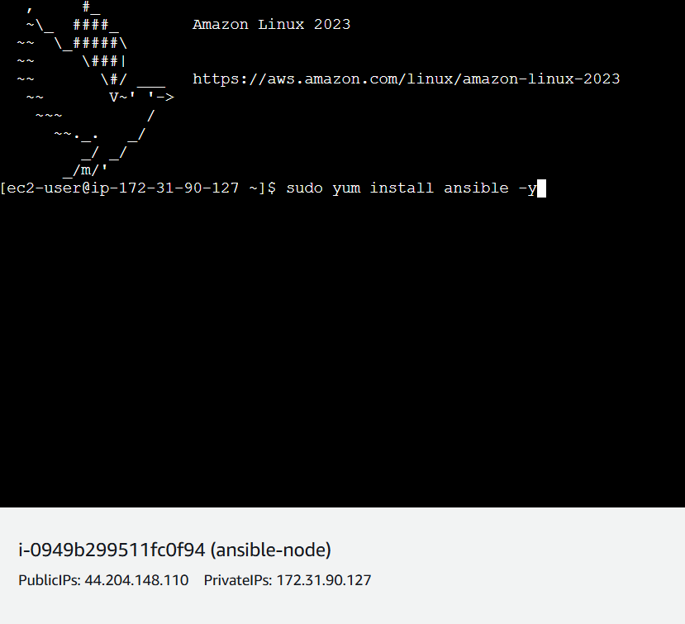

- Generate a keys in ansible master
ssh-keygen
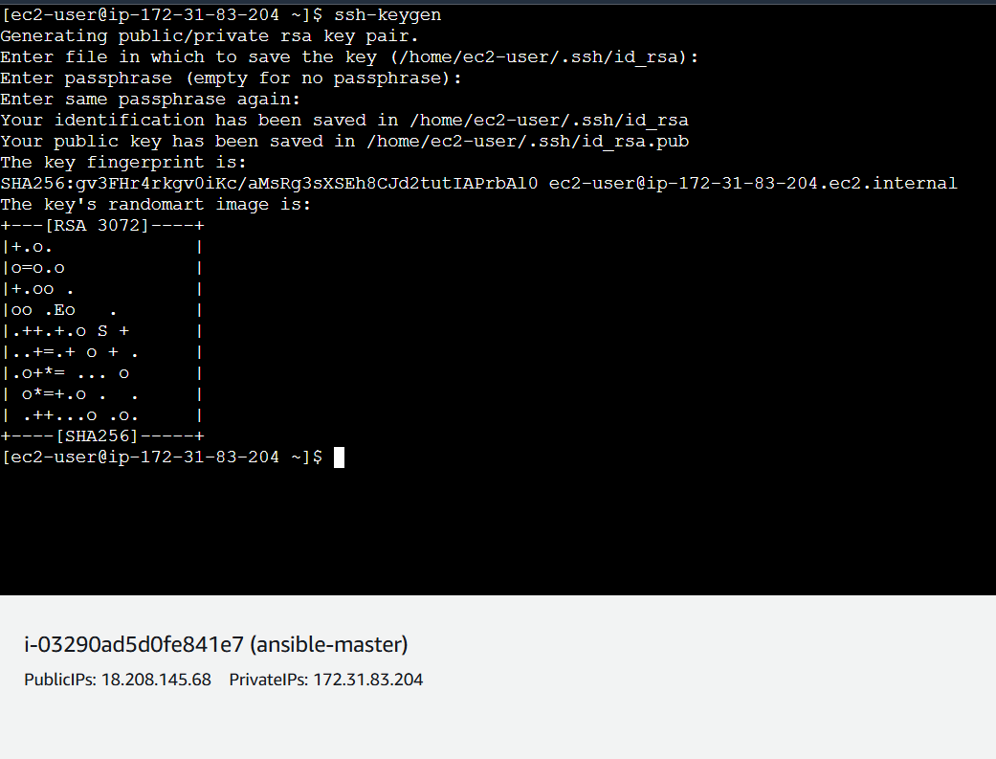
- Switch to .ssh folder copy the id_rsa.pub file key
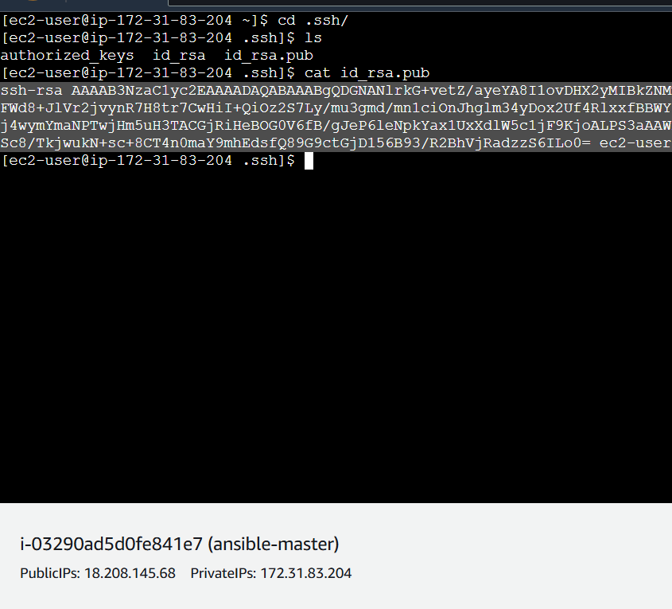

- Paste the master public key into authorized keys
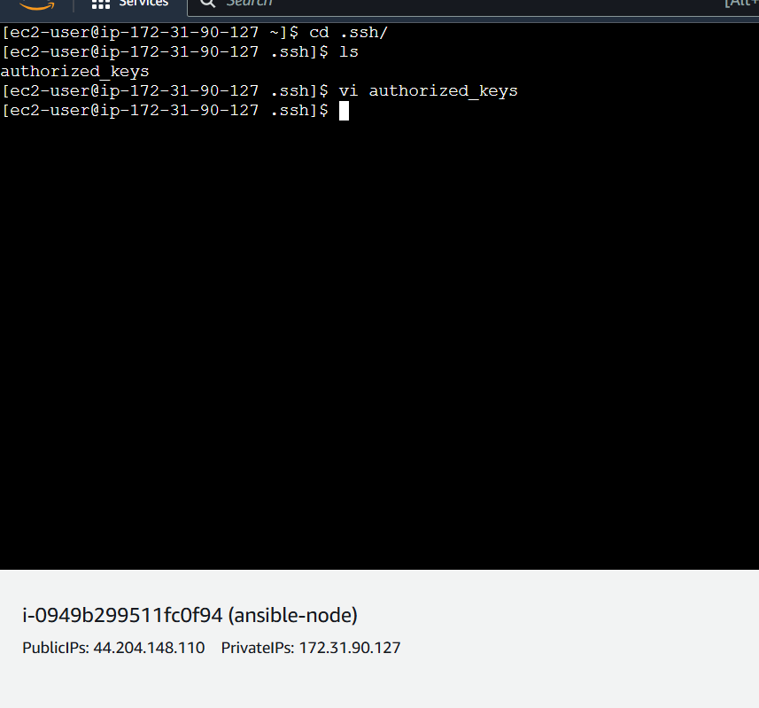
- Like this paste ansible master public key into ansible node authorized keys
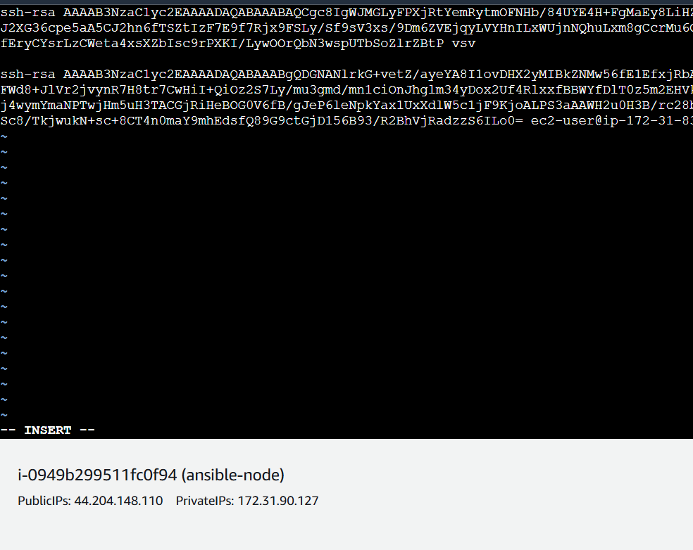
############### same like launch another node add the ansible master public key new node ##############################

- Crete anible.cfg file and paste below mater
sudo vi /etc/ansible/ansible.cfg #create config file
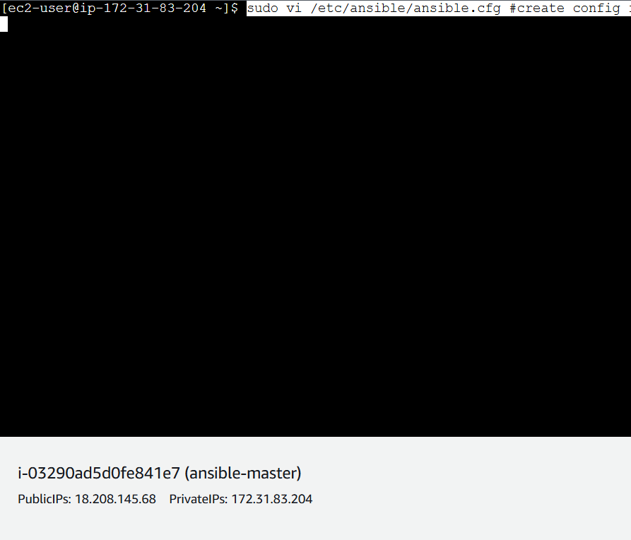
- Paste this one into ansible.cfg file
[defaults]
host_key_checking = False
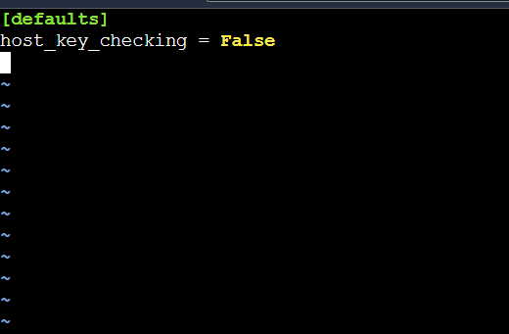

- Creet hosts file for nodes connection and paste below mater
sudo vi /etc/ansible/hosts
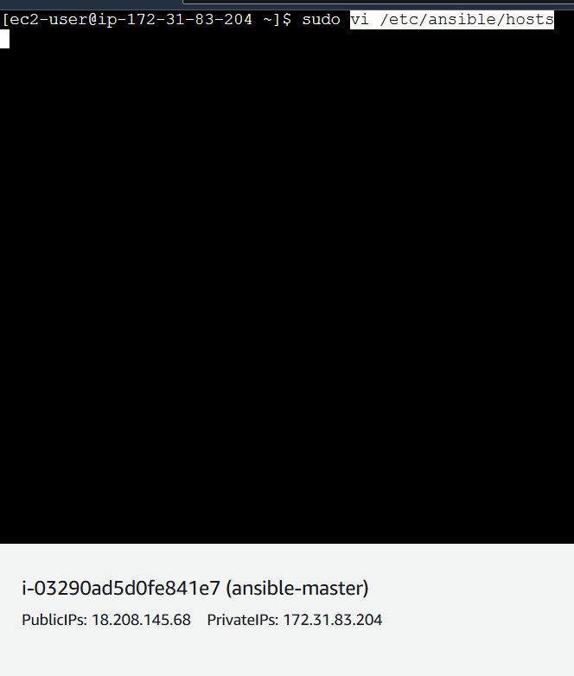

- Paste your node private ip into hosts file
172.31.29..82
172.31.30.27
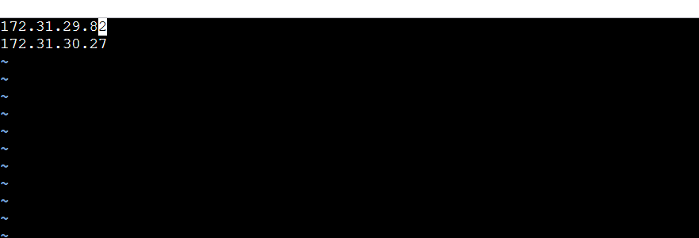

- After done above process just give ping command to check the node master connection
- If it is successfully connected mens you will get below output
ansible all -m ping
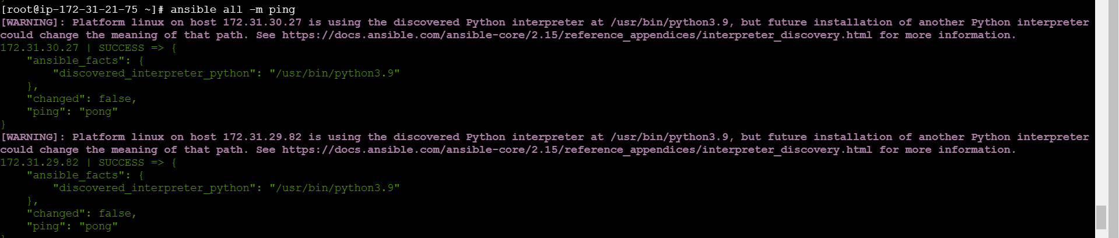

- Create a ansible playbook and paste bellow code
vi ansible-cloudwatch-playbook.yaml
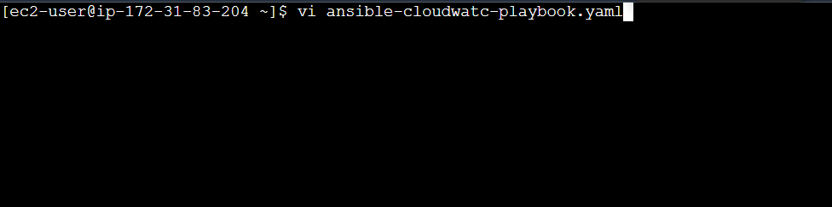

- Pate below code
---
- name: Setup Apache and CloudWatch on EC2
hosts: all
become: yes
tasks:

- name: Install CloudWatch Agent
yum:
name: amazon-cloudwatch-agent
state: present

- name: Create CloudWatch agent config
copy:
dest: /opt/aws/amazon-cloudwatch-agent/bin/config.json
content: |
{
"logs": {
"logs_collected": {
"files": {
"collect_list": [
{
"file_path": "/var/log/*",
"log_group_name": "LOG-FROM-EC2",
"log_stream_name": " {instance_id}",
"retention_in_days": 1
}
]
}
}
}
}

- name: Start the CloudWatch agent
command: /opt/aws/amazon-cloudwatch-agent/bin/amazon-cloudwatch-agent-ctl -a fetch-config -m ec2 -c file:/opt/aws/amazon-cloudwatch-agent/bin/config.json -s

- name: Check CloudWatch agent status
command: /opt/aws/amazon-cloudwatch-agent/bin/amazon-cloudwatch-agent-ctl -a status
register: cw_agent_status

- debug:
var: cw_agent_status.stdout_lines
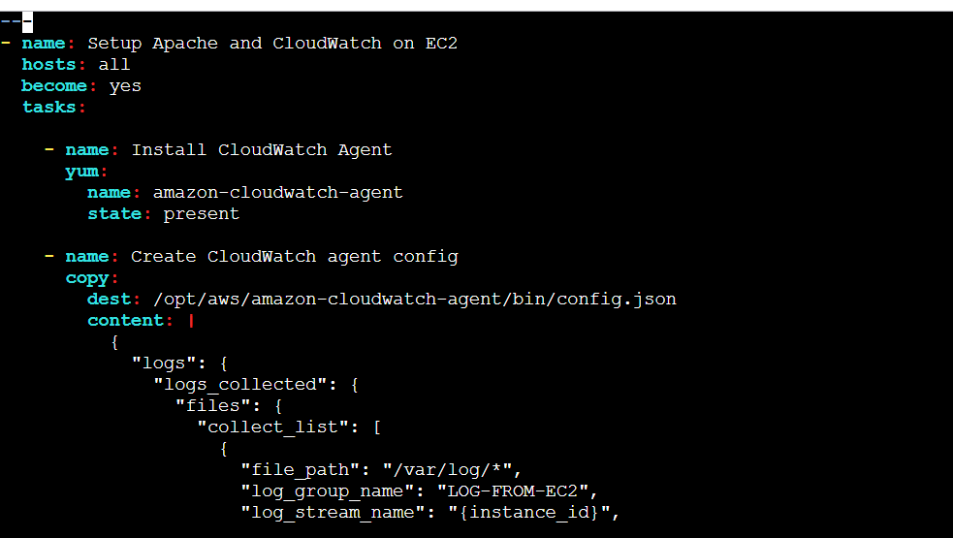

- this is yaml file
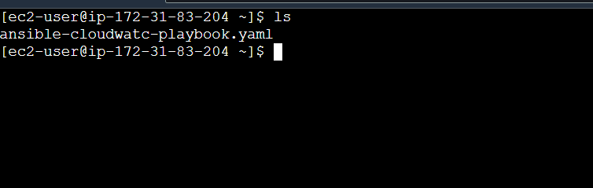
- execute the ansible-playbook yaml file
ansible-playbook ansible-cloudwatch-playbook.yaml
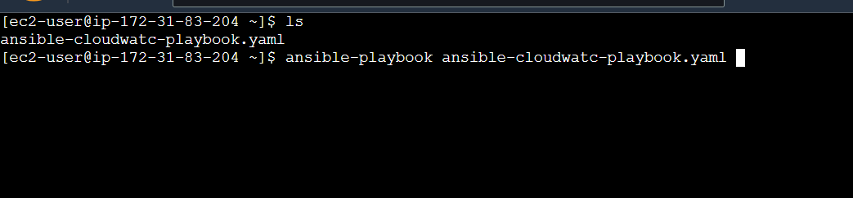
- successfully completed ansible playbook

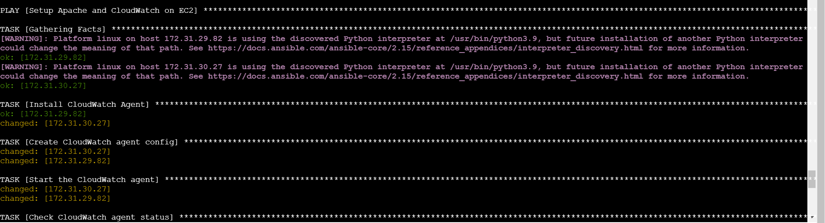
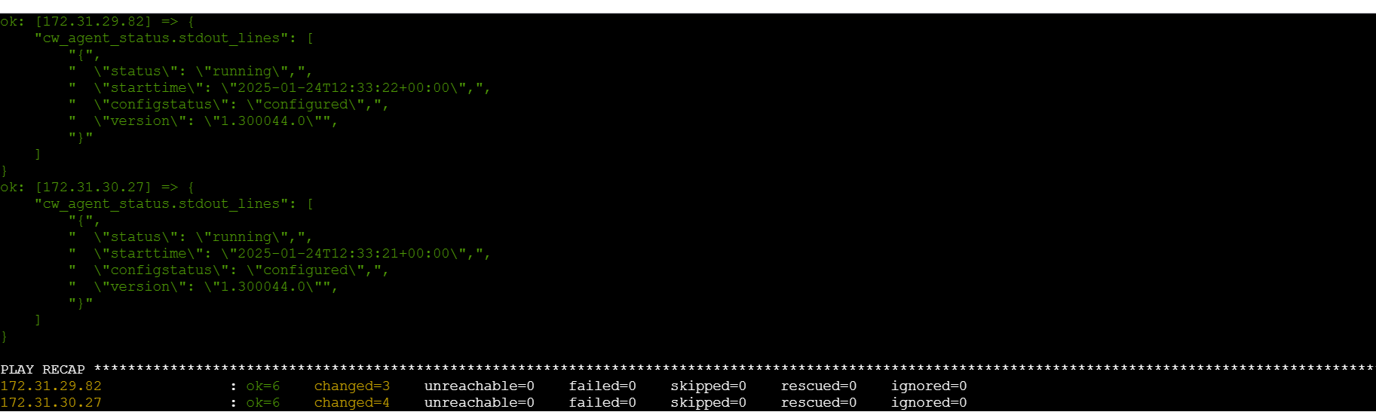

- log grop is creted
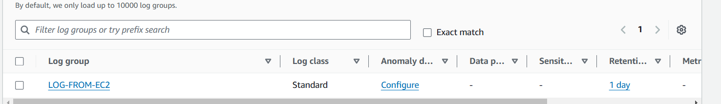
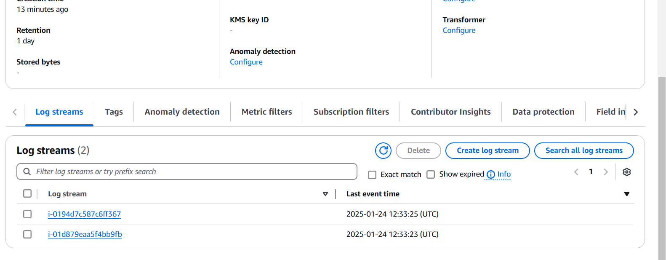

- iam installed httpd in ansible node
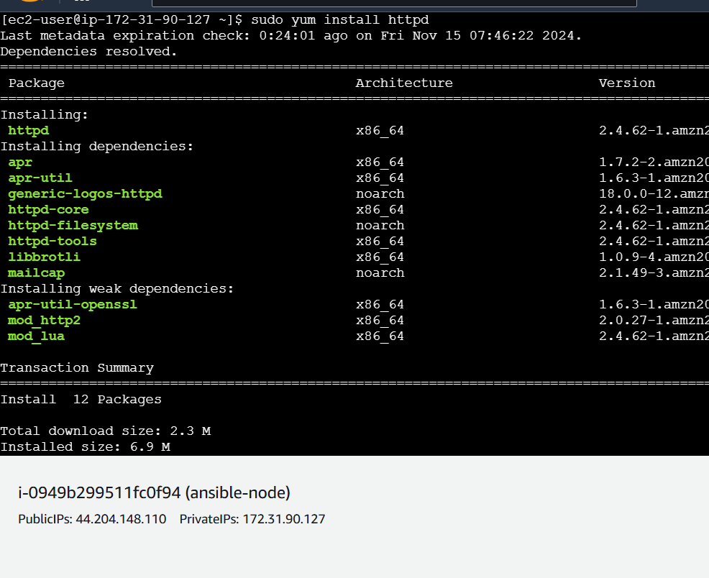
- In log group I am able to see httpd logs

