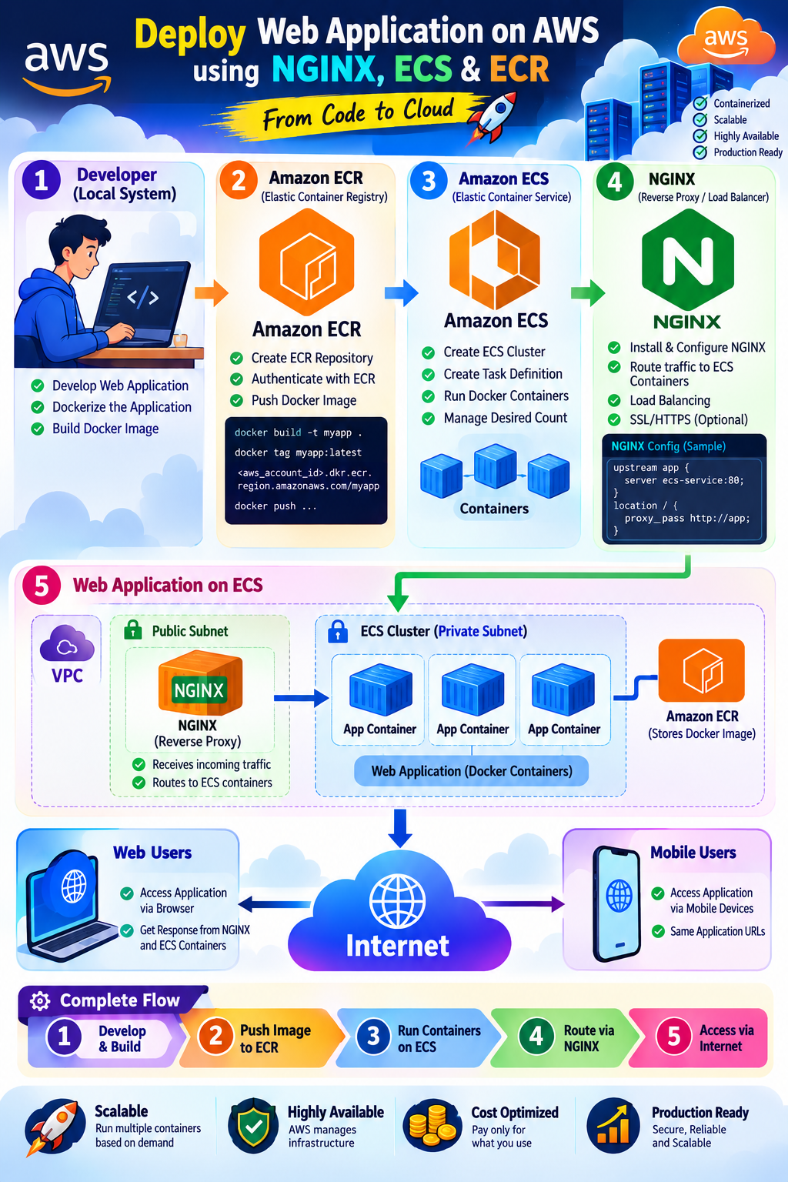

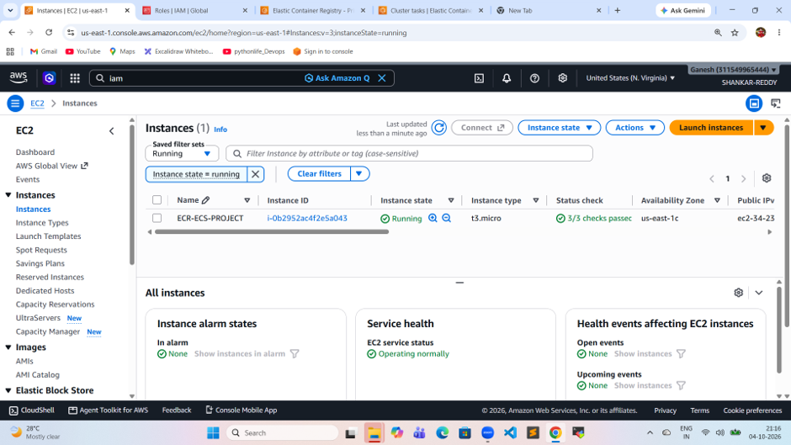

real-time DevOps container deployment where a web application is developed locally, containerized using Docker, stored in Amazon ECR, deployed on Amazon ECS, and exposed to users through NGINX.
Developer / Local System
│
│ 1. Develop Application
▼
Docker
│
│ 2. Build Docker Image
▼
Amazon ECR
│
│ 3. Pull Image
▼
Amazon ECS
│
│ 4. Run Containers
▼
NGINX
Reverse Proxy
│
▼
Internet
/ \
▼ ▼
Web Users Mobile Users

Developer – Local System
The developer creates the web application on their local machine.
index.html
app.py
requirements.txt
Dockerfile
The application is then converted into a Docker image.
[root@ip-172-31-16-71 ec2-user]# history
1 dnf update
2 sudo dnf install docker -y
3 sudo systemctl enable docker
4 sudo systemctl start docker
5 sudo systemctl status docker
6 sudo usermod -aG docker ec2-user
Dockerfile
FROM nginx:latest

COPY . /usr/share/nginx/html

EXPOSE 80
Build the image
docker build -t my-web-app .
Test locally
docker run -d -p 8080:80 my-web-app
Then access
http://localhost:8080
Amazon ECR – Store Docker Image
Amazon ECR = Elastic Container Registry
ECR is a private container registry provided by AWS.
Instead of keeping the Docker image only on your laptop, we push it to ECR
Create repository
aws ecr create-repository \
--repository-name my-web-app \
--region us-east-1

Authenticate Docker
aws ecr get-login-password --region us-east-1 | \
docker login --username AWS \
--password-stdin <ACCOUNT_ID>.dkr.ecr.us-east-1.amazonaws.com
Tag image:
docker tag my-web-app:latest \
<ACCOUNT_ID>.dkr.ecr.us-east-1.amazonaws.com/my-web-app:latest
Push:
docker push \
<ACCOUNT_ID>.dkr.ecr.us-east-1.amazonaws.com/my-web-app:latest
Amazon ECS – Run the Container
ECS = Elastic Container Service
ECS is responsible for running and managing Docker containers

ECS Cluster
│
├── Task Definition
│
└── ECS Service
│
└── Running Container
Task Definition
The task definition tells ECS:
- Which Docker image to use
- Container name
- CPU
- Memory
- Port
- IAM task role, if required
- Environment variables

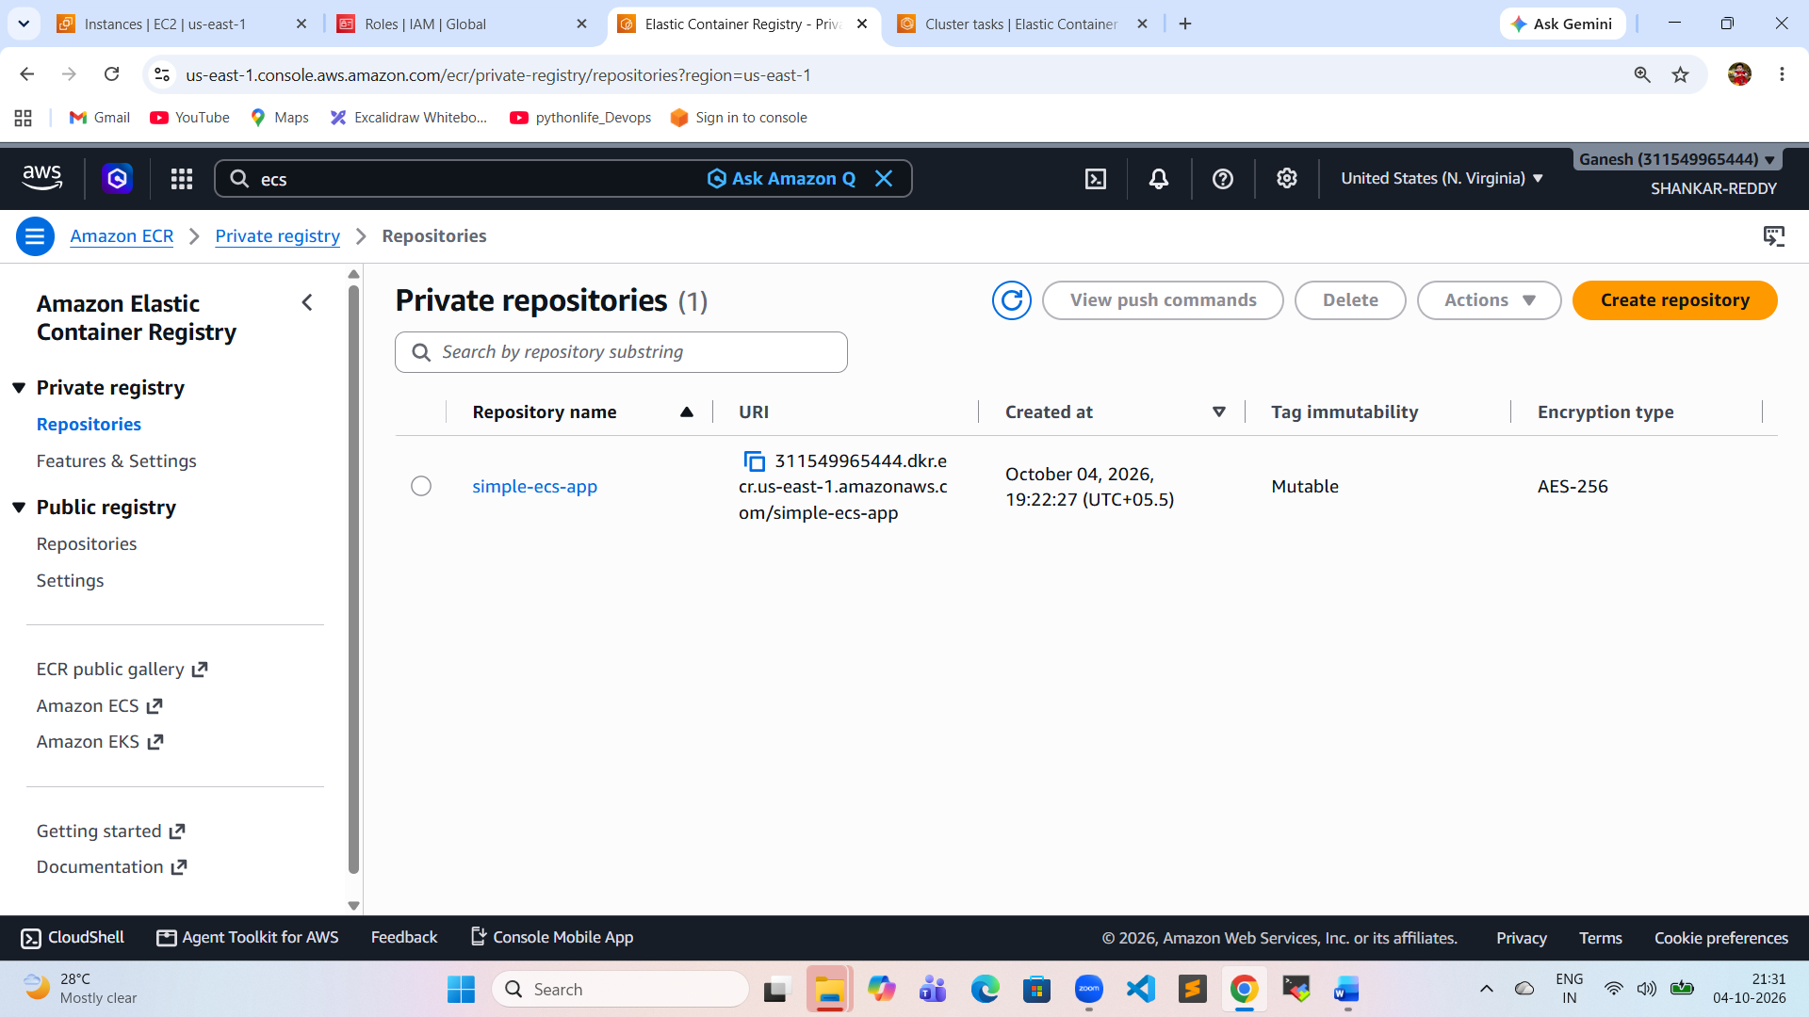
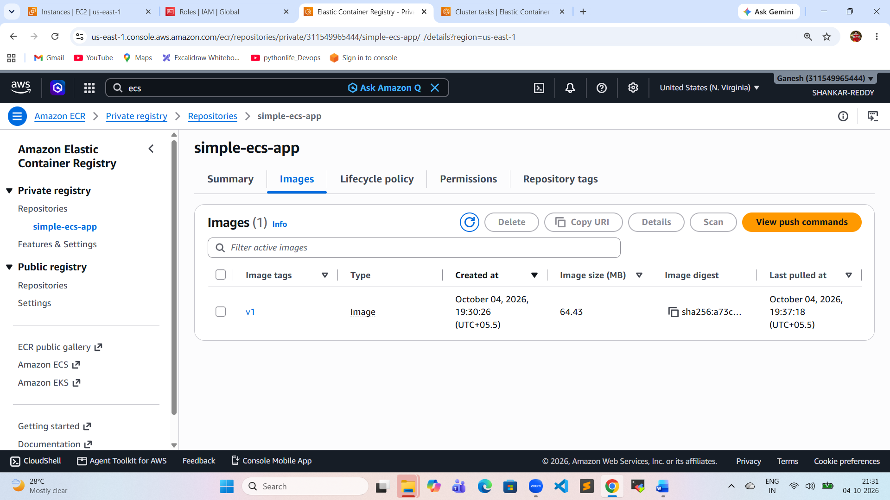
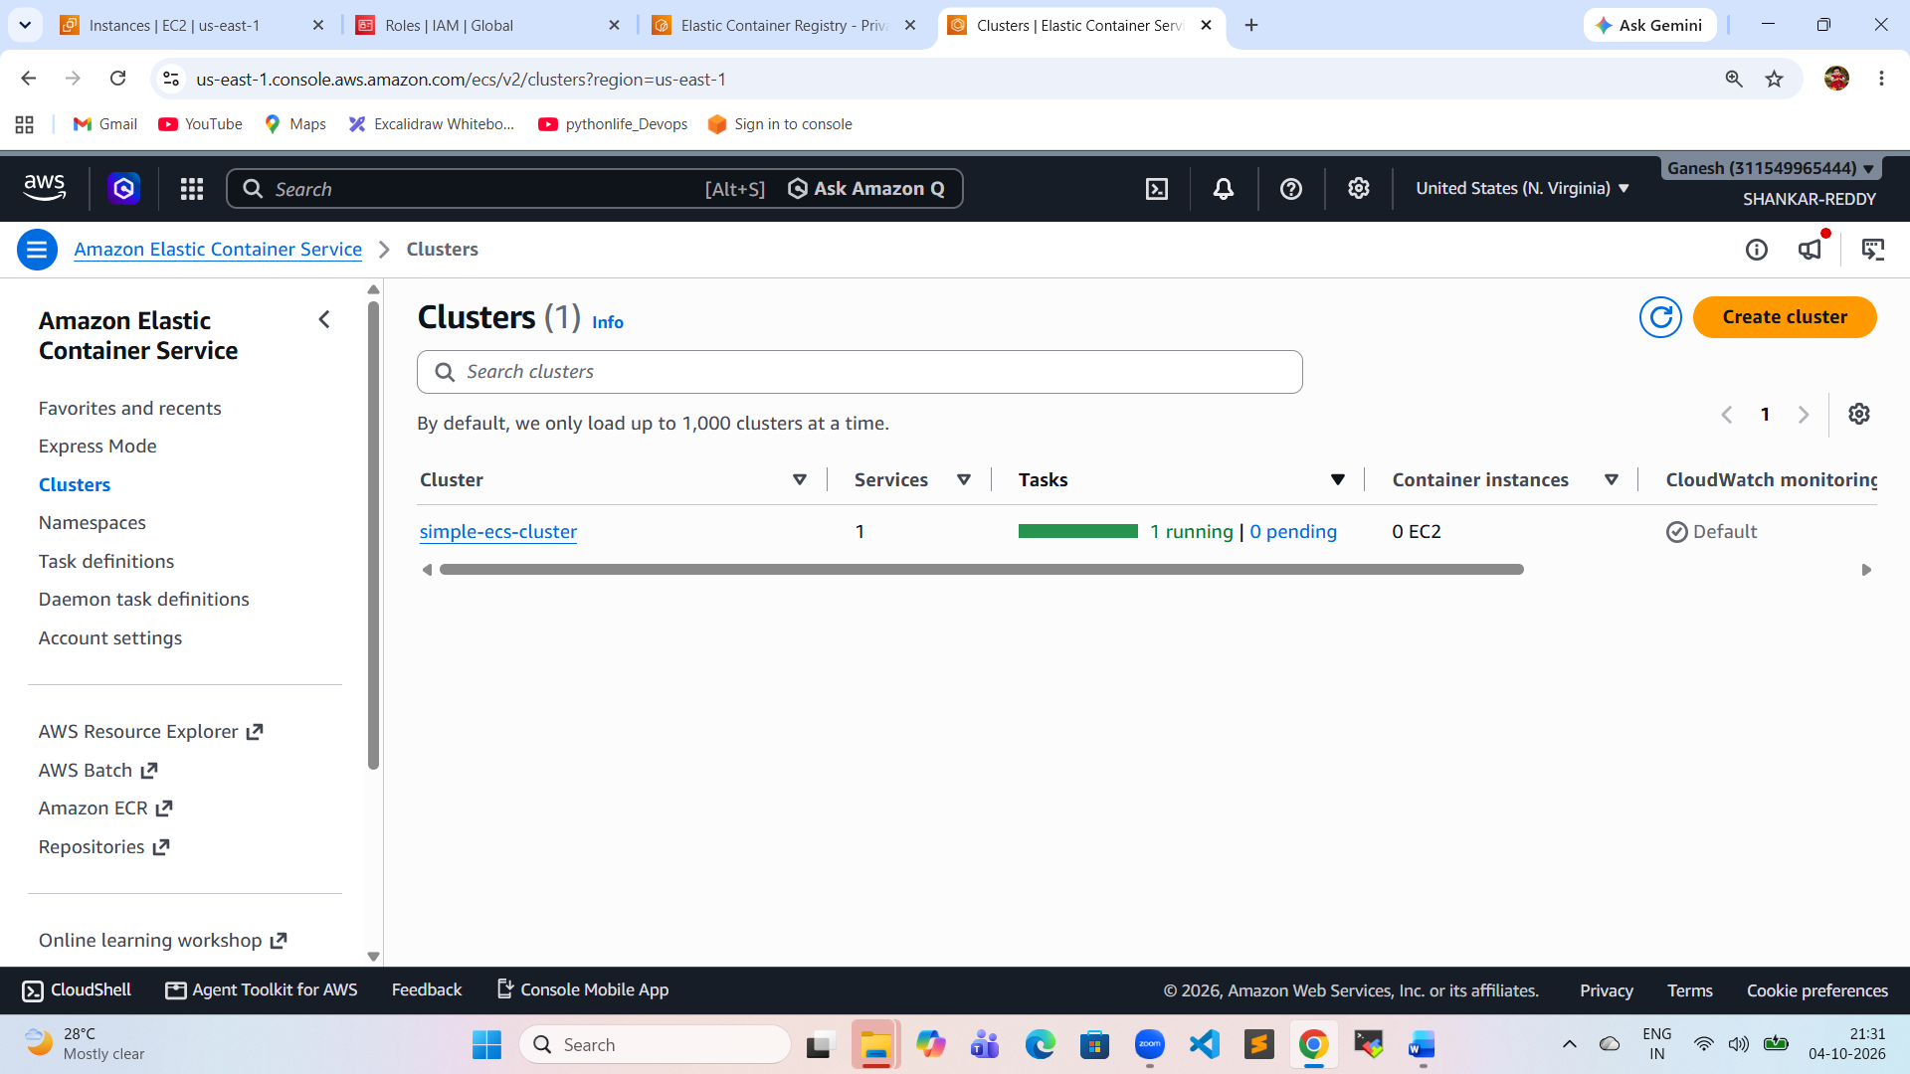
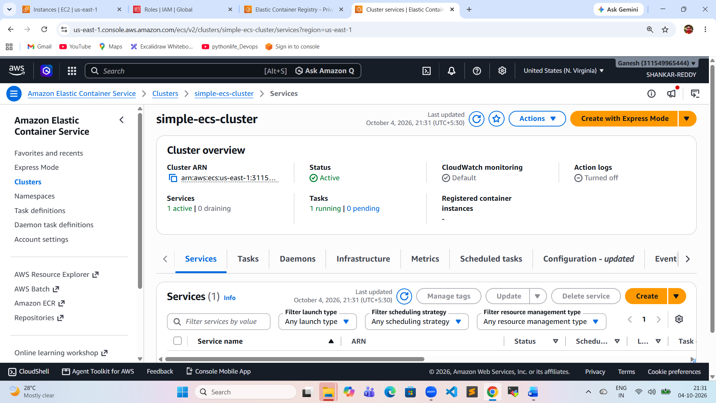
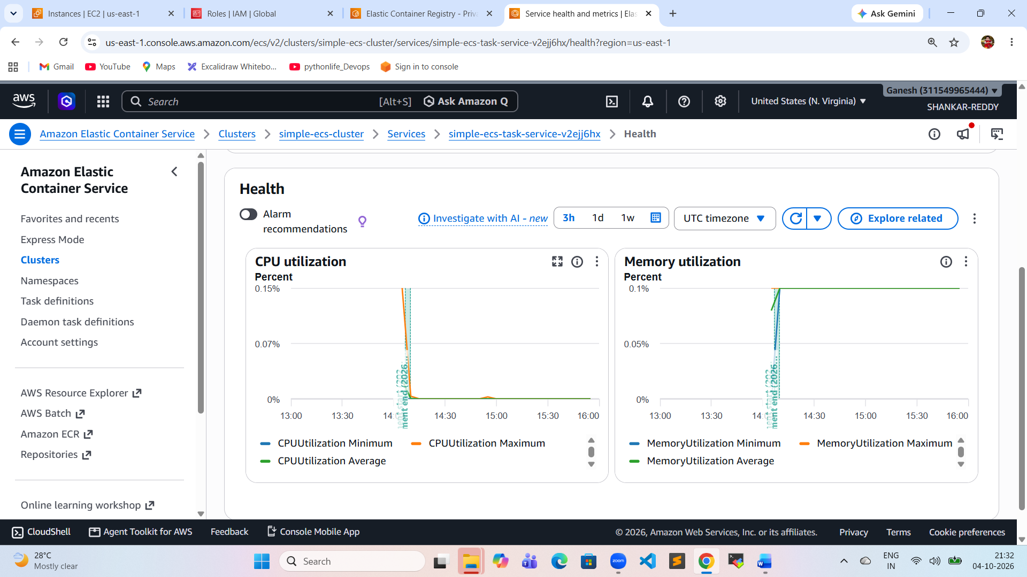
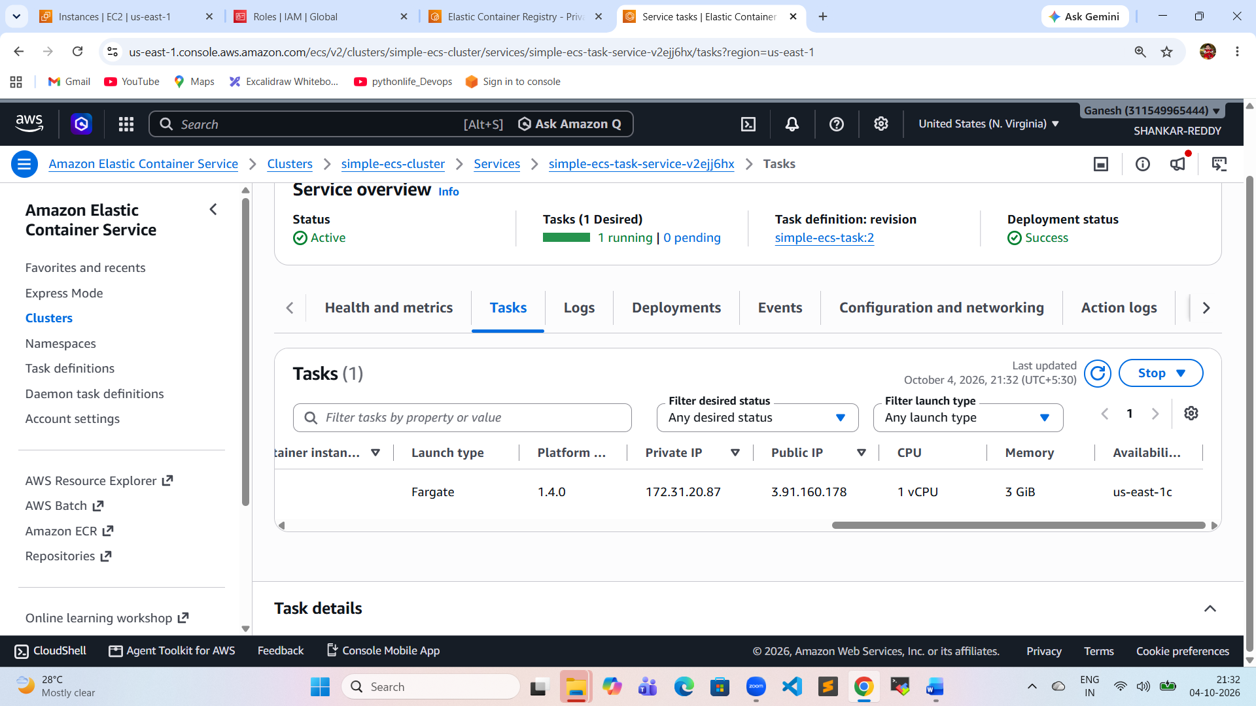
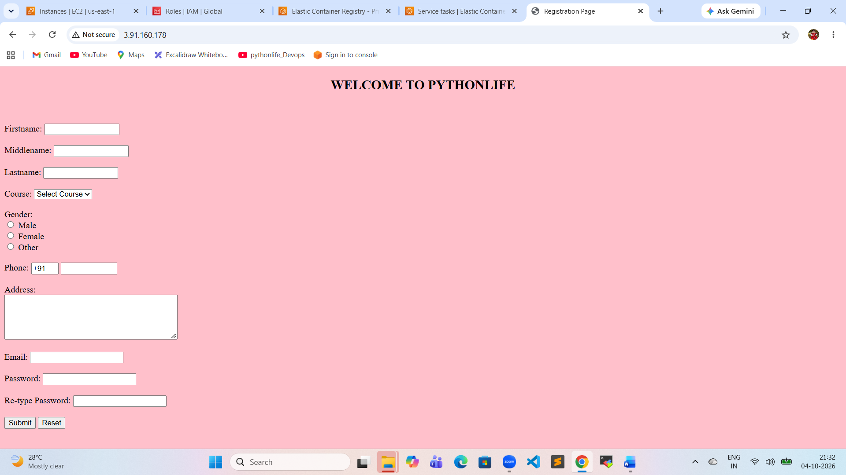

Web Application on ECS
- The application actually runs inside Docker containers managed by ECS.
- User Access
- Finally, users access the application through the Internet.
First, I developed the web application and created a Docker image. I pushed the Docker image to Amazon ECR. Then I created an ECS cluster and task definition using that ECR image. ECS pulled the image and launched the application containers. NGINX was used as a reverse proxy to route incoming requests to the application. Finally, users accessed the application through the Internet

