UNIVERSITY OF INFORMATION TECHNOLOGY, VNU-HCM
FACULTY OF SOFTWARE ENGINEERING

Software Requirements Specification

for

Event Registration System

Version 1.0
Prepared by Group 11
SE113.Q21 - Software Verification and Validation
Supervisor: Nguyen Thi Thanh Truc
Project duration: January 26, 2026 - May 2, 2026

Truong Thien Phu - 23521190 - Team Leader
Mai Xuan Tuan - 23521714 - Member

Ho Chi Minh City, May 2026
Table of Contents
1. Introduction 1
1.1 Purpose 1
1.2 Document Conventions 1
1.3 Project Scope and Product Features 1
1.4 References 1
2. Overall Description 2
2.1 Product Perspective 2
2.2 User Classes and Characteristics 3
2.3 Operating Environment 4
2.4 Design and Implementation Constraints 5
2.5 Assumptions and Dependencies 5
3. System Features 5
3.1 Manage Accounts and Authentication 5
3.1.1 Description 5
3.1.2 Functional Requirements 5
3.2 Browse and View Events 6
3.2.1 Description 6
3.2.2 Functional Requirements 6
3.3 Register for Events and Manage Reservations 6
3.3.1 Description 6
3.3.2 Functional Requirements 6
3.4 Internal Wallet and QR Payment 9
3.4.1 Description 9
3.4.2 Functional Requirements 9
3.5 Submit and Track Event Requests 9
3.5.1 Description 9
3.5.2 Functional Requirements 9
3.6 Administer Events and Approve Requests 10
3.6.1 Description 10
3.6.2 Functional Requirements 10
3.7 Notifications 10
3.7.1 Description 10
3.7.2 Functional Requirements 10
3.8 Reports and Statistics 11
3.8.1 Description 11
3.8.2 Functional Requirements 11
4. Data Requirements 11
4.1 Logical Data Model 11
4.2 Data Dictionary 11
4.3 Reports 12
4.3.1 Event Registration Summary Report 12
4.3.2 User Transaction History Report 13
4.4 Data Integrity, Retention, and Disposal 13
5. External Interface Requirements 13
5.1 User Interfaces 13
5.2 Software Interfaces 13
5.3 Hardware Interfaces 13
5.4 Communications Interfaces 13
6. Quality Attributes 14
6.1 Usability Requirements 14
6.2 Performance Requirements 14
6.3 Security Requirements 14
6.4 Safety Requirements 14
6.5 Availability Requirements 14
6.6 Robustness Requirements 14
Appendix A: Analysis Models 15
Appendix B: Requirement Traceability to Testing 16
Appendix C: Final Acceptance Criteria 16

Revision History
Name | Date | Reason For Changes | Version
Truong Thien Phu | 26-Jan-2026 | Initialized the SRS document, selected the Event Registration System topic, and drafted the purpose, project scope, and initial product overview. | 0.1
Truong Thien Phu; Mai Xuan Tuan | 15-Feb-2026 | Added the overall system description, user classes, operating environment, assumptions, constraints, and initial functional requirement groups. | 0.2
Group 11 | 10-Mar-2026 | Completed the main system features, including authentication, event browsing, ticket reservation, wallet payment, QR top-up, event request, admin approval, notifications, and reporting requirements. | 0.3
Group 11 | 31-Mar-2026 | Updated data requirements, logical data model, data dictionary, business rules, external interface requirements, and nonfunctional requirements. | 0.4
Mai Xuan Tuan | 20-Apr-2026 | Added and refined analysis diagrams, requirement traceability mapping, acceptance criteria, and alignment with the planned verification artifacts. | 0.5
Truong Thien Phu | 02-May-2026 | Baselined the final SRS for course submission according to the COS SRS template, with finalized Release 1.0 scope and approved requirements. | 1.0

1. Introduction

1.1 Purpose
This SRS describes the functional and nonfunctional requirements for software release 1.0 of the Event Registration System (ERS). The document is intended for the development team, verification team, and course instructor to understand what the system shall do, what behavior shall be verified, and what boundaries apply to the final project submission.
Unless explicitly marked as optional or future work, all requirements in this SRS are committed for Release 1.0. The wording is written to support direct conversion into test cases, unit/service tests, system tests, Playwright automation scenarios, and defect reports.

1.2 Document Conventions
The keyword “shall” identifies mandatory behavior. The keyword “should” identifies a recommended behavior that can be deferred if it is not part of the implemented release. Requirement identifiers use the following prefixes: ACC for account and authentication, EVT for events, RES for reservation, PAY for wallet and payment, REQ for event request, ADM for administration, NOTI for notification, REP for reporting, and NFR prefixes for quality attributes.
User, Admin, Reservation, Transaction, Event Request, and Notification are treated as domain terms. Status values such as Pending, Confirmed, Cancelled, Success, Failed, Approved, Rejected, and Withdrawn shall be used consistently in the user interface, API responses, database records, and test artifacts.

1.3 Project Scope and Product Features
The ERS is a web-based system that supports event publication, event discovery, ticket reservation, internal wallet payment, simulated QR top-up, user-submitted event requests, administrative approval, in-app notification, and basic operational reporting. The system replaces fragmented manual registration through spreadsheets, forms, messages, or emails with a single controlled workflow.
Release 1.0 focuses on the features needed for the software verification final project: registration and login, event browsing, ticket reservation and cancellation, balance and transaction consistency, event request approval, role-based access control, notification, traceability, and acceptance criteria. Real bank integration, native mobile applications, AI recommendation, public community chat, and advanced accounting reports are outside the mandatory release scope.

1.4 References
- IEEE Computer Society, IEEE Recommended Practice for Software Requirements Specifications, IEEE Std 830-1998, 1998.
- ISO/IEC/IEEE, ISO/IEC/IEEE 29148:2018 - Systems and Software Engineering - Life Cycle Processes - Requirements Engineering, 2018.
- B. Nuseibeh and S. Easterbrook, “Requirements Engineering: A Roadmap,” in Proceedings of the Conference on the Future of Software Engineering (FOSE/ICSE 2000), ACM, 2000.
- B. H. C. Cheng and J. M. Atlee, “Research Directions in Requirements Engineering,” in Proceedings of the Future of Software Engineering (FOSE 2007), IEEE Computer Society, 2007.
- M. Glinz, “On Non-Functional Requirements,” in Proceedings of the 15th IEEE International Requirements Engineering Conference (RE 2007), IEEE, 2007.
- A. van Lamsweerde, Requirements Engineering: From System Goals to UML Models to Software Specifications, John Wiley & Sons, 2009.
- K. Pohl, Requirements Engineering: Fundamentals, Principles, and Techniques, Springer, 2010.
A. Mavin, P. Wilkinson, A. Harwood, and M. Novak, “Easy Approach to Requirements Syntax (EARS),” in Proceedings of the 17th IEEE International Requirements Engineering Conference (RE 2009), IEEE, 2009.
- K. E. Wiegers and J. Beatty, Software Requirements, 3rd ed., Microsoft Press, 2013.
- X. Franch, M. Glinz, D. Méndez, and N. Seyff, “A Study about the Knowledge and Use of Requirements Engineering Standards in Industry,” Requirements Engineering, Springer, 2022.

2. Overall Description

2.1 Product Perspective
The Event Registration System is a new web application used to centralize the complete lifecycle of internal events. It provides a single platform where users can discover events, reserve tickets, pay with an internal wallet, request new events, receive status updates, and review their own history. Admin users maintain official events, approve or reject event requests, inspect reservations, and monitor basic statistics.
Figure 1 summarizes the high-level architecture and the testing boundary. The frontend communicates with backend APIs; the backend enforces authentication, authorization, business rules, and state changes; the database stores Users, Events, Reservations, Transactions, EventRequests, and Notifications. The lower part of the diagram identifies verification layers used by the project: unit/service tests, system tests, and Playwright automation.
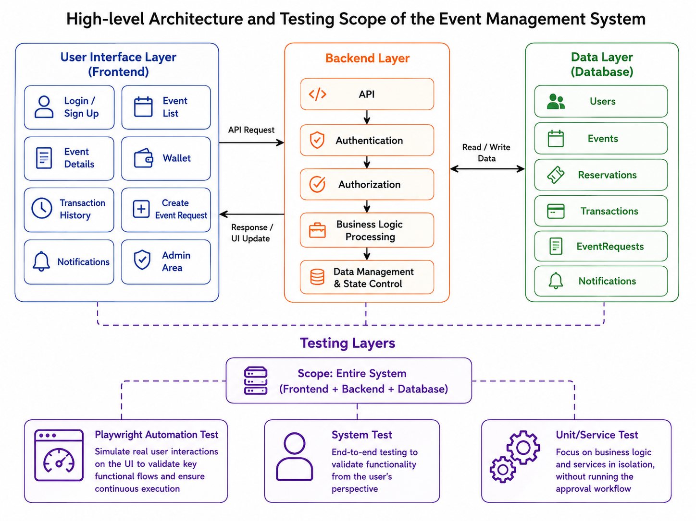
Figure 1. Context and testing architecture for Release 1.0 of the Event Registration System.

Figure 2 refines the context boundary. It shows external actors, supporting components, the ERS core, the database, and the verification suite used to validate the system during the course timeline.
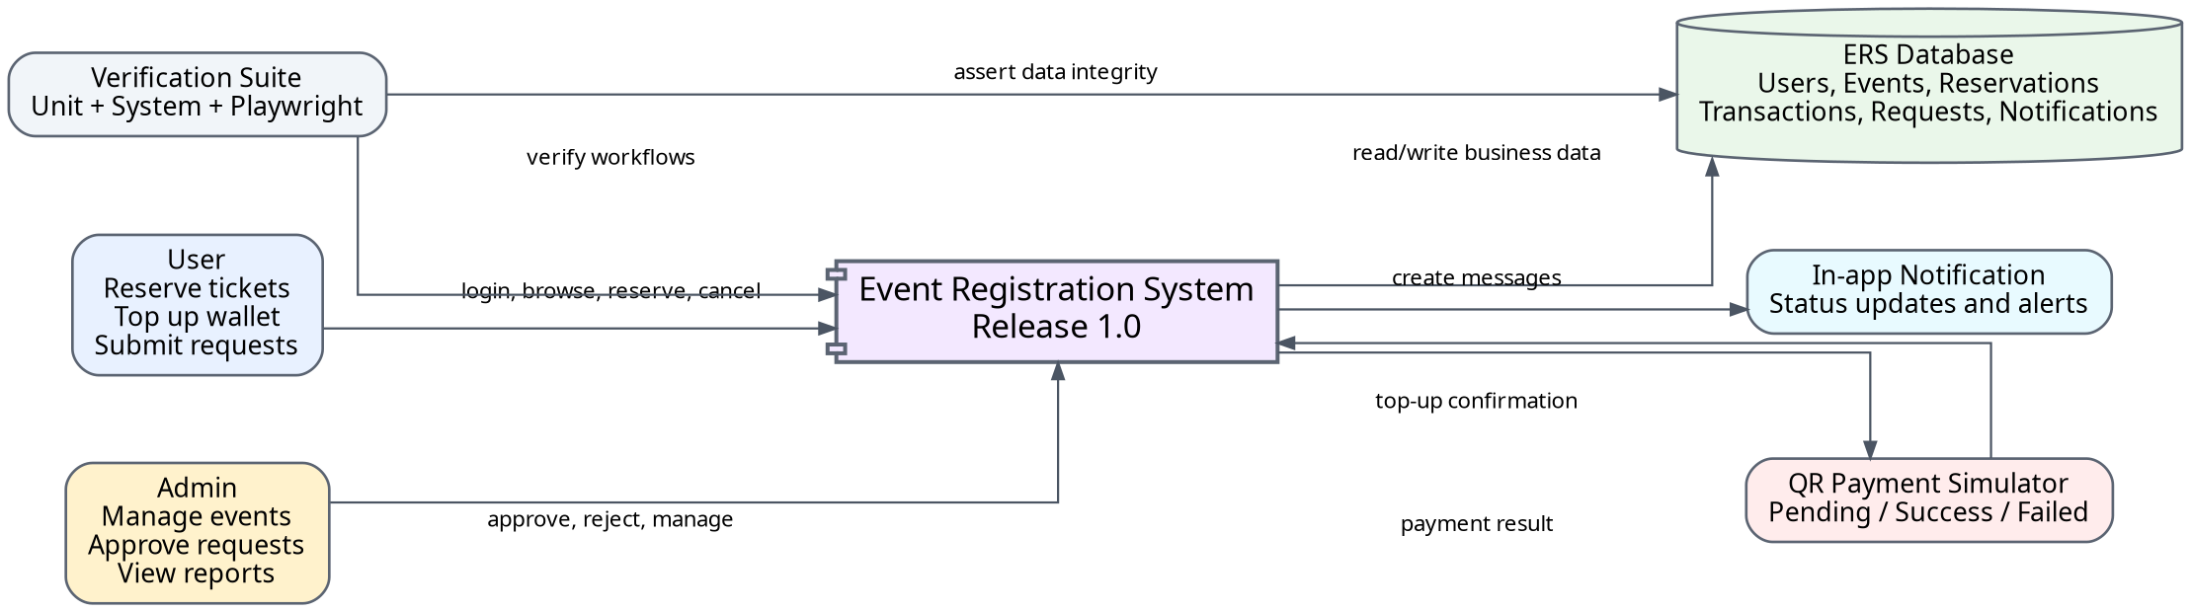
Figure 2. System context diagram for Release 1.0 of the Event Registration System.

2.2 User Classes and Characteristics
User Class | Description and Characteristics
User (favored) | A User is the primary end user who registers, logs in, views event lists, checks event details, reserves tickets, cancels reservations when allowed, tops up the internal wallet, submits event requests, tracks request status, and reads notifications. Users shall only access their own reservations, transactions, event requests, and notifications.
Admin | An Admin manages official event data and review workflows. Admins can create, update, disable, or soft-delete events; approve or reject event requests; view participants; and inspect dashboard statistics. Admin functions shall be protected by authentication and role-based authorization.
Payment Simulator | The Payment Simulator represents the QR top-up confirmation component in the project scope. It can mark top-up transactions as Success, Failed, or Expired for testing without connecting to a real banking gateway.
Notification Component | The Notification Component creates in-app notifications after important business events such as successful reservation, cancellation, top-up result, or event request decision. Email/SMS/push notification can be treated as future integration unless configured in the deployed project.

Figure 3 summarizes the main User and Admin use cases. It is included to make the SRS easier to trace into system test cases and Playwright scenarios.
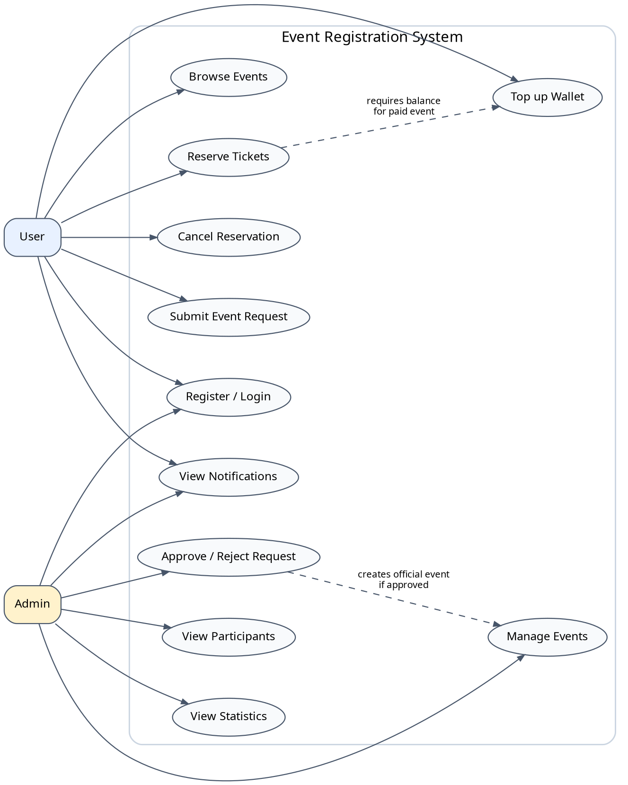
Figure 3. Main use case diagram for User and Admin actors.

2.3 Operating Environment
OE-1: The ERS shall operate correctly on current versions of Google Chrome, Microsoft Edge, Mozilla Firefox, and Apple Safari used in the course environment.
OE-2: The ERS shall support access from desktop browsers and responsive mobile browsers with a minimum practical width of approximately 360 px.
OE-3: The backend shall run in the project deployment environment or local development environment approved by the team, with a database capable of storing users, events, reservations, transactions, event requests, and notifications.
OE-4: The system shall support repeatable test execution by using seed data for at least one normal User, one Admin, several events, wallet balances, and boundary data for capacity and transaction testing.

2.4 Design and Implementation Constraints
CO-1: The frontend, backend, and database responsibilities shall remain separated so that UI tests, API/system tests, and unit/service tests can be executed independently.
CO-2: Passwords shall be hashed before storage. Plain text passwords shall not be stored in the database, logs, or API responses.
CO-3: All business-critical validation shall be repeated on the backend. Frontend validation is useful for usability but shall not be the only protection for quantity, balance, role, or ownership rules.
CO-4: QR top-up may be implemented through a simulated confirmation flow in Release 1.0, but transaction states and balance changes shall remain consistent and traceable.
CO-5: Important state-changing operations shall be traceable through requirement identifiers and test cases. This includes reservation, cancellation, top-up, payment, refund, and approve/reject operations.

2.5 Assumptions and Dependencies
AS-1: The project is evaluated in an academic environment; therefore, simulated QR payment and in-app notification are acceptable when real external services are not configured.
AS-2: A user is considered authenticated only when a valid session or token is present and accepted by the backend.
AS-3: Event capacity, remaining seats, balance, and transaction status are treated as authoritative backend data, not as values controlled by the client.
DE-1: The reservation workflow depends on reliable update of event capacity and reservation records in the data layer.
DE-2: Paid reservation depends on consistent wallet balance and transaction handling. A reservation shall not be confirmed if the related payment cannot be completed consistently.
DE-3: Admin approval depends on the event request state machine. Requests in terminal states shall not be processed again.

3. System Features

3.1 Manage Accounts and Authentication

3.1.1 Description
A person shall create an account, log in, log out, and access features according to the assigned role. Account management is a foundation for all security-sensitive features. Priority = Very High.

3.1.2 Functional Requirements
ACC.Register.Input: The ERS shall require a full name, email address, and password for account registration. The system shall validate required fields before creating a new user.
ACC.Register.Email: The ERS shall reject registration when the email is empty, has an invalid format, or already exists in the system.
ACC.Register.Password: The ERS shall reject passwords that do not meet the configured length and complexity rules. A valid password shall be stored only as a hash.
ACC.Register.Role: A newly registered account shall receive the User role by default. Admin role assignment shall not be available through the public registration screen.
ACC.Login: The ERS shall authenticate a User or Admin by email and password. On success, the system shall create a session or token and route the actor to the appropriate area.
ACC.Login.Fail: If login credentials are invalid, the ERS shall return a generic login error and shall not reveal whether the email exists.
ACC.Logout: The ERS shall allow an authenticated actor to end the session. After logout, direct URL access or browser back navigation shall not reopen protected pages without authentication.
ACC.Authorize: The ERS shall check role permissions for protected APIs and pages. A normal User shall receive 401/403 or an equivalent access-denied response when attempting Admin operations.
ACC.Reset.Optional: If password recovery is included in the deployed release, the ERS shall use an expiring verification token or simulated verification flow. If not implemented, this feature shall be marked optional/future in the test plan.

3.2 Browse and View Events

3.2.1 Description
A User needs clear event information before deciding to reserve tickets. The event browsing feature shall display only eligible public events and shall represent registration status accurately. Priority = High.

3.2.2 Functional Requirements
EVT.List: The ERS shall display a list of events that are eligible for public visibility, including event title, time, location, ticket price, and availability status.
EVT.List.Empty: If no event is available, the ERS shall show a friendly empty state rather than an error or blank screen.
EVT.Detail: The ERS shall display event detail including title, description, date and time, location, capacity, remaining seats, ticket price, registration policy, and cancellation policy.
EVT.Detail.NotFound: If an event is deleted, disabled, unpublished, or not found, the ERS shall show an appropriate message or route the user back to the event list.
EVT.Filter: If filter or sort controls are provided, the ERS shall apply them to public events without exposing Draft, Disabled, or Cancelled events to normal Users.
EVT.Status: The ERS shall use event status to decide display and action availability. Draft shall not be public; Published may be public and reservable; Closed, Cancelled, or Completed shall not accept new reservations.

3.3 Register for Events and Manage Reservations

3.3.1 Description
A User whose identity has been verified may reserve tickets for a published event if the event is open, enough seats remain, and wallet balance is sufficient when a payment is required. The workflow shall behave as one logical transaction. Priority = Very High.

3.3.2 Functional Requirements
RES.Start: The ERS shall allow only an authenticated User to start the reservation workflow from a valid event detail page.
RES.Block.Unavailable: The ERS shall prevent reservation when the event is not Published, registration is closed, the event is cancelled, or no seats remain.
RES.Quantity.Valid: The ERS shall require quantity to be an integer greater than or equal to 1 and less than or equal to the configured maximum tickets per reservation.
RES.Quantity.Invalid: If quantity is empty, zero, negative, non-numeric, or greater than the limit, the ERS shall reject the request and shall not create a reservation.
RES.Capacity.Check: Before confirmation, the ERS shall check remaining seats. The sum of confirmed reservation quantities for an event shall never exceed event capacity.
RES.Payment.Check: For paid events, the ERS shall calculate total amount as quantity multiplied by ticket price and verify that the User wallet balance is sufficient before confirming the reservation.
RES.Payment.Free: For free events, the ERS shall not create a payment deduction and shall not reduce the User wallet balance.
RES.Confirm: When all validation succeeds, the ERS shall create a reservation with a unique identifier, user_id, event_id, quantity, status, created time, and payment reference if applicable.
RES.Transaction: For paid reservations, the ERS shall create a PAYMENT transaction and link it to the reservation. No wallet deduction shall exist without a corresponding transaction record.
RES.Done.Atomic: Reservation creation, remaining-seat update, wallet deduction, payment transaction, and success notification shall be handled as one logical transaction. If a required step fails, the ERS shall roll back or compensate to avoid partial success.
RES.Cancel: The ERS shall allow a User to cancel only his or her own reservation when the reservation status and cancellation deadline allow it.
RES.Cancel.Refund: If cancellation requires refund, the ERS shall create a REFUND transaction, increase wallet balance by the approved amount, release reserved seats, and mark the reservation Cancelled.
RES.Cancel.Deny: If a reservation belongs to another User, is already Cancelled, is Completed, or is outside the cancellation policy, the ERS shall reject cancellation and keep data unchanged.
RES.History: The ERS shall show each User only his or her own reservation history, including event, quantity, status, creation time, and available actions.
RES.Idempotency: The ERS shall prevent duplicate reservation or duplicate refund caused by double click, page refresh, or repeated API calls with the same business intent.

Figure 4 shows the reservation activity flow that should be used as the reference path for positive and negative reservation test cases.
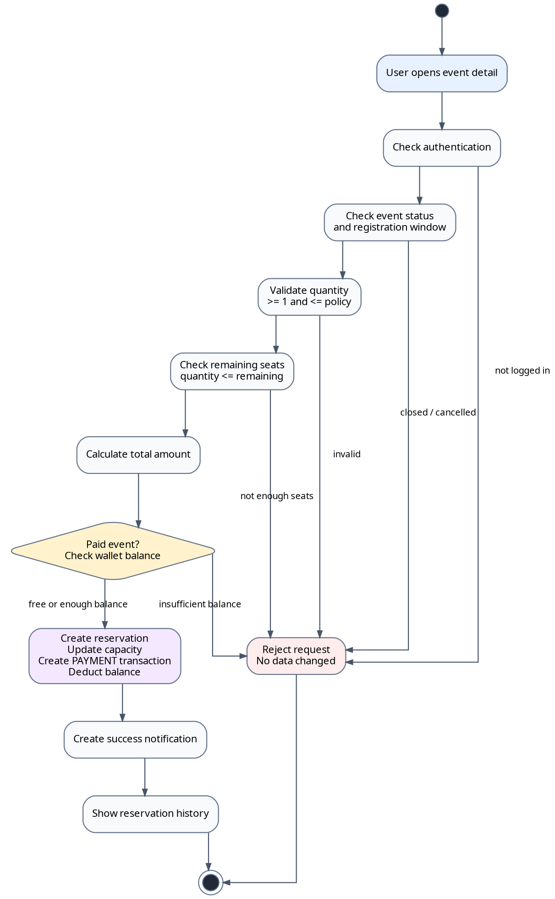
Figure 4. Activity diagram for the ticket reservation workflow.

3.4 Internal Wallet and QR Payment

3.4.1 Description
The internal wallet supports payment for paid events. QR top-up can be simulated in Release 1.0, but transaction state and wallet balance shall remain accurate. Priority = High.

3.4.2 Functional Requirements
PAY.Balance: The ERS shall display the authenticated User wallet balance. The system shall not display the balance of another User.
PAY.TopUp.Create: The ERS shall create a TOPUP transaction in Pending status when a User submits a valid top-up amount greater than 0.
PAY.TopUp.Invalid: If the top-up amount is empty, zero, negative, non-numeric, or above a configured maximum, the ERS shall reject it and shall not create a transaction.
PAY.TopUp.QR: The ERS shall display a QR code or simulated payment information after creating a Pending top-up transaction. Wallet balance shall not increase while the transaction is Pending.
PAY.TopUp.Success: When a Pending top-up is confirmed as successful, the ERS shall mark it Success, increase wallet balance by the transaction amount, store completion time, and create a notification.
PAY.TopUp.NoRepeat: The ERS shall not add money twice if the same top-up transaction is confirmed more than once.
PAY.TopUp.Fail: If top-up fails or expires, the ERS shall mark the transaction Failed or Expired and keep wallet balance unchanged.
PAY.Payment: The ERS shall create a PAYMENT transaction for each successful paid reservation and link it to the corresponding reservation and event.
PAY.History: The ERS shall show a User his or her own transaction history in reverse chronological order, including type, amount, status, time, and business reference.
Figure 5 presents the QR top-up sequence in Release 1.0. The important verification point is that balance increases only after the Pending transaction is confirmed as Success.
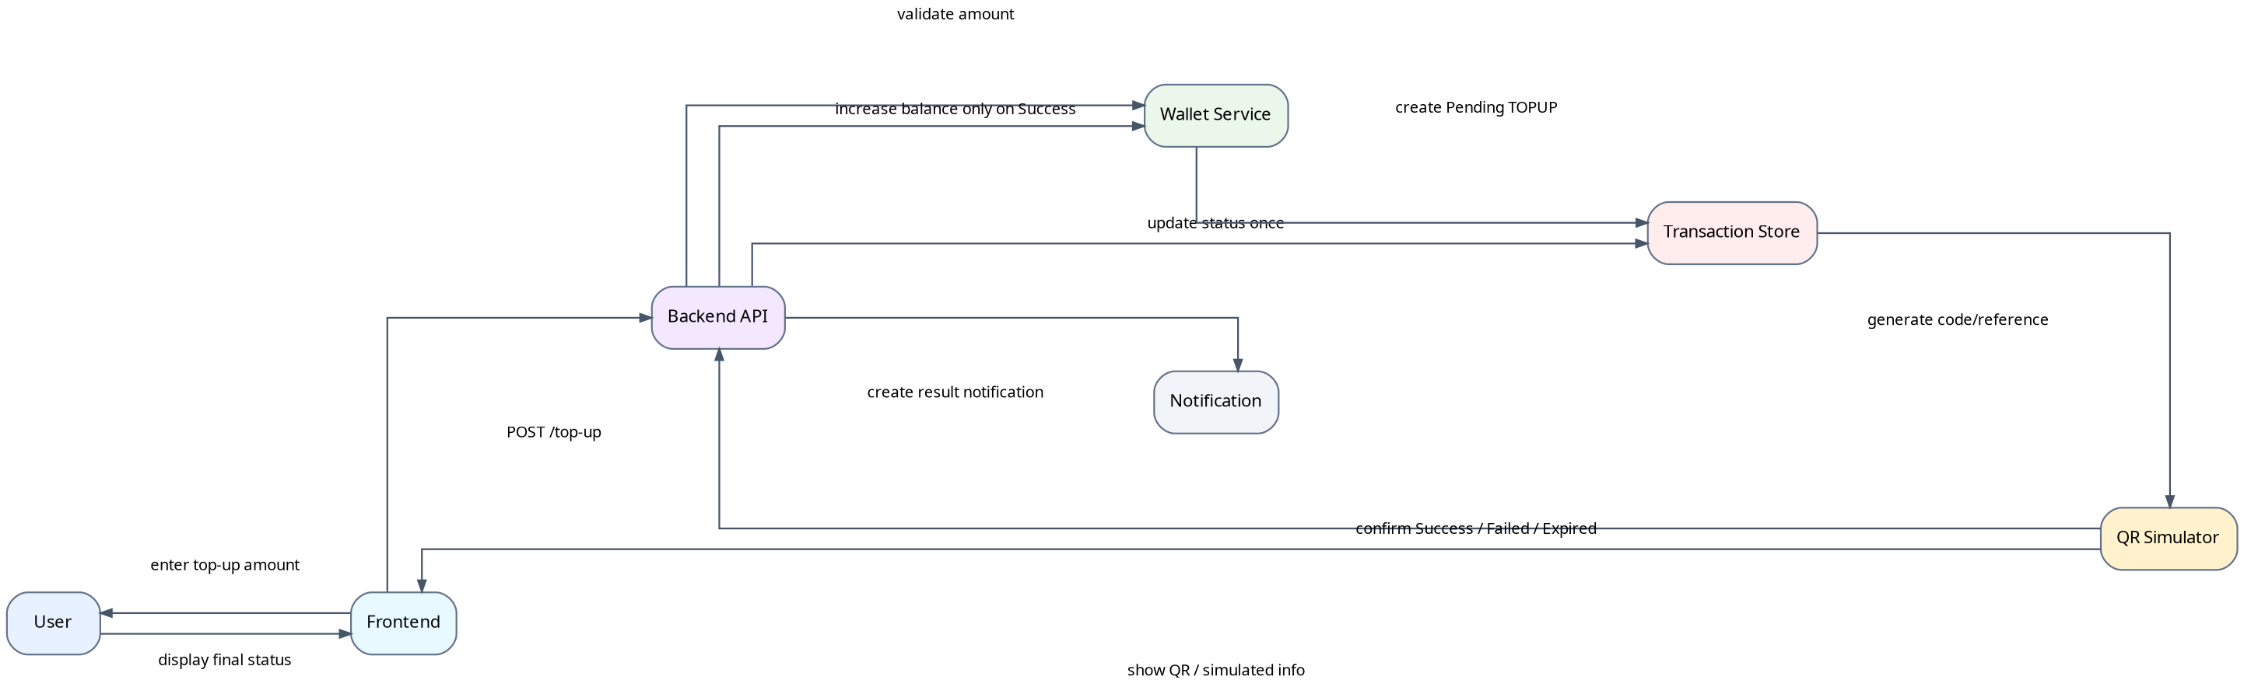
Figure 5. Sequence diagram for simulated QR top-up and wallet update.

3.5 Submit and Track Event Requests

3.5.1 Description
A User may propose a new event for Admin review. The proposal shall remain separate from official event data until an Admin approves it. Priority = High.

3.5.2 Functional Requirements
REQ.Create: The ERS shall allow an authenticated User to create an event request by entering title, description, proposed time, location, expected capacity, ticket price if any, and contact details if needed.
REQ.Validate: The ERS shall reject event requests with missing required fields, invalid time, negative capacity, negative price, or text exceeding configured length.
REQ.Status.Initial: A valid event request shall be stored with owner user_id and initial status Pending or Submitted.
REQ.Edit: The ERS shall allow a User to edit only his or her own event request while the request is Pending or Submitted.
REQ.Edit.Deny: The ERS shall prevent User edits when the request is Approved, Rejected, or Withdrawn.
REQ.Withdraw: The ERS shall allow the owner to withdraw a request that has not reached a terminal state. Withdrawn requests shall not appear in the Admin pending queue.
REQ.Track: The ERS shall allow a User to view his or her own event requests with current status, decision note, and related event link if approved.

3.6 Administer Events and Approve Requests

3.6.1 Description
Admin features control data visible to all Users. These features shall be protected by authentication, authorization, and state checks. Priority = Very High.

3.6.2 Functional Requirements
ADM.Event.Create: The ERS shall allow only Admin to create an official event with valid title, description, time, location, capacity, ticket price, and status.
ADM.Event.Update: The ERS shall allow only Admin to update event data. The system shall prevent updates that would make capacity smaller than already confirmed tickets unless a clear administrative policy handles affected reservations.
ADM.Event.Disable: The ERS shall allow Admin to disable, cancel, or soft-delete events while retaining history needed for traceability and testing.
ADM.Event.ActiveReservation: If an event has active reservations, disabling or cancelling the event shall follow a defined policy: block the action, cancel affected reservations, or notify participants as configured.
ADM.Request.List: The ERS shall allow Admin to view event requests by status, submission time, and owner.
ADM.Request.Approve: The ERS shall allow Admin to approve only a Pending/Submitted request. Approval shall update the request to Approved, record processor and time, create or prepare an official event, and notify the owner.
ADM.Request.Approve.Rollback: If official event creation fails, the ERS shall not leave the request marked Approved without a valid event or compensating record.
ADM.Request.Reject: The ERS shall allow Admin to reject a Pending/Submitted request with a reason. The system shall store rejection reason, processor, time, and notify the owner.
ADM.Request.NoRepeat: The ERS shall not allow approve/reject processing on requests that are already Approved, Rejected, or Withdrawn.
ADM.Participants: The ERS shall allow Admin to view participants/reservations for an event, including user identity needed for operation, quantity, status, and reservation time.

3.7 Notifications

3.7.1 Description
Notifications keep Users and Admins aware of important system events. In-app notification is mandatory; external email or push can be optional unless implemented. Priority = High.

3.7.2 Functional Requirements
NOTI.Create: The ERS shall create a notification after successful reservation, cancellation, top-up result, event request approval, or event request rejection.
NOTI.Content: A notification shall include recipient, type, content, read/unread status, creation time, and reference to the relevant event, reservation, transaction, or request when available.
NOTI.Isolation: A User shall only view notifications addressed to that User. Admin-only notifications shall not be visible to normal Users.
NOTI.List: The ERS shall display notification list in newest-first order and distinguish read and unread notifications.
NOTI.Read: The ERS shall allow a recipient to mark a notification as read. A User shall not mark another User notification as read.
NOTI.Navigate: When a notification links to a business object, the ERS shall navigate to that object only if the object exists and the recipient has permission to view it.
NOTI.Failure: Failure to create or send a notification shall not corrupt the primary business transaction. The system should log the notification failure for later review.

3.8 Reports and Statistics

3.8.1 Description
Release 1.0 provides basic reporting for operations and verification rather than enterprise-level financial reports. Priority = Medium.

3.8.2 Functional Requirements
REP.Dashboard: The ERS shall provide an Admin dashboard showing total events, users, reservations, transactions, and event requests by status.
REP.EventStats: The ERS shall show per-event statistics including confirmed tickets, cancelled tickets, remaining seats, and occupancy rate.
REP.TransactionStats: The ERS shall summarize transactions by type and status. Failed, Expired, or Pending top-ups shall not be counted as successful received money.
REP.Empty: If there is no data for a report, the ERS shall display zero values or an empty state rather than a technical error.
REP.Access: Administrative reports and statistics shall be accessible only to Admin.

4. Data Requirements

4.1 Logical Data Model
Figure 6 shows the main logical entities for Release 1.0. Users own reservations, transactions, event requests, and notifications. Events are reserved by Users through Reservations. Paid reservations are connected to Transactions. Approved EventRequests can result in official Events.
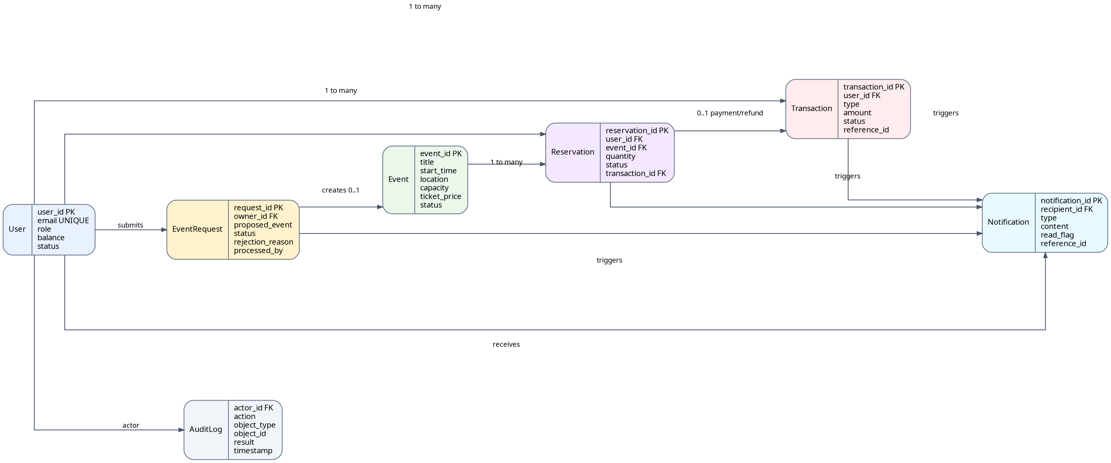
Figure 6. Logical data model for Release 1.0 of the Event Registration System.

4.2 Data Dictionary
Data Element | Description | Composition or Data Type | Length | Values
user | A person who can use ERS functions according to role. | user_id + full_name + email + password_hash + role + balance + status |  | role = USER, ADMIN
user_id | Unique identifier for a user account. | integer or UUID | 36 | unique, not null
full_name | Display name of the account owner. | Unicode text | 100 | required
email | Primary login identifier and contact address. | email string | 120 | unique, lowercase normalized
password_hash | Secure hash of the user password. | string | 255 | plain text forbidden
role | Authorization level assigned to an account. | enum | 16 | USER, ADMIN
balance | Internal wallet amount available to the user. | decimal currency | 12,2 | >= 0
event | Official event visible or manageable in the system. | event_id + title + description + start_time + location + ticket_price + capacity + status
event_id | Unique identifier for an event. | integer or UUID | 36 | unique, not null
event title | Short name of the event. | Unicode text | 150 | required
event description | Detailed event information shown in detail page. | Unicode text | 2000 | optional but recommended
event time | Date and time at which the event occurs. | datetime |  | must be valid
event location | Place where the event is held. | Unicode text | 255 | required
capacity | Maximum number of tickets/participants allowed. | integer | 6 | >= 0
remaining seats | Tickets still available for confirmed reservation. | integer | 6 | 0..capacity
ticket price | Price of one ticket in the internal wallet. | decimal currency | 12,2 | >= 0
event status | Lifecycle state of an event. | enum | 16 | Draft, Published, Closed, Cancelled, Completed, Disabled
reservation | Record that a User has reserved tickets for an Event. | reservation_id + user_id + event_id + quantity + status + transaction_id
reservation_id | Unique identifier for a reservation. | integer or UUID | 36 | unique, not null
quantity | Number of tickets in one reservation. | integer | 4 | >= 1; <= event policy and remaining seats
reservation status | Current state of a reservation. | enum | 16 | Pending, Confirmed, Cancelled, Completed, Failed
transaction | Record of a wallet balance change or top-up request. | transaction_id + user_id + type + amount + status + reference_id
transaction_id | Unique identifier for a transaction. | integer or UUID | 36 | unique, not null
transaction type | Business reason for money movement. | enum | 16 | TOPUP, PAYMENT, REFUND
amount | Money amount associated with a transaction. | decimal currency | 12,2 | > 0 for top-up/payment/refund
transaction status | Processing state of a transaction. | enum | 16 | Pending, Success, Failed, Expired
event request | User proposal for a new event waiting for Admin review. | request_id + owner_id + title + description + proposed_time + capacity + price + status
request status | State of an event request. | enum | 16 | Submitted/Pending, Approved, Rejected, Withdrawn
rejection reason | Reason provided by Admin when rejecting an event request. | Unicode text | 500 | required when configured
notification | In-app message delivered after important business events. | notification_id + recipient_id + type + content + read + reference_id
notification type | Category of notification. | enum | 32 | RESERVATION, PAYMENT, REQUEST, ADMIN, SYSTEM
read flag | Indicates whether recipient has read notification. | boolean | 1 | false by default
audit log | Trace of important operations for debugging and verification. | actor + action + object + result + timestamp |  | recommended

4.3 Reports

4.3.1 Event Registration Summary Report
Report Attribute | Specification
Report ID | ERS-RPT-1
Report Title | Event Registration Summary
Report Purpose | Admin wants to see registration status for an event or all events so that capacity, participation, and operational risk can be monitored.
Priority | Medium
Report Users | Admin
Data Sources | Events, Reservations, Users, Transactions
Frequency and Disposition | Generated on demand from the Admin dashboard; displayed in the browser and may be exported in future releases.
Latency | The dashboard and report view should display within 3 seconds in the normal test dataset.
Report Body | Event title, capacity, confirmed tickets, cancelled tickets, remaining seats, occupancy rate, paid amount, refund amount, and participant list link.
Selection Criteria | Event, status, date range, or all current events.
Sort Criteria | Newest events first by default; Admin may sort by occupancy or status if implemented.
Security Access Restrictions | Only Admin may retrieve this report.

4.3.2 User Transaction History Report
The User Transaction History Report shall display the authenticated User’s own top-up, payment, and refund transactions in reverse chronological order. It is generated on demand from the wallet or transaction history screen. A User may retrieve only his or her own transaction records.

4.4 Data Integrity, Retention, and Disposal
DI-1: The ERS shall ensure wallet balance is never negative after any valid operation.
DI-2: The total quantity of Confirmed reservations for an event shall not exceed event capacity.
DI-3: Each wallet balance change shall have a corresponding transaction record with User, type, amount, status, and timestamp.
DI-4: A paid reservation shall be Confirmed only when the related payment is successful or completed within the same logical transaction.
DI-5: Approved, Rejected, or Withdrawn event requests shall be terminal and shall not be processed again.
DI-6: Critical records such as events, reservations, transactions, event requests, and notifications should be retained at least until final course evaluation and should be soft-deleted when deletion is needed.
DI-7: Test seed data shall be resettable so automation and system tests can be repeated without hidden dependencies on previous runs.

5. External Interface Requirements

5.1 User Interfaces
UI-1: The ERS shall provide screens for registration, login, event dashboard, event detail, reservation form, reservation history, wallet, transaction history, event request submission, event request tracking, notification center, Admin dashboard, event management, request approval, participant list, and reports.
UI-2: All forms shall display validation errors near the relevant input field when practical, such as email format errors, invalid quantity, invalid top-up amount, or missing required event request fields.
UI-3: Main actions such as Reserve, Cancel Reservation, Top Up, Submit Request, Approve, Reject, and Logout shall provide clear success or failure feedback.
UI-4: The user interface shall remain usable on desktop and mobile-width screens. Critical buttons shall remain visible and tappable on narrow screens.
UI-5: The system shall present role-appropriate navigation. Normal Users shall not see Admin-only actions unless the action is protected and disabled for explanation.

5.2 Software Interfaces
SI-1: Frontend shall communicate with backend through documented HTTP API endpoints or equivalent service calls.
SI-2: Backend shall require authentication for reservation, cancellation, top-up, transaction history, event request, notification, and all Admin endpoints.
SI-3: Backend shall communicate with the database to persist Users, Events, Reservations, Transactions, EventRequests, Notifications, and audit information when implemented.
SI-4: The QR payment simulator shall notify or allow the backend to update a Pending top-up transaction to Success, Failed, or Expired.
SI-5: The notification component shall create in-app notification records through backend service logic. External email or push service integration is optional unless configured in the project release.

5.3 Hardware Interfaces
No dedicated hardware interfaces have been identified for Release 1.0. Users access the system through standard computers, tablets, or smartphones with a browser. QR images may be scanned by a phone in future releases, but the mandatory project scope supports simulated confirmation.

5.4 Communications Interfaces
CI-1: In production-like deployment, communication between browser and server shall use HTTPS to protect credentials and personal data. HTTP may be used only in local test environments.
CI-2: API responses shall use clear status codes and error messages so tests can distinguish validation failure, authorization failure, not-found data, and server error.
CI-3: If external email, SMS, push notification, or real payment gateway is integrated later, communication failures shall be logged and shall not corrupt already completed primary business transactions.

6. Quality Attributes

6.1 Usability Requirements
USE-1: A new User should be able to view an event and complete the first successful reservation without reading a separate manual, provided the User has sufficient balance when the event is paid.
USE-2: Validation messages shall be specific and actionable. For example, the system shall indicate insufficient balance, exceeded quantity limit, invalid email, or closed event rather than a generic failure.
USE-3: Admin screens shall show enough information for decision-making, including request title, description, proposed time, location, owner, status, and rejection reason if applicable.

6.2 Performance Requirements
PER-1: In the normal test dataset, event list and event detail pages should respond within 3 seconds in the project test environment.
PER-2: State-changing operations such as reserve, cancel, top-up confirm, approve, and reject shall return a clear success or failure result without leaving the UI in indefinite loading state.
PER-3: The system should support a classroom-scale test load with dozens of requests without corrupting capacity, balance, transaction, or reservation data.

6.3 Security Requirements
SEC-1: Passwords shall be stored only as hashes and shall not be logged or returned in API responses.
SEC-2: Unauthenticated actors shall not reserve, cancel, top up, submit event requests, view private data, or access Admin endpoints.
SEC-3: Admin endpoints shall verify role. Normal Users shall not create, update, disable, or delete official events; approve or reject requests; view Admin statistics; or see participant lists.
SEC-4: A User shall access only his or her own reservations, transactions, event requests, and notifications. Requests using another User ID shall be denied.
SEC-5: Client input shall be treated as untrusted. Backend shall validate quantity, amount, status, role, ownership, and IDs before processing.

6.4 Safety Requirements
SAF-1: The ERS shall display event time, location, and registration status clearly to reduce the risk of users attending the wrong event or misunderstanding cancellation status.
SAF-2: If the system stores event notes related to physical attendance requirements, the UI should display them on the event detail page before reservation.
SAF-3: Financially relevant actions in the internal wallet shall require clear confirmation and shall show the resulting status so users are not misled about payments or refunds.

6.5 Availability Requirements
AVL-1: The ERS should be available during the team’s demonstration and testing window except for planned maintenance or reset operations.
AVL-2: If the backend or database is unavailable, the UI shall show a clear error or retry message rather than displaying misleading stale success data.
AVL-3: Seed data and reset scripts should be available so the system can be restored to a known testing state before demonstration or automation runs.

6.6 Robustness Requirements
ROB-1: If a reservation request fails after any intermediate step, the ERS shall roll back or compensate so that balance, transaction, reservation, and remaining seats remain consistent.
ROB-2: If a top-up confirmation is repeated, the ERS shall not add money more than once for the same transaction.
ROB-3: If an Admin approve/reject request is repeated, the ERS shall return the current terminal state or a safe error instead of processing the request again.
ROB-4: The system shall handle not-found objects, expired sessions, invalid IDs, and forbidden ownership access without crashing the UI.
ROB-5: Important errors should be logged with enough context to support defect analysis without exposing passwords or sensitive personal data.

Appendix A: Analysis Models
Figure 7 summarizes the primary state transitions that affect verification. Reservation transitions focus on payment, capacity, cancellation, and completion. Event request transitions focus on the Admin approval process and terminal states.
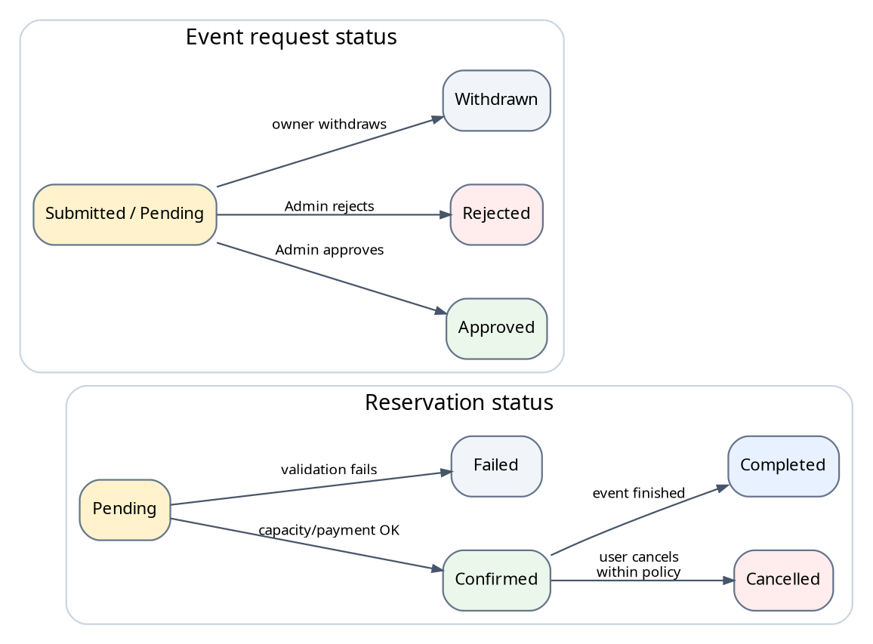
Figure 7. State-transition diagrams for reservation and event request statuses.
Figure 8 shows the lifecycle of an official event. This diagram helps verify which statuses are public, which statuses allow reservation, and which statuses are terminal or administrative only.
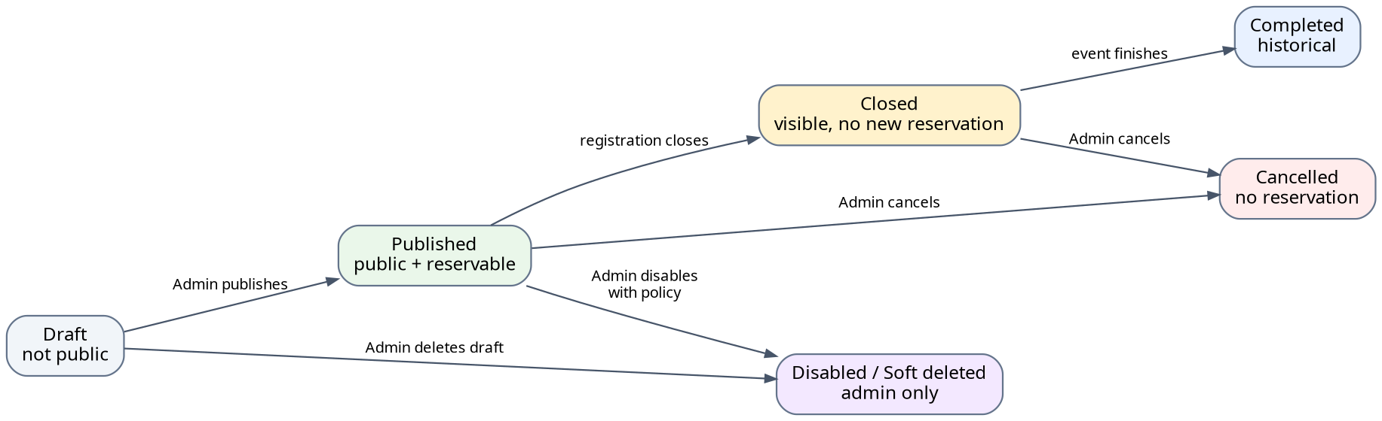
Figure 8. Lifecycle diagram for official event status.
The diagrams emphasize the most important negative tests: a Confirmed reservation shall not be cancelled twice, a Failed reservation shall not consume capacity, a Withdrawn request shall not be approved, and an Approved or Rejected request shall not be processed again.

Appendix B: Requirement Traceability to Testing
Requirement Area | Verification Focus | Suggested Evidence
FR-01, FR-02 / ACC | Registration, login, logout, role recognition, invalid login, expired session, User/Admin access separation. | Unit/service tests for auth; system tests for login; Playwright AUTH scenarios.
FR-04, FR-05 / EVT | Event list, event detail, public visibility, empty state, closed/cancelled event display. | System tests for dashboard and detail; Playwright EVDASH scenarios.
FR-06, FR-07, FR-08 / RES | Reserve tickets, invalid quantity, capacity boundary, insufficient balance, cancellation, rollback and idempotency. | Service tests for reservation logic; system/API tests for state changes; Playwright RESERVE and CAPACITY scenarios.
FR-09 / PAY | Wallet balance, QR top-up pending/success/failed/expired, payment, refund, transaction history. | Service tests for balance/transaction; Playwright BILLQR scenarios.
FR-10 / NOTI | Notification creation, list, read state, permission isolation, navigation to referenced objects. | System tests and Playwright NOTIFY scenarios.
FR-11, FR-12 / REQ | Submit, edit, withdraw, track event request; deny edit after terminal state. | System/API tests and Playwright REQSUB scenarios.
FR-13, FR-14 / ADM | Create/update/disable event, approve/reject request, prevent repeated processing, participant list, reports. | Admin API tests, role negative tests, Playwright ADMINAPR scenarios.
NFR Security | No token, invalid token, normal User calls Admin API, access by another User ID. | Negative API tests expecting 401/403 or equivalent denial.
NFR Data Integrity | Balance not negative, capacity not exceeded, transaction exists for money changes, terminal request not processed twice. | Unit/service tests and database assertions after system tests.

Appendix C: Final Acceptance Criteria
The project shall be considered acceptable for final submission when the implemented system, tests, and report evidence demonstrate the criteria below.
- All mandatory features in Release 1.0 have clear requirements and matching test cases.
- Main User flows pass: registration/login, event browsing, reservation, cancellation, top-up, event request, and notification.
- Main Admin flows pass: event management, request approve/reject, participant review, and dashboard statistics.
- Normal Users are blocked from Admin functions and from accessing another User’s private reservations, transactions, event requests, or notifications.
- Data after tests remains consistent: wallet balance is not negative, event capacity is not exceeded, transactions are traceable, and terminal requests are not processed twice.
- No unresolved Critical or High defects remain at final submission unless explicitly deferred and justified.
- Automation scenarios either pass or have linked defect records explaining remaining failures.
- SRS, Test Plan, Test Case Specification, Test Report, Automation Result, and Defect Log use consistent requirement IDs or mapping so traceability can be reviewed.

