Lab 2 5/22/2017

Lab View Array and For Loop

Part II Front and Block Diagram; Figure 1 & Figure 2

Front Panel
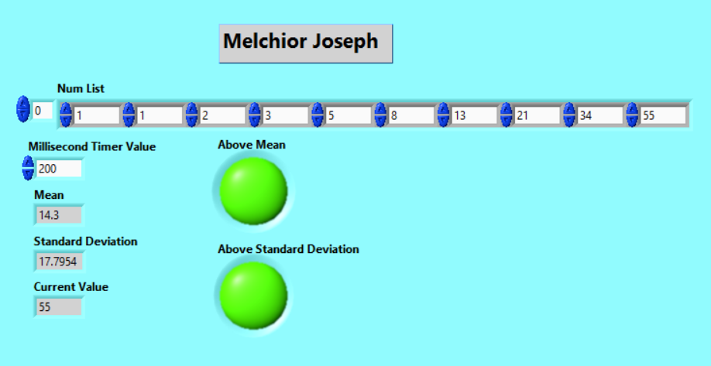
Figure 1.

Block Diagram
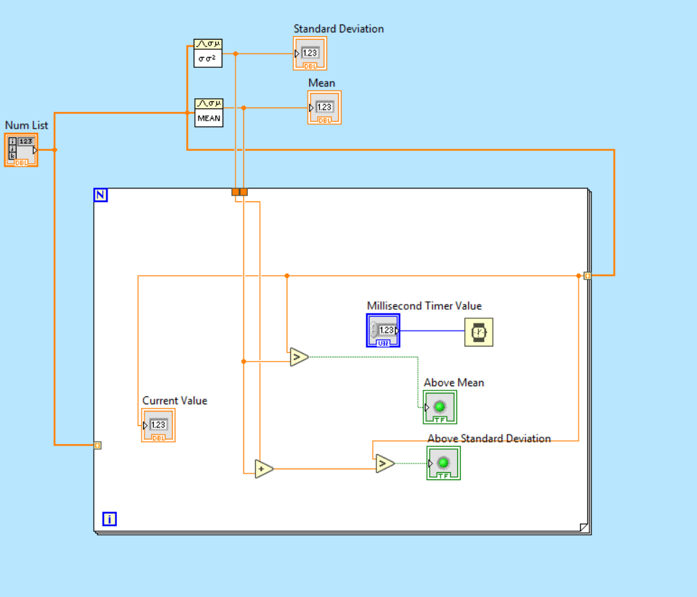
Figure 2.

Part I Front and Block Diagram; Figure 3 & Figure 4

Front Panel 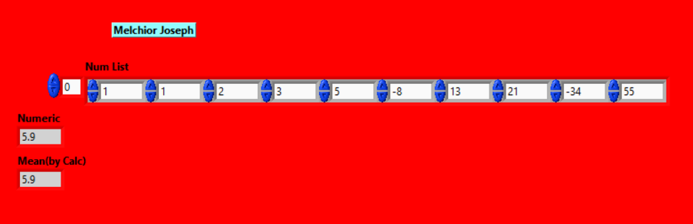
Figure 3.

Block Diagram
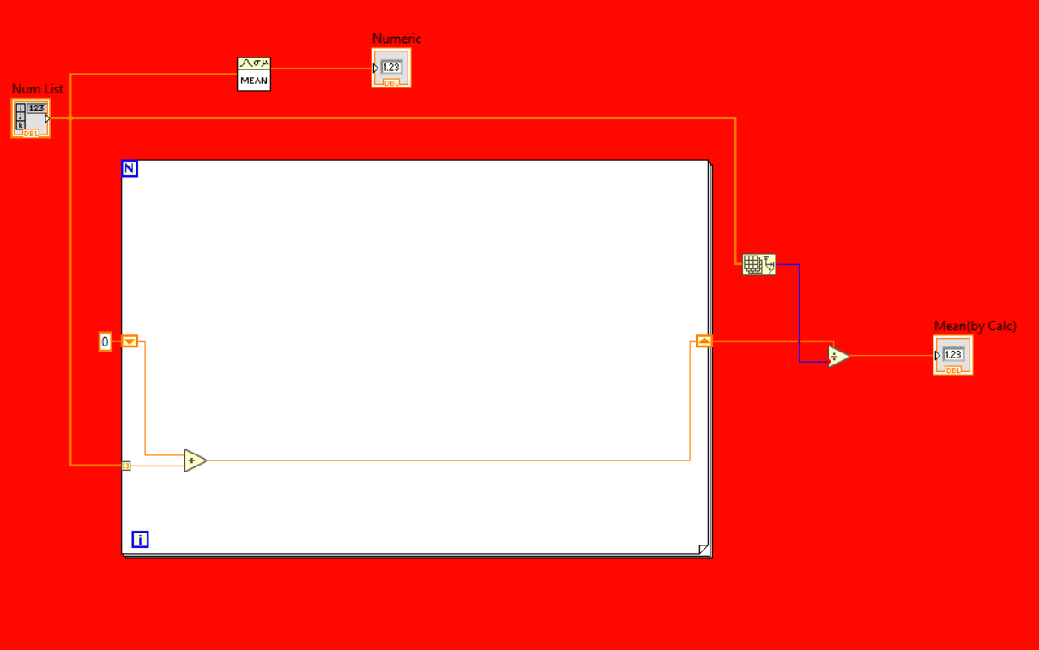
Figure 4.

