Lab 3 6/5/2017
Lab View Array and For Loop

Bonus Part II Figure 1

Original and Manipulated Rat Respiration Rate Graphs
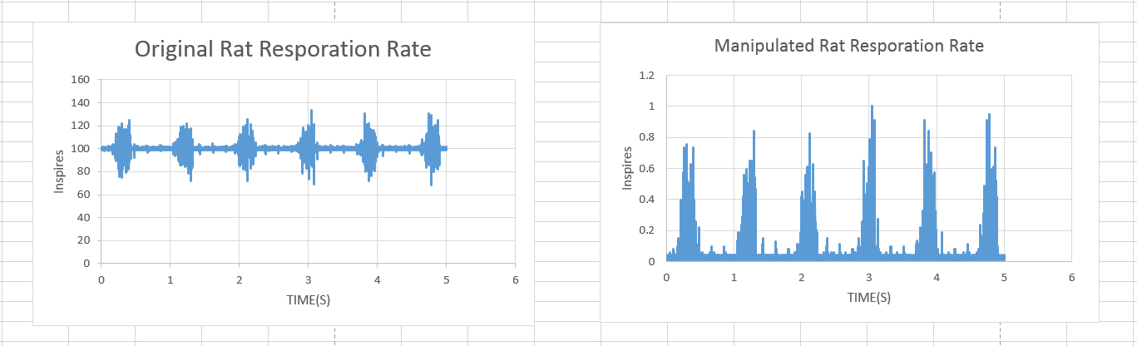
Figure 1.

Part I Front and Block Diagram; Figure 2 & Figure 3
Front Panel 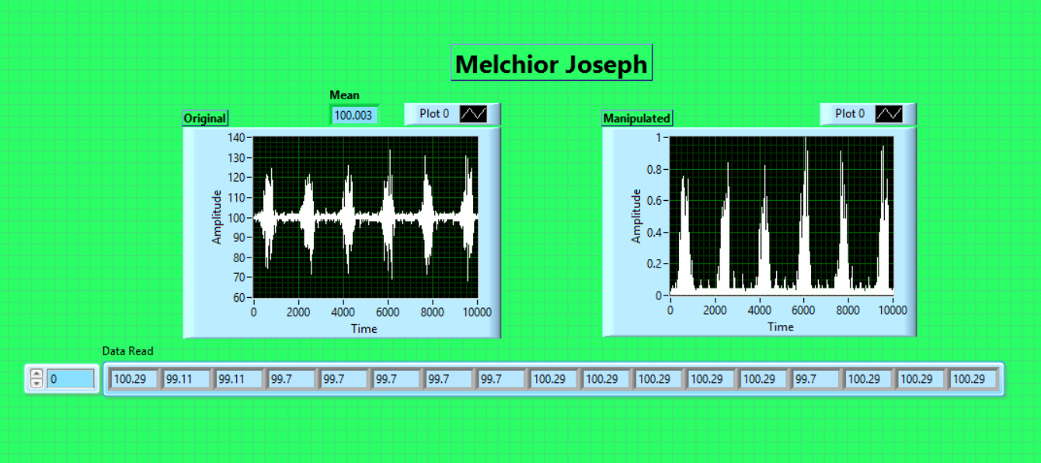
Figure 2.

Block Diagram
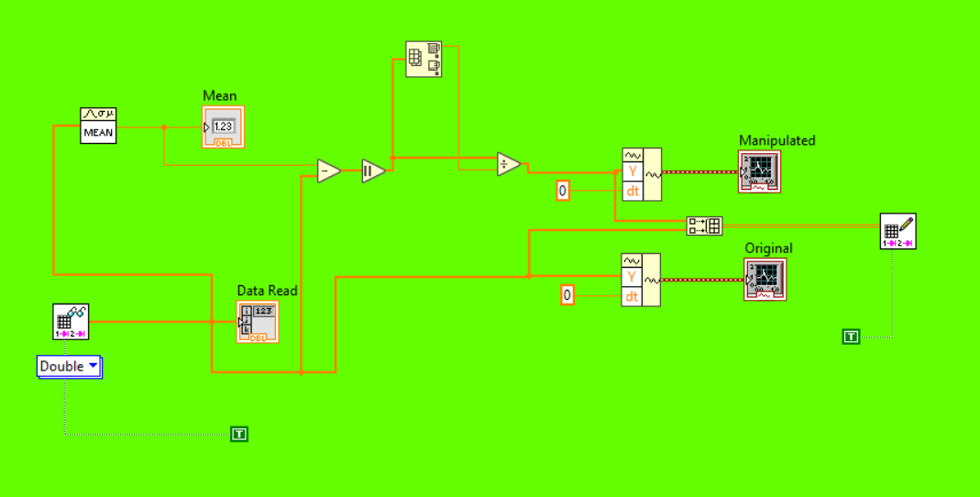
Figure 3.

