Lab 4 6/12/2017
Lab 4 Setup my Rio Module
Function: Flushed Flat Surface Function.
The designed function of MyRio is to flash the Led Button indicating when a surface is flat.When the Rio is on a Flushed surface either oriented upside down, sideway, or simply laying on a flushed desk we will have the boolean button 'Flushed Flat Surface' turn on in the program front Panel. On the program side we have indicated 3 led based on the orientation of the Rio. This feature can be useful for when cleaning or creating a drone which cleans a home in multiple dimensions, so a walls ceiling and floors. This function can provide Feedback to the orientation. Currently all three Flat orientation are calibrated to greater than 90% of normal gravity.

Project Explorer
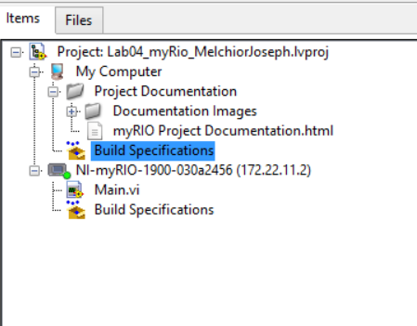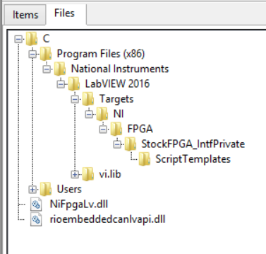
Figure 1.
Front Panel 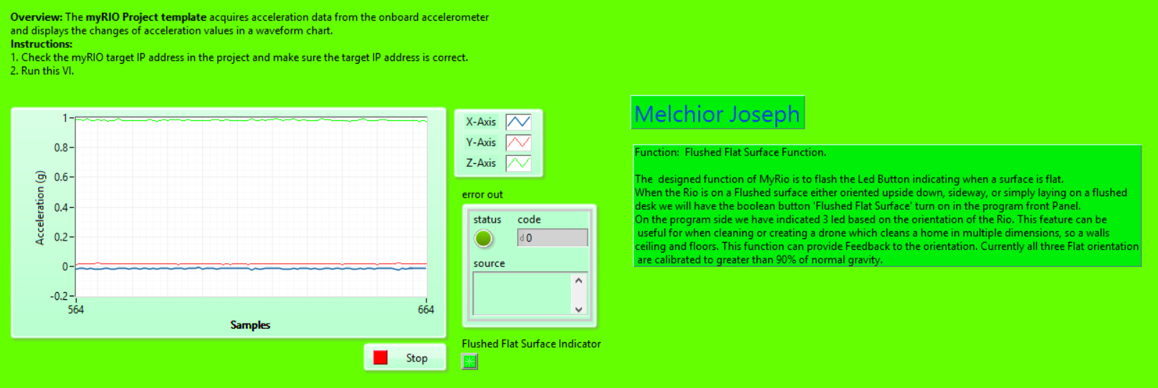
Figure 2.

Block Diagram
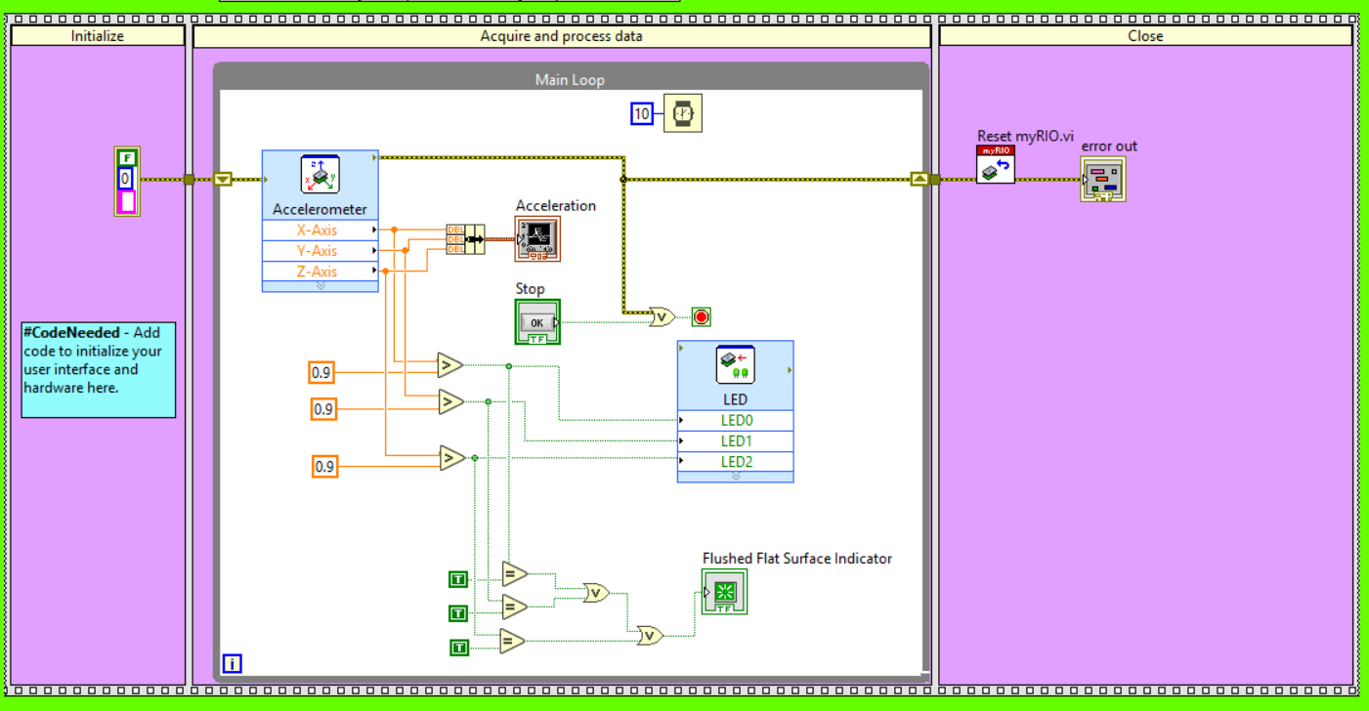
Figure 3.

