Lab 6 7/17/2017

Lab 6 My RIO Analog Digital Conversion(ADC) Temperature Control

Texas Instruments LM35Dt temperature sensor
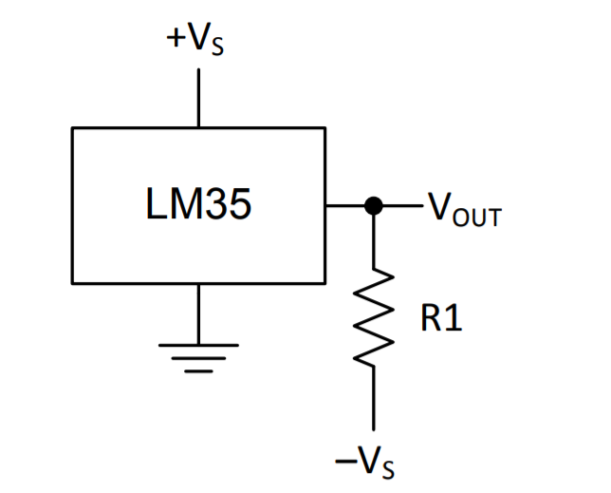
T = V_{T} / 10 mV/ºC
Project Explorer
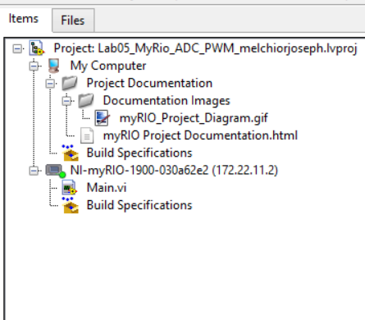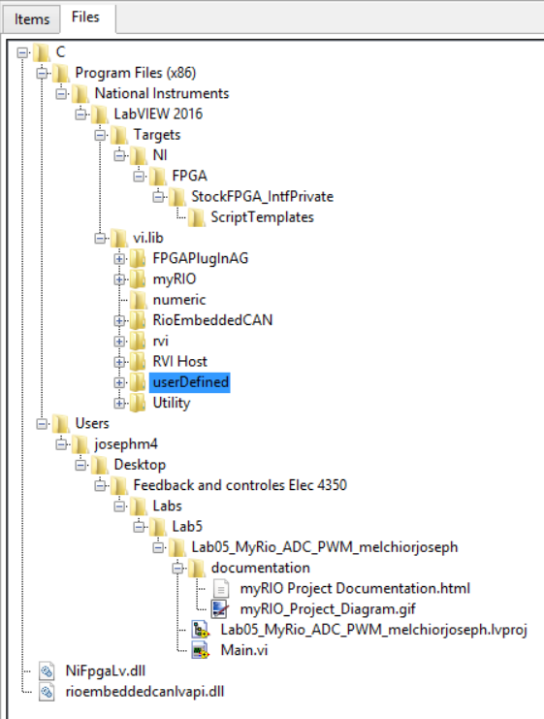
Figure 1.
Front Panel 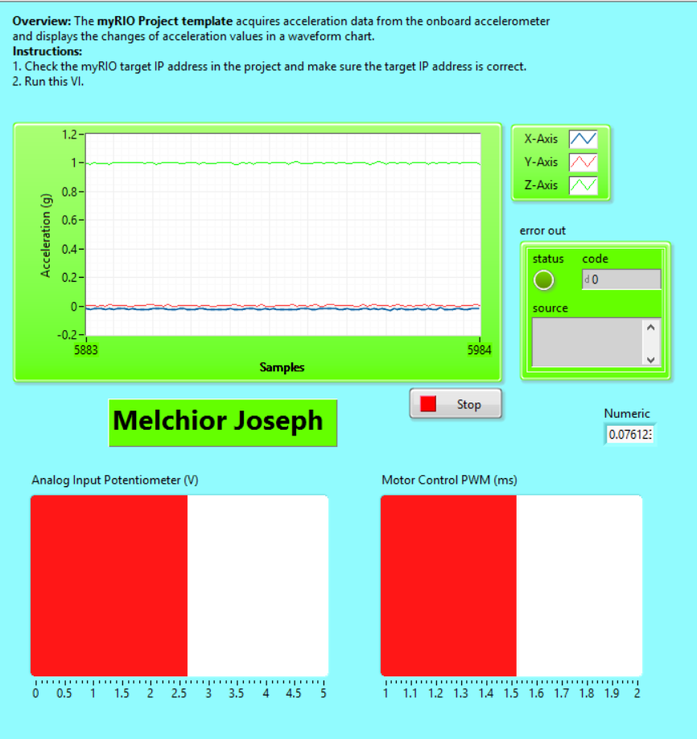
Figure 2.

Block Diagram
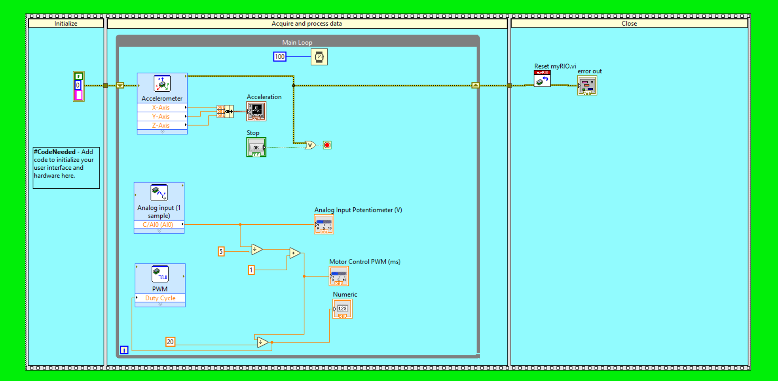
Figure 3.

