Lab 6 7/17/2017

Lab 6 My RIO Analog Digital Conversion(ADC) Temperature Control

Texas Instruments LM35Dt temperature sensor
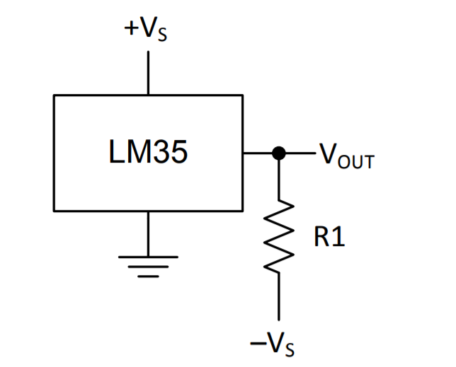
T = V_{T} / 10 mV/ºC
V_{T} = 100VTºC

Results:
Case | Low Threshold | High Threshold | Temperature | Led Status
A | 70 | 75 | 63.563 | off
B | 70 | 75 | 73.754 | on
C | 70 | 75 | 89.652 | off
Table 1

Front Panel
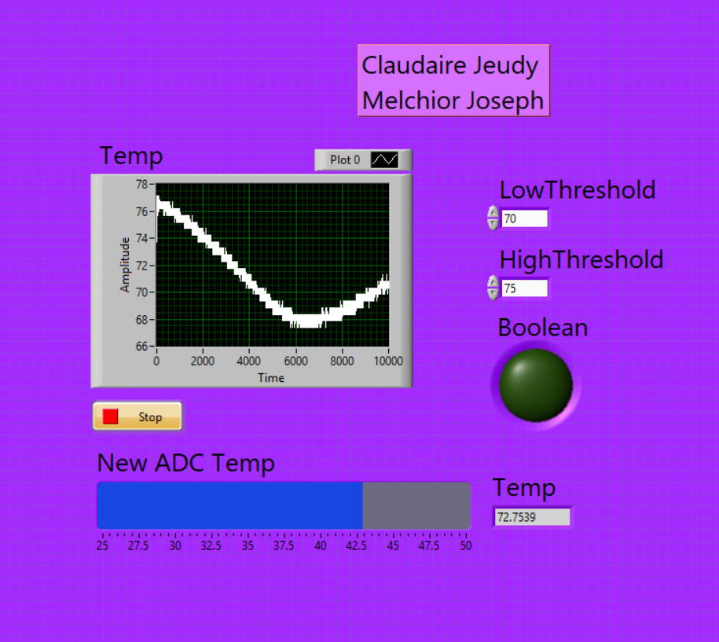
Figure 1.

Block Diagram
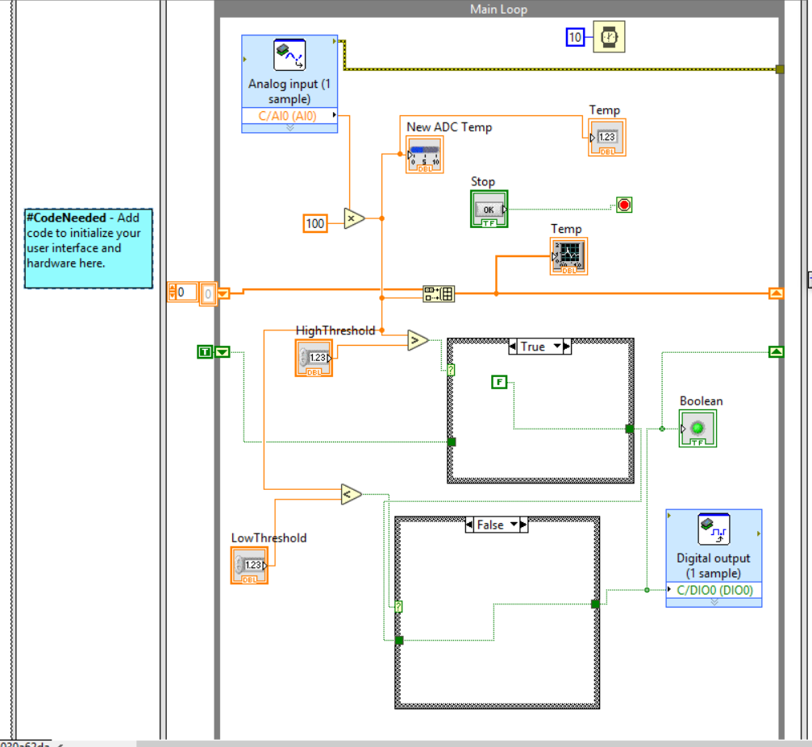
Figure 2.

