Lab 7 8/13/2017
Lab 7 My RIO EMG
Project Explorer
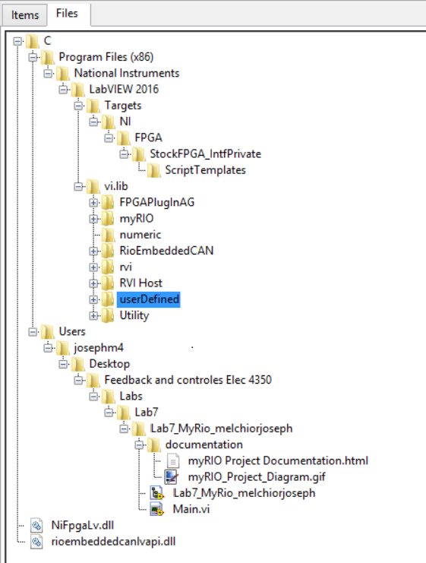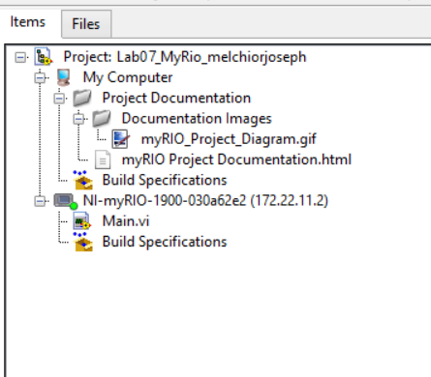
Figure 1.
Front Panel 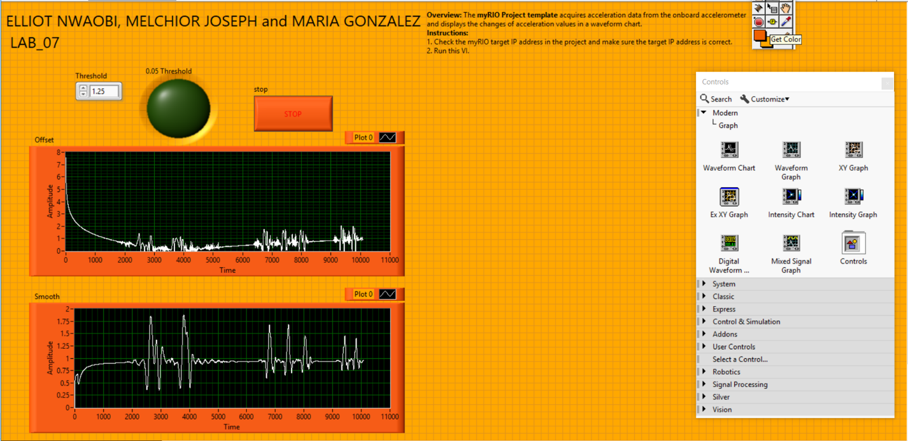
Figure 2.

Block Diagram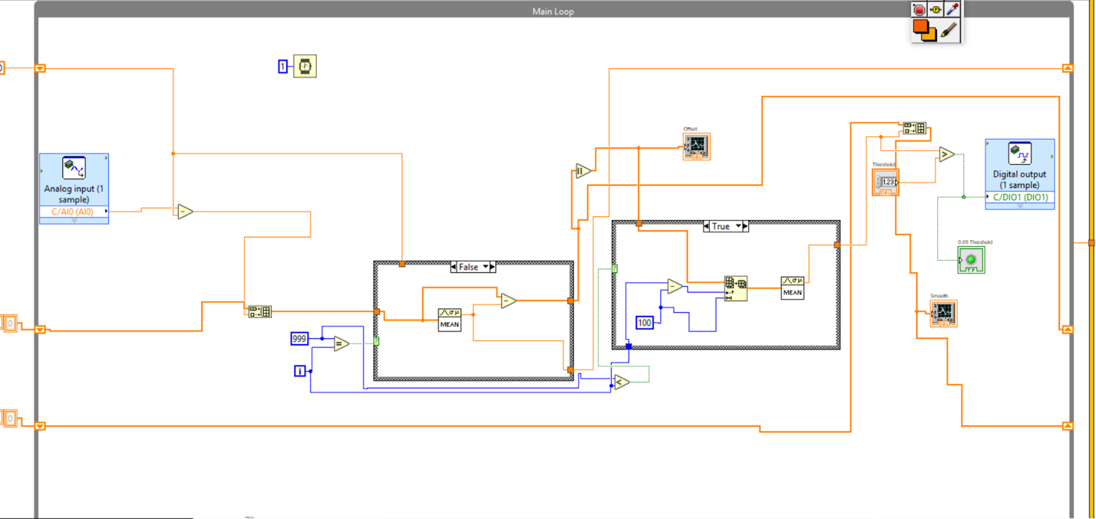
Figure 2.

Bonus: The algorithm has been implemented so that the EMG waves responds to a user’s arm with a red led; when the user contrast their muscle the red LED lights up.

