**CELERY**

helps in creating scalable application

can create efficient application by using it

Celery is kind of task which uses the DS queue---> 1st in 1st out

its a queue

if we have some heavy task and we dont want to execute in django process and want to execute task in seperate flow which will not affect our main application then we can use celery.

it can be crown job or preodic schedular

Eg if i want to manage bday for employe then i ca set a task and celery will take care of it

It wont work alone it will use redis or rabbit MQ(broker) which will work faster then sql. and schedule its task.

It’s a task queue

Djamgo will send task to celery to do the work on the bases of prioritization and availability

Task queue will distribute the work load and allow Django application to be available

Message Broker

Djanjo -🡪 Task Manager—> Message Broker

Message Broker can be Rabbit MQ and/Redis (Which one you use and on average whyat are the task you are maintaining)

Django 🡪 RabbitMQ🡪Celery(Worker processes)

Command for celery🡪 pip install celery

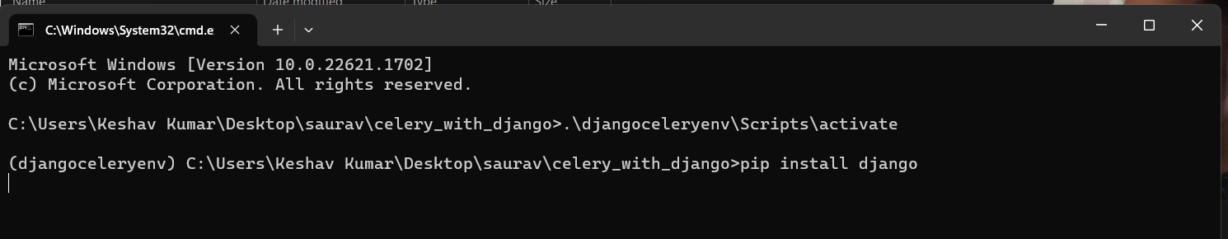



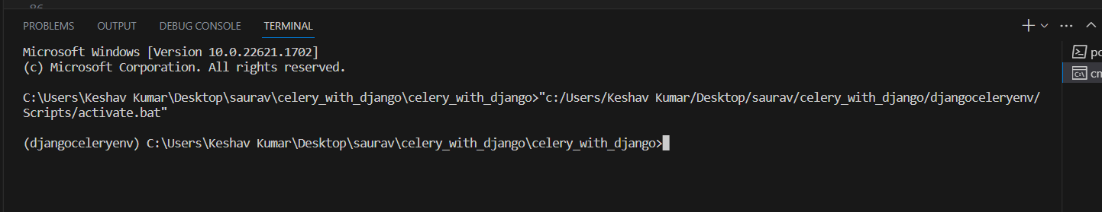



We will create our project add celery, task files and make changes in setting, url, views. Then we will run the celery server

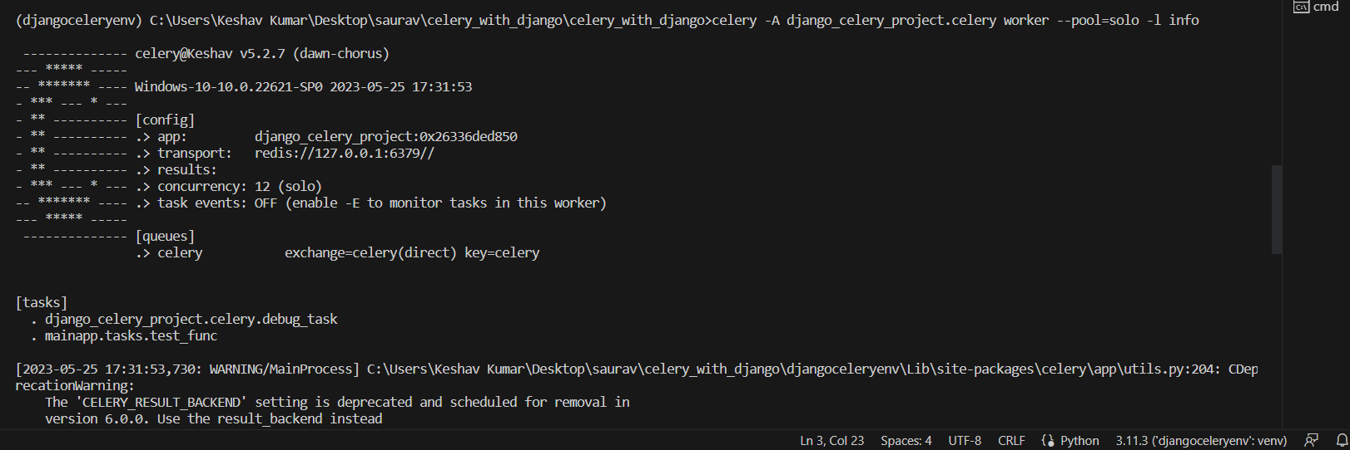

And Django server

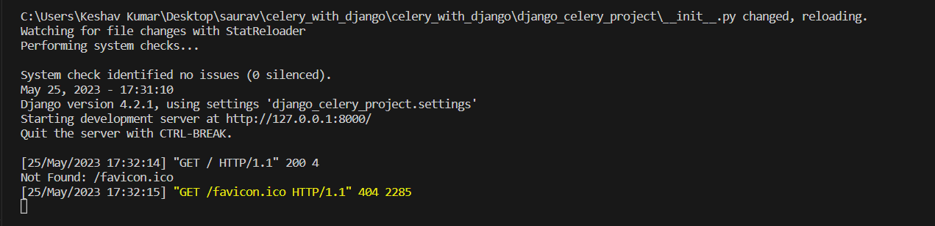

If everything works fine then we can see that now the task is being handle by celery and not by Django

With below output in celery cmd

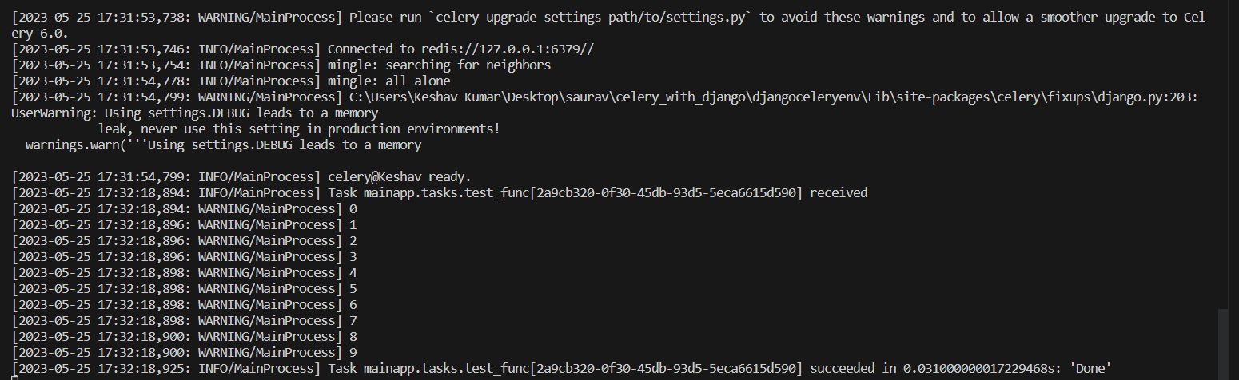

We can login to admin and check the task details

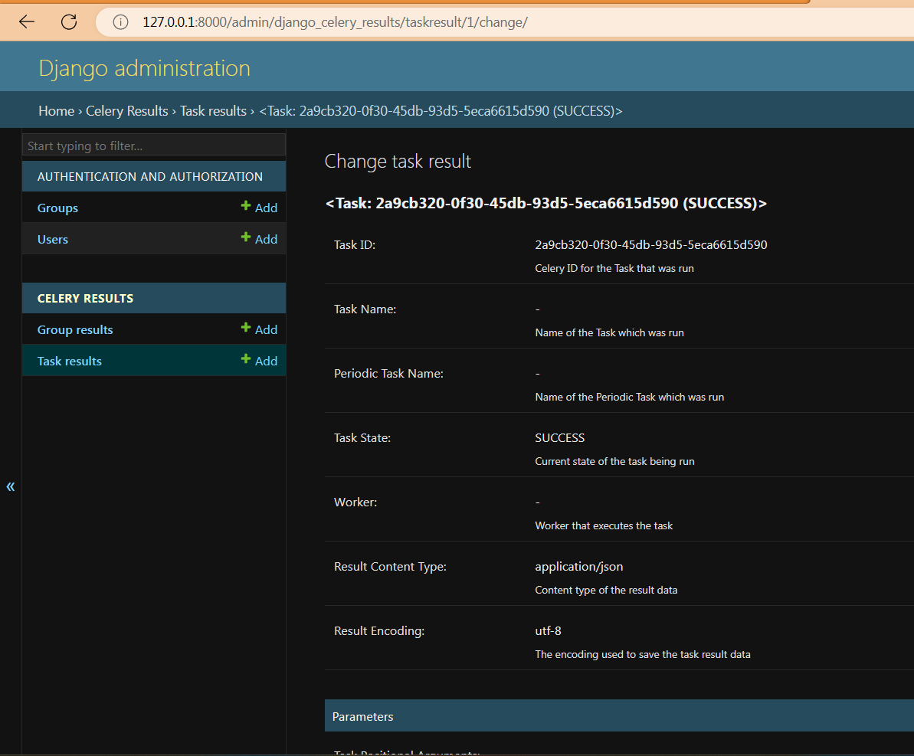

Add celery Beat to perform schedule task or perform task

pip install django-celery-beat

do modificvation in celery.py and setting.py and run the server

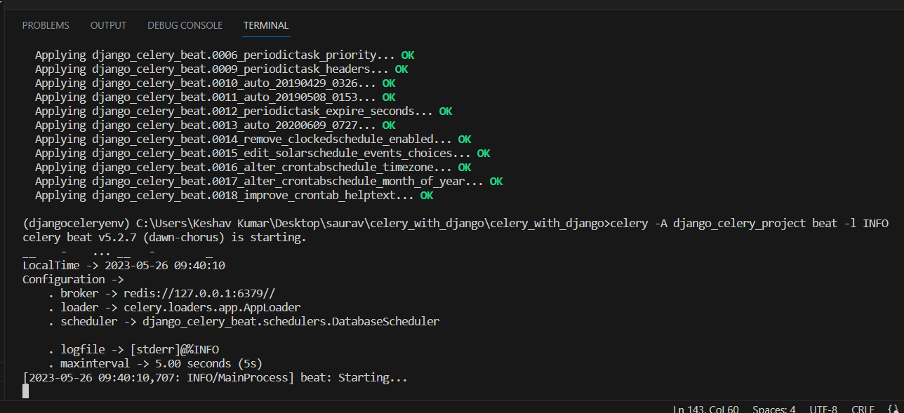

Why to use celery

3rd party API calls

High CPU intensive task

Periodic/Scheduled Task

Improve user experience

Broker create connection between app and celery and those are rabbit mq raddish Django orm

Celery provide serializer like json yaml etc