POSTGRESQL

INNVOICE

INSTALL latest version of postgresql and open pgadmin4

CREATE a Database

Inside new DB go to Schema and go under table and open the Query Tool

Create Customer table

Set pre defined data type of sex field by defining sex_type and alter the customer table

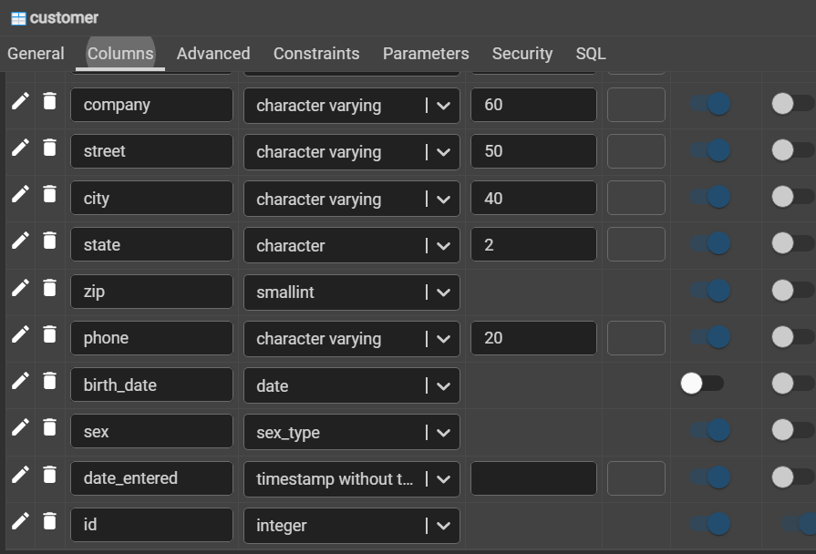

Create SALE_person table

Create product type table

Create product table use foreign key to stablish connection with product_type table

CREATE and ITEM table which will refer the product table to show the quantity.

Create Sales order table to record the details

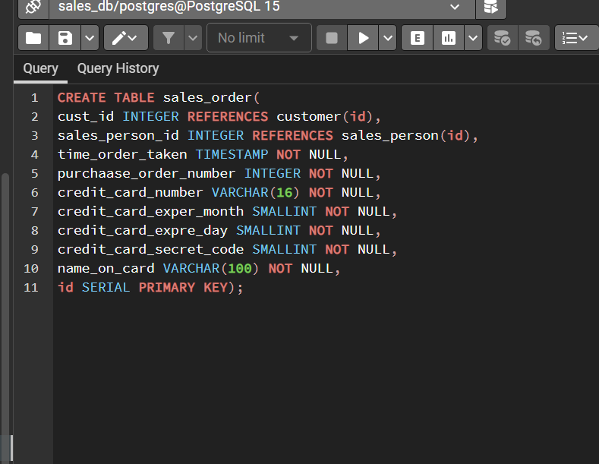

Create a sales Item table so that discount tax and other details can be captured here

If you want to add any other column then we can use “ALTER and ADD” to add

If you want to alter table and alter one of the column then we can use two alter

To rename the column we can use rename

To drop the column we can “drop”

Before drop

After Drop there is no weekday

CREate transaction type table

Create INDEX

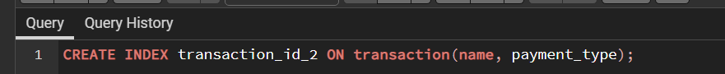

To DELETE we can use ”truncate” truncate will delete all the data inside but not the table

TO delete the table we can use DROP table and its name