**Informatikai és távközlési alapok II.**

**Házi feladat**

**Statikus route beállítás**

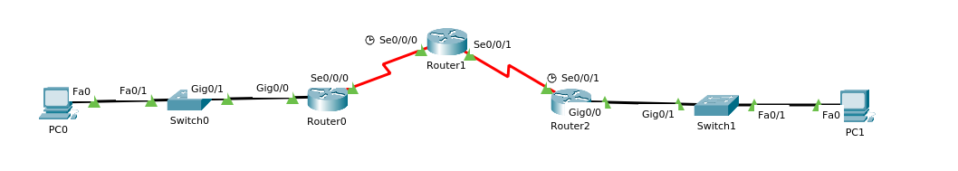

|  |  |  |  |  |
| --- | --- | --- | --- | --- |
| **Eszköz** | **Hostname** | **Interface** | **IP address** | **Subnet mask** |
| Router0 | RLeft | G0/00 | 192.168.0.1 | /27 |
|  |  | S0/0/0 | 1.1.1.1 | /30 |
| Router1 | RMiddle | S0/0/0 | 1.1.1.2 | /30 |
|  |  | S0/0/1 | 2.2.2.1 | /30 |
| Router2 | RRight | S0/0/1 | 2.2.2.2 | /30 |
|  |  | G0/0 | 192.168.10.1 | /28 |
| Switch0 | SwLeft |  |  |  |
| Switch1 | SwRight |  |  |  |
| PC0 |  |  | 192.168.0.3 | /27 |
| PC1 |  |  | 192.168.10.3 | /28 |

Készítse el az ábrán látható topológiát, konfigurálja a hálózati eszközöket az alábbiak szerint:

1. Minden hálózati eszközön állítson be a consol vonalra jelszót ami a vezetékneve legyen.
2. Minden hálózati eszközön állítson be privilegizált jelszót ami a keresztneve legyen.
3. Minden hálózati eszközön konfiguráljon telnet hozzáférést “december” jelszóval az 5 15 vonali portokra.
4. Minden eszközön konfiguráljon SSH hozzáférést a 0 4 vonali portokra ahol a domain név “hazi.lan”, a felhasználónév “admin” a jelszó “adminka” legyen. A kulcs párat 1024 bites titkosítással hozza létre.
5. Minden jelszót titkosítson.
6. Konfiguráljon bannert ami tartalmazza a “tilos” szót.
7. Állítsa be a hálózati eszközök interfészeinek a táblázat szerinti ip címeket.
8. Konfiguráljon statikus útvonalakat a routereken a hálózatok összekapcsolásához.
9. Kérdezze le a routing táblát minden routeren, az eredményt másolja egy szöveges állományba.
10. Pinggel ellenőrizze a kapcsolatot a PC0 és a PC1 között.

Az elkészült feladatot és a szöveges állományt töltse fel a tanteremben.

192.168.0.1/27

192.168.0.1

192.168.0.30

192.168.0.31

255.255.255.224

192.168.10.1/28

192.168.10.1

192.168.10.14

192.168.10.15

255.255.255.240

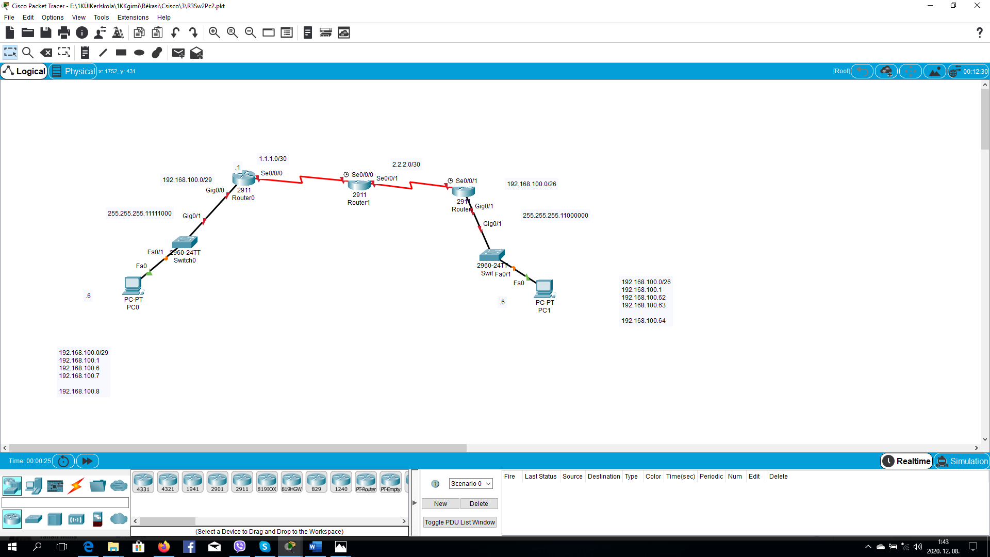

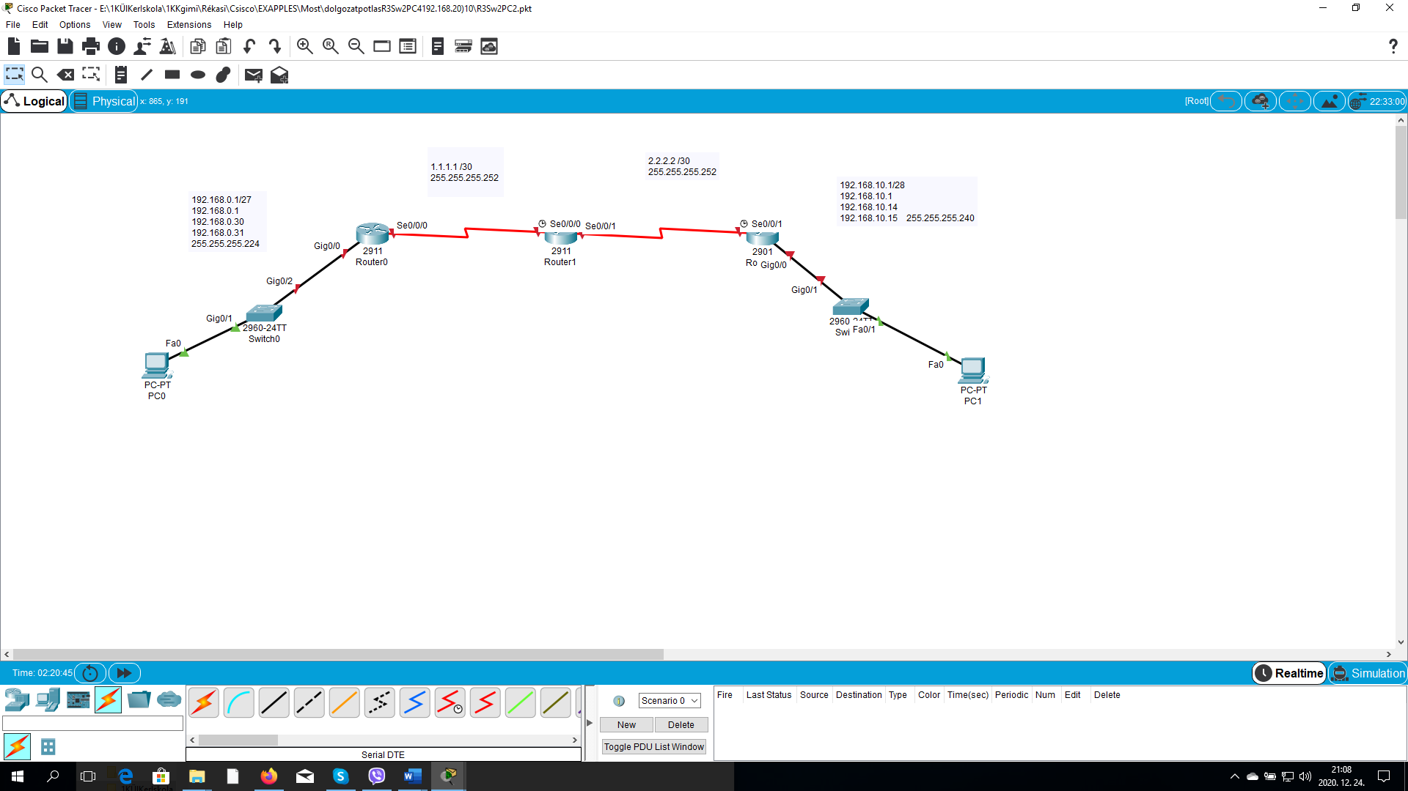

|  |  |  |
| --- | --- | --- |
| Network:  Gate Way:  PC  Broadcast:  Netmask: | 192.168.0.1/27  192.168.0.1 192.168.0.30  192.168.0.31  255.255.255.224 | 192.168.10.1/28  192.168.10.1  192.168.10.14  192.168.10.15  255.255.255.240 |

|  |  |
| --- | --- |
| Network | Netmask |
| 1.1.1.1 /30 | 255.255.255.252 |
| 2.2.2.2 /30 | 255.255.255.252 |

Address: 192.168.0.1 11000000.10101000.00000000.000 00001  
Netmask: 255.255.255.224 = 27 11111111.11111111.11111111.111 00000  
Wildcard: 0.0.0.31 00000000.00000000.00000000.000 11111  
=>

Network: 192.168.0.0/27 11000000.10101000.00000000.000 00000 (Class C)  
Broadcast: 192.168.0.31 11000000.10101000.00000000.000 11111  
HostMin: 192.168.0.1 11000000.10101000.00000000.000 00001  
HostMax: 192.168.0.30 11000000.10101000.00000000.000 11110  
Hosts/Net: 30 ([Private Internet](http://www.ietf.org/rfc/rfc1918.txt))

Address: 192.168.10.1 11000000.10101000.00001010.0000 0001  
Netmask: 255.255.255.240 = 28 11111111.11111111.11111111.1111 0000  
Wildcard: 0.0.0.15 00000000.00000000.00000000.0000 1111  
=>

Network: 192.168.10.0/28 11000000.10101000.00001010.0000 0000 (Class C)  
Broadcast: 192.168.10.15 11000000.10101000.00001010.0000 1111  
HostMin: 192.168.10.1 11000000.10101000.00001010.0000 0001  
HostMax: 192.168.10.14 11000000.10101000.00001010.0000 1110  
Hosts/Net: 14 ([Private Internet](http://www.ietf.org/rfc/rfc1918.txt))

Address: 1.1.1.1 00000001.00000001.00000001.000000 01  
Netmask: 255.255.255.252 = 30 11111111.11111111.11111111.111111 00  
Wildcard: 0.0.0.3 00000000.00000000.00000000.000000 11  
=>

Network: 1.1.1.0/30 00000001.00000001.00000001.000000 00 (Class A)  
Broadcast: 1.1.1.3 00000001.00000001.00000001.000000 11  
HostMin: 1.1.1.1 00000001.00000001.00000001.000000 01  
HostMax: 1.1.1.2 00000001.00000001.00000001.000000 10  
Hosts/Net: 2

Address: 2.2.2.2 00000010.00000010.00000010.000000 10  
Netmask: 255.255.255.252 = 30 11111111.11111111.11111111.111111 00  
Wildcard: 0.0.0.3 00000000.00000000.00000000.000000 11  
=>

Network: 2.2.2.0/30 00000010.00000010.00000010.000000 00 (Class A)  
Broadcast: 2.2.2.3 00000010.00000010.00000010.000000 11  
HostMin: 2.2.2.1 00000010.00000010.00000010.000000 01  
HostMax: 2.2.2.2 00000010.00000010.00000010.000000 10  
Hosts/Net: 2

Készítse el az ábrán látható topológiát, konfigurálja a hálózati eszközöket az alábbiak szerint:

1. Minden hálózati eszközön állítson be a consol vonalra jelszót ami a vezetékneve legyen.
2. Minden hálózati eszközön állítson be privilegizált jelszót ami a keresztneve legyen.
3. Minden hálózati eszközön konfiguráljon telnet hozzáférést “december” jelszóval az 5 15 vonali portokra.
4. Minden eszközön konfiguráljon SSH hozzáférést a 0 4 vonali portokra ahol a domain név “hazi.lan”, a felhasználónév “admin” a jelszó “adminka” legyen. A kulcs párat 1024 bites titkosítással hozza létre.
5. Minden jelszót titkosítson.
6. Konfiguráljon bannert ami tartalmazza a “tilos” szót.
7. Állítsa be a hálózati eszközök interfészeinek a táblázat szerinti ip címeket.
8. Konfiguráljon statikus útvonalakat a routereken a hálózatok összekapcsolásához.
9. Kérdezze le a routing táblát minden routeren, az eredményt másolja egy szöveges állományba.
10. Pinggel ellenőrizze a kapcsolatot a PC0 és a PC1 között.

Az elkészült feladatot és a szöveges állományt töltse fel a tanteremben.

FELADAT Switch konfigurálása hostnév:

**jelszavak titkosítása**

privat jelszó: milla **consol talian**

**privilegizált jelszó milla**

**telnet hozzáférést “** **december dolgozat” jelszóval** az 5 15 vonali portokra.

konfiguráljon SSH hozzáférést a 0 4 vonali portokra ahol a **domain név “** **hazi.lan doli.local”, a felhasználónév “****admin rendszer” a jelszó “****adminka gazda”**

**SSH hozzá**férést a 0 4 vonali portokra ahol a **domain név “doli.local”, a felhasználónév “rendszer” a jelszó “gazda”** legyen.

FELADAT Switch konfigurálása hostnév:

**jelszavak titkosítása**

privat jelszó: milla **consol talian**

**privilegizált jelszó milla**

**telnet hozzáférést “** **december” jelszóval** az 5 15 vonali portokra.

konfiguráljon SSH hozzáférést a 0 4 vonali portokra ahol a **domain név** **“** **hazi.lan”, a felhasználónév “admin” a jelszó “adminka”**

**SSH hozzá**férést a 0 4 vonali portokra ahol a **domain név “doli.local”, a felhasználónév “rendszer” a jelszó “gazda”** legyen

consol jelszó: talian

telnet jelszó: talian

domain: hazi.lan

ssh felh. admin jelszó: adminka

Megoldás Switch CLI menüben:

**Sw0 Sw1**

Switch>en

Switch#conf t

Enter configuration commands, one per line. End with CNTL/Z.

Switch(config)#no ip domain lookup

Switch(config)#hostname Sw0 SwLeft Sw1SwRight

Sw0(config)#banner motd #Tilos a belepes *Talian Milla*#

Sw0(config)#line console 0

Sw0(config-line)#password talian

Sw0(config-line)#login

Sw0(config-line)#line vty 5 15

Sw0(config-line)#password **december**

Sw0(config-line)#login

Sw0(config-line)#exit

Sw0(config)#service password-encryption

Sw0(config)#enable secret milla

Sw0(config)#banner motd #Tilos a belepes *Talian Milla*#

Sw0(config)#ip domain-name **hazi.lan**

Sw0(config)#crypto key generate rsa

The name for the keys will be: Sw0.doli.local

Choose the size of the key modulus in the range of 360 to 2048 for your

General Purpose Keys. Choosing a key modulus greater than 512 may take

a few minutes.

How many bits in the modulus [512]: 1024

% Generating 1024 bit RSA keys, keys will be non-exportable...[OK]

Sw0(config)#username admin secret adminka

*Mar 1 5:12:27.575: %SSH-5-ENABLED: SSH 1.99 has been enabled

Sw0(config)#line vty 0 4

Sw0(config-line)#login local

Sw0(config-line)#transport input ssh

Sw0(config-line)#exit

Sw0(config)#do copy run sta

Destination filename [startup-config]?

Building configuration...

[OK]

Sw0(config)#do show run

Building configuration...

Router0: R0RLeft Router1: R1Rmiddle Router2:  R2RRight

|  |  |
| --- | --- |
| Router0 | RLeft |
| Router1 | RMiddle |
| Router2 | RRight |

**Router R0RLeft Route1 R1Rmiddle Router2 RRight**

Router>en

R0Raktar#conf t

Enter configuration commands, one per line. End with CNTL/Z.

R0Raktar(config)#no ip domain lookup

R0Raktar(config)#hostname R0Raktar

R0RLeft (config)#line console 0

R0Raktar(config-line)#password talian

R0Raktar(config-line)#login

R0Raktar(config-line)#exit

R0Raktar(config)#line vty 5 15

R0Raktar(config-line)#password **december**

R0Raktar(config-line)#login

R0Raktar(config-line)#exit

R0Raktar(config)#service password-encryption

R0Raktar(config)#enable secret milla

R0Raktar(config)#banner motd #Tilos a belepes *Talian Milla*#

R0Raktar(config)#ip domain-name **“** **hazi.lan**

R0Raktar(config)#crypto key generate rsa

% You already have RSA keys defined named R0Raktar.doli.local .

% Do you really want to replace them? [yes/no]:

% Please answer 'yes' or 'no'.

% Do you really want to replace them? [yes/no]: yes

The name for the keys will be: R0Raktar.doli.local

Choose the size of the key modulus in the range of 360 to 2048 for your

General Purpose Keys. Choosing a key modulus greater than 512 may take

a few minutes.

How many bits in the modulus [512]: 1024

% Generating 1024 bit RSA keys, keys will be non-exportable...[OK]

R0Raktar(config)#username admin secret adminka

*Mar 2 11:42:4.887: %SSH-5-ENABLED: SSH 1.99 has been enabled

R0Raktar(config)#line vty 0 4

R0Raktar(config-line)#transport input ssh

R0Raktar(config-line)#exit

R0Raktar(config)#do copy run sta

Destination filename [startup-config]?

Building configuration...

[OK]

R0Raktar(config)#

R0Raktar#show ip int brief

Interface IP-Address OK? Method Status Protocol

GigabitEthernet0/0 192.168.50.1 YES manual up up

GigabitEthernet0/1 unassigned YES unset administratively down down

GigabitEthernet0/2 unassigned YES unset administratively down down

Serial0/0/0 unassigned YES unset down down

**Router0**

Router0>en

Router#conf t

Enter configuration commands, one per line. End with CNTL/Z.

Router(config)#no ip domain lookup

R0(config)# int g0/0

R0(config-if)#ip address 192.168.0.1 255.255.255.224

R0(config-if)#no shut

R0(config-if)#do copy run sta

R0(config)#int s0/0/0

R0(config-if)#ip address 1.1.1.2 255.255.255.252 9.9.9.9.1 255.255.255.252

R0(config-if)#no shut

R0(config-if)#do copy run sta

**Router1**

Router1>en

Router#conf t

Enter configuration commands, one per line. End with CNTL/Z.

Router(config)#no ip domain lookup

R1(config)#int s0/0/0

R1(config-if)#ip address 1.1.1.2 255.255.255.252

R1(config-if)#no shut

R1(config)#int s0/0/1

R1(config-if)#ip address 2.2.2.1 255.255.255.252

R1(config-if)#no shut

R1(config-if)#do copy run sta

**Router2**

Router>en

Router#conf t

Enter configuration commands, one per line. End with CNTL/Z.

Router(config)#no ip domain lookup

R2(config)#int s0/0/1

R2(config-if)#ip address 2.2.2.2 255.255.255.252

R2(config-if)#no shut

R2(config)#int g0/0

R2(config-if)#ip address 192.168.10.1 255.255.255.240

R2(config-if)#no shut

R2(config-if)#

Press RETURN to get started!

Router>enable

Router#configure terminal

Enter configuration commands, one per line. End with CNTL/Z.

Router(config)#hostname R2RRight

R2RRight(config)#no ip domain lookup

R2RRight(config)#exit

R2RRight#

%SYS-5-CONFIG_I: Configured from console by console

R2RRight#conf t

Enter configuration commands, one per line. End with CNTL/Z.

R2RRight(config)#int g0/0

R2RRight(config-if)#ip address 192.168.10.1 255.255.255.240

R2RRight(config-if)#no shut

R2RRight(config-if)#

%LINK-5-CHANGED: Interface GigabitEthernet0/0, changed state to up

%LINEPROTO-5-UPDOWN: Line protocol on Interface GigabitEthernet0/0, changed state to up

R2RRight(config-if)#do copy run sta

Destination filename [startup-config]?

Building configuration...

[OK]

R2RRight(config-if)#exit

R2RRight(config)#int s0/0/1

R2RRight(config-if)#ip address 2.2.2.2 255.255.255.252

R2RRight(config-if)#no shut

%LINK-5-CHANGED: Interface Serial0/0/1, changed state to down

R2RRight(config-if)#

R2RRight(config-if)#do copy run sta

Destination filename [startup-config]?

Building configuration...

[OK]

R2RRight(config-if)#

Press RETURN to get started!

Router>en

Router#conf t

Enter configuration commands, one per line. End with CNTL/Z.

Router(config)#no ip domain lookup

Router(config)#hostname R0RLeft

R0RLeft(config)#line console 0

R0RLeft(config-line)#password talian

R0RLeft(config-line)#login

R0RLeft(config-line)#exit

R0RLeft(config)#line vty 5 15

R0RLeft(config-line)#password december

R0RLeft(config-line)#login

R0RLeft(config-line)#exit

R0RLeft(config)#service password-encryption

R0RLeft(config)#enable secret milla

R0RLeft(config)#banner motd #Tilos a belepes *Talian Milla*#

R0RLeft(config)#ip domain-name hazi.lan

R0RLeft(config)#crypto key generate rsa

The name for the keys will be: R0RLeft.hazi.lan

Choose the size of the key modulus in the range of 360 to 2048 for your

General Purpose Keys. Choosing a key modulus greater than 512 may take

a few minutes.

How many bits in the modulus [512]: 1024

% Generating 1024 bit RSA keys, keys will be non-exportable...[OK]

R0RLeft(config)#username admin secret adminka

*Mar 1 2:51:3.512: %SSH-5-ENABLED: SSH 1.99 has been enabled

R0RLeft(config)#line vty 0 4

R0RLeft(config-line)#transport input ssh

R0RLeft(config-line)#exit

R0RLeft(config)#do copy run sta

Destination filename [startup-config]?

Building configuration...

[OK]

R0RLeft(config)#show ip int brief

^

% Invalid input detected at '^' marker.

R0RLeft(config)#show ip int brief

^

% Invalid input detected at '^' marker.

R0RLeft(config)#do show run

Building configuration...

Current configuration : 1132 bytes

!

version 15.1

no service timestamps log datetime msec

no service timestamps debug datetime msec

service password-encryption

!

hostname R0RLeft

!

!

!

enable secret 5 $1$mERr$JWt13exBx5jXxrfLcEI.//

!

!

!

!

!

!

no ip cef

no ipv6 cef

!

!

!

username admin secret 5 $1$mERr$jQyuMjLbycBbkQeXLY0hJ0

!

!

license udi pid CISCO2911/K9 sn FTX1524N25B-

!

!

!

!

!

!

!

!

!

no ip domain-lookup

ip domain-name hazi.lan

!

!

spanning-tree mode pvst

!

!

!

!

!

!

interface GigabitEthernet0/0

no ip address

duplex auto

speed auto

shutdown

!

interface GigabitEthernet0/1

no ip address

duplex auto

speed auto

shutdown

!

interface GigabitEthernet0/2

no ip address

duplex auto

speed auto

shutdown

!

interface Serial0/0/0

no ip address

clock rate 2000000

shutdown

!

interface Serial0/0/1

no ip address

clock rate 2000000

shutdown

!

interface Vlan1

no ip address

shutdown

!

ip classless

!

ip flow-export version 9

!

!

!

banner motd ^CTilos a belepes *Talian Milla*^C

!

!

!

!

!

line con 0

password 7 08354D4200180B

login

!

line aux 0

!

line vty 0 4

login

transport input ssh

line vty 5 15

password 7 0825494D0C14071200

login

!

!

!

end

R0RLeft(config)#

R0RLeft(config)#

R0RLeft(config)#

R0RLeft(config)#

R0RLeft(config)#

R0RLeft(config)#

R0RLeft(config)#int g0/0

R0RLeft(config-if)#ip address 192.168.0.1 255.255.255.224

R0RLeft(config-if)#no shut

R0RLeft(config-if)#

%LINK-5-CHANGED: Interface GigabitEthernet0/0, changed state to up

%LINEPROTO-5-UPDOWN: Line protocol on Interface GigabitEthernet0/0, changed state to up

R0RLeft(config-if)#do copy run sta

Destination filename [startup-config]?

Building configuration...

[OK]

R0RLeft(config-if)#

0RLeft(config-if)#do copy run sta

Destination filename [startup-config]?

Building configuration...

[OK]

R0RLeft(config-if)#exit

R0RLeft(config)#int s0/0/0

R0RLeft(config-if)#ip address 1.1.1.1 255.255.255.252

R0RLeft(config-if)#no shut

%LINK-5-CHANGED: Interface Serial0/0/0, changed state to down

R0RLeft(config-if)#do copy run sta

Destination filename [startup-config]?

System Bootstrap, Version 15.1(4)M4, RELEASE SOFTWARE (fc1)

Technical Support: http://www.cisco.com/techsupport

Copyright (c) 2010 by cisco Systems, Inc.

Total memory size = 512 MB - On-board = 512 MB, DIMM0 = 0 MB

CISCO2911/K9 platform with 524288 Kbytes of main memory

Main memory is configured to 72/-1(On-board/DIMM0) bit mode with ECC disabled

Readonly ROMMON initialized

program load complete, entry point: 0x80803000, size: 0x1b340

program load complete, entry point: 0x80803000, size: 0x1b340

IOS Image Load Test

___________________

Digitally Signed Release Software

program load complete, entry point: 0x81000000, size: 0x3bcd3d8

Self decompressing the image :

########################################################################## [OK]

Smart Init is enabled

smart init is sizing iomem

TYPE MEMORY_REQ

Onboard devices &

buffer pools 0x022F6000

-----------------------------------------------

TOTAL: 0x022F6000

Rounded IOMEM up to: 36Mb.

Using 6 percent iomem. [36Mb/512Mb]

Restricted Rights Legend

Use, duplication, or disclosure by the Government is

subject to restrictions as set forth in subparagraph

(c) of the Commercial Computer Software - Restricted

Rights clause at FAR sec. 52.227-19 and subparagraph

(c) (1) (ii) of the Rights in Technical Data and Computer

Software clause at DFARS sec. 252.227-7013.

cisco Systems, Inc.

170 West Tasman Drive

San Jose, California 95134-1706

Cisco IOS Software, C2900 Software (C2900-UNIVERSALK9-M), Version 15.1(4)M5, RELEASE SOFTWARE (fc2)Technical Support: http://www.cisco.com/techsupport

Copyright (c) 1986-2007 by Cisco Systems, Inc.

Compiled Wed 18-Jul-07 04:52 by pt_team

Image text-base: 0x2100F918, data-base: 0x24729040

This product contains cryptographic features and is subject to United

States and local country laws governing import, export, transfer and

use. Delivery of Cisco cryptographic products does not imply

third-party authority to import, export, distribute or use encryption.

Importers, exporters, distributors and users are responsible for

compliance with U.S. and local country laws. By using this product you

agree to comply with applicable laws and regulations. If you are unable

to comply with U.S. and local laws, return this product immediately.

A summary of U.S. laws governing Cisco cryptographic products may be found at:

http://www.cisco.com/wwl/export/crypto/tool/stqrg.html

If you require further assistance please contact us by sending email to

export@cisco.com.

Cisco CISCO2911/K9 (revision 1.0) with 491520K/32768K bytes of memory.

Processor board ID FTX152400KS

3 Gigabit Ethernet interfaces

DRAM configuration is 64 bits wide with parity disabled.

255K bytes of non-volatile configuration memory.

249856K bytes of ATA System CompactFlash 0 (Read/Write)

--- System Configuration Dialog ---

Would you like to enter the initial configuration dialog? [yes/no]: System Bootstrap, Version 15.1(4)M4, RELEASE SOFTWARE (fc1)

Technical Support: http://www.cisco.com/techsupport

Copyright (c) 2010 by cisco Systems, Inc.

Total memory size = 512 MB - On-board = 512 MB, DIMM0 = 0 MB

CISCO2911/K9 platform with 524288 Kbytes of main memory

Main memory is configured to 72/-1(On-board/DIMM0) bit mode with ECC disabled

Readonly ROMMON initialized

program load complete, entry point: 0x80803000, size: 0x1b340

program load complete, entry point: 0x80803000, size: 0x1b340

IOS Image Load Test

___________________

Digitally Signed Release Software

program load complete, entry point: 0x81000000, size: 0x3bcd3d8

Self decompressing the image :

########################################################################## [OK]

Smart Init is enabled

smart init is sizing iomem

TYPE MEMORY_REQ

HWIC Slot 0 0x00200000 Onboard devices &

buffer pools 0x022F6000

-----------------------------------------------

TOTAL: 0x02AF6000

Rounded IOMEM up to: 45Mb.

Using 6 percent iomem. [45Mb/512Mb]

Restricted Rights Legend

Use, duplication, or disclosure by the Government is

subject to restrictions as set forth in subparagraph

(c) of the Commercial Computer Software - Restricted

Rights clause at FAR sec. 52.227-19 and subparagraph

(c) (1) (ii) of the Rights in Technical Data and Computer

Software clause at DFARS sec. 252.227-7013.

cisco Systems, Inc.

170 West Tasman Drive

San Jose, California 95134-1706

Cisco IOS Software, C2900 Software (C2900-UNIVERSALK9-M), Version 15.1(4)M5, RELEASE SOFTWARE (fc2)Technical Support: http://www.cisco.com/techsupport

Copyright (c) 1986-2007 by Cisco Systems, Inc.

Compiled Wed 18-Jul-07 04:52 by pt_team

Image text-base: 0x2100F918, data-base: 0x24729040

This product contains cryptographic features and is subject to United

States and local country laws governing import, export, transfer and

use. Delivery of Cisco cryptographic products does not imply

third-party authority to import, export, distribute or use encryption.

Importers, exporters, distributors and users are responsible for

compliance with U.S. and local country laws. By using this product you

agree to comply with applicable laws and regulations. If you are unable

to comply with U.S. and local laws, return this product immediately.

A summary of U.S. laws governing Cisco cryptographic products may be found at:

http://www.cisco.com/wwl/export/crypto/tool/stqrg.html

If you require further assistance please contact us by sending email to

export@cisco.com.

Cisco CISCO2911/K9 (revision 1.0) with 491520K/32768K bytes of memory.

Processor board ID FTX152400KS

3 Gigabit Ethernet interfaces

2 Low-speed serial(sync/async) network interface(s)

DRAM configuration is 64 bits wide with parity disabled.

255K bytes of non-volatile configuration memory.

249856K bytes of ATA System CompactFlash 0 (Read/Write)

--- System Configuration Dialog ---

Would you like to enter the initial configuration dialog? [yes/no]: n

Press RETURN to get started!

Router>enable

Router#configure terminal

Enter configuration commands, one per line. End with CNTL/Z.

Router(config)#hostname R1Rmiddle

R1Rmiddle(config)#no ip domain lookup

R1Rmiddle(config)#int s0/0/0

R1Rmiddle(config-if)#ip address 1.1.1.2 255.255.255.252

R1Rmiddle(config-if)#no shut

R1Rmiddle(config-if)#

%LINK-5-CHANGED: Interface Serial0/0/0, changed state to up

%LINEPROTO-5-UPDOWN: Line protocol on Interface Serial0/0/0, changed state to up

R1Rmiddle(config-if)#do copy run sta

Destination filename [startup-config]?

Building configuration...

[OK]

R1Rmiddle(config-if)#exit

R1Rmiddle(config)#int s0/0/1

R1Rmiddle(config-if)#ip address 2.2.2.1 255.255.255.252

R1Rmiddle(config-if)#no shut

R1Rmiddle(config-if)#

%LINK-5-CHANGED: Interface Serial0/0/1, changed state to up

%LINEPROTO-5-UPDOWN: Line protocol on Interface Serial0/0/1, changed state to up

R1Rmiddle(config-if)#do copy run sta

Destination filename [startup-config]?

Building configuration...

[OK]

R1Rmiddle(config-if)#

(c) of the Commercial Computer Software - Restricted

Rights clause at FAR sec. 52.227-19 and subparagraph

(c) (1) (ii) of the Rights in Technical Data and Computer

Software clause at DFARS sec. 252.227-7013.

cisco Systems, Inc.

170 West Tasman Drive

San Jose, California 95134-1706

Cisco IOS Software, C2900 Software (C2900-UNIVERSALK9-M), Version 15.1(4)M5, RELEASE SOFTWARE (fc2)Technical Support: http://www.cisco.com/techsupport

Copyright (c) 1986-2007 by Cisco Systems, Inc.

Compiled Wed 18-Jul-07 04:52 by pt_team

Image text-base: 0x2100F918, data-base: 0x24729040

This product contains cryptographic features and is subject to United

States and local country laws governing import, export, transfer and

use. Delivery of Cisco cryptographic products does not imply

third-party authority to import, export, distribute or use encryption.

Importers, exporters, distributors and users are responsible for

compliance with U.S. and local country laws. By using this product you

agree to comply with applicable laws and regulations. If you are unable

to comply with U.S. and local laws, return this product immediately.

A summary of U.S. laws governing Cisco cryptographic products may be found at:

http://www.cisco.com/wwl/export/crypto/tool/stqrg.html

If you require further assistance please contact us by sending email to

export@cisco.com.

Cisco CISCO2911/K9 (revision 1.0) with 491520K/32768K bytes of memory.

Processor board ID FTX152400KS

3 Gigabit Ethernet interfaces

2 Low-speed serial(sync/async) network interface(s)

DRAM configuration is 64 bits wide with parity disabled.

255K bytes of non-volatile configuration memory.

249856K bytes of ATA System CompactFlash 0 (Read/Write)

--- System Configuration Dialog ---

Would you like to enter the initial configuration dialog? [yes/no]: n

Press RETURN to get started!

Router>enable

Router#configure terminal

Enter configuration commands, one per line. End with CNTL/Z.

Router(config)#hostname R1Rmiddle

R1Rmiddle(config)#no ip domain lookup

R1Rmiddle(config)#int s0/0/0

R1Rmiddle(config-if)#ip address 1.1.1.2 255.255.255.252

R1Rmiddle(config-if)#no shut

R1Rmiddle(config-if)#

%LINK-5-CHANGED: Interface Serial0/0/0, changed state to up

%LINEPROTO-5-UPDOWN: Line protocol on Interface Serial0/0/0, changed state to up

R1Rmiddle(config-if)#do copy run sta

Destination filename [startup-config]?

Building configuration...

[OK]

R1Rmiddle(config-if)#exit

R1Rmiddle(config)#int s0/0/1

R1Rmiddle(config-if)#ip address 2.2.2.1 255.255.255.252

R1Rmiddle(config-if)#no shut

R1Rmiddle(config-if)#

%LINK-5-CHANGED: Interface Serial0/0/1, changed state to up

%LINEPROTO-5-UPDOWN: Line protocol on Interface Serial0/0/1, changed state to up

R1Rmiddle(config-if)#do copy run sta

Destination filename [startup-config]?

Building configuration...

[OK]

R1Rmiddle(config-if)#do show run

Building configuration...

Current configuration : 857 bytes

!

version 15.1

no service timestamps log datetime msec

no service timestamps debug datetime msec

no service password-encryption

!

hostname R1Rmiddle

!

!

!

!

!

!

!

!

no ip cef

no ipv6 cef

!

!

!

!

license udi pid CISCO2911/K9 sn FTX1524DV18-

!

!

!

!

!

!

!

!

!

no ip domain-lookup

!

!

spanning-tree mode pvst

!

!

!

!

!

!

interface GigabitEthernet0/0

no ip address

duplex auto

speed auto

shutdown

!

interface GigabitEthernet0/1

no ip address

duplex auto

speed auto

shutdown

!

interface GigabitEthernet0/2

no ip address

duplex auto

speed auto

shutdown

!

interface Serial0/0/0

ip address 1.1.1.2 255.255.255.252

clock rate 2000000

!

interface Serial0/0/1

ip address 2.2.2.1 255.255.255.252

!

interface Vlan1

no ip address

shutdown

!

ip classless

!

ip flow-export version 9

!

!

!

!

!

!

!

!

line con 0

!

line aux 0

!

line vty 0 4

login

!

!

!

end

R1Rmiddle(config-if)#

R1Rmiddle(config-if)#

R1Rmiddle(config-if)#

