MINISTRY OF EDUCATION AND SCIENCE OF THE REPUBLIC OF KAZAKHSTAN

INTERNATIONAL INFORMATION TECHNOLOGY UNIVERSITY

COMPUTER ENGINEERING AND INFORMATION SECURITY DEPARTMENT

Project

NoSQL Data Bases

Database structure

Done by student __Uali Camilla_

Group _CSSE-1808K DA-2

Almaty 2021

Database

The data for project were generated automatically, and store in several collections, yet I have one database, inside where other collections with fake data can be found.

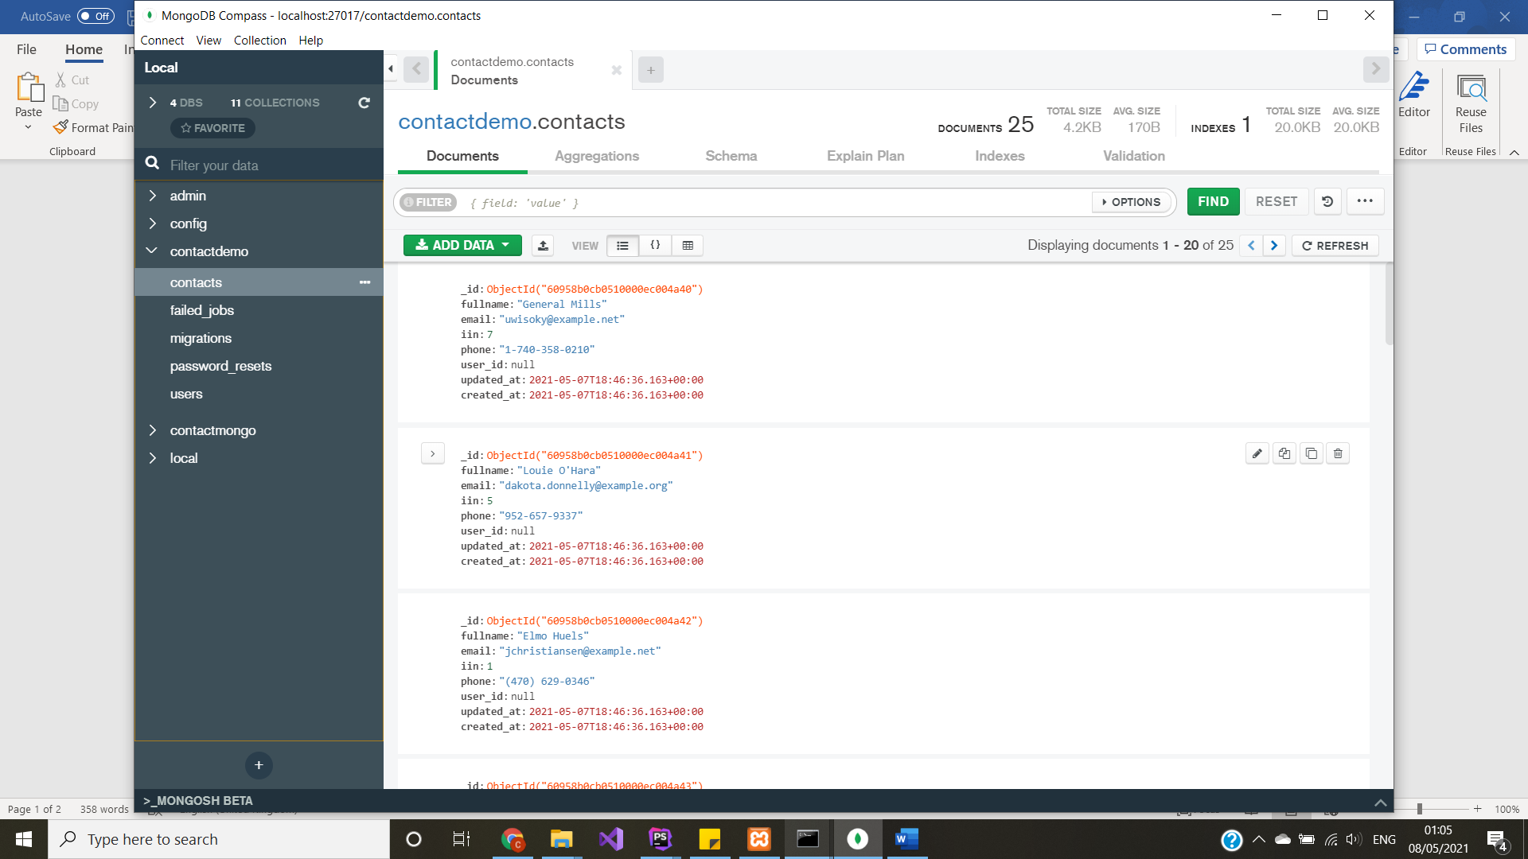

The details:

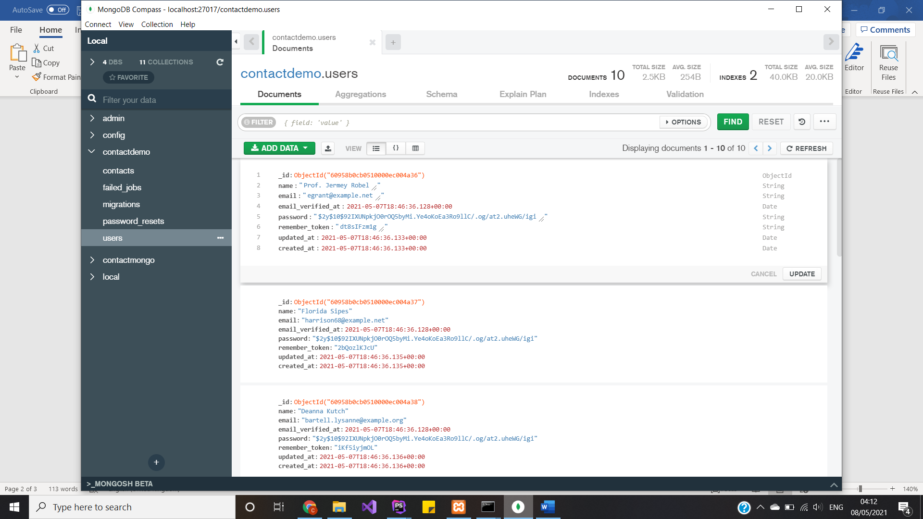

Database connection:

First install, php_monogdb.dll and add the php.ini, then manage Xampp with mongodb feature.

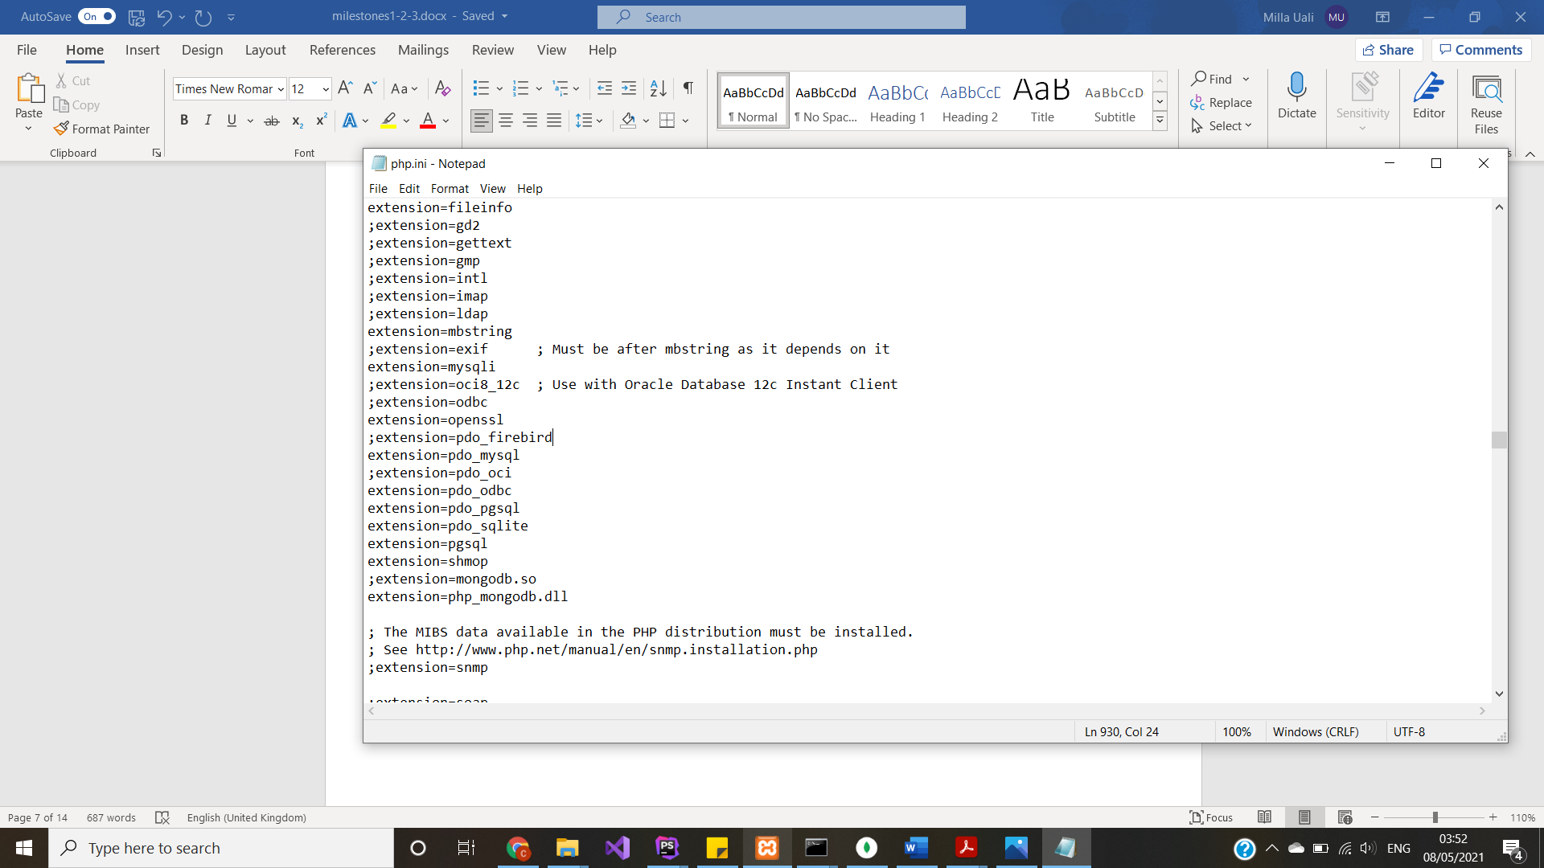

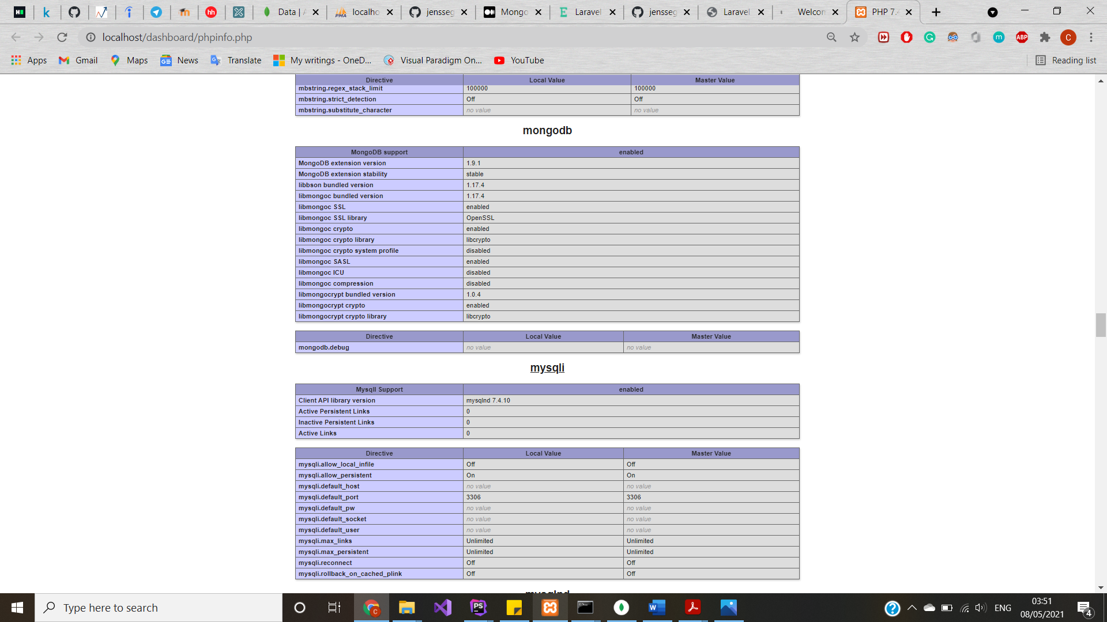

Then, create new Laravel project with MongoDB extension. And add new package, running this code in terminal:

composer require jenssegers/mongodb.

After that, modify configuration files, first, app.php file:

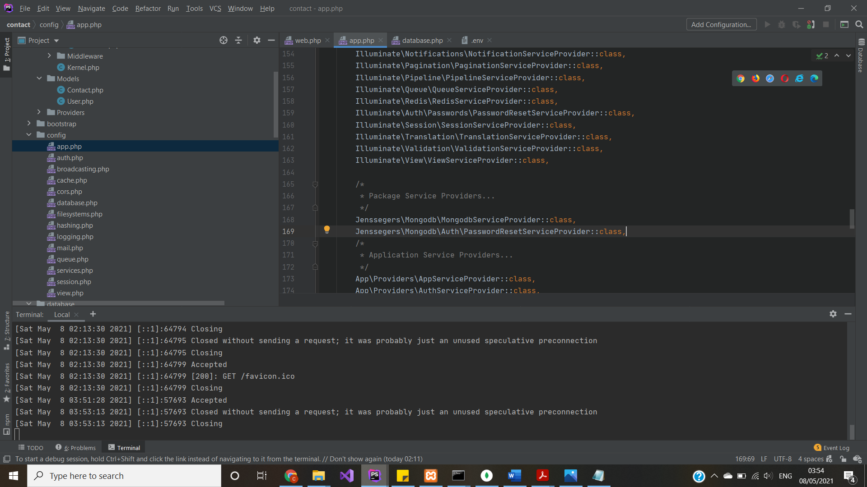

.env file:

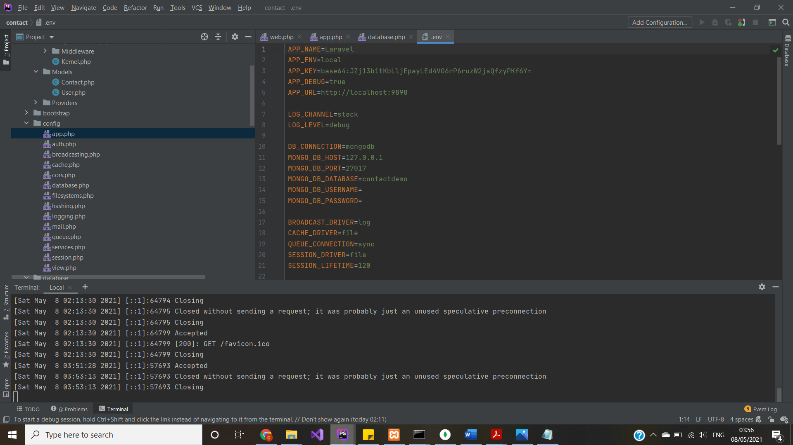

database.php file:

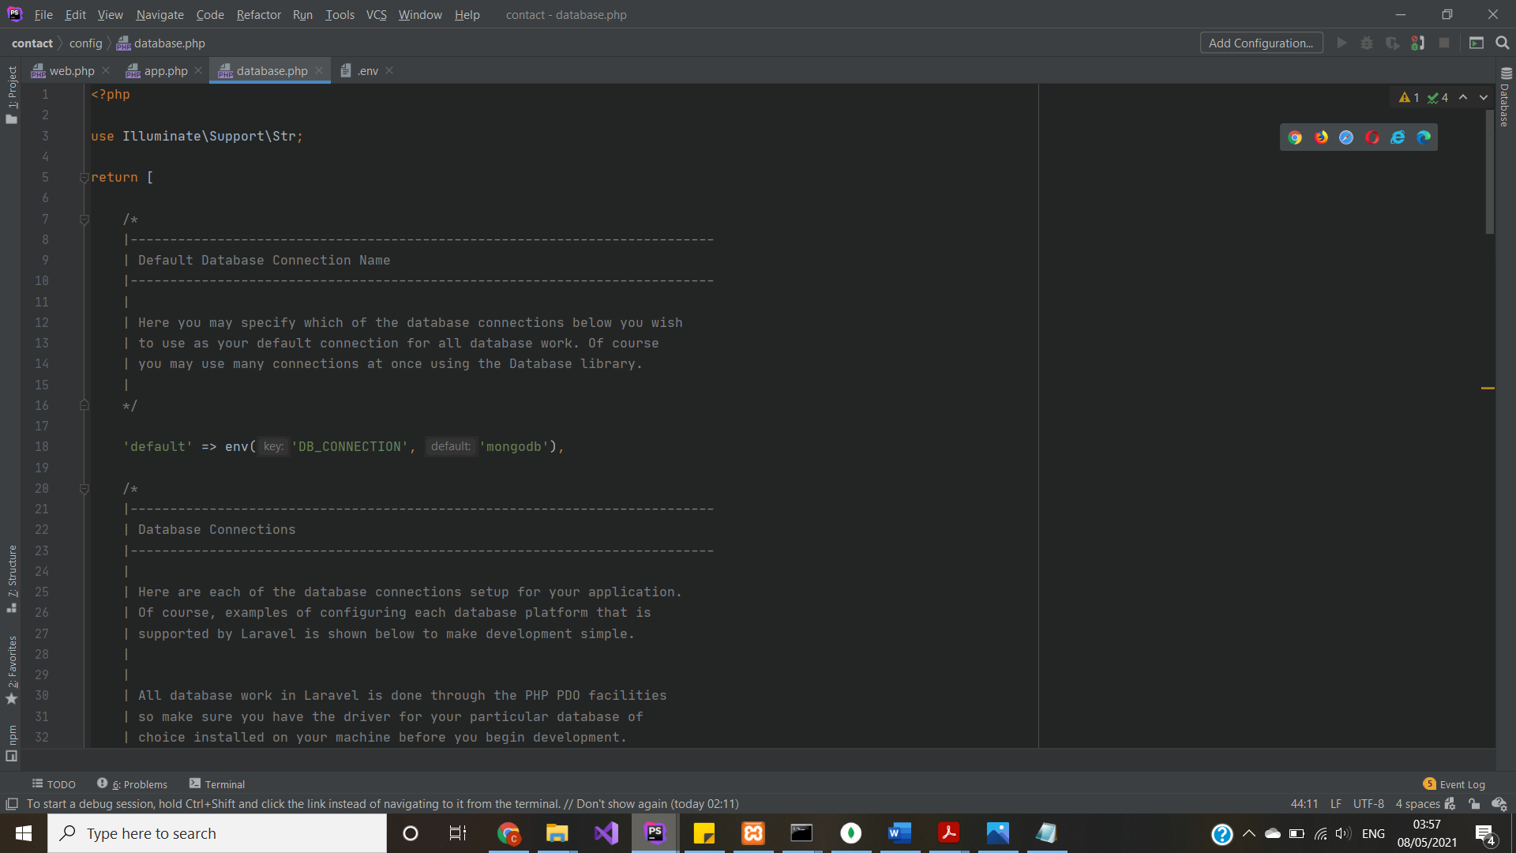

And

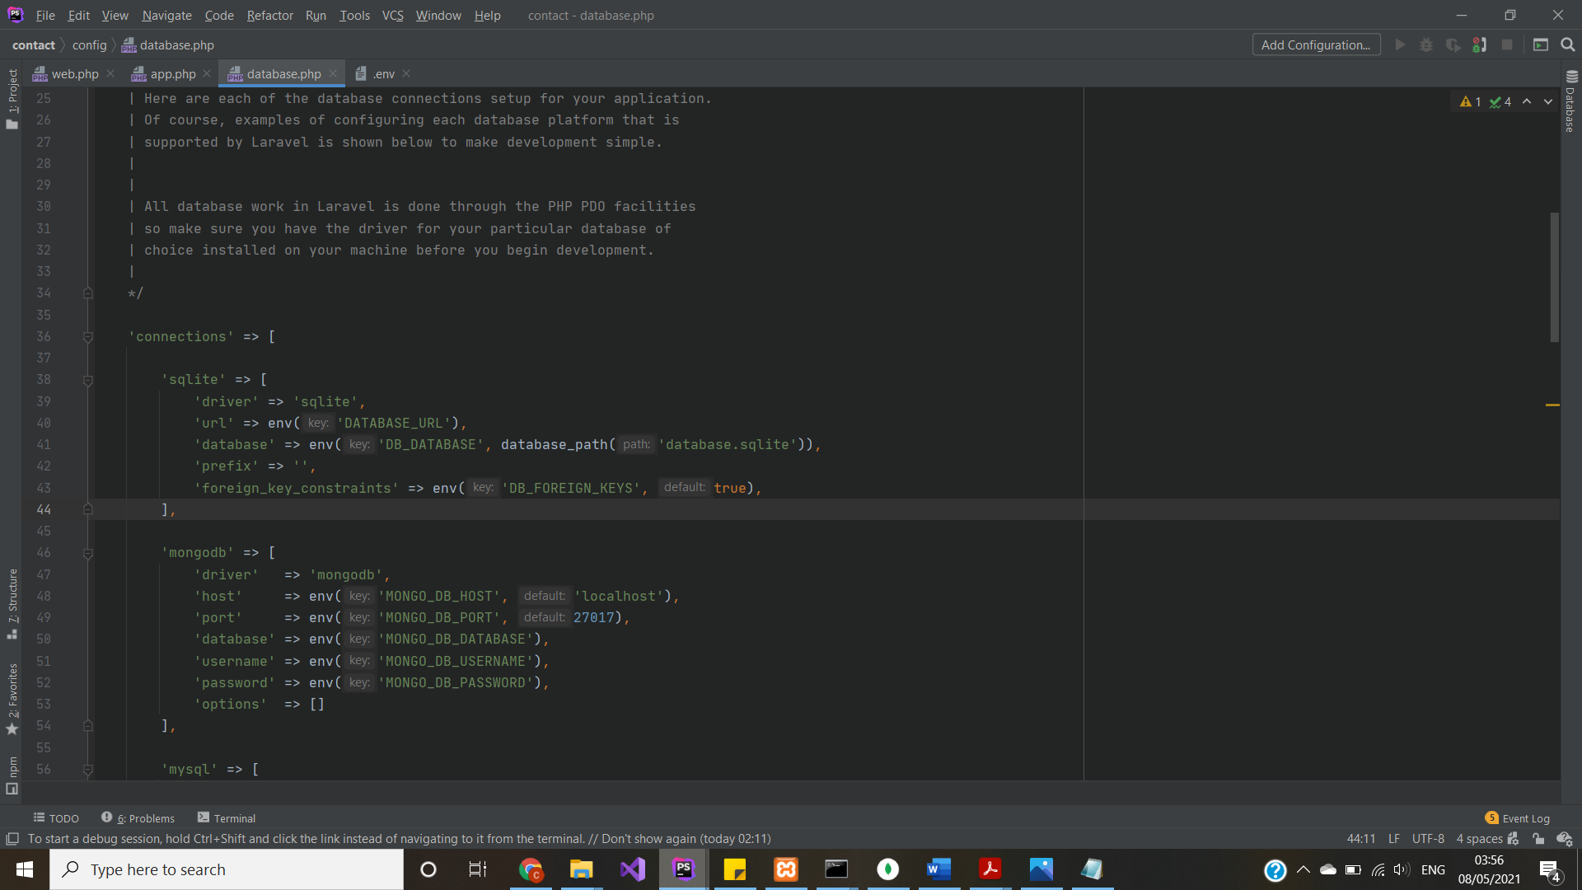

Run mongoshell and mongod:

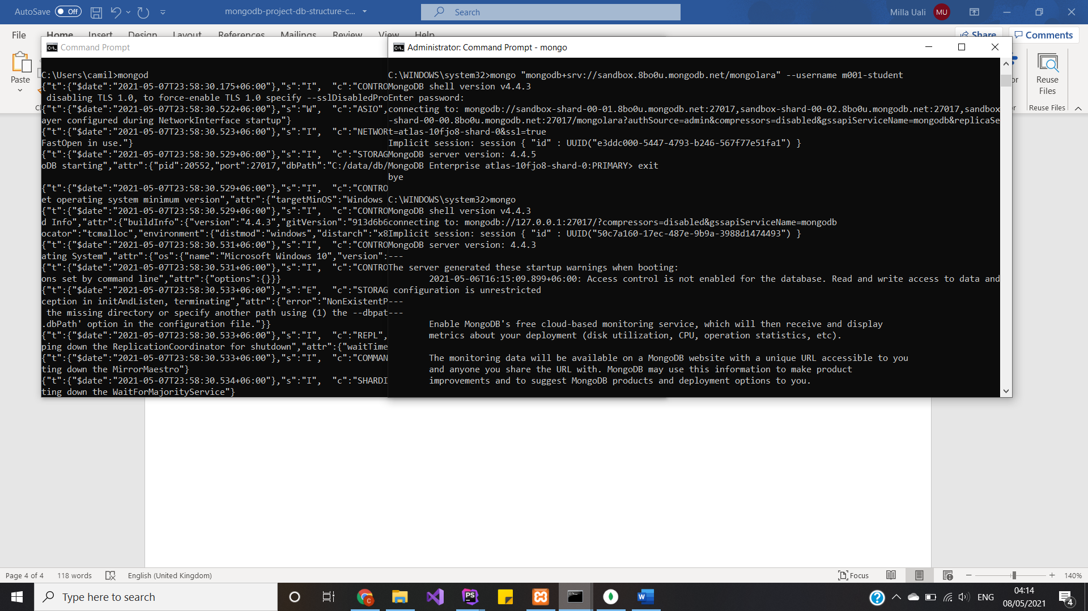

Change in models:

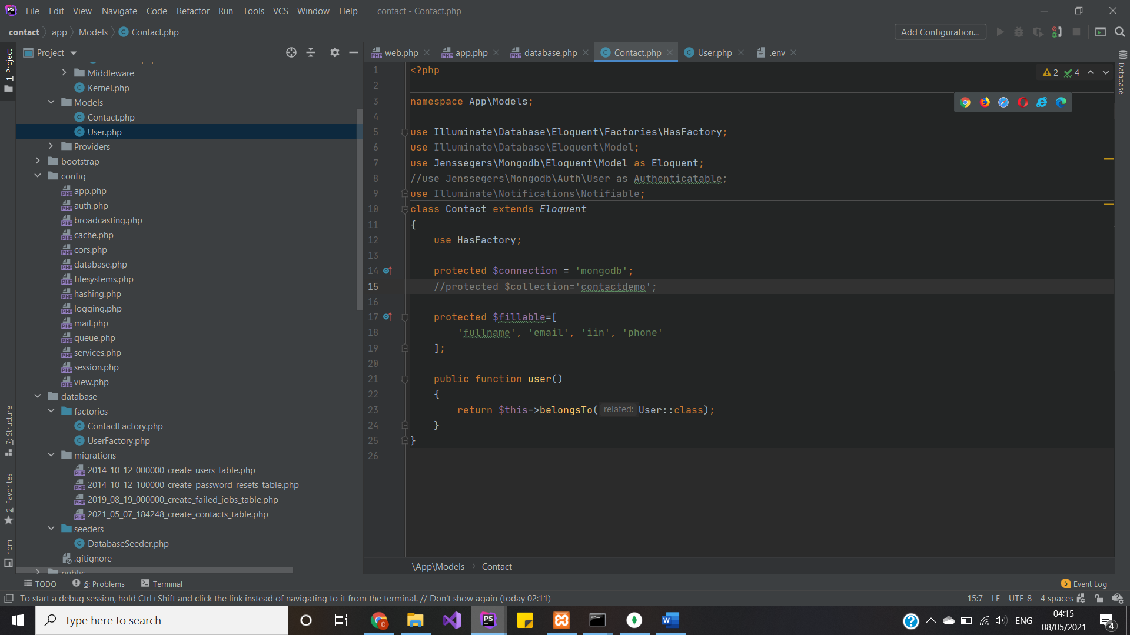

Auth models:

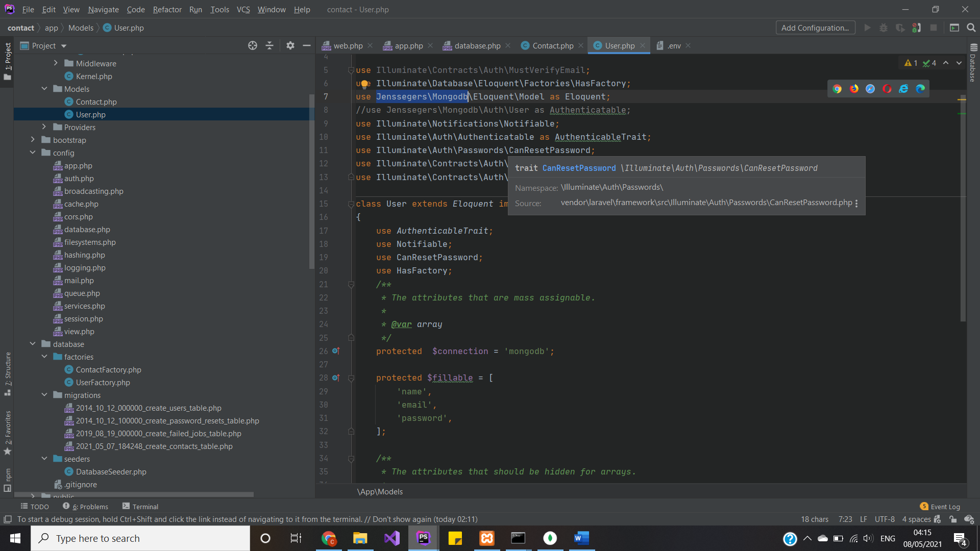

Schema files pretty much the same, yet we can use different approach, by just creating function, yet did not work so I did nothing:

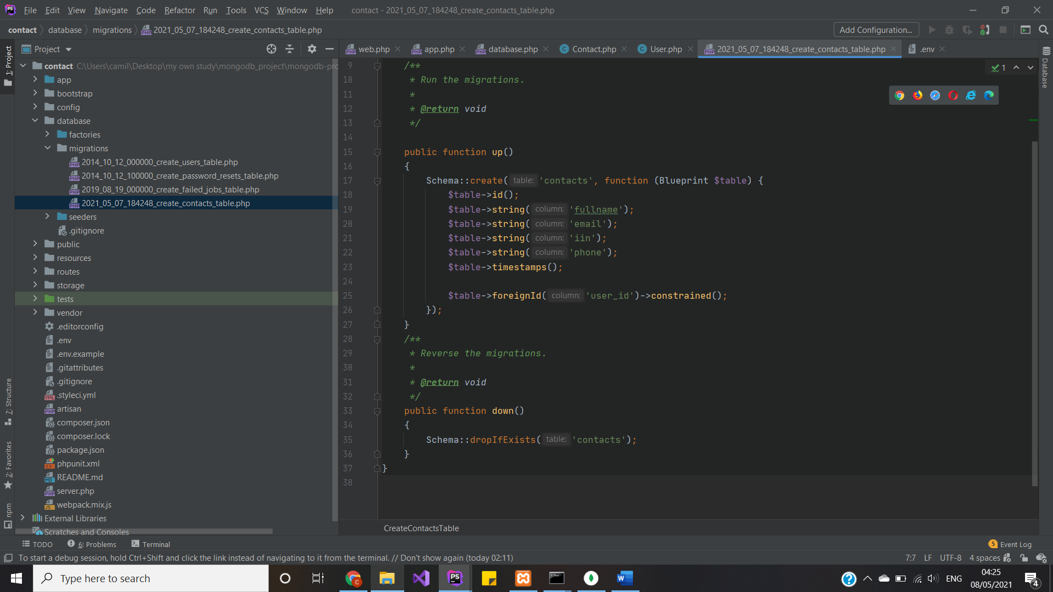

<https://morioh.com/p/3264375fd68d>

<https://faun.pub/when-to-use-nosql-getting-started-with-mongodb-in-laravel-f5376ceaf545>

<https://github.com/jenssegers/laravel-mongodb>

<https://github.com/swisnl/laravel-fulltext>

<https://laracasts.com/discuss/channels/laravel/laravel-mongodb-relationships>

<https://tkacz.pro/laravel-eloquent-mongodb-relations/>

<https://fullstackstanley.com/read/simple-search-with-laravel-and-elasticsearch/>

<https://arianacosta.com/php/laravel/tutorial-full-text-search-laravel-5/>

<https://gitee.com/qianli/laravel-mongodb>