**PROBLEM STATEMENT :- All of us face many problems namely:-**

* **how to save energy easily by reducing electricity bill**
* **how to remove the possibility of being locked out by losing a physical key**
* **how to check if you had locked your door or turned that appliance off after you actually leave**
* **how to inform you about the foot traffic on your porch when you're not at home**

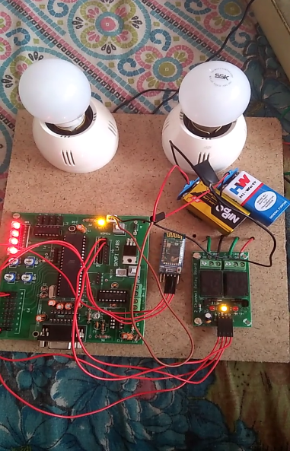**OBJECTIVE:-**Solving the above mentioned problems by setting up a control mechanism using technology so as to minimize human intervention for their operation i.e, using AUTOMATION

**SOLUTION:-**Home automation is simply automation of household activities by interfacing the appliances in the house through electronic and appropriate communication protocols. Ability to use our cell phone to view camera footage, unlock our door or turn lights on/off are just some basic connected home features. Teaching your home to react and adjust based on our preference is where the true potential is.

The pic shown above is the model prepared which works through an Arduino Bluetooth control app.

ELEMENTS REQUIRED FOR HOME AUTOMATION

|  |  |
| --- | --- |
| **Elements** | **FUNCTIONS** |
| SENSORS | Measure or detect changes in an environment like the temp, humidity,motion etc |
| CONTROLLERS | Control the output based on the input from the sensors |
| ACTUATORS | Electrical loads like lighting systems and other fans,appliances |
| BUSES | Communication channels between all the devices that are part of the home automation systems |
| INTERFACES | For users to interact with the systems and multi device interaction ,user friendly interfaces are also developed |
|  |  |

The model built will have the following mechanism:-

* control the lighting system using mobile phone
* Smart phone app acts as an interface between mobile phone and Bluetooth module
* HC05 blue-tooth module establishes the communication channel between phone and controller
* Microcontroller development board acts as the controller unit of our project.

RELAY MODULE 5V to 230V

MICROCONTROLLER

HC05 BLUETOOTH MODULE

Electrical load

MOBILE PHONE

**SCHEMATIC DESIGN OF THE MICROCONTROLLER BOARD**

Power supply 9 V

PORT 2:-

MOTOR DRIVER IC L293d

Ex- connections of motors

PORT 3:-

This port is free

PORT 1:-

Comparator IC LM324 converts the analog form of the signal to digital form required by the microcontroller

Ex;-connections of IR sensors

PORT 0:-

This port is set free

MICROCONTROLLER

Voltage regulator IC 7805 used to convert the 9 V supplied by the battery to 5V required by the microcontroller

Hence this solution would meet our needs for automating our homes . The model built here is for low scale but can be implemented on a large scale basis. Full home control systems with devices and apps dedicated to control and interact with any appliance at home are becoming more prelevant.