Use Case: Camera

Revision History
Date | Version | Author | Description of change
09/25/2017 | 1.0.1 | NCC | Initial Draft

Use Case: Camera
Id: UC- 006

Description
The user is takes a picture and the picture are sent to the EC2 search for valuation. Once the user has sent the picture, the system redirects the user to the home screen.
Frequency: every time the user wants to take a picture
Level: Summary
Assumptions:
- Start Screen Use Case has successively followed its natural flow
  - no exceptions flows
  - no alternative flows
- The user knows how to use basic android apps
- The android device has a camera built into it
Primary Actor:
- Users of the SeeFood app
Supporting Actors:
- SeeFood system
- android app camera
- EC2 Server
Pre-Conditions:
- SeeFood app is installed on Android device
- Android device must be connected to Internet
  - Wi-Fi
  - 4G network
- EC2 Server is in a Ready State
Post Conditions:
Success end condition:
- System Sends image for evaluation
- User gets redirected to the home screen
Failure end condition:
Minimal Guarantee
- Critical Error: SeeFood App closes and returns user to android OS control
Trigger:
- User takes a picture

Main Success Scenario
- The system loads the camera app
- The User takes a picture
- The system prompts the user with a message that asking them if they want to send this picture for evaluation
    - See Figure 1
- The user clicks the Yes button
- The system sends the picture for evaluation
- The system redirects the user to the home screen
- Use Case ends

Extensions

5. The system fails to connect to the Internet
- The system loads an error message notifying the user of the problem
    - See Figure 2:
- The user clicks the okay button
  - by doing this the user verifies they understands the problem
- The system halts at home screen

5. The system fails to establish connection to EC2 server
- The system loads an error message notifying the user of the problem
    - See Figure 3:
- The user clicks the okay button
  - by doing this the user verifies they understands the problem
- The system halts at home screen

Variations
4. Instead of clicking the Yes button, the user clicks No button
- Use Case begins back at step 1 of the Main Success Scenario

Variations: system exit
- User clicks on the menu tab
- System loads drop-down menu
- User clicks the exit option
- System exits the SeeFood app
- Use Case ends

Variations: Gallery option
- User clicks on the menu tab
- System loads drop-down menu
- User clicks the Gallery option
- System loads the Gallery screen
- Use Case ends

Variations: Home option
- User clicks on the menu tab
- System loads drop-down menu
- User clicks the Home option
- System loads the Home screen
- Use Case ends

Variations: View Image option
- User clicks on the menu tab
- System loads drop-down menu
- User clicks the View Image option
- System loads the View Image screen
- Use Case ends

Figures
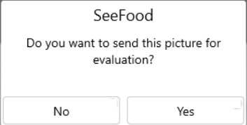
Figure 1
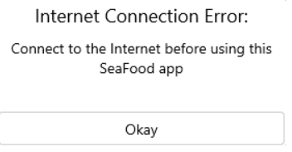
Figure 2: Internet connection
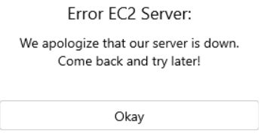
Figure 3: EC2 connection

