Use Case: Home Screen

Revision History
Date | Version | Author | Description of change
09/25/2017 | 1.0.1 | NCC | Initial Draft

Use Case: Home Screen
Id: UC-002
Description: The home screen is displayed
Frequency: Primary Screen for SeeFood app
Level: Summary
Assumptions:
- The user knows how to use basic android apps
Primary Actor:
- Users of the SeeFood app
Supporting Actors:
- SeeFood system
- EC2 Server
Pre-Conditions:
- SeeFood app is installed on Android device
- User has successfully completed the natural flow of Start Screen Use Case
- Android device must be connected to Internet
  - Wi-Fi
  - 4G network
- EC2 Server is in a Ready State
Post Conditions:
Success end condition:
- Home Screen image is initialized with default image
Failure end condition:
Minimal Guarantee
- Critical Error: SeeFood App closes and returns user to android OS control
Trigger:
- Completion of Use Case: Start Screen

Main Success Scenario
- System Loads Home Screen
- The system displays default image
    - See Figure 1:
- The system displays default survey ratio is food
    - See Figure 1:
- Use Case ends

Extensions
The system fails to connect to the Internet
- The system loads an error message notifying the user of the problem
    - See Figure 2:
- The user clicks the okay button
  - by doing this the user verifies they understands the problem
- The system halts at home screen

The system fails to establish connection to EC2 server
- The system loads an error message notifying the user of the problem
    - See Figure 3:
- The user clicks the okay button
  - by doing this the user verifies they understands the problem
- The system halts at home screen

Variations
Variations: system exit
- User clicks on the menu tab
- System loads drop-down menu
- User clicks the exit option
- System exits the SeeFood app
- Use Case ends

Variations: Gallery option
- User clicks on the menu tab
- System loads drop-down menu
- User clicks the Gallery option
- System loads the Gallery screen
- Use Case ends

Variations: Camera option
- User clicks on the menu tab
- System loads drop-down menu
- User clicks the Camera option
- System loads the Camera screen
- Use Case ends

Variations: View Image option
- User clicks on the menu tab
- System loads drop-down menu
- User clicks the View Image option
- System loads the View Image screen
- Use Case ends

Special Requirements
None: As of initial draft
Figures
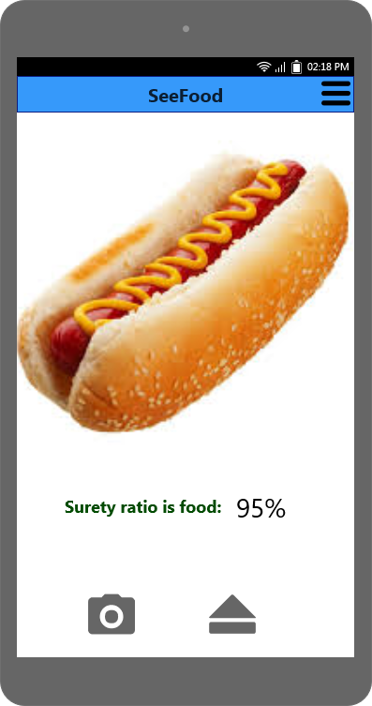
Figure 1: home screen

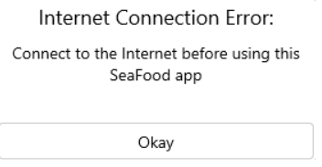
Figure 2: Internet connection
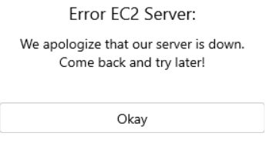
Figure 3: EC2 connection

