Use Case: Home Screen View Images

Revision History
Date | Author | Description of change
9/25/2017 | NCC | Initial draft

Use Case: Home Screen View Images
Id: UC-004
Description: The user navigates to the image view. The image view displays thumbnails and evaluations of previous images which are stored on the server.
Frequency: Every time the user navigates to the view image screen
Level: Summary
Assumptions:
- Start Screen Use Case has successively followed its natural flow
  - no exceptions flows
  - no alternative flows
- The user knows how to use basic android apps
- The server has available images and their results saved
Primary Actor:
- Users of the SeeFood app
Supporting Actors:
- SeeFood system
- EC2 Server
- Database application or some storage device for images and the results
Pre-Conditions:
- SeeFood app is installed on Android device
- Android device must be connected to Internet
  - Wi-Fi
  - 4G network
- EC2 Server is in a Ready State
Post Conditions:
Success end condition:
- User is redirected to the view image page
Failure end condition:
- View image page has no images
Minimal Guarantee
- Critical Error: SeeFood App closes and returns user to android OS control
Trigger:
- User clicked on menu tab

Main Success Scenario
- User clicks on the menu tab
    - See Figure 1:
- System loads drop-down menu
- User clicks the View Image option
- System loads the View Image screen
  - See Use Case: View Image Thumbnails
- Use Case ends

Extensions
None

Variations
1a. Instead of clicking the View Image option, the user clicks the Gallery option
- System loads the Gallery screen
- This Use Case ends
1b. Instead of clicking the View Image option, the user clicks the Camera option
- System loads the Camera screen
- This Use Case ends
1a. Instead of clicking the View Image option, the user clicks the Exit option
- System exits the SeeFood app
- This Use Case ends

Special Requirements
None: As of initial draft
Figures
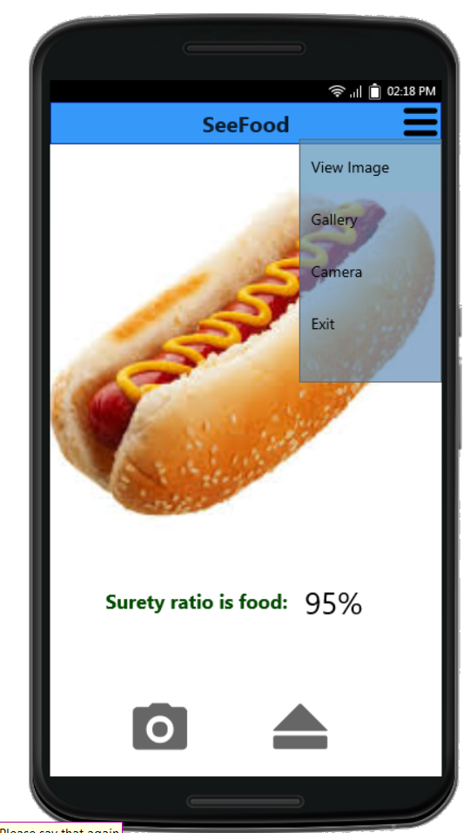
Figure 1: Menu tab

