Use Case: Start Screen

Revision History
Date | Version | Author | Description of change
09/25/2017 | 1.0.1 | NCC | Initial Draft

Use Case: Start Screen
ID: UC-001
Description: The system loads the SeeFood loading page.
Frequency: Every time the seafood app get started this use case will get utilized
Level: Summary
Assumptions:
- The user knows how to use basic android apps
Primary Actor:
- Users of the SeeFood app
Supporting Actors:
- SeeFood system
- EC2 Server

Pre-Conditions:
- SeeFood app is installed on Android device
- Android device must be connected to Internet
  - Wi-Fi
  - 4G network
- EC2 Server is in a Ready State
Post Conditions:
Success end condition:
- System successfully loads homepage about
  - See Use Case: Home Screen
Failure end condition:
- SeeFood App failed to load
Minimal Guarantee
- SeeFood App closes and returns user to android OS control
Trigger:
- User clicked on SeeFood App icon

Main Success Scenario
- The system loads SeeFood start screen
    - See Figure 1:
- The system checks for core requirements
  - The system checks for Internet connection
  - The system establishes connection to EC2 server
- The system loads home screen
- Use Case ends

Extensions
2a. The system fails to connect to the Internet
- The system loads an error message notifying the user of the problem
    - See Figure 2:
- The user clicks the okay button
  - by doing this the user verifies they understands the problem
- The system closes SeeFood App and returns user to android OS control

2b. The system fails to establish connection to EC2 server
- The system loads an error message notifying the user of the problem
    - See Figure 3:
- The user clicks the okay button
  - by doing this the user verifies they understands the problem
- The system closes SeeFood App and returns user to android OS control

Variations
None

Special Requirements
- The system should take no longer than a minute to establish connection with the EC2 server

Figures


Figure 1: Start Screen
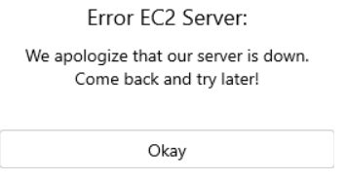
Figure 2: EC2 Error message

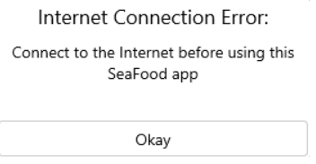
Figure 3: EC2 Error message

