Use Case Gallery

Revision History
Date | Version | Author | Description of change
09/25/2017 | 1.0.1 | NCC | Initial Draft

Use Case: Gallery
Id: UC-006
Description
The user can select from available images stored on their local android device to be evaluated on the EC2 server. Additionally, the user can select and send more than one image for evaluation. Lastly, once images are sent to the server the user gets redirected back to the home screen.
Frequency: When the user decides to send an image from their local system
Level: Summary
Assumptions:
- The user knows how to use basic android apps
- The user has images stored on their local device
Primary Actor:
- Users of the SeeFood app
Supporting Actors:
- SeeFood system
- Android Gallery app
- EC2 Server
Pre-Conditions:
- SeeFood app is installed on Android device
- Android device must be connected to Internet
  - Wi-Fi
  - 4G network
- EC2 Server is in a Ready State
- User has images on local machine
Post Conditions:
Success end condition:
- System Sends image for evaluation
- User gets redirected back to the Home Screen
Failure end condition:
Minimal Guarantee
- Critical Error: SeeFood App closes and returns user to android OS control
Trigger:
- Use Case: Home Screen Image Evaluation

Main Success Scenario
- The system displays the gallery
    - see Figure 1
- The User selects images for evaluation
- The User clicks the checkmark icon button
- The system displays a alert message asking the user if they want to send those images
    - see Figure 4
- The User clicks the okay button
- The system sends the images to the EC2 server
- The User is redirected to the home screen
- The Use Case end

Extensions
The system fails to connect to the Internet
- The system loads an error message notifying the user of the problem
    - See Figure 2:
- The user clicks the okay button
  - by doing this the user verifies they understands the problem
- The system halts at home screen

The system fails to establish connection to EC2 server
- The system loads an error message notifying the user of the problem
    - See Figure 3:
- The user clicks the okay button
  - by doing this the user verifies they understands the problem
- The system halts at home screen

Variations
- Instead of clicking the Yes button, the user clicks No button
- the system closes the alert message box
- the use case starts over at step 1 of the Main Success Scenario

Variations: system exit
- User clicks on the menu tab
- System loads drop-down menu
- User clicks the exit option
- System exits the SeeFood app
- Use Case ends

Variations: Home option
- User clicks on the menu tab
- System loads drop-down menu
- User clicks the Home option
- System loads the Home screen
- Use Case ends

Variations: Camera option
- User clicks on the menu tab
- System loads drop-down menu
- User clicks the Camera option
- System loads the Camera screen
- Use Case ends

Variations: View Image option
- User clicks on the menu tab
- System loads drop-down menu
- User clicks the View Image option
- System loads the View Image screen
- Use Case ends

Figures
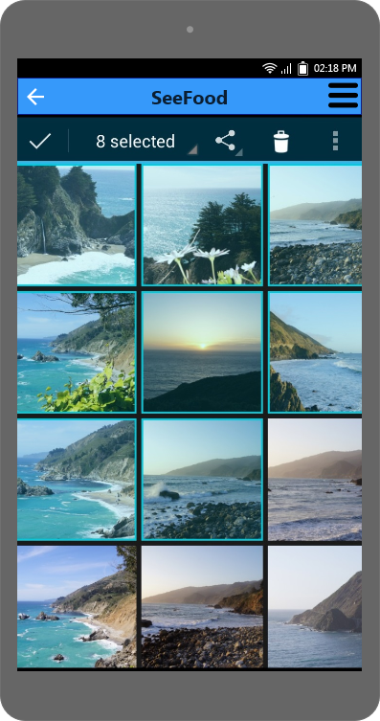
Figure 1
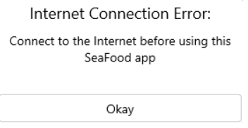
Figure 2: Internet connection
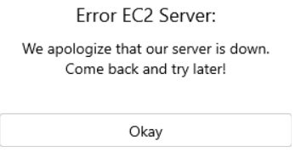
Figure 3: EC2 connection
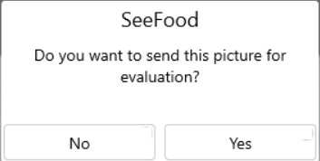
Figure 4

