Use Case: Home Screen Image Evaluation

Revision History
Date | Version | Author | Description of change
09/25/2017 | 1.0.1 | NCC | Initial Draft

Use Case: Home Screen Image Evaluation
Id: UC-003
Description: The user takes (camera) or selects (gallery) an image and sends it to the EC2 server for evaluation.
Frequency: Primary Screen for SeeFood app
Level: Summary
Assumptions:
- The user knows how to use basic android apps
Primary Actor:
- Users of the SeeFood app
Supporting Actors:
- SeeFood system
- EC2 Server
- Use Case: Camera
- Use Case: Android Gallery
Pre-Conditions:
- SeeFood app is installed on Android device
- Android device must be connected to Internet
  - Wi-Fi
  - 4G network
- EC2 Server is in a Ready State
Post Conditions:
Success end condition:
- System Sends image for evaluation
- Home Screen image is updated with image and evaluation result
Failure end condition:
- User sends unknown file types
- User sends an unorthodox image resolution
Minimal Guarantee
- Error message is displayed notifying user of image resolution problem
- Error message is displayed notifying user of image file extension problem
- Critical Error: SeeFood App closes and returns user to android OS control

Trigger:
- User clicks Camera icon button
- User clicks on Gallery icon button
- User clicks menu tab
  - User clicks Camera button
- User clicks menu tab
  - User clicks Gallery button

Main Success Scenario
A. Camera icon button
- User clicks Camera icon button
- System loads camera app
  - See Use Case: Camera
- System sends picture to EC2 server for evaluation
  - See Use Case: EC2 Server Evaluation
- System receives evaluation results
- System updates home screen image display with picture taken
    - See Figure 1:
- System updates Surety ratio is food with image evaluation result
    - See Figure 1:
- Use Case ends

B. Gallery icon button
- User clicks Gallery icon button
- System loads android gallery app
  - See Use Case: Android Gallery
- System sends picture or pictures to EC2 server for evaluation
  - See Use Case: EC2 Server Evaluation
- System receives evaluation results
- System updates home screen image display with last selected picture
    - See Figure 1:
- System updates Surety ratio is food with last received evaluation result
    - See Figure 1:
- Use Case ends

Extensions
B4b. The user submitted an unknown file type
- The system loads an error message notifying the user of the problem
    - See Figure 4:
- The user clicks the okay button
  - by doing this the user verifies they understands the problem
- The system halts at home screen

Exception flow for A and B:
3a. The system fails to connect to the Internet
- The system loads an error message notifying the user of the problem
    - See Figure 2:
- The user clicks the okay button
  - by doing this the user verifies they understands the problem
- The system halts at home screen

3b. The system fails to establish connection to EC2 server
- The system loads an error message notifying the user of the problem
    - See Figure 3:
- The user clicks the okay button
  - by doing this the user verifies they understands the problem
- The system halts at home screen

Variations
- Instead of clicking the Camera icon button, the User clicks the menu tab
- System loads drop-down menu
- User clicks Camera button option
- Use Case returned to Main flow at step 2

- Instead of clicking the Gallery icon button, the User clicks the menu tab
- System loads drop-down menu
- User clicks Gallery button option
- Use Case returned to Main flow at step 2

Variations: system exit
- User clicks on the menu tab
- System loads drop-down menu
- User clicks the exit option
- System exits the SeeFood app
- Use Case ends

Variations: View Image option
- User clicks on the menu tab
- System loads drop-down menu
- User clicks the View Image option
- System loads the View Image screen
- Use Case ends

Special Requirements
None: As of initial draft
Figures
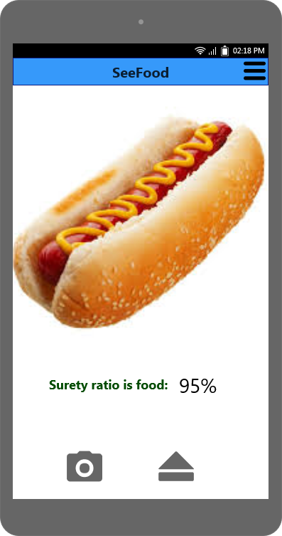
Figure 1: home screen

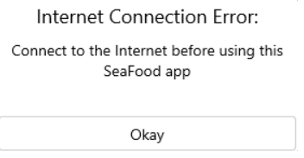
Figure 2: Internet connection
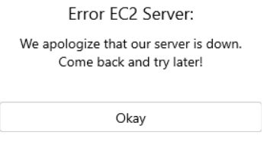
Figure 3: EC2 connection

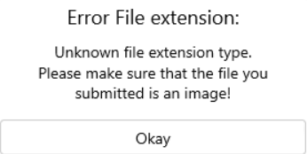
Figure 4: File Exe

