Use Case: View Image Thumbnails

Revision History
Date | Version | Author | Description of change
09/25/2017 | 1.0.1 | NCC | Initial Draft

Use Case: View Image Thumbnails
Id: UC-005
Description
The user can view image thumbnails and their evaluations in an image gallery.
Frequency: Only when the user wants to view thumbnails
Level: Summary
Assumptions:
- Start Screen Use Case has successively followed its natural flow
  - no exceptions flows
  - no alternative flows
- The user knows how to use basic android apps
- The server has available images and their evaluation results
Primary Actor:
- Users of the SeeFood app
Supporting Actors:
- SeeFood system
- EC2 Server
- Database application
Pre-Conditions:
- SeeFood app is installed on Android device
- User has successfully completed the natural flow of Start Screen Use Case
- Android device must be connected to Internet
  - Wi-Fi
  - 4G network
- EC2 Server is in a Ready State
Post Conditions:

Success end condition
- The user is able to view thumbnails and their evaluation results
Failure end condition:
- There are no image files on the server
Minimal Guarantee
- Critical Error: SeeFood App closes and returns user to android OS control

Trigger:
- System automatically downloads thumbnails and resolution requirements

Main Success Scenario
- The View Image Thumbnail screen is displayed
- The system automatically starts downloading the thumbnails and evaluation results
- The system displays each thumbnail and its evaluation results in a sorted column of food or not food:
    - See Figure 1
- Use Case Ends

Extensions
The system fails to connect to the Internet
- The system loads an error message notifying the user of the problem
    - See Figure 2:
- The user clicks the okay button
  - by doing this the user verifies they understands the problem
- The system halts at home screen

The system fails to establish connection to EC2 server
- The system loads an error message notifying the user of the problem
    - See Figure 3:
- The user clicks the okay button
  - by doing this the user verifies they understands the problem
- The system halts at home screen

Variations
Variations: system exit
- User clicks on the menu tab
- System loads drop-down menu
- User clicks the exit option
- System exits the SeeFood app
- Use Case ends

Variations: Gallery option
- User clicks on the menu tab
- System loads drop-down menu
- User clicks the Gallery option
- System loads the Gallery screen
- Use Case ends

Variations: Camera option
- User clicks on the menu tab
- System loads drop-down menu
- User clicks the Camera option
- System loads the Camera screen
- Use Case ends

Variations: Home option
- User clicks on the menu tab
- System loads drop-down menu
- User clicks the Home option
- System loads the Home screen
- Use Case ends

Special Requirements
None: As of initial draft

Figures
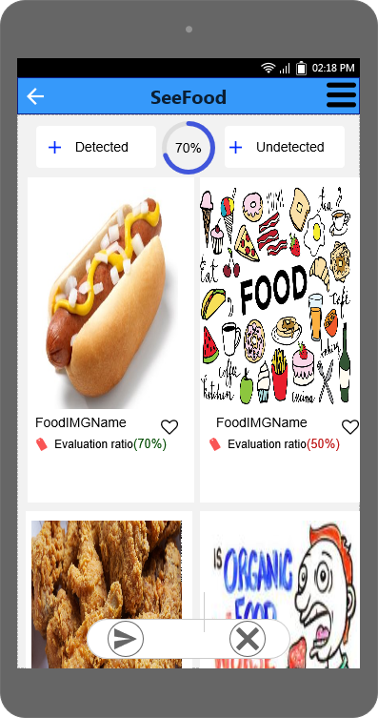
Figure 1

