Here's what I learned in Woodstock VT today. Joab Hoisington, my 5 times great grandfather, was a Major in the revolutionary war. He died in 1777 from smallpox. His widow remarried and left Woodstock for other places like the Midwest. This sets the backdrop for the following pictures courtesy of the Woodstock Historical Society via Matthew Powers. I have put comments on some of the pictures for clarification.

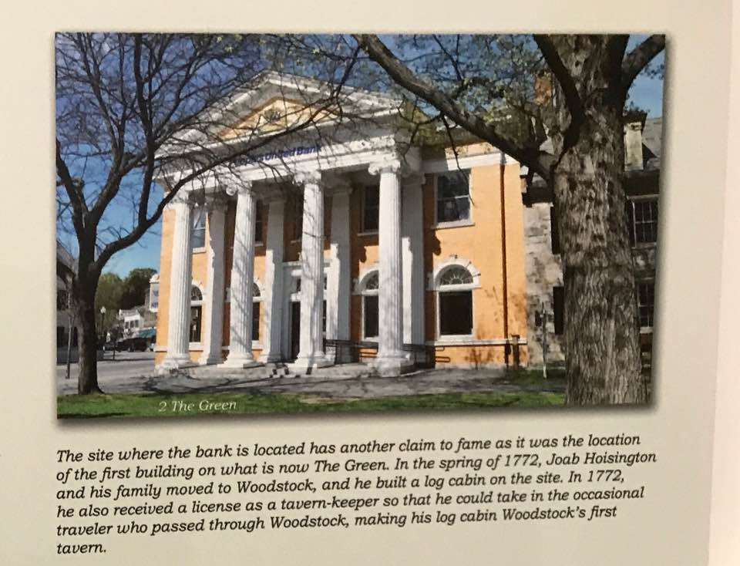

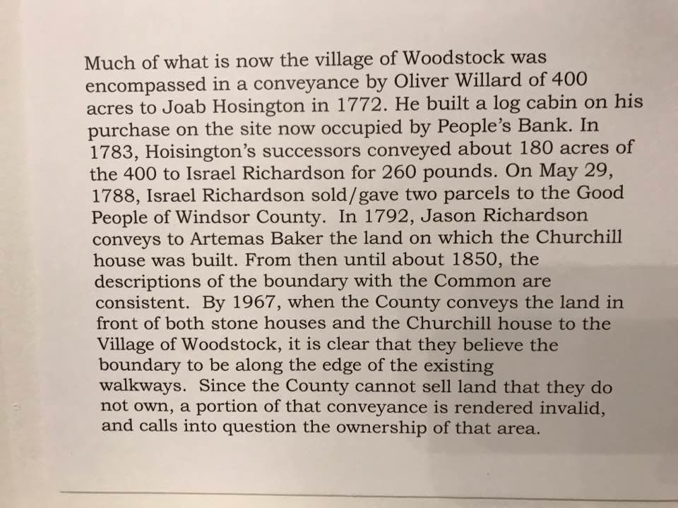

The back section of the house, the part that looks like it is turned sideways, is believed to be the Hoisington house originally built where the bank in picture 1 is currently located. After the widow Hoisington moved on, it is believed that Richardson decided to move the house to his property. This caused some confusion in the transfer recordings and as a result, the green space in front of the bank building is still, to this day, registered to Hoisington.

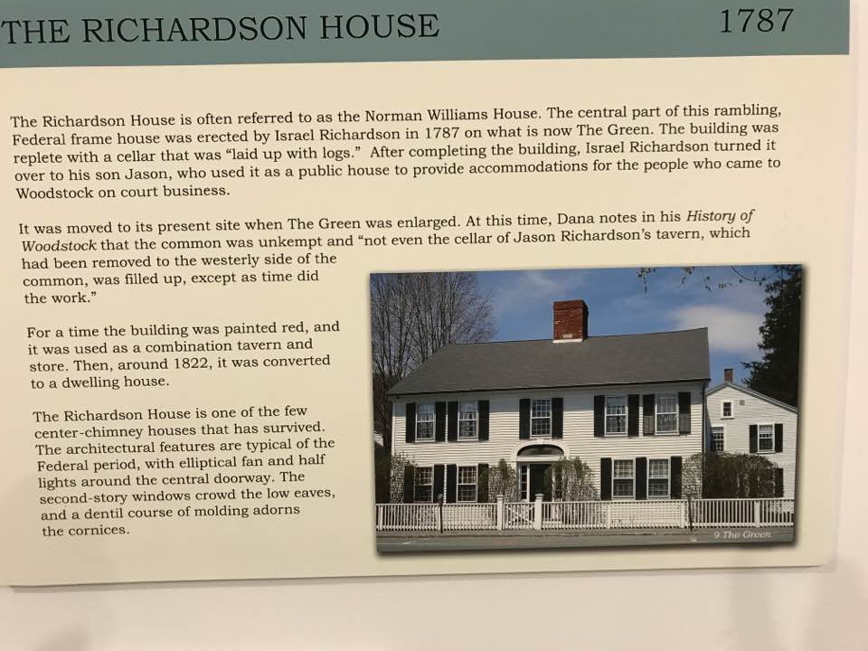

This is me laying claim to the Hoisington land mentioned in the previous picture.

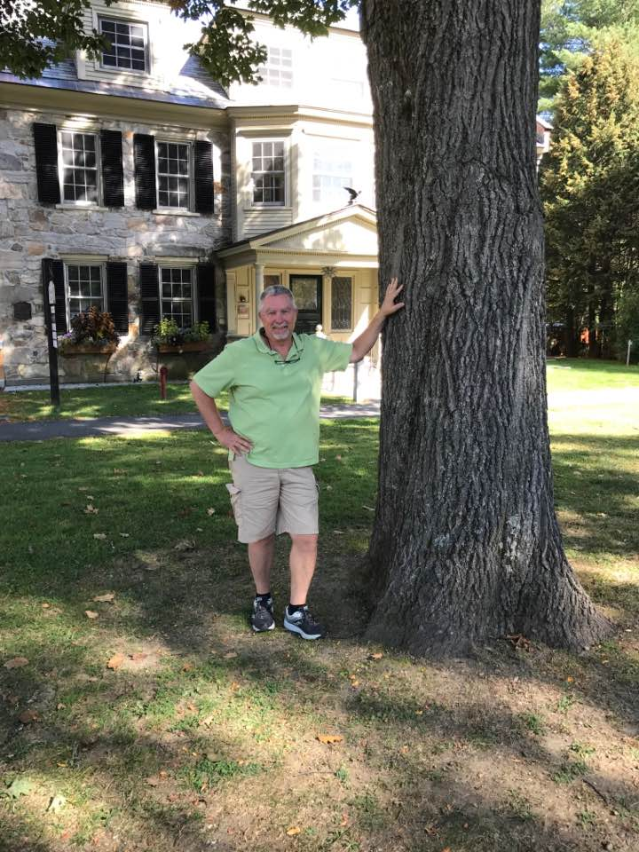

Here's Peggy and I having lunch on our new property.

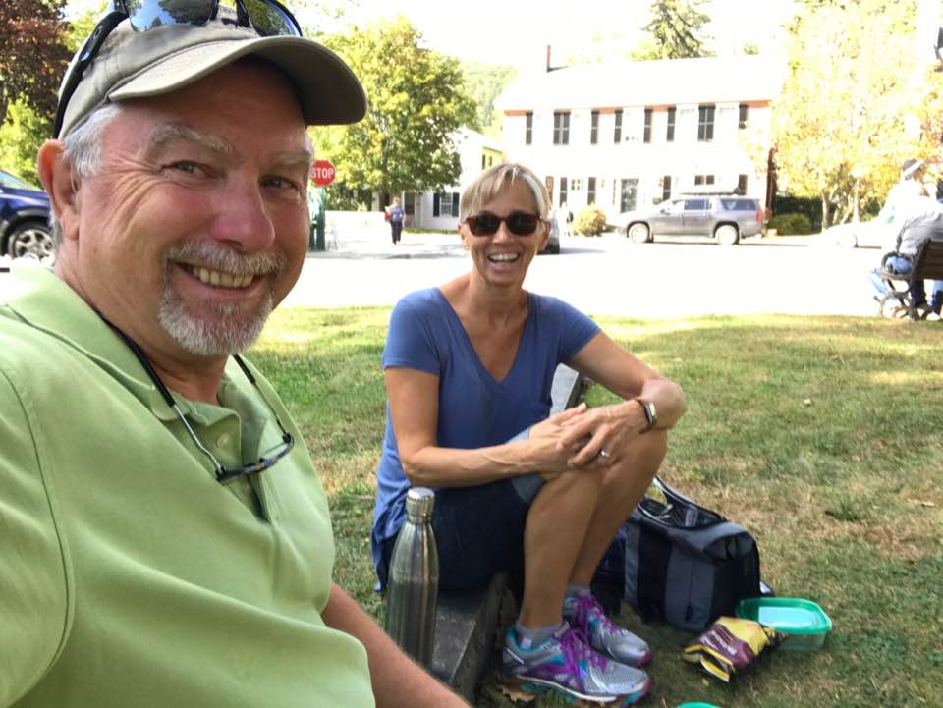

This is me standing in front of the one time Hoisington house.

