# Email Exchanges between Dennis Miller and Charlotte Miller Smith

## 2025 02 11, 1:12 PM

Question:

Do you know what caused Grandfather (High Miller) to lose his eyesight?

Response:

He had bad cataracts. I remember he had surgery for them but it was kind of experimental at the time. We visited during that time. He was confined to bed with sandbags holding his head. He couldn’t move at all for a period of time. Beyond that I’m not sure. Medicine was pretty crude compared to today. I also remember him getting transfusions to keep his blood counts up. It was assumed that sooner or later he would become ill from this and probably die. His body was not producing its own red blood cells.

## 2025 02 11, 4:50 PM

Question:

Do you know whether Grandfather had rheumatoid arthritis?  I ask because I read that he suffered from arthritis even as a young man and then the automobile accident exacerbated it.

Response:

I’m sure he had it in his back. Roland had told me he injured his back in a car accident about 1932. His doctor recommended a warm climate for him as the South Dakota winter would not be good for him. I believe 1936 is when they first went to Texas. I know he returned to SD to sell his business assets around 38 and returned to Texas permanently in 1940. All things related to moving to Texas was for his health.

## 2025 02 28, 6:31 PM

Question:

Is Ailt Grandfather's father?  Are the others in the picture his parents and siblings?

Response:

Yes, that is correct. This was taken shortly before his mother passed away. She was diagnosed with breast cancer.

Gerund and Eike front center are the parents.

## 2025 02 28, 6:35 PM

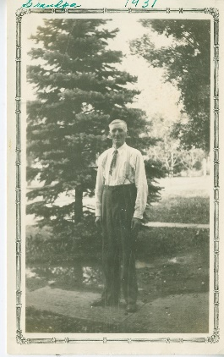

Response:

This is our great grandfather Ailt Miller, aka AL, High's father. He moved to Rock City IL about the time of this photo. He lived with Roy and Iva Hoffmeister. Iva his daughter. He served in the post office with Roy who was the postmaster. I had a conversation with Jean Sorn, Iva's daughter about this. She was about 7 or 8 when he died. She remembers him coming home for lunch and lying down upstairs in his room and just passing away. He is buried in the Rock Grove cemetery with Andy Miller and Roy and Iva. they are all together there. I've attached pictures. The broad view shows all the families together and a close up so you can read the smaller stone.

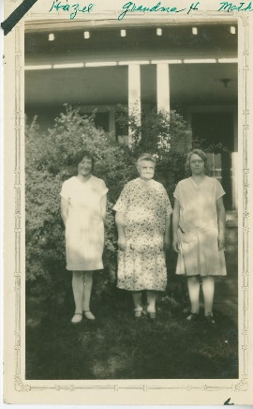 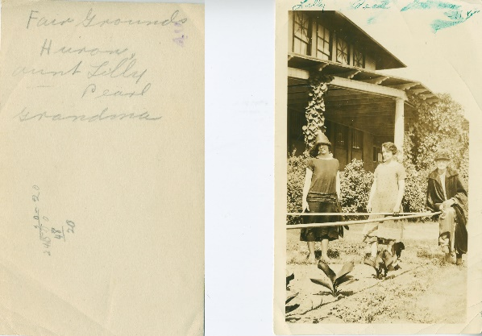

Response:

This is Bert on the right, her mother Edith center and Bert's sister Hazel on the left. The lower picture shows grandmother's aunts, Lily and Pearl. The picture say Huron SD which is where Pearl lived with her husband where they operated a filling station. Married name Niblo.

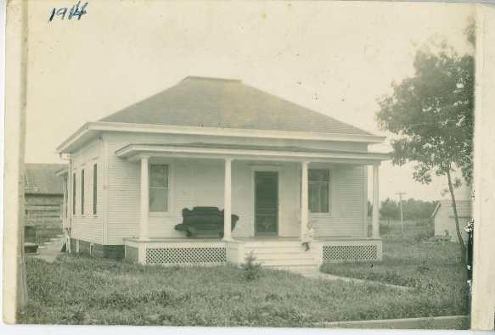

Response:

I believe this is the home where Grandfather and Grandfather lived at least for a while. This would be in Lennox SD. Most likely Elvira sitting on the front porch as she was the only living child at that time. She would be 2 in 1914. They did have a daughter in 1914 born April and died August. Lillian Ada.

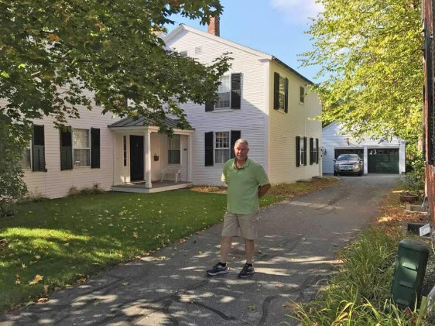

Question:

This lovely house that you laid claim to — which Hoisington owned it?  Joab?

Response:

Yes, according to the historical society, this house belonged to Joab Hoisington. It was moved from it's original location just a short distance away still on the village green where the bank currently stands. There is a small strip of land in front of the bank that is still deeded to Joab. It was to be deeded to the village but a small strip never transferred.

Question:

Is it a private residence now?

Response:

Yes. I don't remember if I ever got the original foot print of his land but he owned a large portion of that area. I sent you a picture about his original location. He operated a saw and grist mill and his home was also used as a tavern, which I believe for the time period meant more of a travel stop than how we define tavern. I think I remember seeing an early layout of the town showing his land but I can't put my hands on it. If I come across it I will forward it to you. It is a beautiful area. You should check it out. Make sure to visit the historical society.

Here it is as a picture instead of a link. His estate would have sold the property. His Widow married Captain John Strong. I’ve never been able to find out much about him but they moved to Quebec and died there. I find it odd that he achieved the rank of captain but there isn’t much about his service. The only thing I can find is he served under General Schuyler 1776-1777. I also find it odd that they moved to Quebec. Argenteuil specifically. It’s my understanding that this was common for colonists that were loyal to the crown. When I visited the historical society I met a guy that was supposed to put me in touch with a descendant of the Strong family but he never followed through.  
  
I haven’t looked at this information for some time and my memories are a little fuzzy.

Question:

Do you know the address for this house?

Response:

I think 11 N Park St

This was given to me by the historical society. I think the guy said it is allegorical and not documented. Take it for what it's worth.

## 2025 03 02, 3:51 PM

Question:

I believe you told me once that someone in Grandmother's ancestral tree came over on the Mayflower.  Is that correct?  Do you have a name?

Response:

Richard Warren. He died in 1628. His wife went on to live until 1673 and conducted her own affairs. This was unusual for the times and she was well respected as a good manager of her assets. Joe Q was grandfather’s brother. Shelby was your dad’s cousin. I got to spend time with him in 2012. He had a very interesting life as a sportscaster. He was 6’9”. No information on Hattie.

Here is the tree for Richard Warren

Richard Warren       Elizabeth Walker

Richard Church      Elizabeth Warren

Caleb Church         Joanna Sprague

Matthew Boomer    Hannah Church

Caleb Boomer        Sarah Martin

Matthew Boomer    Jane "Jean" Weld

Matthew Boomer Jr   Sarah Wordell

Joab Hoisington      Hulda Boomer

Albert J Hoisington   Elizabeth Limb

Albert L Hoisington   Edith Hamilton

Henry Miller      Alberta Hoisington

The Spencer line is the same family as Lady Diana. I followed a thread that goes back about 2500 years but I have not verified anything. Or do I know how to. There is a common ancestor in many trees. Her name is Alice Whitbread. If you search her you will find a lot. She is an ancestor to about half the presidents and many other famous people.

## 2025 03 07, 11:50 AM

Question:

Did Grandfather inherit his general store from his father?  In my notes, I have that he inherited the funeral parlor.

Response:

I don't think inherit would be correct. His father died in 1936 and That is about the time of Grandfather's accident that initiated him moving to Texas. His  father moved to Illinois about 1930-31. I don't have any information about the business transferring but I have heard my dad tell stories about the business and growing up in that environment. I have found in the 1910 census that he and his brother Jerry are operating a general store together. I have heard that they had a falling out over some financial matter and did not have a good relationship. It appears from the census, that the building was rented. I did talk to a Lennox resident in 2012 that was good friends with the person that had purchased the business when grandfather left SD. Unfortunately, I started my research about 15-20 years too late. There would have been people with first hand knowledge still available to talk to. I know Grandfather's brothers were in business in Lennox. Joe Q ran a grocery store and he had no children. Al Anthony ran a drug store that had a soda fountain. My dad occasionally worked there. His children were Shelby and Marrianne. His brother Jerry also had a drug store in a near by community. He had a son named Jerry Roland Miller who became a doctor in Indianapolis.

I don't have a lot of facts about Grandfather's business. How he got started or just a lot of specifics. We know he was a funeral director. I've been told he also sold furniture and insurance. Roland told me he went to Texas in the late 30's but in the 1940 census he was back in Lennox. Roland told me he had to sell his business building. There was a fire that damaged the second story. He had the top floor removed making it a single story building. I don't think the building is still standing. After that he returned to Texas for good.

1920 Census has him as proprietor of furniture store. 1930 Census says agent insurance. 1940 does not list occupation. I have nothing to say that his father ever owned the funeral parlor or store. I do have information that he worked at a funeral parlor. He also serve as police chief, postmaster and laborer.

## 2025 03 07, 1:38 PM

Question:

Is this a general store?  Would it be Ailt's?  I think the picture came from Aunt Sis.  She labels it as from 1909 and that Grandfather is on left.  I don't know who the other man is.

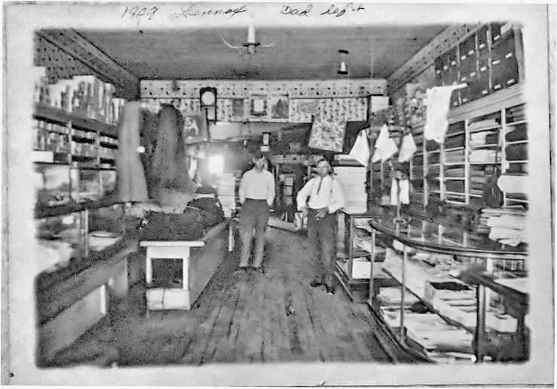

Response:

I have never seen this. the 1910 census says Grandfather is a store proprietor. This certainly looks like a general store. No idea who the other person is. Ailt was a tall man and this guy looks shorter than Grandfather. He looks too old to be Jerry but he does look like he could be a relative. Very interesting. Thanks for sharing. I wonder if the other man is who he rented from.

## 2025 03 08, 11:37 AM

Question:

The picture that I scanned was from a scrapbook that Mother put together for me.  On the same page is a picture of classroom from grade school.  I assume one of the children is Daddy, but the photo is very poor and Mother did not annotate either picture.  The handwriting on the photo is not Mother's writing.  I think she must have gotten it from Aunt Sis.

This photo was in with a lot of loose photos and again I think it must be from Aunt Sis.  She has checked the man in the white shirt.  Any idea of the context?

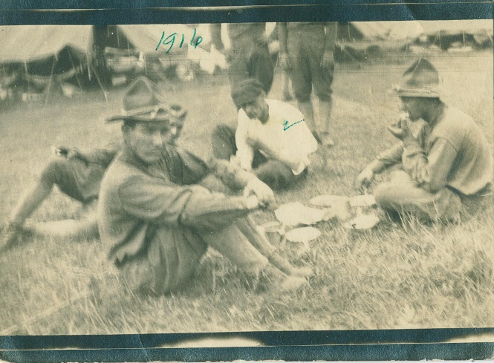

Response:

I have that photo. I have no idea where it was taken. He is the only one in civilian clothes. 1916 would be during the war. looks like lunch time.

## 2025 03 28, 10:56 AM

Response:

Not sure if you have this info:

A L Hoisington had a second wife, Eva May Davis. They had a daughter, Mildred. I met with a cousin that had descended from Grandmother's sister. She personally knew Mildred. Mildred was married 3 times. one husband ended up in jail for shooting a guy. One of her husbands ran a carnival. My dad had told me he worked one summer at a carnival. I can only assume that it was the same one. Also we visited the cemetery where Eva May is buried. Her grave stone says she was the first white child born in South Dakota. The 1920 census lists her as married bur A L is not part of her household. She is living with her father. 1930 Census says she is divorced. Some day I hope to find a copy of the divorce decree.

## 2025 03 28, 11:01 AM

Response:

Here’s pictures of Eve May and her family. Also a group photo with the Davis family and Al Hoisington and a photo of Al. I received these from a cousin descendant of grandmother’s sister. She knew Mildred. I went back and double checked on John Davis (Eva’s father and wearing a lot of medals). He does have Civil War records but I can’t see them. He was in Illinois then. Grandmother’s grandfather on her mother’s side, John Hamilton also was in Illinois and served in the Civil War. I wonder if they were in the same unit.

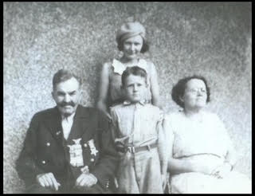

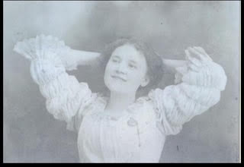

I know that grandmother did not speak fondly of her life growing up. The only thing she would say is she had an unhappy childhood. I think she would say not much good happened during her youth. She would have been about 10 when Al and her mother divorced. She was then taken by her father to South Dakota. He remarried when grandmother was 14. She married Grandfather at 17. I believe I found an Iowa census in 1905 With Al living in Walnut IA with grandmother, her younger sister and Eva. Though they weren't yet married, she was listed as Eva Hoisington.I also talked to a Hoisington decedent in 2012 That said that Al had a drinking problem. This lady knew our dad and called him Corky. She had met him at her grandmother's 50th wedding anniversary. She said Grandmother had driven to Winterset IA from SD with 2 of her sons for the event so your dad would have been there as well. Her grandmother was Victoria Hoisington married name Johnson. Hard to say if grandmother just had difficulty adjusting through all the changes or if she was actually mistreated. A L seems to have disappeared around 1915 so she would have been left with her step-mother as well. She certainly improved her life by marrying Grandfather and I always thought she was very devoted to him. certainly circumstances leave much room for speculation.

Question:

What is the name of the cemetery where Eva is buried and its location?

Response:

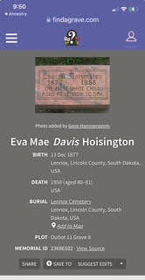

Question:

Daddy is wearing the same t-shirt in both of these pictures.  Would he be in high school.  The house does not look like the one on Hermosa St in SA

Response:

They lived in rented places before settling in the house we knew. Roland said they had no furnishings and rented fully furnished. The first location I have is Salinas. And I believe at one more location before ending up on Hermosa.

I went back and double checked on John Davis. He does have Civil War records but I can’t see them. He was in Illinois then. Grandmother’s grandfather on her mother’s side, John Hamilton also was in Illinois and served in the Civil War. I wonder if they were in the same unit.

## 2025 04 04, 2:00 PM

This is labeled Keith and Keith.  Do you know who the little Keith was?  Would this be Lennox?

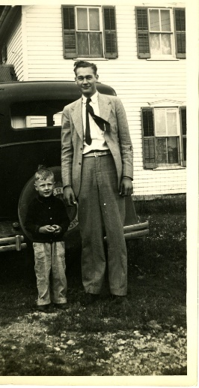

Response:

Little Keith was Andy's son so possibly the farm outside Rock City IL

Question:

Know any interesting facts about this picture.  They were dressed to kill!  I assume Corky is on the left and Keith the right.

Response:

There are a whole series of pictures in front of that tree. One of the other pictures is Elvira in a graduation cap and gown so I'm assuming it was all based around her graduation.

Response:

The story I remember is the boys (Corky, Keith, Roland, and Bud) all had 4 names. Because of all the Millers in Lennox, they choose 3 names to use so there would be less confusion. I'm not sure what name the used before school. Donald Roland Addison Miller. All I have for Elvira is Elvira Luella Miller. Alvin Harold Porter Miller