Gary Miller
Lab4 Report

Given first is the content of the twitter4j.properties file before running the CreateProperties file.
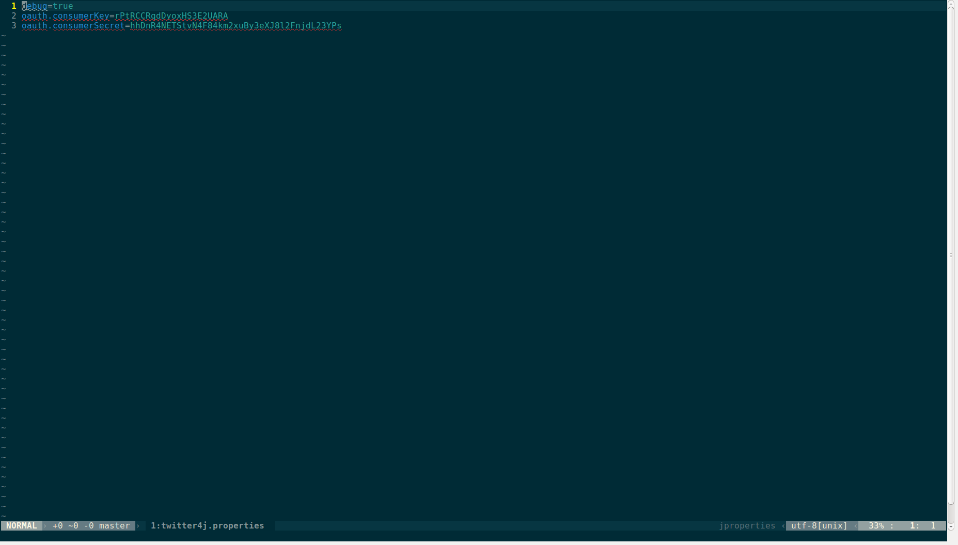
And this is the content after running CreateProperties.

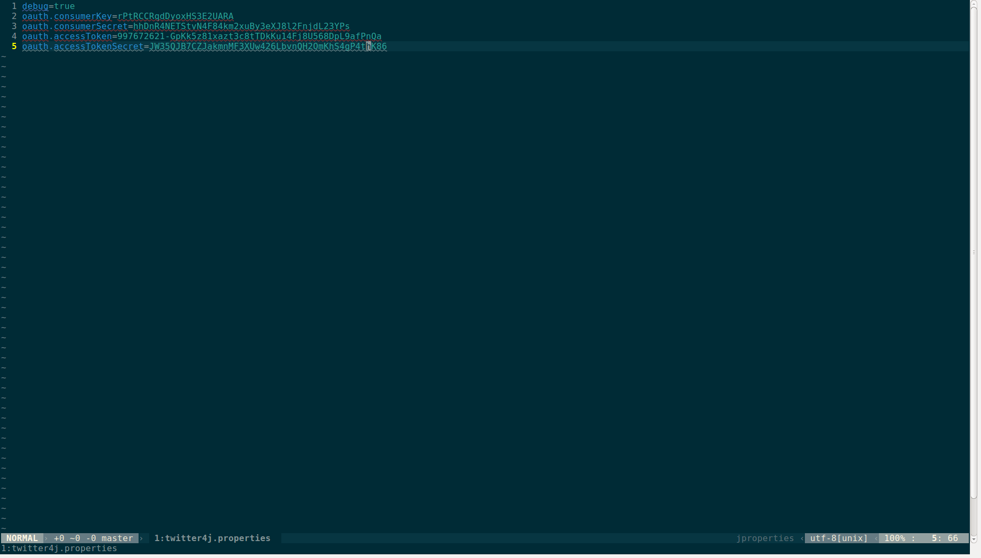
Shown below is a screenshot of the website that the program CreatProperties.java asks you to visit. Here, it gives you a code to enter and validate you account so that it can connect to the twitter servers.
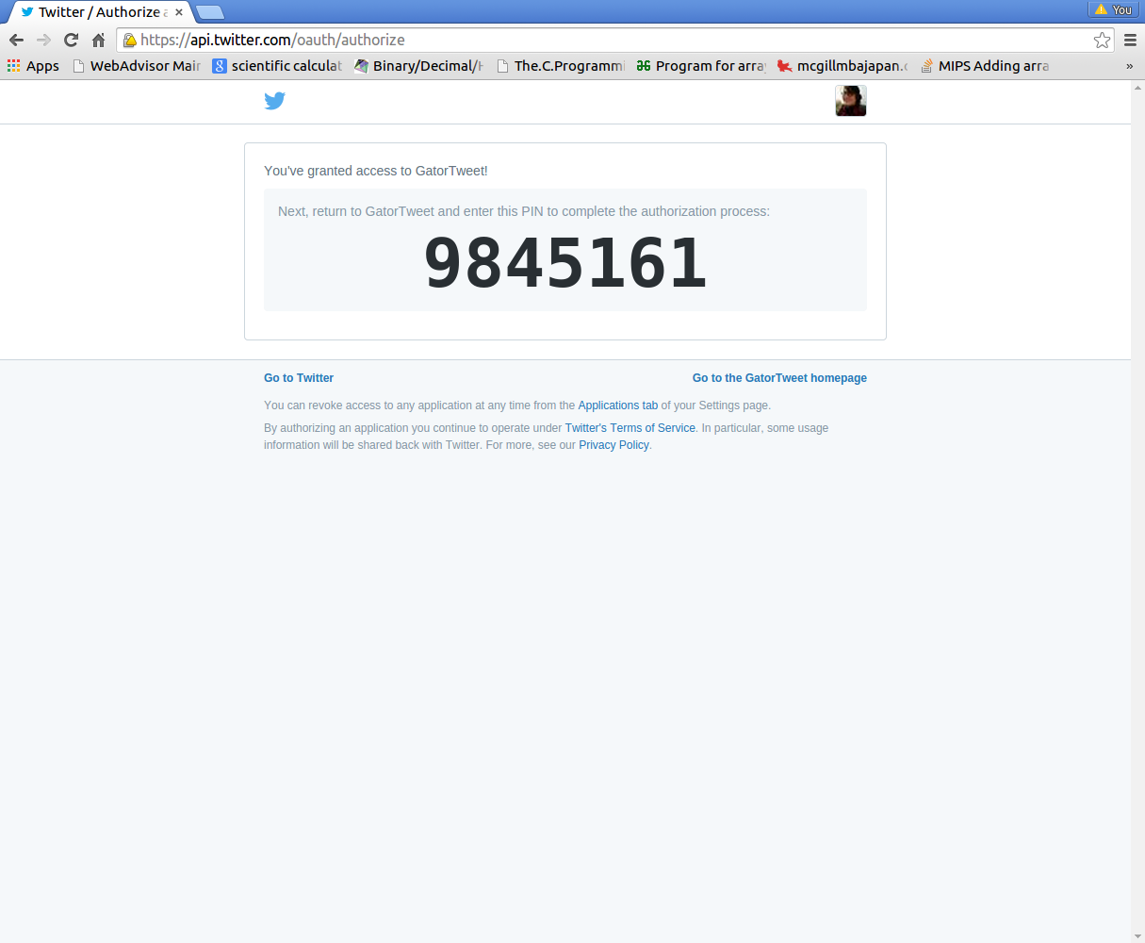

Next, we show the output provided by the GetHomeTimeline program, which is a method added to our main GatorTweet.java program that retrieves and prints to the console the user's twitter timeline.
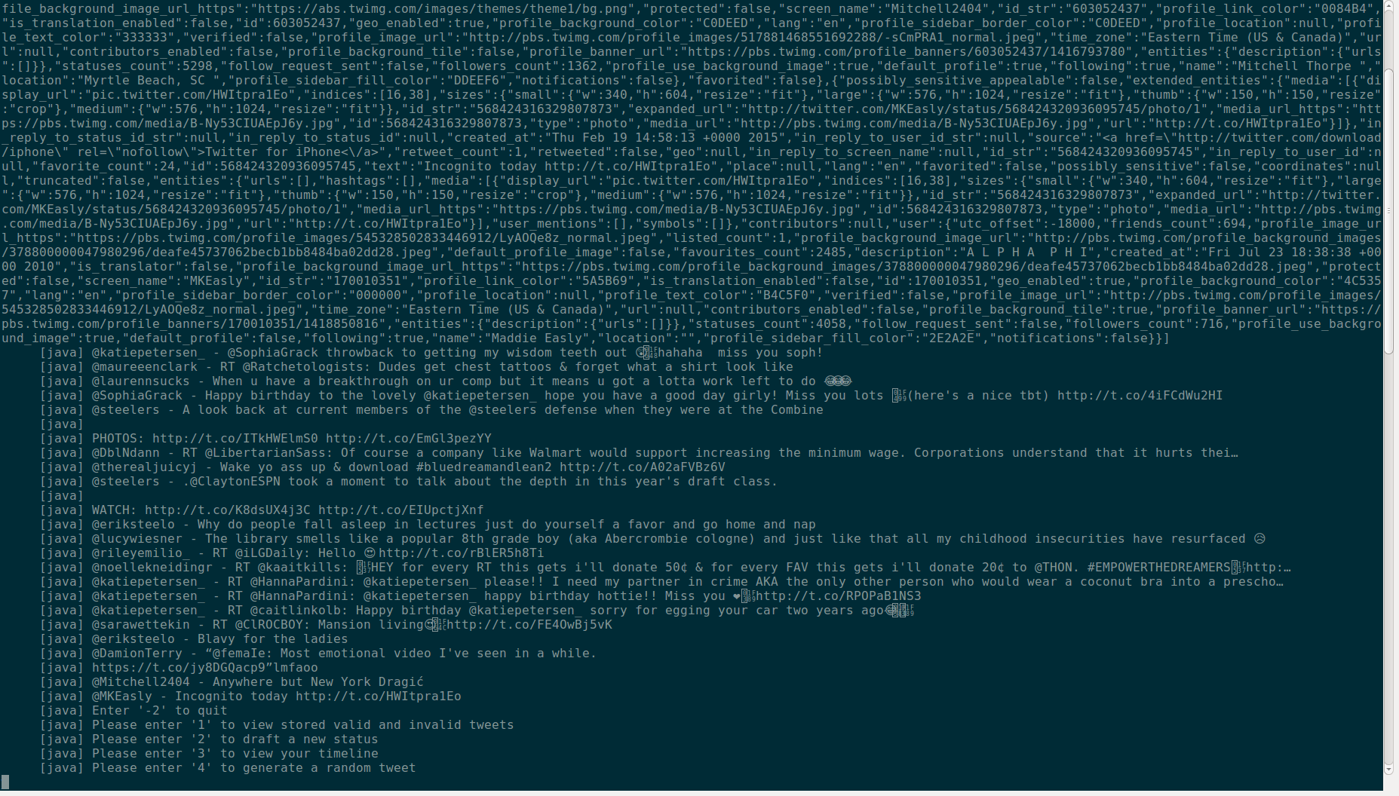

The method that I added to my GatorTweet program, was one that generated a random integer between 0 and 140. It then took this integer and tweeted that I was thinking of that number. Sample output is shown below.
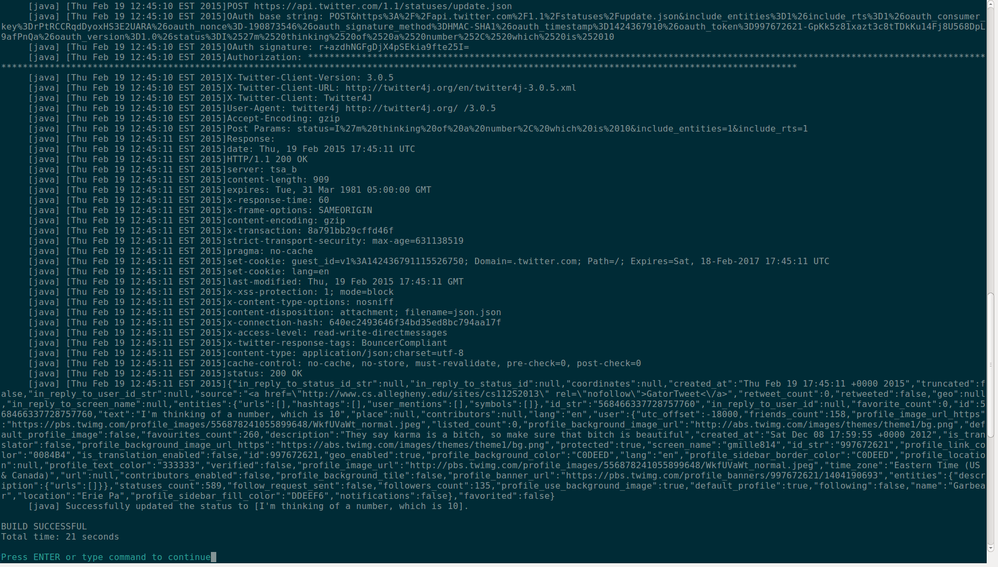
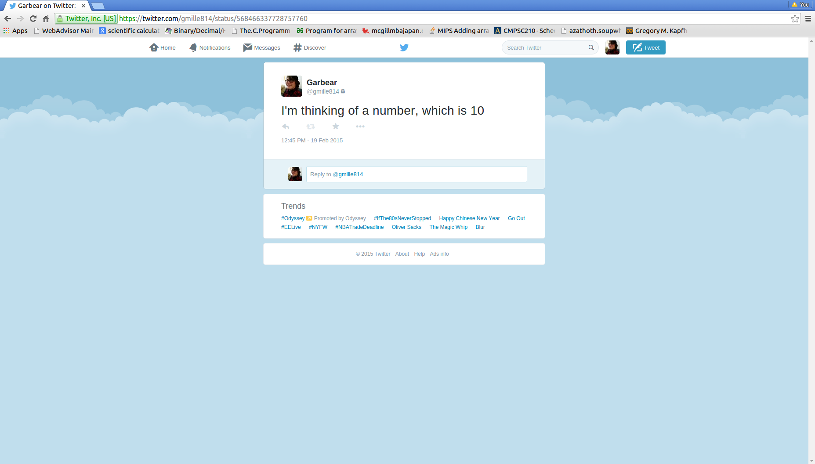

Shown below is the GetHomeTimeline method when debugging mode is disabled.
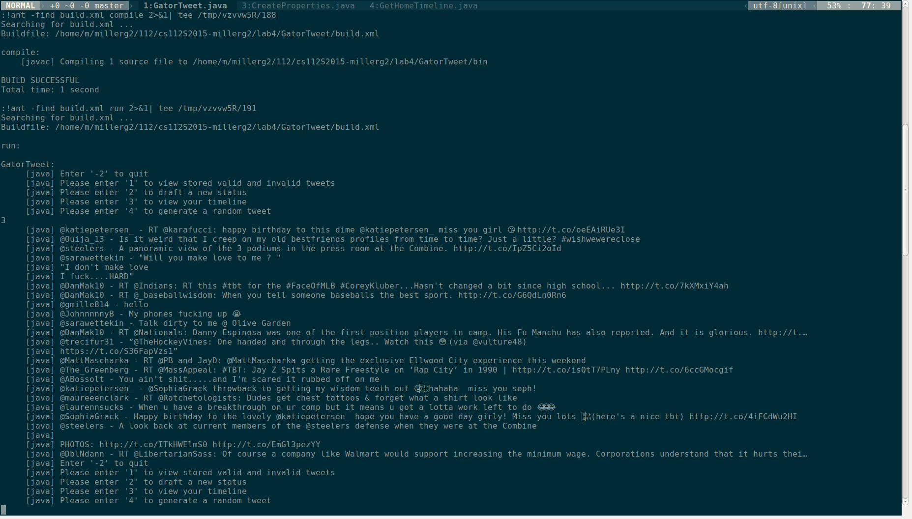

Reflecting on this lab the biggest challenges faced, were first and foremost continuing to familiarize myself with compiling and running programs not all in the same directories. This was done by setting classpaths and using the build.xml file to connect all of our classes together, as well as connect the programs to the twitter servers. Another big challenge was getting familiar with all the predefine objects in the twitter4j classes. One of the harder things to figure out in this lab was what to format the parameters needed to correctly compile and run the methods found on the twitter4j documentation center.

Thinking towards the future the are several other methods that could be added to make this program more complete. One of these obvious methods that is a suggestion on the twiiter4j site is to add a method that allows direct messaging to other users. Also, something else someone could try to add to their program is the ability to delete our edit tweets directly from the gvim environment, opposed to having to load the twitter web page. Finally, if someone who was working on a twitter project such as this was truly ambitious and a veteran coder, they could attempt to design at GUI, or a graphical user interface. While this is certainly more complex than adding another method to the program, added a graphical user interface would complete this program and allow it to be converted into a mobile app, or even a widget or desktop application.

