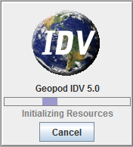
Geopod Quick Start Guide

1. Start IDV. To start IDV, double-click the shortcut on your desktop. As IDV starts, you will see a window appear with the IDV logo. If the Geopod plugin for IDV has been installed correctly, you will see the line "Geopod IDV <version number>" under the IDV logo. If not, you will need to reinstall the Geopod
plugin.

2. Select Data Source for Geopod to Use. Once IDV has finished loading, you will see several windows. Go to the one titled "Dashboard" and open the "Data Choosers" tab (see figure below). In the column on the left, under the entry for "General" you will see several options, including two: "Files" and "Catalogs" which you can use to find data sources.

o If you are using a local dataset provided by your instructor, choose "Files" and then navigate to the directory containing the file you want to use.
o To use a data source from an online collection, choose "Catalogs" and then locate the file you want to use from the lists provided.

Once you have found the data source that you want to use, select it (so that it is highlighted in blue) and then click the "Add Source" button at the bottom of the screen.

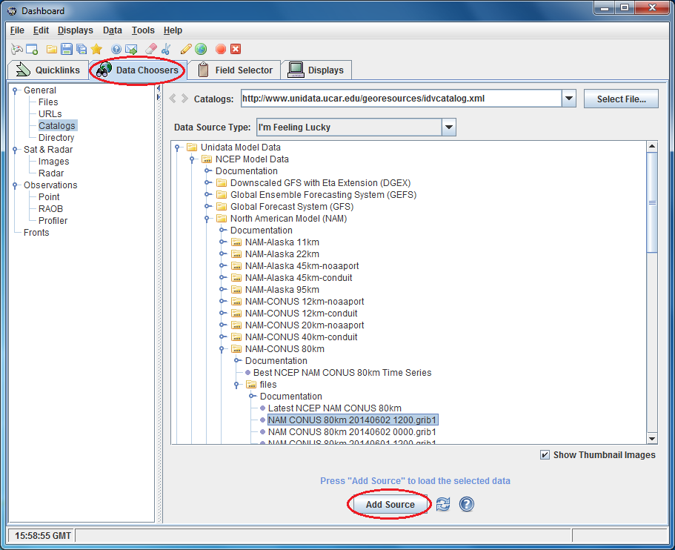
3. Load Geopod with an Isosurface. Once you have added a data source, IDV will automatically open the "Field Selector" tab for you (see figure below). Within this tab, the screen will be divided into three columns. On the far left you will see a column titled "Data Sources." In this column you will see the data source that you have just loaded. Make sure that there is only one data source listed. Using multiple data sources with Geopod will cause it to malfunction.

In the center column, titled "Fields", you will see the following entries: "2D grid" and "3D grid". Double- click the "3D grid" entry to expand it. You will see a list of the possible types of isosurfaces you can load (such as Absolute vorticity @ Isobaric surface, Geopotential height @ Isobaric surface, Relative humidity @ Isobaric surface, etc.).

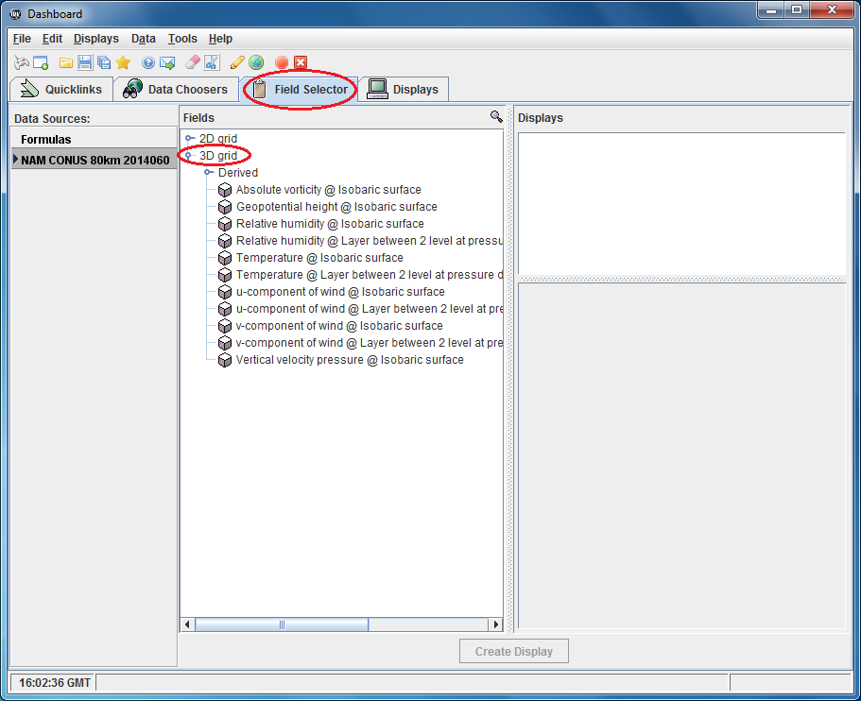
Select (click on) one of these isosurface types from the list under "3D grid". A list of options will now appear in the section titled "Displays" on the far right of the screen.

The first category in the list will be "3D Surface". It will be automatically expanded and its first entry, "Geopod", selected (highlighted in blue). You want to ensure this entry remains selected so that Geopod will load.

The second entry you should see is "Isosurface". Hold down the CTRL key on your keyboard and click on "Isosurface" to select it. Check to make sure that both the "Isosurface" and "Geopod" entries are now selected (highlighted in blue).

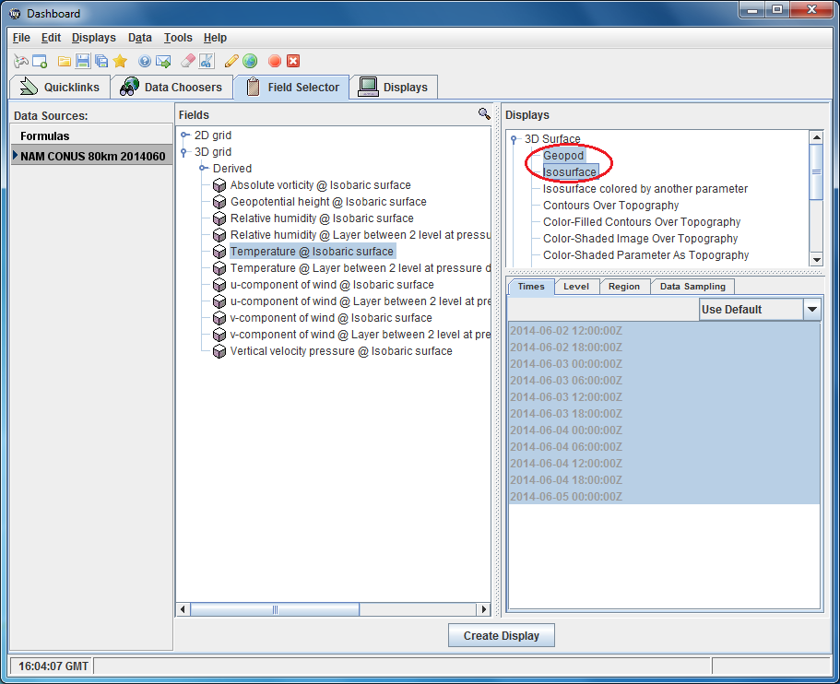
In the lower portion of the "Displays" section you will see a tab titled "Times" and a list of time values, all of which are selected (highlighted in blue) by default. On the right inside the "Times" tab you will see a dropdown menu which is set to "Use Default". Using the dropdown menu, choose the second option: "Use Selected".

Next you must select (click on) one of the time values from the list. You are now ready to start Geopod. Click the "Create Display" button at the bottom of the screen. The Geopod application should load within seconds.

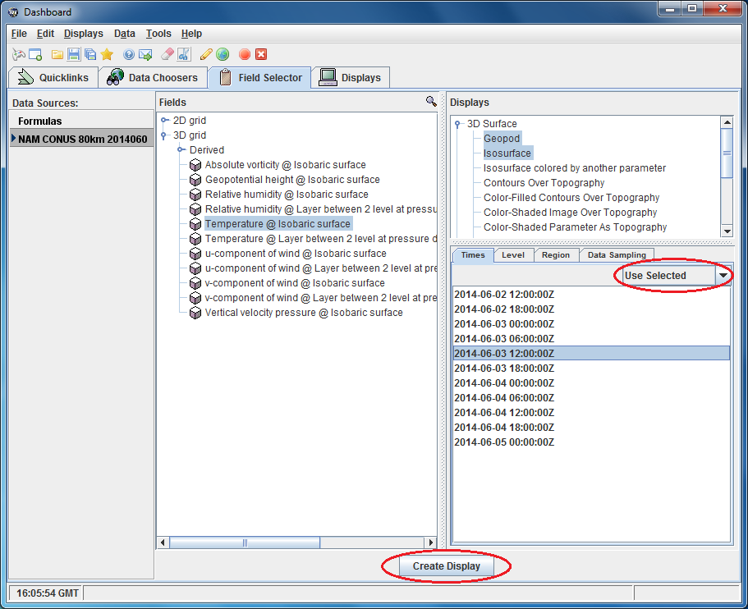

Troubleshooting

• Geopod loads but there is no isosurface
You probably didn’t have the "Isosurface" entry selected when you launched Geopod. To fix this, go to the "Field Selector" tab in IDV's "Dashboard" window. Under "3D Surface" select "Isosurface" but do not hold down the CTRL key. Ensure that just "Isosurface" and not "Geopod" is selected this time. Click the "Create Display" button; the isosurface should appear in Geopod.
• An isosurface appears in one of the IDV windows, but Geopod does not start
You probably didn’t have "Geopod" selected when you created the display. To fix this, go to the "Field Selector" tab in IDV's "Dashboard" window and select just "Geopod" from the list of entries. Now click the "Create Display" button. Geopod should load, along with the isosurface you had previously selected.

