Table of Contents

Introduction.....................................................................................................................p. 1

Using Geopod With IDV................................................................................................p. 1

The Geopod Interface.....................................................................................................p. 5

Navigating the Geopod...................................................................................................p. 9

Keyboard navigation functions...........................................................................p. 9

Mouse navigation functions................................................................................p. 10

Mini-map and Geocoding...................................................................................p. 11

Attitude indicator & Compass.............................................................................p. 11

Lat/Lon/Alt display.............................................................................................p. 11

Autopilot.............................................................................................................p. 11

Features...........................................................................................................................p. 13

Gridpoints...........................................................................................................p. 13

Isosurface Lock...................................................................................................p. 13

Noted locations & Notepad.................................................................................p. 14

Parameter Chooser..............................................................................................p. 15

Dropsonde Panel.................................................................................................p. 16

Distance Measurer...............................................................................................p. 17

Isosurface Display...............................................................................................p. 18

Flight Playback....................................................................................................p. 19

Controls...........................................................................................................................p. 19

Keyboard Controls……………………………………………………………..p. 20

Mouse Controls………………………………………………………………...p. 21

Introduction

Welcome to Geopod: Geoscience Probe of Discovery! Geopod is an interactive interface that allows you to explore a 3D world of real and reliable geophysical data, using Unidata’s Integrated Data Viewer software. You will be able to virtually travel to specific locations and record precise atmospheric data all from your computer. As an educational tool, Geopod will help increase and broaden your understanding of the atmosphere. This user’s guide explains the functionality of Geopod and how to navigate the interface.

Using Geopod with IDV

Geopod is a plugin for Unidata’s Integrated Data Viewer (IDV). You will need to install IDV and the Geopod installer before using it for the first time. Please see the Geopod website for instructions on how to do this.

Although you don’t need to have prior experience with IDV to use Geopod, you will need to be familiar with a few processes, such as loading data sources and isosurfaces. This section provides a general overview on how Geopod interacts with IDV. For step-by-step instructions on how to run Geopod, see the Geopod Quick Start Guide, available on the Geopod website.

Geopod allows you to visualize conditions in the atmosphere by flying through 3D isosurfaces and viewing the values of various atmospheric parameters at the Geopod's location inside the atmosphere. The data Geopod uses to determine the shape of the isosurfaces and the values for the parameters displayed comes from 1) a Data Source, loaded from IDV and 2) a time value, chosen from the ones available for that Data Source. Accordingly, to load Geopod from IDV you must first specify a Data Source and
then a time value. Although you typically load an isosurface along with Geopod, you may load an isosurface in IDV without loading Geopod, and you may load Geopod without an isosurface. The following sections will cover the three main operations you will need to perform in IDV: loading a data source, loading Geopod with an isosurface, and loading additional isosurfaces.

Loading a Data Source

Before you can load the Geopod plugin and begin exploring isosurfaces, you must first use IDV to specify the data source from which the meteorological data used to create the isosurface should be obtained. To do this you can use the "Data Choosers" tab inside the Dashboard window that appears automatically every time you run IDV. Inside this tab on the left you will see a list with several options and sub-options. Under "General" you can select "Catalogs" to find and load an online data set, or "Files" to use a local data set from your computer.
If you choose "Catalogs," a file structure, beginning with an entry for IDV Catalog, will be displayed on the right. By expanding the folders listed under IDV Catalog,
you can find a variety of different files that can be loaded as data sources in IDV. The majority of these are not designed to be used with Geopod. To use Geopod you must select a 3D gridded dataset which ends with a ".grib1" extension. In addition, we strongly recommend that you use a data source with a resolution of 80km or greater. Data sets with smaller resolutions are larger and take a long time to load. Depending on the memory available on your system, they may also cause IDV to fail with an "Out of Memory" error or make Geopod respond slowly.

Please note that Geopod is designed to display data from only one data source at a time. Although you can load several data sources in IDV, loading multiple data sources in IDV at any time before or while using Geopod may cause the Geopod application to behave strangely or produce errors, even after the additional datasets are removed.

Once you have selected an appropriate data source, load it by clicking the "Add Source" button at the bottom of the "Data Choosers" tab. The "Field Selector" tab will open automatically so you can proceed to the next step.

Loading Geopod with an Isosurface

This step assumes you have already loaded exactly one data source (see the above section for instructions).

Under normal conditions, you will always want to use Geopod with at least one isosurface. So before you can load Geopod, you must select an appropriate field from which you can load a 3D isosurface. Fields available for a data source are listed in the "Fields" section under the "Field Selector" tab.

The "Fields" section is usually divided into "2D grid" and "3D grid." Since Geopod is intended for visualizing 3D data only, you will want to use just the entries that are found by expanding "3D grid." This includes the entries immediately under "3D grid" as well as some of the entries under the sub-heading "Derived." There is an easy way to tell if a particular field is compatible with Geopod. When you select (click on) a field entry, a list of options will appear under the "Displays" section on the right-hand side of the screen. If this list of options contains a "3D Surface" entry, and the "3D Surface" entry, when expanded, contains an option titled "Isosurface," then the field can be used with Geopod.

Once you have selected a compatible field to use for your first 3D isosurface, you will need to select from the "Displays" section both the "Geopod" entry (this will be the first entry in the list of options, which is automatically selected), and the "Isosurface" (or "Isosurface colored by another parameter") option under the "3D Surface" category. Holding down the CTRL key while clicking will allow you to select multiple options from the "Displays" section.
Before proceeding, we recommend you check to make sure that both "Isosurface" (or "Isosurface colored by another parameter") and "Geopod" in the "Displays" section are selected. If the "Isosurface" option is not selected, Geopod will still load, but no isosurface will be displayed. In this situation, refer to the section below for instructions on adding isosurfaces after Geopod is already running. If on the other hand the "Geopod" option is not selected, the isosurface will load in IDV, but the Geopod application will not run. In this case, you will need to repeat the steps in this section, but this time select only "Geopod" and not "Isosurface" from the "Display" section.

The final step before loading Geopod is to choose a single time value for which the parameter data and isosurface will be created. To do this, use the "Times" tab located below the "Displays" section in the lower right-hand corner of the window. Uncheck the "Use Defaults" box and select the desired time from those listed.

When you are ready to load Geopod, click "Create Display." The Geopod application window will appear in a few seconds.

Loading Additional Isosurfaces

Adding an additional isosurface after Geopod is running follows much the same process used to load Geopod with the original isosurface. You will first need to open the “Field Selector” tab in IDV’s Dashboard window. Clicking the “ADD NEW ISOSURFACE” button in Geopod’s Isosurface View panel (which may be accessed by clicking the “ADD NEW ISOSURFACE” button), will take you there automatically. In the "Fields" section under "3D grid," select the field/parameter you would like to use for the additional isosurface. As with your initial isosurface field, make sure this field is compatible with Geopod by ensuring that it contains an "Isosurface" entry under "3D Surface" in the "Displays" section. Select either the "Isosurface" or "Isosurface colored by another parameter" option under "3D Surface." Ensure that the "Geopod" entry at the bottom of the "Displays" section is no longer selected.

If you already have one or more isosurfaces loaded in Geopod and are adding another isosurface, make sure that you keep the same time value you originally selected under the "Times" tab in the bottom right hand corner of the screen. Atmospheric conditions change for different time values. If you load an isosurface from a different time, the conditions it reflects may be inconsistent with those used for Geopod's parameter display.

When you are finished, click the "Create Display" button at the bottom of the screen to load the new isosurface.

Please note that loading multiple isosurfaces in Geopod will affect how the grid points feature behaves. See the “Gridpoints” entry under “Features” for more details.
The above sections cover all the interaction you will need to have with IDV in order to use Geopod. Once you have successfully loaded Geopod and any additional isosurfaces, you should not need to use IDV for anything else. Although some features of IDV, such as the ability to change the value or color of an isosurface or the type of map that is displayed in the background, are completely compatible with Geopod, many are not. In general, using IDV to load other data sources or create other displays (except additional
3D isosurface displays as described above) will cause the Geopod application to behave erratically or fail, so use extreme caution when using other IDV features with Geopod.

The Geopod Interface

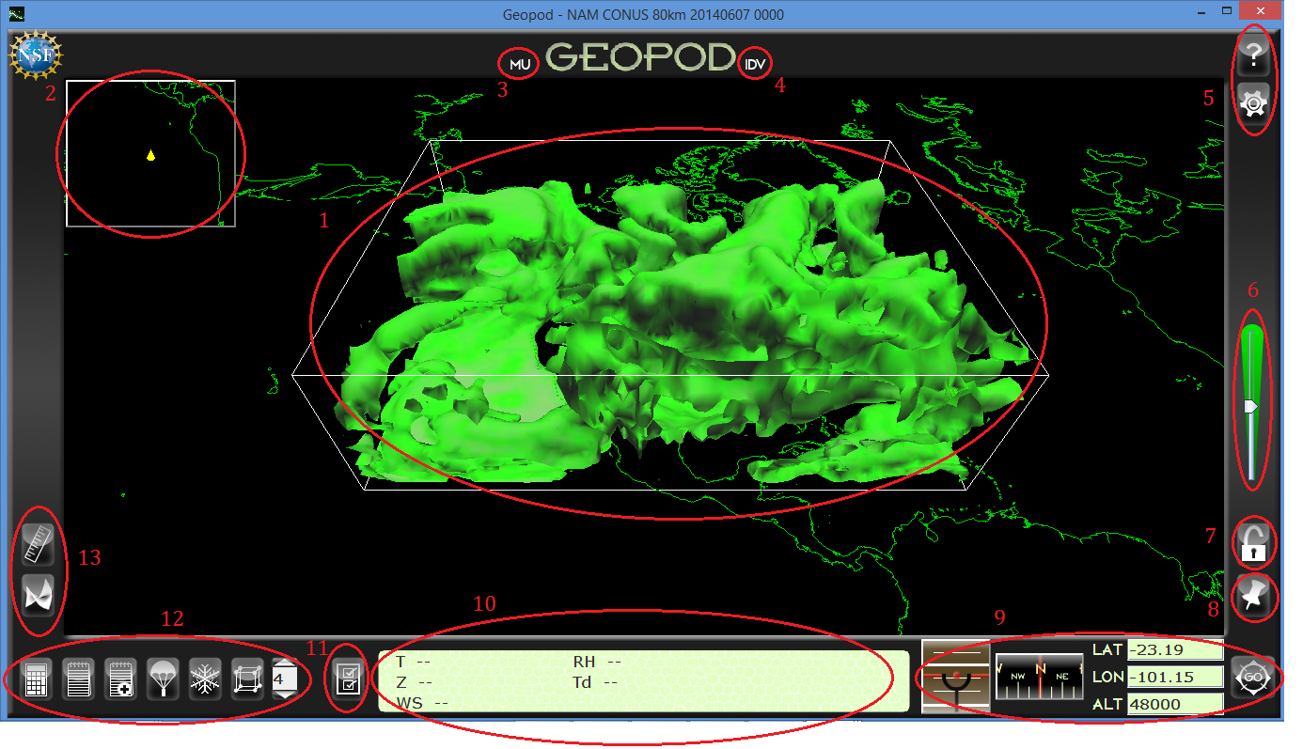

1. Data Volume

The data volume contains the data used to create the isosurface. The Geopod will sample parameters from the data volume as you move within it.

2. Mini-map

The Mini-map shows the location of the Geopod on the world map. The Geopod is represented by a yellow marker.

3. Millersville University Button
Loads the Millersville University page in your web browser.

4. IDV Button

Click the “IDV” button to toggle (hide or show) the display of IDV 
windows.
5. Help and Settings

a) Help Button

You can bring up a help page at any time by clicking the help button in the upper right-hand corner of the screen. The help page contains a complete list of all key controls, as well as information about Geopod and some useful resources.



b) Settings Button

Allows you to change advanced user-specific settings that control how the Geopod behaves.

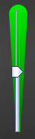
6. Speed Control

Allows you to increase or decrease the speed at which the Geopod moves.

7. Lock Button

This allows you to lock onto an isosurface. Please see the “Isosurface


Lock” section under “Features” for more details.

8. Geocode Button

This button opens the lookup panel, which will display the Geopod's geographic location. If no city, state, or country can be found for the Geopod's current location, "No Address Found" will be displayed. To fly


to a specific location, such as Millersville, PA, type the location into the textbox and click "Look Up". This will put the latitude and longitude of the location in the Lat and Lon boxes. You can then press “GO” to fly there using the autopilot.

9. Navigation Panel

a) Attitude Indicator

Measures the roll and pitch of the Geopod. The red line indicates the roll and the distance from the ball to the white line dividing the blue and brown areas indicates the pitch. Please see the “Attitude Indicator and Compass” section under “Navigating the Geopod” for more details.
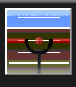

b) Compass

The compass shows the heading of the Geopod.
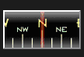

c) Lat/Lon/Alt Display

Displays the current latitude, longitude, and altitude of the Geopod.
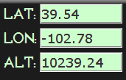

d) Go Button

Click to fly to a specified destination using the autopilot. See


"Navigating the Geopod" for more information.

10. Parameter Display

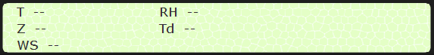
The parameter display area can display up to 9 different parameters on a 3x3 grid. Some of the default parameters are temperature (T), geopotential height (Z), wind speed (WS), relative humidity (RH), and dewpoint (Td). You can move parameters within the parameter display area by dragging and dropping them.

11. Parameter Chooser

Click the parameter chooser button to choose which parameters you wish to display. Please see the “Parameter Chooser” section under “Features” for more details.


12. Primary Buttons

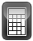
- Calculator

Opens the calculator.

b) Notepad

Displays the notepad. Please see the “Noting Locations and Notebook”
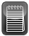

section under “Features” for more information.

c) Add Note

Note the Geopod’s current location. Please see the “Noting Locations and


Notebook” section under “Features” for more information.
d) Dropsonde

Displays the dropsonde panel which allows you to launch, view, or remove dropsondes. See "Dropsonde Utility" under "Features" for more information.
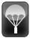

e) Particle Imager

Displays the particles which could form in the atmosphere given the conditions at your current location. Click on the image to cycle through all available particles.
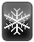

f) Grid Point Selector and Density Selector

Displays grid points and allows you to adjust the density of grid points displayed. Please see the “Grid points” section under “Features”.
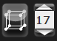

13. Primary Buttons Cont.

a) Distance Measurer

Displays the distance measurer, which allows you to determine the Geopod's distance from another location. Please see the "Distance Measurer" section under "Features" for more information.


b) Isosurface Display

Displays a list of the currently loaded isosurfaces and allows you to change their values or remove them. See "Isosurface Display" under "Features" for more information.
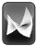

Navigating the Geopod

The Geopod is a probe which allows you to immerse yourself in the 3D data volume. When you use Geopod, you can think of yourself being at a certain location inside the 3D world that you see on the screen. Using any one of various navigation controls, you can move the Geopod inside this world. When you move, you will see the image on your screen change, but that is because you, in the Geopod, are moving, much as buildings appear to fly past you when driving a car. Your navigation controls allow you to move the Geopod within the world, not alter the world or the data volume itself. All of your controls will be relative to the Geopod's position and orientation within this 3D world. For example, moving "up" will increase your altitude if you are level with the earth's surface, or move you across the surface if you are above the earth looking down. We suggest you use your right hand to move the mouse while keeping your left hand positioned over the w, s, a, and d keys on the keyboard.

Keyboard Navigation Functions

The four main navigation keys are w, s, a, and d. The w key moves the Geopod forward, in whatever direction it is facing. The s key moves the Geopod backward. The a key moves the Geopod to the left. The d key moves the Geopod to the right.

The f and c keys move the Geopod up and down, respectively. What moving "up" or "down" does in relation to the 3D world depends on the Geopod's orientation. If the Geopod happens to be level with the earth's surface, these keys will change the distance of the Geopod from the surface. Regardless of how the Geopod is situated in the world, f will always allow you to go up to see the things just above the top of your screen, and c will always allow you to go down and see what is just below the bottom of your screen.

D (right)

F (up)

S (back)

W (forward)

C (down)
A (left)

You can change the speed at which the Geopod moves when the w, s, a or d keys are pressed using the -- and + (Shift not needed) keys or the speed control located along the right hand side of the screen. To change the speed, simply press one of these buttons (you may need to press repeatedly to see a noticeable difference in speed) or drag the slider on the speed control.

To make the Geopod level with the earth's surface, press the space bar. This will automatically rotate you so that you are level.

In order to look to the left or right while remaining stationary, press the q and e buttons. The q button will allow you to the look to the left and the e button will allow you to look to the right. Continuously pressing one or the other will rotate you in a complete circle.

To change the speed at which you rotate when q and e are pressed, use the < and > keys (again, you don't need to use the shift key). You may need to press them several times for your rotation rate to be noticeably faster or slower.

The r key will reset the Geopod to its original starting position, facing North and tilting slightly downward to view the data volume. To view the data volume from a top-down perspective, press the t key, which will orient the Geopod so that it is centered above the data volume and facing downward.

Mouse Navigation Functions

You can rotate the Geopod using the right and left mouse buttons. Clicking and dragging with either mouse button will allow you to rotate the Geopod in the direction you drag. The data volume will appear to move in the opposite direction -- this is because you are turning away from it. If you use the left mouse button, the distance that the Geopod rotates will depend on the distance you drag. The farther you drag the mouse across the screen, the farther the Geopod will rotate in that direction. Using the right mouse button allows you to rotate continuously for as long as you hold the mouse button down. The speed at which you rotate depends on the distance you have dragged the cursor. The direction you rotate depends on where your cursor is relative to where it was when you first pressed the mouse button. For example, if you press the right mouse button while the cursor is in the center of the screen and then drag to the right, the Geopod will rotate to the right, increasing in speed the farther you drag. If you drag the cursor back to the left, your rate of rotation will slow and eventually stop as you reach the center of the screen. If you continue to drag to the left, the Geopod will then begin rotating in that direction.

The scroll wheel causes the Geopod to roll, that is, tilt to the right or left side while still facing the same direction. This functionality will only work if roll is not disabled. By default, Geopod disables rolling to make navigation easier. You can change this behavior and allow rolling by changing the "Disable Roll" property to "Off" under Settings.

The Geopod interface also provides several tools to help you determine where you are inside the 3D world, and how you are oriented (which way you are facing, whether you are level or tilted, etc.).
Mini-map and Geocoding

The mini-map in the upper left-hand corner of the screen shows where the Geopod is using a top-down view of the earth's surface. The yellow triangle also shows you what direction the Geopod is facing. Flying forward (using the w key) will cause the Geopod to move in the direction that the triangle is pointing. If you want to know what specific geographic location the Geopod is currently over, just use the Geocode button (see description in interface overview).

Attitude Indicator and Compass

The attitude indicator measures the roll (side to side tilt) and pitch (facing downward or upward) of the Geopod relative to the earth's surface. The red line indicates the roll of the Geopod and the red ball is used to determine pitch. The blue section represents the sky (upward pitch) and the brown section represents the ground (downward pitch). For example, when the ball is in the brown portion, it means that the Geopod is flying towards the ground. The farther the ball is from the dividing line the greater the pitch. If the red line and the white lines on the indicator are parallel, then the Geopod is upright and not tilted to either side. If the red line is exactly on the white line dividing the blue and brown portions of the indicator, then the Geopod is level with the surface. (If you want to make certain the Geopod is perfectly level and upright, use the space bar). The blue area on the indicator should generally be above the brown area. If this is reversed, then the Geopod is upside-down.

The compass indicates the heading of the Geopod using standard directions: North, Northeast, etc. This will correspond to the direction the yellow triangle is pointing in the mini-map. Like any compass, this one may behave erratically if the Geopod is facing straight down.

Lat/Lon/Alt Display

The Lat, Lon, and Alt boxes in the lower right hand corner display the Geopod's current location (except in a few special cases, which will be described later). Latitude is measured in degrees from the equator; valid latitude values can range from
90 to -90 (north and south poles), exclusive. Longitude is also measured in degrees and can range from -180 to 180. Altitude is typically measured in meters, but it varies depending on the dataset. These values will continuously update as you fly.

In addition to manual navigation, the Geopod interface provides the ability to fly to any location you wish using the autopilot feature.

Autopilot

To use the autopilot, simply enter your destination into the Lat, Lon and Alt fields, then press Enter or click the Go button. The latitude and longitude you enter must be within the valid ranges given above, and the altitude value must be positive. If you
enter an invalid value, the field will turn red and the Geopod will not move. Once you engage the autopilot, it will fly the Geopod directly to the specified location. For example, if the location you entered is behind the Geopod, it will fly backwards to get there. Reverse geocoding (location lookup) and gridpoint selection also use the autopilot, but will automatically enter a location into the Lat/Lon/Alt boxes for you. See the sections on these functions for specific details.
Features

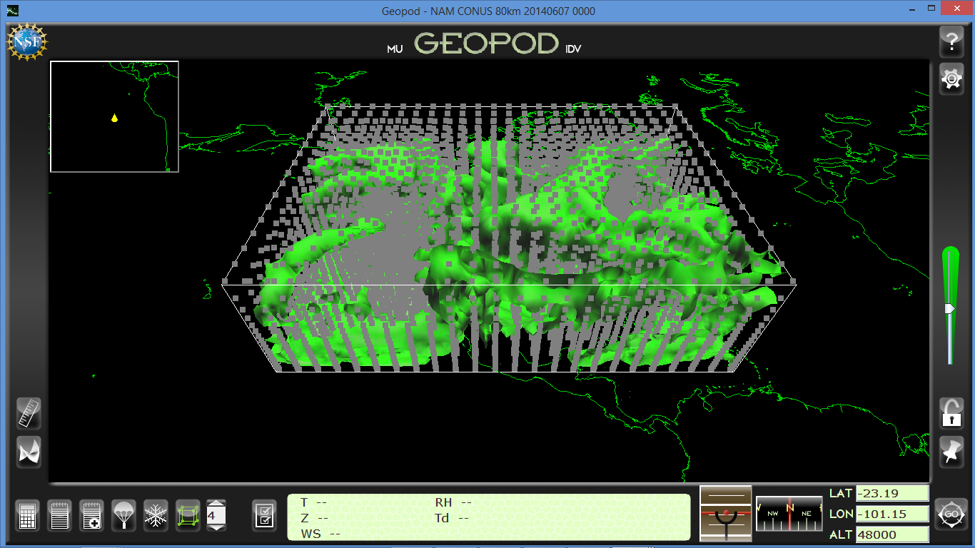
Grid points:

The isosurface you can view with the Geopod is created by interpolating data from many points inside the data volume. To view these points, you can click the grid points button or press the g key. While the points are displayed, the button will be green . To hide the grid points, click the grid points button again. The number to the right of the grid points button indicates the density of grid points to be displayed. A density of 20 means that every 20th grid point is displayed. You can use the up and down arrows above and below the box to change the grid point density.

To sample data at a specific grid point, first click on the grid point to select it. The grid point you have selected will become red. If you have difficulty selecting a grid point, it may be partially obscured by another grid point; move the Geopod slightly and try again. When you select a grid point, its latitude, longitude,
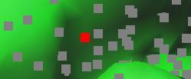

and altitude will be automatically entered in the Lat, Lon, and Alt boxes in the navigation panel. To fly to the grid point and see parameter values there, click the GO button.

Grid points depend on the data for a particular isosurface parameter, and may be different for isosurfaces with different parameters, even for the same time value. Although Geopod can display multiple isosurfaces, it is only capable of displaying one set of grid points at a time. So if multiple isosurfaces having different grid points are loaded, the points shown will not be accurate for all surfaces. Therefore, we recommend that you avoid using the grid points feature while multiple isosurfaces are loaded.

Isosurface Lock:

The Isosurface Lock allows you to lock onto and fly along an isosurface. To enable the isosurface lock, click the lock button on the right-hand side of the screen, or press the l (lowercase L) key. The lock button icon will become a closed, green lock when the isosurface lock is enabled. While the lock is enabled, you will


become locked on the surface if you fly within the data volume. You will still be able to navigate across the surface, but will not be able to move vertically or use the autopilot. To unlock from the surface, click the lock button or press l again. While you are locked
onto the surface, the path you travel will be painted in yellow. You can clear your path from the surface by pressing i.

Noted Locations and Notepad:

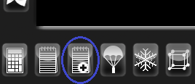
The "Note Location" feature allows you to save information about the Geopod's current location. When you note a location, all current parameter values, along with the geopod's current latitude, longitude, and altitude and, optionally, a
comment that you enter, will be entered in the Notepad, where they can later be viewed, edited, or saved. To note the geopod's current location, press n or click the Note Location button in the lower left-hand corner of the screen.

A panel will appear prompting you for a comment to enter along with this location and parameters. You don't need to enter a comment, but it may help you remember later why you noted this location. Type a comment in the text box if you wish, then click "Save Parameters" or press Enter to note the location
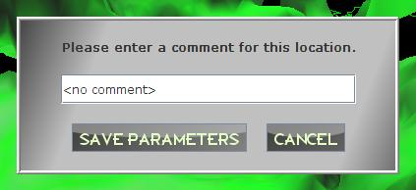

An entry like the following will be added to your Notepad:
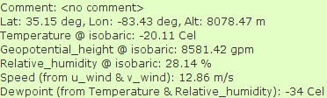

The Notepad allows you to view and edit your noted locations, as well as enter notes yourself. To open the notepad, click the Notepad button, which is just to the left of the Note Location button in the lower left-hand corner of the screen, or press Ctrl-n. You can save your noted locations, or any notes you have made yourself, by clicking "SAVE". The first time you save your noted locations, you will need to enter a file name where your notes will be saved, afterwards, the file name will be displayed at the top or your notepad, and clicking "SAVE" will save the notes to that file.

Your notes will be saved as a text file (the file
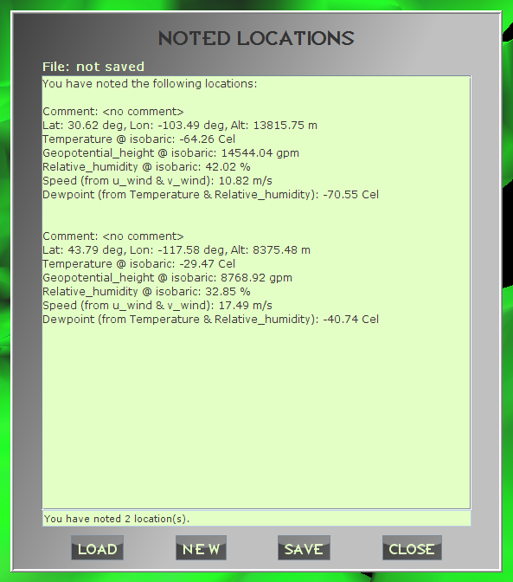

extension will be “txt”); you can open previously saved notes, or any “.txt” file, by clicking "LOAD" and selecting that file, then choosing "open". To get a new, blank page for notes, click "NEW". You can close and open the Notepad without losing your notes, but they will be lost if you exit Geopod without saving them first.

Parameter Chooser:

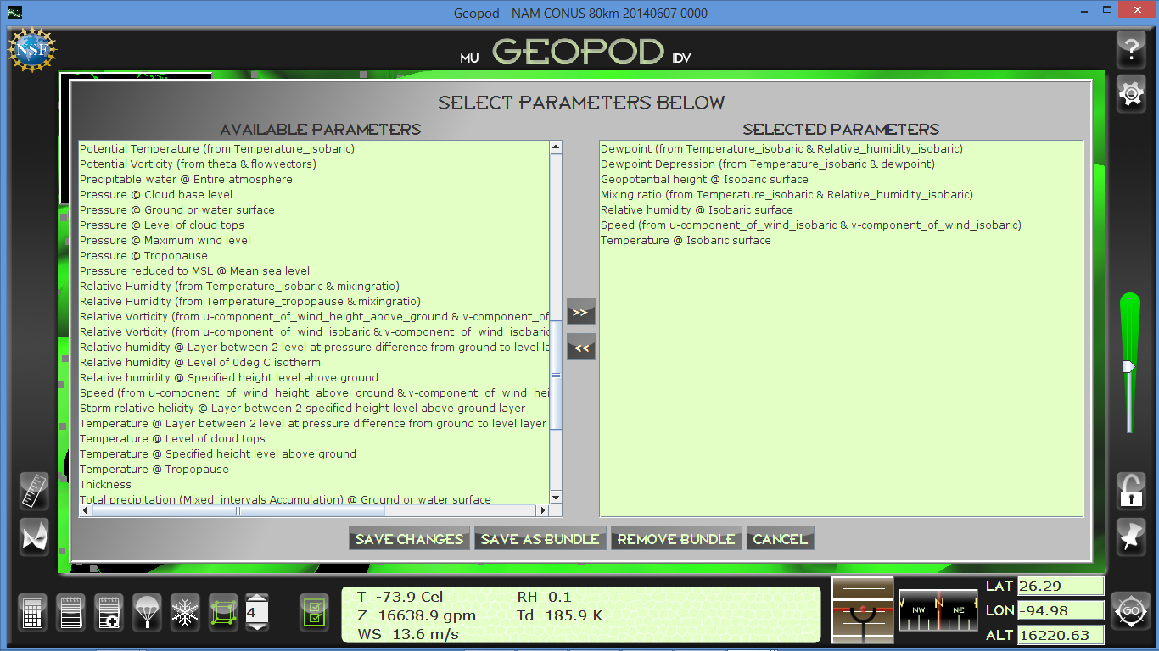
The parameter chooser allows you to choose which parameters you would like to see in the


parameter display panel. To display the parameter selection window, click the parameter chooser button to the left of the parameter display panel on the bottom of your screen or press the p key. The parameter chooser button will turn green after being clicked and the
parameter selection window will appear on screen.

To move a parameter to the parameter display panel, click on the desired parameter under the “Available Parameters” column. The selected parameter will then be highlighted. Once highlighted, click the right-facing arrow and the selected parameter will appear under the “Selected Parameters” column.

To remove a parameter from the parameter display panel, click on the desired parameter under the “Selected Parameters” column. The selected parameter will then be highlighted. Once highlighted, click the left-facing arrow and the selected parameter will be removed from the "Selected Parameters" column and appear under the “Available Parameters” column.

Once you are finished choosing your desired parameters, you can click the “Save Changes” button at the bottom of the parameter selection window. Once you save changes, the parameter selection window will close and the chosen parameters will appear in the parameter display panel. If you have loaded more than 9 parameters, the remainder (up to 10 more) will be displayed in the overflow panel, which will appear in the left-hand corner of the screen. You can drag and drop parameters back and forth between the parameter and overflow panels. If you later remove all of the parameters from the overflow panel, it will automatically disappear. To display or hide the overflow panel manually, press the o key.

You also have the option of saving multiple parameters as a bundle, which will save your parameter preferences and data set for all subsequent sessions. With the desired data set loaded and the parameters you want listed under the "Selected Parameters" section, click
the “Save Bundle” button to save as a bundle. This bundle can be removed using the
“Remove Bundle” button.

Dropsonde Panel:

Geopod allows you to launch dropsondes, which give you a vertical profile for your current latitude and longitude, provided you are inside the data volume. It also
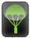

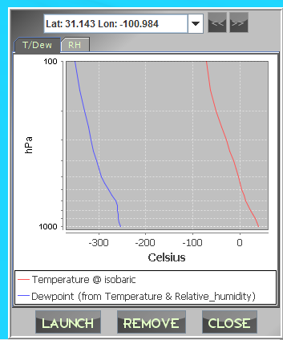

keeps track of all the dropsondes you have launched since you opened the Geopod, unless you choose to remove them. To launch, view, or remove dropsondes, you must open the Dropsonde panel by clicking the Dropsonde button in the bottom right-hand side of the screen or pressing Ctrl-Shift-d. If you have not launched any dropsondes yet, the Dropsonde panel will be empty except for the buttons at the bottom. To launch a dropsonde, first ensure that you are inside the data volume, then click “LAUNCH.” Up to three tabs with different graphs will appear, depending upon which
parameters you have loaded. A graph of temperature vs. pressure and/or dewpoint vs. pressure will appear in the tab marked T/Dew. The Temperature @ isobaric parameter must be loaded for temperature to be displayed on the graph, and the Dewpoint (from Temperature & Relative_humidity) parameter must be loaded for the graph of dewpoint to be displayed (see the section on the Parameter Chooser for details on how to load parameters). If neither parameter is loaded, the T/Dew tab will not appear. A second tab titled RH, containing a graph of relative humidity vs. pressure, will appear if you have loaded the Relative_humidity @ isobaric parameter. In addition, a third tab titled Wind may also appear. This tab will contain a graph of u_wind vs. pressure if the u_wind @ isobaric parameter is loaded, and a graph of v_wind vs. pressure if the v_wind @ isobaric parameter is loaded. If neither parameter has been loaded, this tab will not appear. By default all of the graphs produced for the dropsondes show some parameter plotted against pressure. You can see these parameters plotted against altitude instead by changing "Chart Domain Unit" to "Altitude" under Settings.

When you launch a dropsonde, the latitude and longitude from which it was launched will appear above the graphs. This will help you distinguish among your dropsondes, should you eventually launch several. Whenever you launch a new dropsonde, its graph will be displayed. If you want to see previously
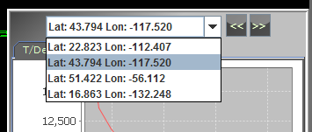

launched dropsondes, you can cycle through them with the "<<" and ">>" buttons located to the right of the latitude/longitude display. The "<<" button will take you back through the dropsondes until you reach the oldest one; the
">>" button will take you forward again until your most recently launched dropsonde is displayed. You can also select a dropsonde from the list that appears when you click the small arrow to the right of the latitude/longitude display. The oldest dropsonde will appear at the top of the list and the most recently launched one will appear at the bottom. The currently displayed dropsonde will be highlighted in blue; to display a different one from the list, just click on it.

If you no longer want to have a particular dropsonde saved in your list, you can easily remove it. Whatever dropsonde is currently displayed can be deleted by clicking the "REMOVE" button located below the chart; it will be removed from the list and the next dropsonde (if you launched more than one) will become visible.

To close the dropsonde panel, click "CLOSE" or click the Dropsonde button again. Your list of launched dropsondes will be saved for the duration of your session and will remain even if you close the panel, but they will be lost when you exit Geopod.

Distance Measurer:

The Distance Measurer allows you to determine the distance between the Geopod and a fixed starting point. To open the Distance Measurer, click the Distance button on the left-hand side of the screen or press Ctrl-d. The distance panel will appear in the top center of your screen. The lat, lon and alt of the fixed starting point will
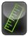

be displayed on the left-hand side of the window, and the distance in kilometers from the starting point to the Geopod's current position will be displayed in the bottom right-hand corner of the window. Note that the Distance Measurer displays not the total length of the path flown by the Geopod, but the straight-line distance between the Geopod and the starting point. The distance shown in the distance panel will update continuously as the Geopod flies.

By default, the fixed starting point is set to be the Geopod's initial position above the data volume. To enter your own starting point, click "SET." In the pop-up window that appears, enter your desired lat, lon and alt, then click "SAVE." The distance displayed will update to reflect the new starting location.
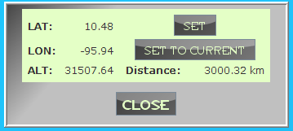

You can also set the starting position to be the Geopod's current position by clicking the "SET TO CURRENT" button. The distance panel will automatically update to reflect the new distance of zero. This feature allows you to conveniently measure how far you have flown from where you were previously.

To close the distance panel, click the "CLOSE" button at the bottom of the panel. The Distance Measurer will remember the starting location after you close the panel, but it will be reset if you shutdown and restart Geopod.

Isosurface Display:


The Isosurface Display panel allows you to manage all of the isosurfaces that are displayed in Geopod. To open the Isosurface Display Panel, click the Isosurface button on the left-hand side of the screen or press Ctrl-i. You will see a list of all currently loaded isosurfaces. Each isosurface entry indicates the parameter for the
isosurface and what value of this parameter the isosurface is showing.

To change the value at which an isosurface is displayed, click the "CHANGE" button next to that isosurface entry. A "Change Isovalue" window will appear with a text field where you can enter the new isosurface value. When changing the isosurface value, you must ensure that it stays within a certain range determined by the isosurface parameter.
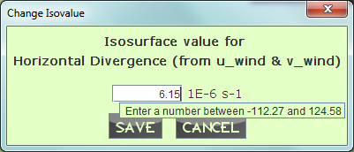

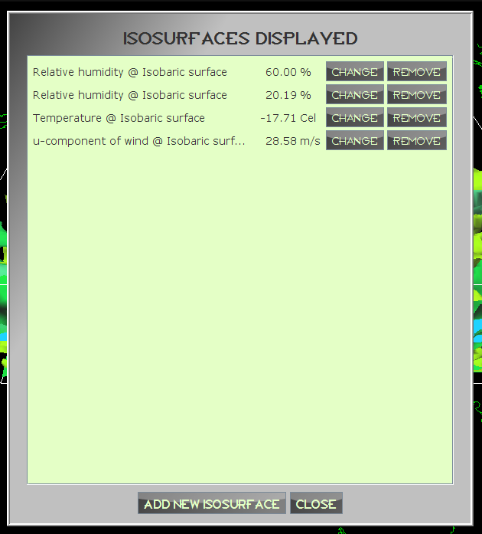
For example, the value an isosurface of Relative humidity @ Isobaric surface must be between 0% and 100.38%. If you hover over the isosurface value text field in the "Change Isovalue" window, you will see a tool tip with the range of values allowed for that particular isosurface. Once you have entered a valid value, click "SAVE" to update the isosurface.

You can also use the Isosurface Display Panel to remove any of the isosurfaces displayed. To remove an isosurface, just click the "REMOVE" button next to that surface's entry.

To display a new isosurface in Geopod, you will need to load it in IDV. Click the "ADD NEW ISOSURFACE" button at the bottom of the Isosurface Display panel. This will bring up the IDV Dashboard's "Field Selector" tab, where you can add the new isosurface. Follow
the instructions for adding multiple isosurfaces given in the Using Geopod with IDV section.

Flight Playback:

By default, Geopod records the path you travel and the locations at which you use particular devices. You can turn recording off and/or clear your flight record under Settings. When a flight record exists, you can use the “Flight Playback” option to replay (fly back through) the Geopod’s most recent flight. You can initiate the flight playback by pressing CTRL-h. To pause/resume the flight playback, press the j key. To stop the flight playback, press the k key.

Notifications will be displayed to show you where you launched a dropsonde, used the particle imager, encountered a particular particle formation category, or noted a location. Flight playback will move the Geopod back along its previous flight path, so it will display current parameter data and position information from the flight. Stopping flight playback will reset the Geopod to its starting position.
Controls

Keyboard Controls:

Action | Key
Move Forward | w
Move Backward | s
Move Left | a
Move Right | d
Move Up | f
Move Down | c
Rotate Left | q
Rotate Right | e
Roll Clockwise | Q (Shift-q)
Roll Counterclockwise | E (Shift-e)
Accelerate | = (Equal sign)
Decelerate | - (Minus sign)
Angular Accelerate | . (Period)
Angular Decelerate | , (Comma)
Lock to Surface | l
Reset Pose | r
Topdown View | t
Make Upright | <space>
Lookup Location | Ctrl-/ (Ctrl-forward slash)
Parameter Display | Ctrl-p
Overflow Display | o
Distance Measurer | Ctrl-d
Note Location | n
View Note Panel | Ctrl-n
Toggle Particle Imager | p
Open Dropsonde Panel | Ctrl-Shift-d
Reset Isosurface Colors | i
View Isosurface Display | Ctrl-i
Display/Hide Gridpoints | g
Mission Panel | m
Settings Manager | Ctrl-s
Play Back Flight Path | Ctrl-h
Pause/Resume Flight Path Playback | j
Stop Flight Path Playback | k
Open System Calculator | Ctrl-c
Help | / (forward slash)
Exit Geopod | <escape>

Mouse Controls:

Left Button | Hold while dragging the mouse to  yaw/pitch.  The rotational angle is proportional to the drag distance.
Right Button | Hold while dragging the mouse for  continuous yaw/pitch.  The rotational speed is proportional to the drag distance.
Wheel | Roll ("Disable Roll" property under  Settings must be set to off.)

