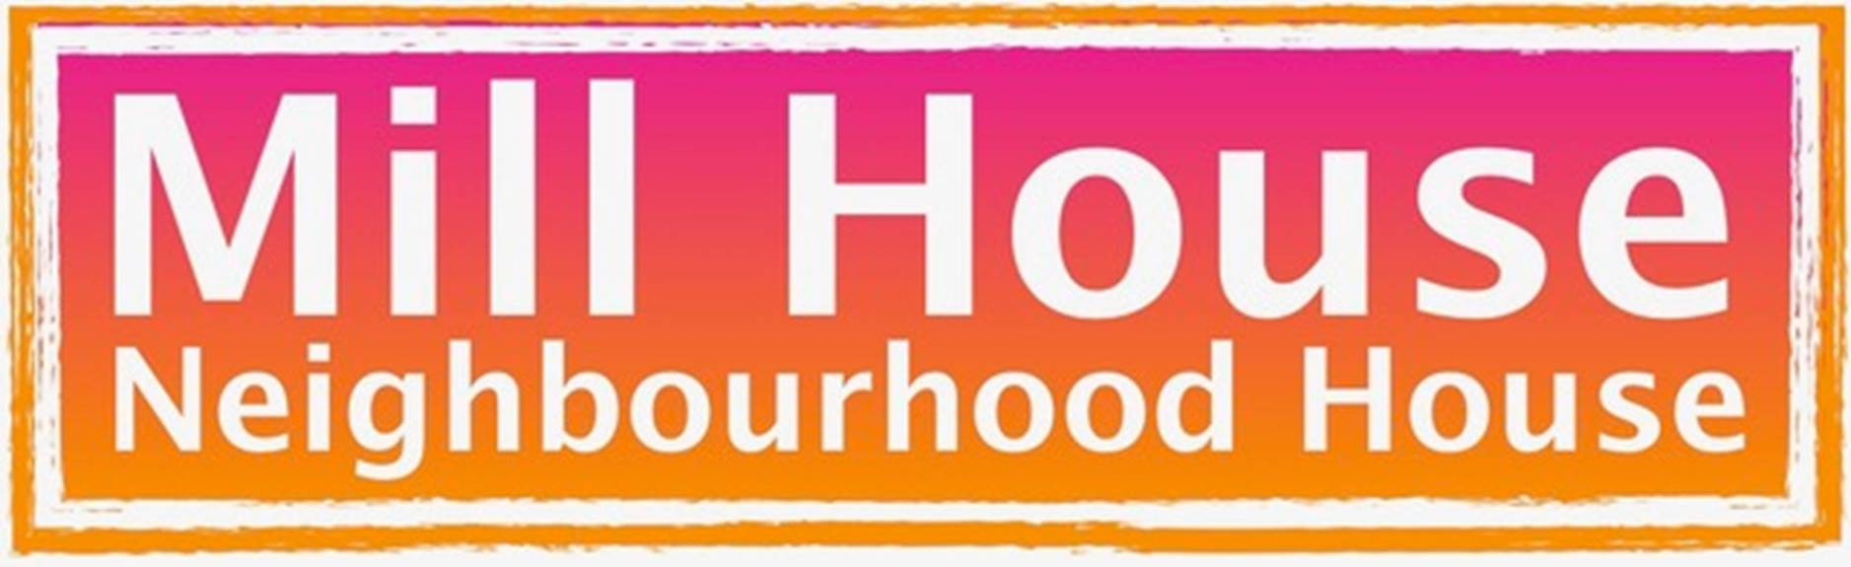
REQUEST FOR CHANGE TO WEBSITE

PAGE CONTENT

PAGE NAME

xxxxxxxx

CURRENT CONTENT
Sample content only...

Welcome to Mill House
A welcoming community space in the heart of Maryborough.

NEW CONTENT
Sample content only…
H1 means

Heading1: Who We Are
WELCOME TO MILL HOUSE

A welcoming community space in the heart of Maryborough.
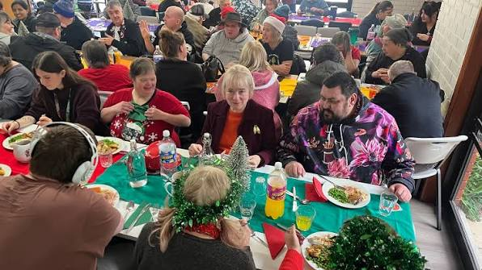
Mill House Neighbourhood House is a place where people come together, connect and belong. We provide a friendly, inclusive space for people of all ages and backgrounds to meet others, share skills, enjoy activities, access support and take part in community life.
As a local community organisation and charity, Mill House is here for everyone — whether you want to make new friends, learn something new, volunteer your time, enjoy a meal, join an activity, access community services or simply drop in for a chat.
We believe strong communities are built on connection, participation and looking out for one another. Mill House provides opportunities for people to contribute, build confidence, develop skills and feel part of the Maryborough community.

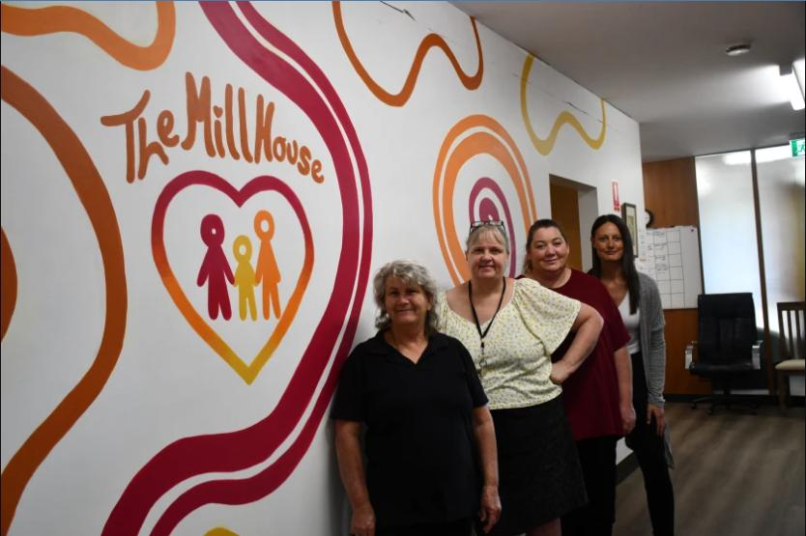
We bring people together, provide practical support and create opportunities for people of all ages and backgrounds to connect, learn and participate. And we provide practical support for individuals and families across the Central Goldfields.
Everyone is welcome at Mill House, regardless of age, ability, background or circumstances.
Our aim is to help people feel connected, supported and involved in their local community.
Come in, get involved and be part of Mill House.

NAVIGATION STRUCTURE
Sample only…

NEW PAGE

PAGE NAME
About

CONTENT

Heading 1: Mill House Activities and Services
Mill House offers a wide range of affordable activities, social groups and support services for people of all ages and abilities.
Whether you are looking for food support, a welcoming place to meet new people, help accessing services or an opportunity to learn something new, there is a place for you at Mill House.

Heading 1: Helping Put Food on the Table

Heading 2: 24/7 Community Food Pantry
Our Community Food Pantry is available 24 hours a day, seven days a week. Members of the Central Goldfields community can access free food and essential items that have been generously donated by local businesses, organisations and community members.
We ask everyone to read the guidelines displayed on the pantry and only take what they need so there is enough to share with others.
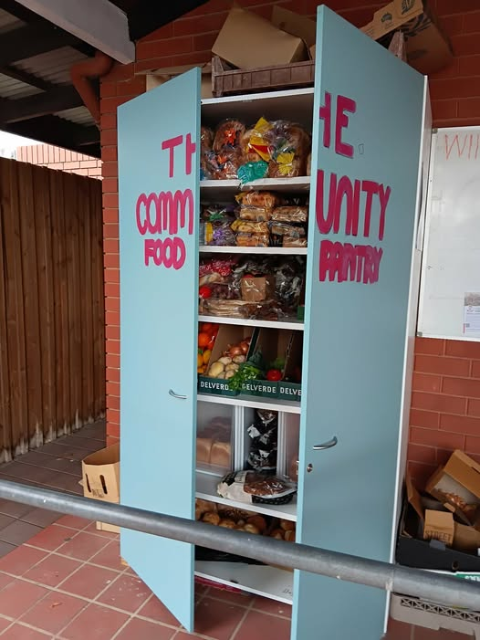

NEW SUBMENU
Sample only…

NAME
What we do

SUBMENU ITEMS / NEW WEB PAGES
- Digital hub
- Food relief
- Emotional support
- Youth

