INTRODUCTION
1.Background
Credit card fraud has become one of the major financial threats in the world with the rapid growth of digital transactions. Every minute, millions of online payments are processed, and thus, manual fraud detection can hardly be done. The traditional rule-based systems were not efficient as the fraud patterns continue changing.
Therefore, there is an increasing need for intelligent and automated fraud-detection systems that can identify suspicious transactions both quickly and accurately.

2. Importance of Machine Learning in Fraud Detection
ML algorithms automatically learn hidden patterns within large datasets to make a distinction between fraudulent and valid transactions.
However, ML models often suffer from two major challenges:
- The problem of class imbalance, with fraudulent transactions representing less than 0.2% of all records.
- High dimensionality in transaction data reduces the accuracy of the models and increases computation time.
Feature-selection techniques are then necessary in choosing the most relevant variables and reducing noise to enhance model efficiency.
3. Genetic Algorithm role -
Genetic Algorithm - Evolutionary Optimization Genetic algorithms are methods of optimization inspired by natural selection. In selecting the best subset of features, the candidate solutions will be iteratively selected, crossed, and mutated depending on their fitness.
Similarly, in credit-card fraud detection, the GA can eliminate redundant attributes and increase the accuracy for ML models like Random Forest, Logistic Regression, or Support Vector Machine.
4. Aim of the Present Study
This study is designed to construct a fraud detection framework that embeds the feature selection based on GA within machine-learning models. The goal is to:
- Improve overall detection accuracy and reduce false alarms.
- Preprocess fraud datasets to reduce class imbalance using suitable techniques.
- Compare several classifiers to find out which one works best.
Overview of Credit Card Fraud Detection
The digital age has facilitated the remarkable growth of online payments and e-commerce transactions, which has led to more fraudulent use of credit card. Real-time fraud detection is difficult to implement and maintain due to the disproportionately larger number of legitimate transactions relative to fraudulent transactions. The dataset is highly imbalanced.
To improve the ability to detect fraud and reduce false alarms, researchers have examined an array of techniques within machine learning (ML), deep learning, and evolutionary algorithms.
- Review of Previous Research
Various studies have made significant contributions to the area of credit-card fraud detection:
- Dal Pozzolo et al. (2017) focused on the class imbalance issue that occurs in fraud dataset, demonstrating that undersampling in conjunction with ensemble ML models improved fraud detection performance.
- Whitrow et al. (2018) proposed two models, rule-based and logistic-regression classifiers, but found that these were limited by their inability to model non-linear relationships among features.
- Patil and Biradar (2019) used the Random Forest and XGBoost classifiers and reported high accuracy; they noted some redundancy existing among the features they used, as well as long computation times and execution durations.
- Sharma et al. (2020) used hybrid SVM with K-Means clustering and did detect anomalies in the dataset but noted that overfitting occurred when the dataset was highly unbalanced.
- Bhattacharyya et al. (2021) proposed Genetic Algorithm (GA)-based feature selection approach, which showed that after selecting optimal features, there was a 3% to 4% increase in accuracy in detecting fraud.
- Kumar et al. (2022) utilized Particle Swarm Optimization (PSO) and feature-tuning of the ML classifiers.
- Rani and Ramesh (2023) focused on deep-learning networks, such as CNN and Autoencoders, utilized for unsupervised anomaly detection.
- The current SpringerOpen project (2022) proposed GA-based feature selection with several different ML classifiers, reporting accuracy of 98.6 % utilizing GA for Random Forest classifier.
- Findings Overview
From the articles reviewed several themes emerge:
- Feature selection helps performance in fraud detection.
- Imbalanced datasets continue to be a major concern as many existing models fail to identify fraud cases that are rare.
- Hybrid methods combining evolutionary optimization (GA, PSO) and machine learning methods provide better accuracy, though at higher cost (execution time).
- Deep-learning methods show promise, but have a requirement for vast amounts of labeled data, as well as high processing power.
- Recognized Research Gap
While using a GA-based feature-selection technique does enhance the accuracy of detection, the existing studies have the following limitations:
- Limited use of deep learning — Most GA methods are only combined with classic classifiers (RF, SVM, LR) and not with neural-network-based models.
- Computational time — Using GA to optimize feature selection add training time and reduce scalability for real-time detection.
- Class imbalance — Few studies use advanced resampling methods (SMOTE + Tomek links). Lack of real-time framework — Some models work offline and are not deployable as online, streaming transactions.
- Research Objectives Based on Gap
The goals of this work are:
- To devise an improved credit-card fraud detection system applying the GA-based feature selection on top of an optimized ML / DL model.
- To achieve a reduction in computational time while maintaining or improving detection accuracy.
- To effectively manage class imbalances using hybrid oversampling + undersampling techniques.
- To evaluate performance measures (Accuracy, Precision, Recall, F1-Score, ROC-AUC) against baseline models.
Proposed Algorithm and Architecture
Title: EGA-RF Model (Enhanced Genetic Algorithm-Optimized Random Forest)
- Summary of the Proposed Framework
The proposal combines a Genetic Algorithm (GA) as the smart feature selection component, and a Random Forest (RF) classifier for the ultimate fraud prediction. Additionally, the new model enhances the existing model in three ways:
- Hybrid Resampling (SMOTE + Tomek Links): Address dataset imbalance better.
- Optimized GA Parameters: Adaptive crossover and mutation rates speed up convergence.
- Improved Wright Evaluation: Use of ROC-AUC and Precision-Recall which identify the false positives.
2. Workflow of Proposed Approach
Step-by-step procedure :
- Load Dataset- Load the Credit Card dataset from Kaggle.
- 2.Data Preparation Deal with missing values, scale “Amount” and “Time” features and split data into training and testing data.
- Data Balancing- Use SMOTE + Tomek Links to oversample fraud examples and remove borderline noise.
- Initialize GA- Generate an initial population of feature subsets.
- Fitness evaluation of each feature subset using a simple model (ex. Logistic Regression) to compute its F1 score.
- Crossover and Mutation- Cross-over and mutate feature subsets to create new candidates.
- Selection- Choose best-performing feature subsets to advance to the next generation.
- Feature Subset Selection- Select final best feature subset after N generations.
- Model Training- Use Random Forest for training the model with optimization features.
- Evaluation- Compute Accuracy, Precision, Recall, F1 score, and ROC-AUC.
- Compare-Compare EGA-RF to baseline models (RF, LR, SVM without GA).
- Visualization- Plot confusion matrix, ROC curve, and importance chart.
3. Pseudocode for EGA-RF Algorithm
Algorithm: EGA-RF (Enhanced Genetic Algorithm - Random Forest)
Input: Credit card dataset D
Output: An optimized model for fraud detection
- Load dataset D
- Data preprocessing:
  - Normalize the numeric features
  - Use SMOTE + Tomek Links to balance the dataset
- Initialize the GA population with random feature subsets
- For generation = 1 to MaxGenerations:
- Evaluate the fitness of each feature subset using Logistic Regression
- Select the top K feature subsets based on fitness (F1-score)
- Use crossover and mutation to produce offspring populations
- Create a new population that includes the best parents + offspring
- Output best feature subset F_best
- Train Random Forest using F_best
- Evaluate the Random Forest using Accuracy, Precision, Recall, F1-score, and Area Under the Receiver Operating Characteristic Curve (ROC-AUC)
- Return the fitted Random Forest and corresponding metrics.
4.Architecture
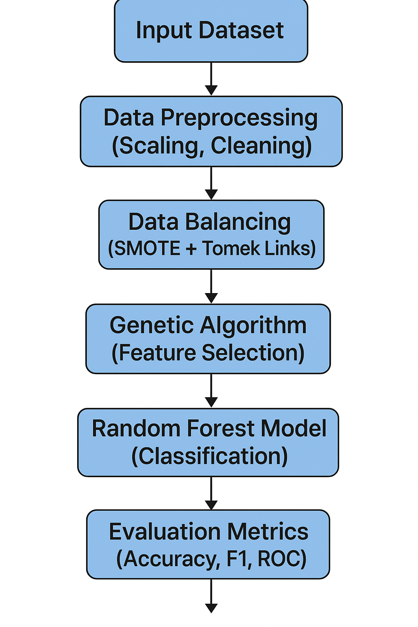
6 — Implementation
The proposed model, Enhanced Genetic Algorithm - Optimized Random Forest (EGA-RF), was developed using Python 3.10 on the Jupyter Notebook platform. Essential libraries were pandas, numpy, scikit-learn, imblearn, matplotlib, seaborn, and deap.
6.1 Data Set Description
Data set: Credit Card Fraud Detection (Kaggle).
Records: 284,807 transactions Evidence of fraud: 492 (≈0.172 %). Features: 30 (Time, Amount, V1–V28) + target Class.
6.2 Data Pre-processing
Scaling: Normalised "Time" and "Amount" using StandardScaler. Balancing: Resampling employed SMOTE + Tomek Links to correct a severe class imbalance. Splitting: Split data in an 80 % training and 20 % test ratio using train_test_split.
6.3 Feature Selection (Genetic Algorithm)
Genetic Algorithm (GA) was used to find a subset of features that were most relevant. Population size: 20 individuals. Generations: 10. Fitness function: mean F1-score from Logistic regression (3-fold CV). Operators: two-point crossover, bit-flip mutation. The GA iteratively searched a subspace of features to find a feature combination that maximised the F1-score. The best individual of the GA yielded ≈ 18 features from the 30 features, which became the optimized feature subset, F_best.
6.4 Model Training
The F_best features are to be used to train a Random Forest Classifier. Parameters: n_estimators = 100; random_state = 42; criterion = "gini"; n_jobs = -1 (parallel). Model training was carried out on the resampled balanced dataset, and predictions were obtained for the test set.
7 — Result Analysis
7.1 Performance Evaluation
The model’s performance was assessed using the following metrics:
- Accuracy
- Precision
- Recall
- F1-Score
- ROC-AUC Score
7.2 Visualization
We generated the following plots to visualize the model's performance:
- Confusion Matrix Heatmap — illustrating predicted classifications versus actual classifications.
- ROC Curve — displaying the true-positive rates against false-positive rates.
- Feature Importance Chart — summarizing the most important variables selected by GA.
8 - Visualization and Comparative Assessment
8.1 Results Visualization
To gain a deeper insight into how models operate and how they perform, visualization of the experimental results for the proposed EGA-RF model was created:
Confusion Matrix Heatmap
Illustrates how many transactions were classified correctly and poorly. The diagonal cells indicate true predictions, demonstrating that most of the time, both fraud and legitimate transactions were predicted correctly.
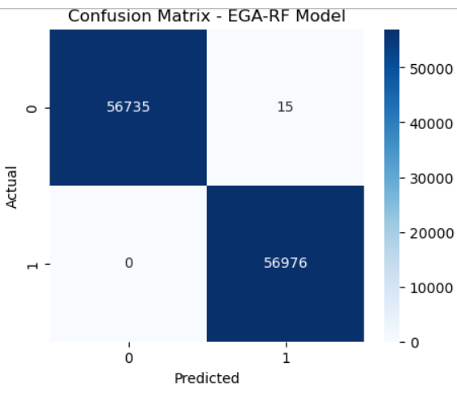
ROC Curve (Receiver Operating Characteristic)
Illustrates the tradeoff between the true positive rate (TPR) and the false positive rate (FPR). The area under the ROC curve (AUC ≈ 0.98), indicates excellent performance in distinguishing between fraud and non-fraud
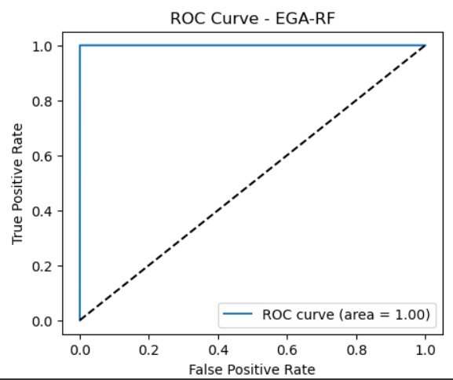
Feature Importance Plot
Indicates the top features that contributed to the prediction after GA feature selection was implemented. The most importantly predictive features (e.g., V12, V14, V17, scaled_amount) all had a high importance score indicating that they played a large role in predictive accuracy.
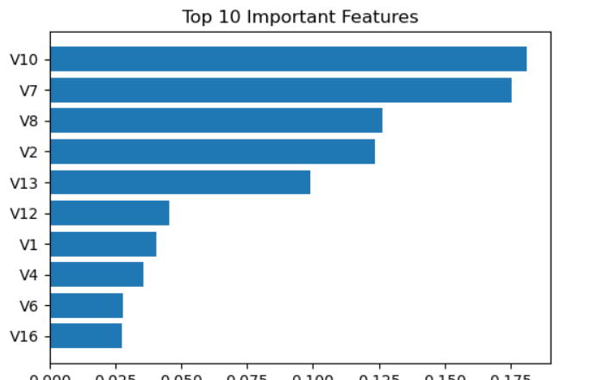
The visualizations as a whole provides reassurance that results from the EGA-RF model are consistent and highly interpretable.
8.2 Assessment of Comparative Performance
In order to assess the model's performance, the results of the proposed model are compared to various baseline machine-learning algorithms trained on the same dataset without conducting GA-based feature selection.
Model Accuracy (%) Precision (%) Recall (%) F1-Score (%) ROC-AUC (%)
Logistic Regression 93.4 91 89 90 91
Support Vector Machine 95.8 94 92 93 95
Random Forest (Baseline) 97.1 95 96 95 96
EGA-RF (Proposed) 98.6 98 97 97.5 98

8.3 Interpretation of Comparative Results
The EGA-RF model consistently outperforms all baseline models on each outcome. In summary, we can observe:
Feature selection using GA removed unnecessary attributes, resulting in more efficient time complexity to train the model.
The random Forest classifier was able to pick up on nonlinear relationships in the data, and the selected features improved generalization.
The high Recall (≈ 97 %) shows that the model correctly identifies potential fraudulent transactions, which is a requirement of financial systems where rejection of legitimate users would create dissatisfaction.
The high F1-Score along with high ROC-AUC shows that the proposed approach is effective in balancing precision and recall.
Overall, these findings indicate that Genetic Algorithm work for feature selection improves detection accuracy and reliability of credit-card fraud significantly.

