Client Visible Components

Preface
This system will not host ePHI or confidential information and/or data.

Lab Systems Handbook Application – Client Perspective
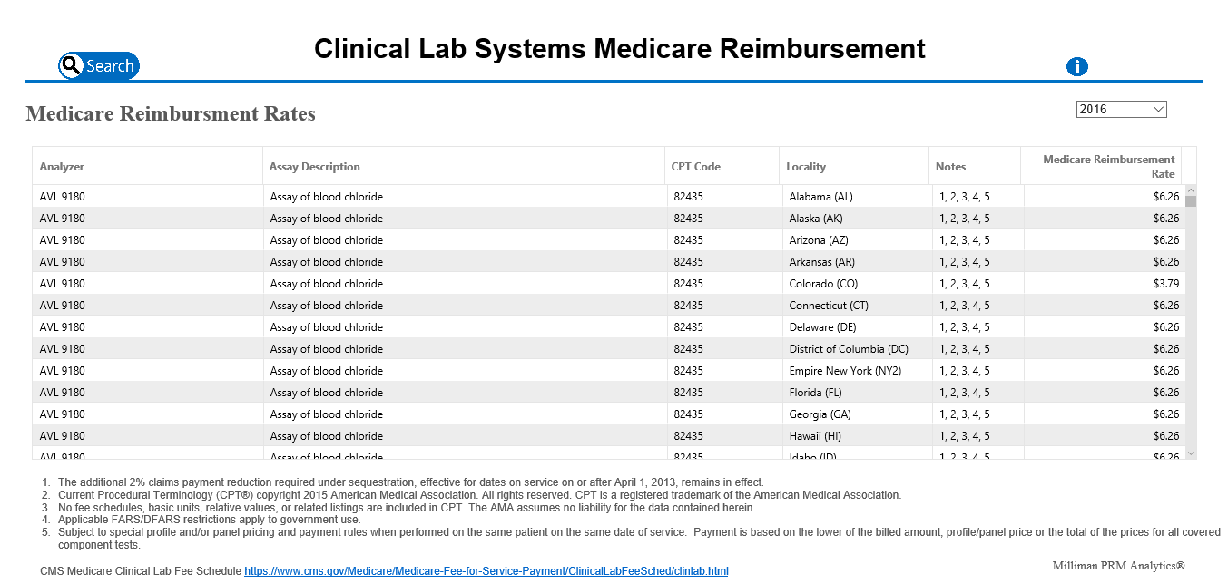
The Roche lab systems handbook is designed to provide reimbursement fee information based on current fee information. Search criteria include
- Search by analyzer name
- Search by analyzer description
- Search by location
- Search by CPT code
Sorting of columnar display data is also supported, however no support for printing is provided.

Lab Systems Handbook Architecture
The lab system handbook web application is a standard multi-tier application written in ASP.Net/C# utilizing PostgreSQL as the database.

- Presentation Layer – Web-based user interface responsible for delivery, formatting, and user interaction with the lab systems handbook system. ( Project: CLSMedicareReimbursement )
- Business Layer – Middle-ware layer responsible for transformation and processing of data to match user interface specifications. Generation of dynamic data queries as specified by user interaction. (Project: CLSBusinessLogic)
- Data Layer - Retrieval of data from data source and caching of frequent data requests. (Project: Framework/CLSdbContext and Framework/Controller)
- Data – Used for storage of structure data( PostgreSQL )

The web application is deployed on two virtual machines in the Milliman data center. The web application server (Indy-Roche-01) is responsible for hosting the custom-built web interface for external user access. The database server (Indy-Roche-02) is responsible for hosting PostgreSQL using a well-known data model. Multiple data sets may be present within the database instance, with only one data set instance active for users. Data sets are implemented as Postgres schema instances, with each schema conforming to the required data model (i.e. each schema has the same set of tables/fields).

- Indy-Roche-01 hosts the presentation, business and data layer
- Indy-Roche-02 hosts the Postgres database server

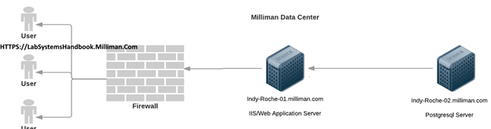

Application Error Handling
Error and information trace messages are logged to a central log file configured via the site ‘web.config’ file. This file will be monitored frequently for error situations/trends and appropriate corrective action will be taken.

Application Access
Access to the lab systems handbook web application is via the URL:

https://labsystemshandbook.milliman.com

By design the application does not require authentication or authorization for access. Due to the open nature of the application, the production web server IIS logs will be monitored frequently to determine the average number of users accessing the system and geographic diversity of users. Expected user load is 1000+ users, however excess users of 5000+ will signal extra steps are needed to restrict user access. Following best practice, access to the web site is allowed using only SSL utilizing the Milliman wildcard SSL certificate. Access attempts via HTTP uses URL re-writing to redirect to HTTPS.

System Operations Components (Milliman Internal Components)

Data Update Operations Overview
The lab systems handbook application has been designed to allow Milliman non-technical personnel to operate and update the system data as required by the client. To facilitate this workflow a web-based configuration editor will be provided to Milliman personnel to make system updates. The guiding requirements for the configuration editor are:
- Allows updating the system with new data sets (PostgreSQL schemas)
- Allows verification/testing of new data sets by Milliman personnel
- Allows updating production system with a new ‘validated’ data set by Milliman personnel
- Allows promoting the new data set to be client-visible with minimal interference to users (minimal interference = web site may clear any active user search at the time of reset)
- Access to the configuration editor will require access to Milliman domain
- Authentication/authorization to the configuration editor will use active directory/LDAP for authentication ( AD authorization group: [TBD] )
- The configuration editor will present an easy to-use-interface
- The configuration editor will clearly display the current schema in use for validation/testing
- The configuration editor will clearly display the current schema in use by the production system (client facing)

Data Update Operations Workflow
This workflow describes how Milliman personnel will provide updated data sets (schemas) to the system, test/validate the updates, and push the data set to the production system for client use.

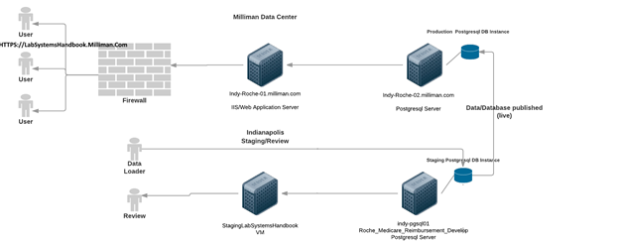

Step 1 – Data Loader
The data loader (person) is responsible for
- Creating PostgreSQL schema instances which match the well-known data model for the system (clone/copy existing schema structure )
- Deleting un-needed PostgreSQL schema instances
- Populating PostgreSQL schema instances with data
No requirements exist that dictate schema instance names, thus naming conventions are the responsibility of the person(s) functioning as the data loaders. Access to the database is controlled via active directory/LDAP groups.

Step 2a – Review/Operator
To update and review new data sets, an operator must be a member of the appropriate active directory/LDAP group, and navigate to:

http://staginglabsystemshandbook.milliman.com/labsystemshandbookconfiguration

This will launch the interface
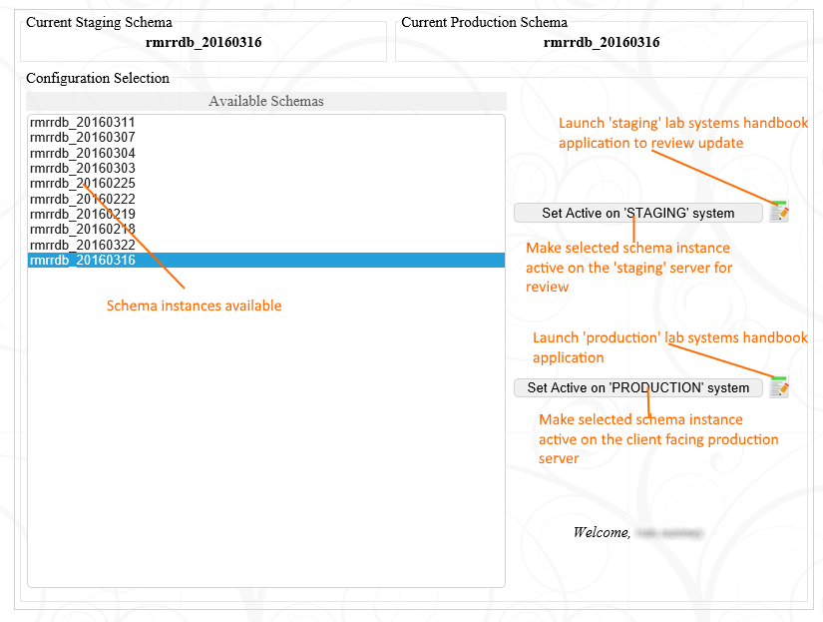
The interface provides the ability for the operator to point the ‘internal’ staging system to the selected schema instance for testing/review (click test button). Schema instances may also be pushed to the production system for client deployment. Clicking the “Set Active on ‘PRODUCTION’ system” button, will prompt the user that changes will be made that affects client users, and provides a way to cancel the request.

Step 2b – Review Only
Milliman personnel may review data set updates by navigating to the staging system web application at:
http://staginglabsystemshandbook.milliman.com/labsystemshandbook

This site is open and does not require the user to authenticate for access.

Data Set “Go Live” Timing
When an operator clicks the “Set Active on ‘PRODUCTION’ system” button, the data set is immediately uploaded to the production database server, however the data is not made live to the client at that time. Due to internal caching/optimization of common queries between the web application and the database, users actively connected will have their search selections cleared and the web interface reset to its default view. To mitigate this situation, the web server machine will reset the connection to the database server at 3am each night when there is an active request pending to change data sets. If no request is pending, no action will be taken. Scheduling of the current 3am cycle is done externally to the web application and may be modified at any time to occur more or less frequently as required.

Data Update Operations Details
Data loaders must conform to the well-known data model represented by the current schema layout. Modifications must be coordinated via ‘Change Management’ to ensure code/data structure do not become misaligned.

Data Update Operations Error Handling
The configuration editor stores log error information to a centralized file configured via the ‘web.config’. The error information logged consists of (at a minimum) – date time stamp, operator name, error message, call stack information, plus other miscellaneous information as deemed useful.

Data Update Architecture
Configuration of the Roche system is maintained as an internal system with system access controlled via active directory group “Roche_Admins”. Each project denoted by the work “Configuration” in the visual studio solution is a segment of the configuration system. Each project is described below with the exception of the common class library which maintains processing code that is utilized as reuse code. The basic control flow of the configuration system is show in the diagram below.

Configuration Editor Web Application ( StagingLabSystemsHandbook.Milliman.com )
Configuration editor is responsible for updating the system configuration for testing/validation and for the production web site. The user interface of the configuration editor is presented in section 2.2.2. The configuration editor is a standard ASP.Net web forms application written using C# 4.0. The configuration editor will display all schemas listed in the targeted database minus database names listed in the applications web.config – “blacklist” configuration item. The target database access is configured via the connection string found in the web.config. Due to the web application requiring access to the database server as an IIS user, MD5 authentication must be configured on the database server for the staging machines IP address for proper access. Credentials for database access are provided in the connection string. Once a user selects a schema for testing and click the “Set active on ‘Staging’ system” button – the configuration editor will update the connection string of the staging web site – located on the same machine as the configuration editor. It is important to note – that each time the production web site it updated, the staging web site should also be updated to keep testing valid. When the user selects the “Set active on ‘Production’ system” – the configuration editor will
- Create a local backup of the requested schema from the target database server(e.g. indy-pgsql01 )
- Uploads the local backup to the production database machine via a web service
- Web service restores the database schema to the production database machine
- Sets a flag ( file based ) that a new schema has been uploaded/restored and it should be made active
The configuration editor will call the web service to determine the name of the active schema on production.

Configuration Editor Web Services (Indy-Roche-02.Milliman.com )
The configuration editor is the coordinating element between the configuration editor and the production system (production web server and production database server). The web service allows the configuration editor to
- Determine the active schema on the production system
- Upload/Restore a new schema on the production database server
The web services allows the configuration daemon to
- Determine if a new schema has been uploaded to made the ‘active’ schema
- Set the ‘schema’ as active, once the production web site web.config connection string has been updated

Configuration Editor Daemon (Indy-Roche-01.Milliman.com)
Daemon is a scheduled task that periodically call the web services to determine if a new schema is available on the production database server. If a new schema is available, the daemon will update the production web site configuration string to point the production web site to the new instance. The daemon is also responsible for
- Notifying the web service the schema is active
- Sending an email to the originator of the request to notify them of the update
- Logging the update to an audit file
The daemon should be scheduled to run off business hours, if the production web site configuration file is updated while users are utilizing the site – their search criteria will be reset. The daemon is currently set to execute each night at 3am. To modify the execution time or frequency – launch the windows task scheduler to review the settings.

Configuration Control Flow Details

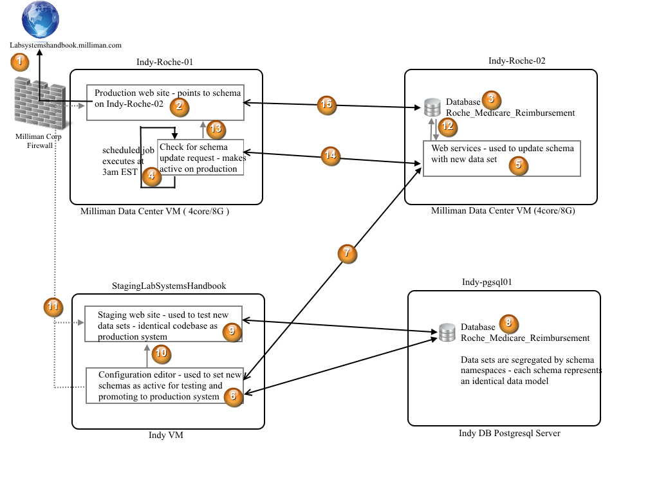
- External Milliman access – Indy-Roche-01 (10.46.101.23 ) is mapped to the external domain name LabSystemsHandbook.Milliman.com and utilizes the Milliman wildcard SSL certificate to enforce encrypted access ( is not required in this case – but is best practice ). Located at the root of the web server is a “default.html” file that is used to redirect the user to the site URL. The site may be safely upgraded by adding another virtual directory – testing access and then changing the “default.html” file to point to the upgraded site.
- Production web site – configured via its web.config – retrieves data from Indy-Roche-02 (production database server)
- Production database server, hosts a single database instance “Roche_Medicare_Reimbursement”
- Scheduled task (windows task scheduler), executes on a pre-defined scheduled. Checks with web services on Indy-Roche-02 to determine if a new schema has been uploaded and is ready to be made public. Once a new schema is available, scheduled task updates the production web site configuration string.
- Web services that coordinate updating the production system with a new schema.
- Configuration editor – responsible for setting “staging” and “production” sites data sets. Accesses Indy-pgsql01 “Roche_Medicare_Reimbursement” database as the originator of data for the system.
- Configuration editor calls web services on Roche-02 to upload/restore databases and set schemas active for production.
- Shared database server, originates data for system
- Staging web site, a clone of the production web site. Used to validate data from database server (indy-pgsql01) before publishing to production.
- Configuration sets staging schema active, by modifying connection string of staging web site
- Configuration may launch the ‘staging’ or ‘production’ web sites as required for testing
- Web services restores schema data to production database
- Daemon updates the configuration string of the production site to point to a new schema instance on production database server
- Daemon checks with web services to determine if a new schema is available
- Production web site access schema on production database server and relays information to users.

System Details

Database Utilization
PostgreSQL 9.5 is used as the structured data store for the lab system handbook application. Via ‘web.config’ files each application deployed may interact with any PostgreSQL server, provided it hosts the appropriate database and schema layout. Programmatic access to the database is provided via DevArt’s DotConnect framework for PostgreSQL and via NPGSQL .Net provider for dynamic queries.

Host Name | Database | Component | Mode | Account
Pgsql01 | Roche_Medicare_Reimbursement | StagingLabSystemsHandbook/web application ( staging ) | MD5 | *Roche_Admin
Indy-Roche-02 | Roche_Medicare_Reimbursement | LabSystemsHandbook/web application ( production ) | MD5 | *Roche_Admin
PRM-Staging-1 | Roche_Medicare_Reimbursement | PRM-Staging-1/web application  (development) | MD5 | *postgres
*Account passwords are stored separately
**Developers may maintain separate database instances local to their development environment

System Backup/Recovery

Database
Database ‘Roche_Medicare_Reimbursement’ hosted on PGSQL01 represents the data origination point for all data within the system. Thus, database restore for all nodes relies on this database instance to be backed up in a timely fashion. PGSQL01 is backed up nightly using pg_dump to save a full backup of the database(s). In addition a VM image backup will be maintained as an extra measure of safety.

Indy-Roche-02 (production) is backed up nightly via VM image. VM image backups are maintained for a 7 day period. In the event of failure, if a VM image cannot be restored, the database will be restored from data residing on PGSQL01.

Servers
Production servers (Indy-Roche-01 and Indy-Roche-02) are backed up nightly via VM image copy. VM images are maintained as a rolling backup for 7 days. In the event the production web server cannot be restored from a VM image backup, it can be cloned from the staging web server, and vice-versa. In the event the production database server cannot be restored from a VM image backup, the server can be rebuilt using the appropriate data from a schema instance from PGSQL01.

Source Code
Source code and work stories/tasks are stored in a GIT repository named “PRM_Analytics” located in VSTS in the Azure cloud at:

https://prmanalytics.visualstudio.com.

Production Recovery (Client facing)

Web server
The production web server (Indy-Roche-01) should be restored from one of the VM image backups maintained by the Milliman data center. In the event a valid VM image is not available, a new VM must be provisioned using the same IP address (10.46.101.23) to keep current firewall rules valid. Once provisioned follow the installation instructions for the production web server (below).

Database server
The production database server (Indy-Roche-02) should be restored from one of the VM image backups maintained by the Milliman data center. In the event a valid VM image is not available, a new VM must be provisioned. Unlike the web server, the IP address of the database server is not important. Once provisioned follow the installation instructions for the database server (below).

Source Code Repository
Project source control utilizes Visual Studio Team Services (VSTS) hosted via the Azure cloud. The URL for access is:

https://prmanalytics.visualstudio.com

Source code and history is currently maintained in the PRM_Analytics repository via a branch off “PRMDevelopment” named “init-Roche”. Once initial development is completed (tested and reviewed) the init-Roche branch will be merged into PRMDevelopment, or will be extracted into its own GIT repository (this action is TBD)

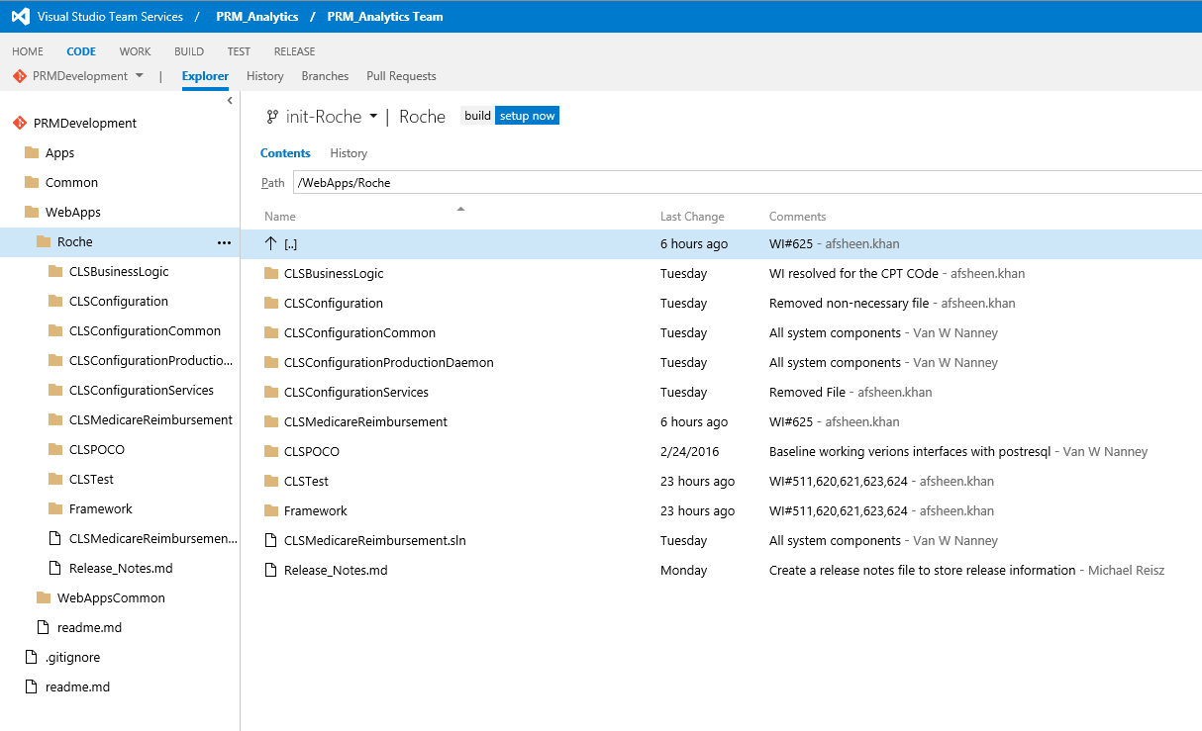

Change Request Management
Requested changes will be prioritized based on client needs and estimated effort to complete/test/deploy the modification. Change requests that are deemed large in nature will be relayed to client for negotiation. Client will be informed of requests that cannot be accommodated along with details of why the request cannot be accommodated. Change requests will be associated to code modifications via VSTS/GIT. Once a change request has been allocated to a developer, the developer will be responsible for:
- Breaking the request down into stories and tasks
- Adding stories and tasks to tracking system ( VSTS )
- Any associated design/assumptions documentation (as required)
- Determination of required resources for development (hardware, software components, etc.)
- Communicating the intended design and assumptions to managing developers
- Attending Scrum meetings
- Creating 1 or more branches from the primary code branch for development
- Unit testing (automated MS tests, when applicable )
- Creating a pull request for review by developers before changes can be merged back to primary code branch
- Developers are responsible for installation of components and backup of any local resources utilized (laptops, VMs, etc.)
- Communicating to managing developers of candidate reuse components created, which should be reviewed for inclusion into common system reuse libraries

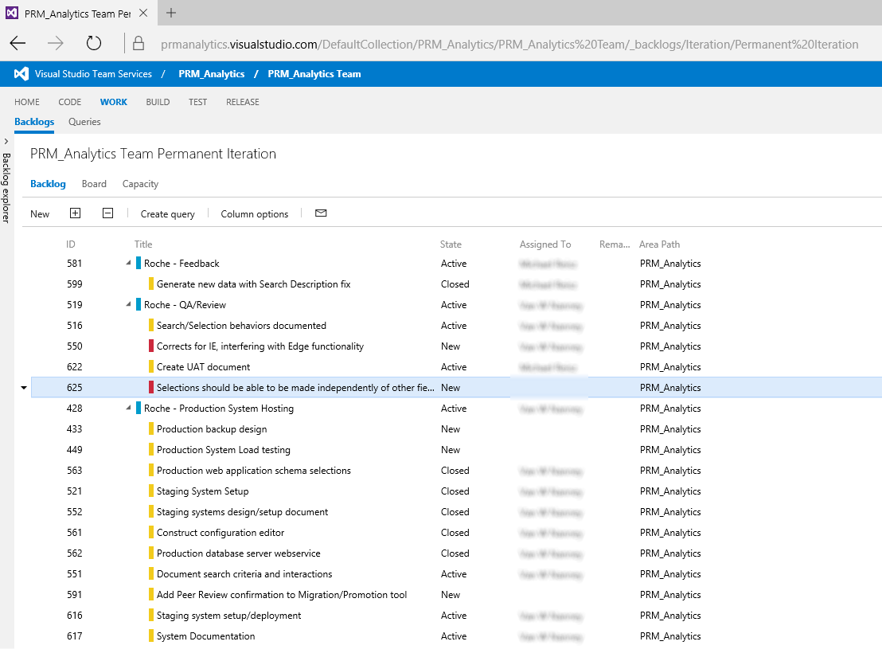

Issue Management (Bugs)
Any issue that is categorized as “critical” and prevents users from performing duties as required will be corrected immediately. Other issues will be prioritized based on the details of error, affected audience size, and whether the issue can be reproduced. Issues will be allocated to developers for correction. Developers will have the same responsibilities and workflow as followed for change request management.

Third Party Software/Licensing
Valid licenses are maintained for all 3rd party software used in development and/or deployment of the software.
- Microsoft Visual Studio – subscriptions licenses maintained via Milliman volume license agreement
- DevArt DotConnect – Milliman Indianapolis maintains developer licenses. Components may be deployed royalty free.
- Npgsql - .Net PostgreSQL provider – Open source - PostgreSQL license ( license link )
- Telerik Controls – Milliman Indianapolis maintains developer licenses. Components may be deployed royalty free.

General System and Installation Details

[In Progress]
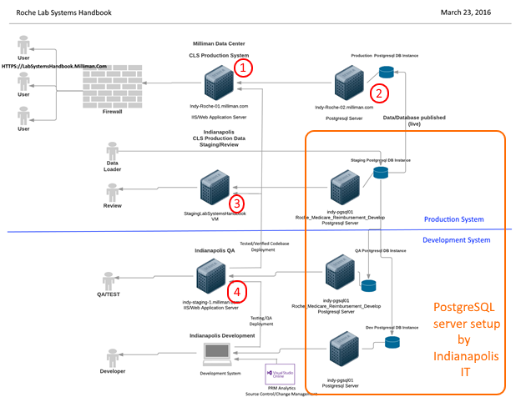

System Loading/Stress Test Results
Testing of the production system utilized WCAT (Microsoft Web Capacity Analysis Tool) to project memory utilization and latency. The results of testing are dependent on the data set available at the time of testing (denoted in graphic). Testing utilized 5 machines to load the production web site, each machine simulated ~800 users. As the tests were run, IIS memory utilization and response latency were logged by WCAT clients to create the aggregated results displayed below. Since Roche-01 is dedicated, a maximum memory load (Memory Ceiling) of 7G was used (machine contains 8G). The results show a maximum load of ~1700 can be supported with a latency of ~4 seconds. (Note: latency represents processing/transport time and does not represent browser parsing or rending of data)

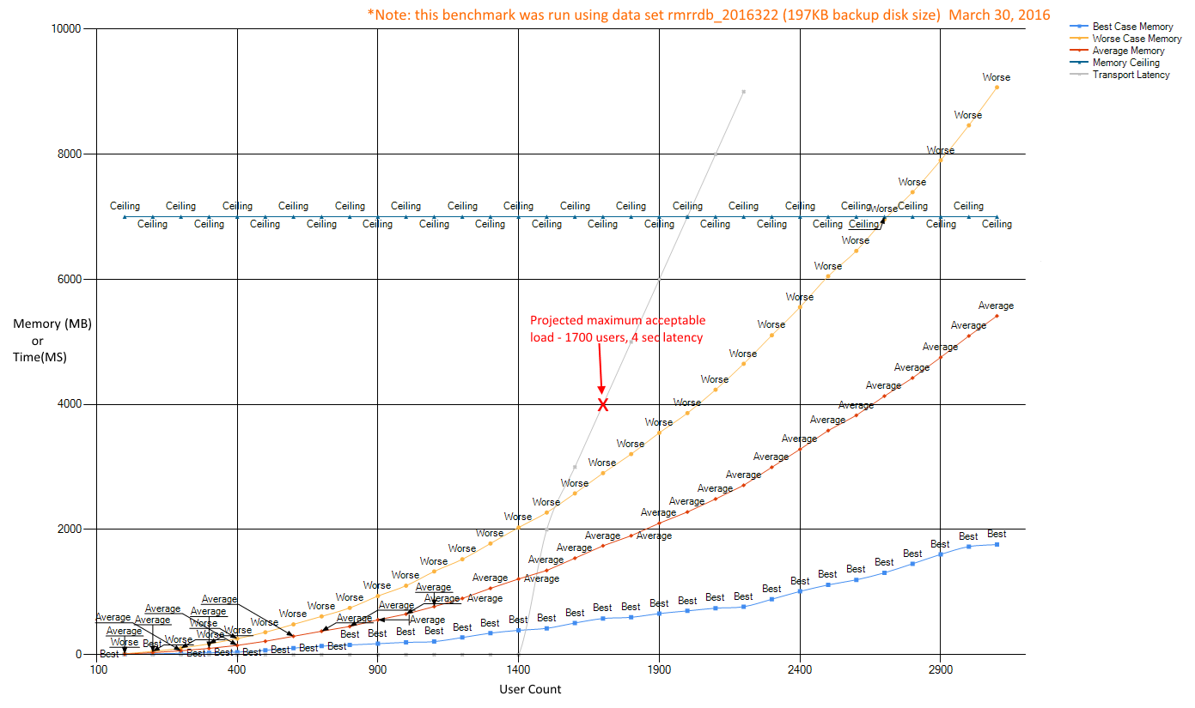

Risk Mitigation

Primary risk for this application is the lack of authentication/authorization to the deployed website and the website’s general availability to internet users. Elimination of this risk could be achieved by
Action | Description | Notes
Individual user authentication | Each user would be registered and provided an account/password | Not feasible due to large number of users
Individual user authentication / user’s self-register | Users would be required to self-register to get an account name and password
Individual user authentication / single-sign-on | Roche system authentication federation to lab system handbook server | Not feasible due to integration cost and effort required
Access limited based on IP restrictions | User access would be limited based on the user’s origin IP address | Not feasible, due to Roche user base distribution (field users)
Code Injection | System compromise via code injection | Tests performed by Naomi Bornemann

To reduce the risk, the web server will be monitored on a weekly schedule to determine approximate user counts (expected range 1,000/5,000) and user base distribution (primary US base/minimal European base). If the user count appears too large (5,000+) or if there is a distribution of users outside the expected US/Europe base, the client will be notified and a course of action determined.

Second, extra intrusion and anti-virus software will be utilized on the web server to monitor access and possible intrusion.

Platforms and Remote Access
- Indy-Roche-01.Milliman.com (10.46.101.23)
- Indy-Roche-02.Milliman.com (10.46.2.37)
- StagingLabSystemsHandbook.Milliman.com
- Indy-PGSQL01.Milliman.com

RDP access to machines is described in a separate document

