# Introduction

This project involves implementing a backtesting application using c#, the application must be able to read a csv file containing price action data and then process that data by backtesting it. You will be required to refer to an excel file called “SuperTrend strategy”, the idea is to recreate the backtesting feature in this file initially and then save all of the results into a database using ado.net and T-SQL. Once this has been achieved the next phase is to implement a set of strategies associated with a list of indicators, similar to the implementation carried out for the “SuperTrend” strategy.

As a developer/engineer you will be required to research and know when the buy and sell signals are for the listed indicators.

Overview

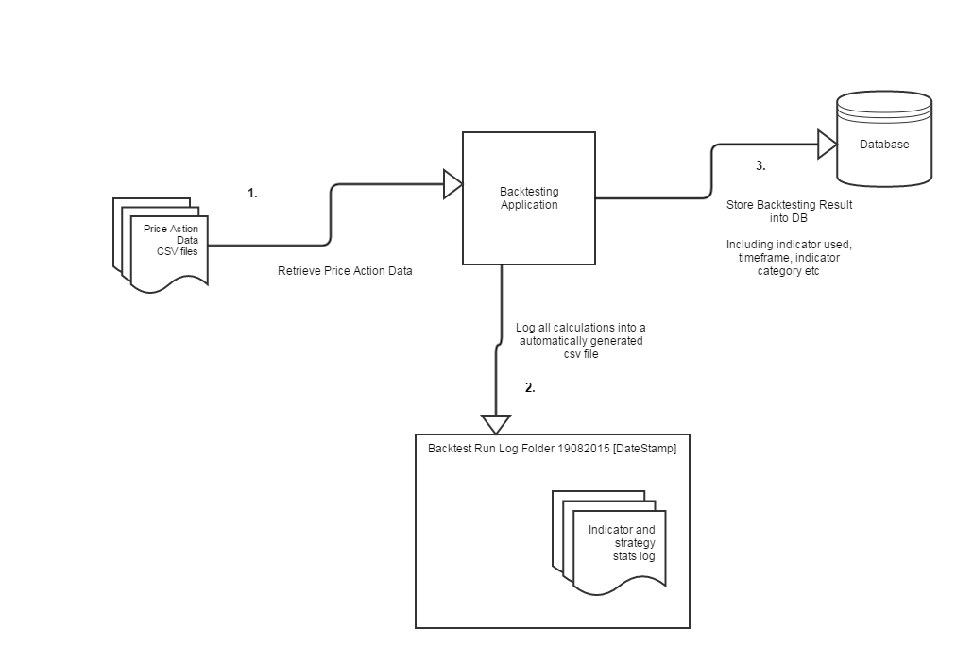

# Tasks