Summary - Int 1, Group A

# *Intermidiate 1*

## *Water*

### Full model - 2 parameters

| formula | R.sq | Q.sq | MAE |
| --- | --- | --- | --- |
| Yield ~ d.30.10. + NPA_10 | 0.9707308 | 0.9492299 | 5.334696 |
| Yield ~ d.30.10. + Pol.iso | 0.9588806 | 0.9342826 | 6.873335 |

***Multicollinearity check***

|  | x |
| --- | --- |
| d.30.10. | 1.005239 |
| NPA_10 | 1.005239 |

***Scaled Coefficients:***

|  | Estimate | Std. Error | t value | Pr(>|t|) |
| --- | --- | --- | --- | --- |
| (Intercept) | 73.25000 | 1.650918 | 44.369244 | 0.00e+00 |
| d.30.10. | -30.06687 | 1.717721 | -17.503932 | 0.00e+00 |
| NPA_10 | -10.92576 | 1.717721 | -6.360615 | 5.37e-05 |

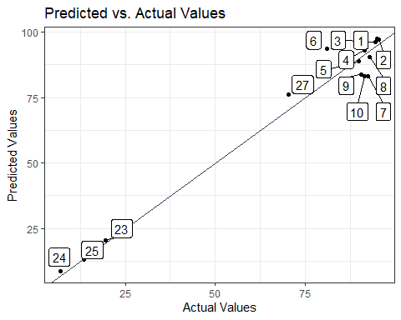 ### Full model - 1 parameters

| formula | R.sq | Q.sq | MAE |
| --- | --- | --- | --- |
| Yield ~ d.30.10. | 0.86308 | 0.8205264 | 10.20601 |

**Scaled Coefficients:**

|  | Estimate | Std. Error | t value | Pr(>|t|) |
| --- | --- | --- | --- | --- |
| (Intercept) | 73.25000 | 3.418684 | 21.426372 | 0.0e+00 |
| d.30.10. | -30.85561 | 3.547736 | -8.697267 | 1.6e-06 |

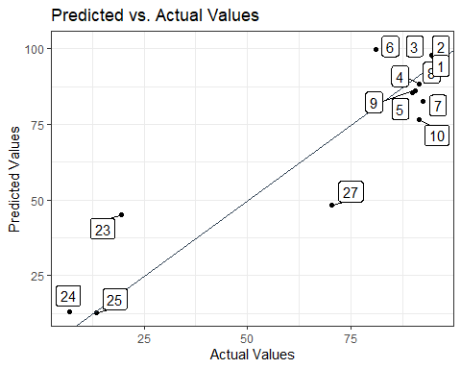

## *Methanol*

### Full model - 2 parameters

| formula | R.sq | Q.sq | MAE |
| --- | --- | --- | --- |
| Yield ~ NPA_32 + diff..31.4. | 0.9540247 | 0.9202190 | 7.140213 |
| Yield ~ NPA_4 + NPA_32 | 0.9417247 | 0.8625145 | 9.409599 |

### Full model - 1 parameter

| formula | R.sq | Q.sq | MAE |
| --- | --- | --- | --- |
| Yield ~ NPA_32 | 0.8184436 | 0.7400442 | 12.12995 |