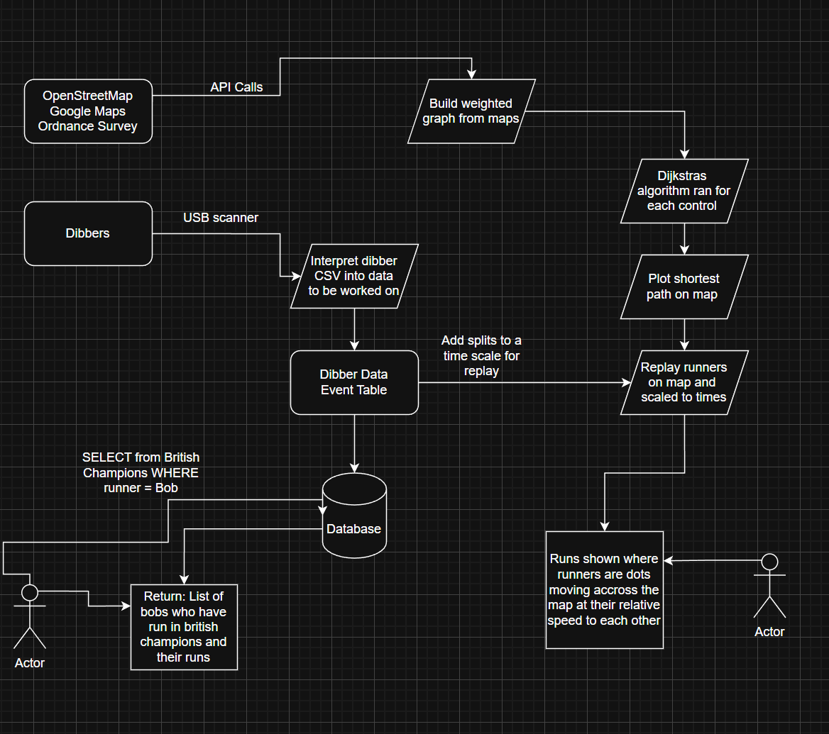

Variable Identifier | Data Type | Purpose
Node: coordinate, terrain, elevation, traversable | Record of float, string, float, boolean | This record will be used for each point on the map recorded by the program and used to construct a weighted graph, it shows the location of each node, terrain type, elevation at that point and whether there are any non-traversable things in the nodes space like a fence or no-entry zone.

Data Flow Diagram Explanation
The data flow diagram illustrates the complete architecture of Pyxis, a software solution designed to support orienteering event planners, organisers and competitors through route analysis, performance tracking and race replay functionality. The system integrates geographical mapping data with competitor timing information to provide a comprehensive platform for event management and post-race analysis.

The first major input to the system consists of geographical data obtained from mapping providers including OpenStreetMap, Google Maps and Ordnance Survey. Pyxis accesses these services through API calls, allowing the software to obtain information relating to terrain, footpaths, elevation and other geographical features. This information forms the foundation of the route planning and pathfinding functionality within the system.
Once the geographical data has been retrieved, it is processed to construct a weighted graph representation of the map. The weighted graph converts the physical environment into a mathematical structure consisting of nodes and weighted edges. Each edge represents a possible movement between locations, while the weighting reflects factors that influence route choice such as distance, elevation change, terrain difficulty and path availability. By modelling the environment in this way, the system is able to perform advanced route analysis using established pathfinding algorithms.

Following graph construction, Dijkstra's algorithm is executed between each control point within a course. The algorithm calculates the lowest-cost route between successive controls, producing an optimal route based on the weighting criteria applied to the graph. The resulting routes are then plotted directly onto the map, creating a visual representation of the most efficient route through the course. These calculated routes form the spatial framework used throughout the remainder of the system.

The second major input consists of competitor data obtained from SI dibbers used during orienteering events. Following an event, competitors' dibber data is transferred to the system through a USB connection. Pyxis interprets the exported CSV data and converts it into a structured format suitable for analysis and storage. This process extracts key information including competitor details, control visits, split times and overall results.

The processed information is stored within the Dibber Data Event Table, which acts as the primary repository for event-specific data. This structured dataset provides a consistent format for further processing and ensures that competitor information can be efficiently analysed and retrieved. The event table is then written to the central database where all historical event data is permanently stored.

The database serves as the core storage component of the system. It contains competitor information, event records, split times, route data and performance history. Through the use of SQL queries, users are able to retrieve information from both current and historical events. For example, users can search for all competitors with a particular name who have participated in a specific competition and obtain a complete history of their performances. This functionality enables long-term performance analysis and allows event organisers to access large volumes of data efficiently.

The final stage of the system combines information from both the route generation subsystem and the competitor data subsystem. Split times extracted from dibber data are converted into a scalable timeline which represents competitor progression throughout the course. This temporal data is combined with the calculated route geometry generated by the pathfinding algorithms.

Using both spatial and temporal information, Pyxis generates a fully interactive race replay. Competitors are represented as moving markers on the map and progress along the calculated routes according to their recorded split times. The replay system accurately reflects the relative positions and speeds of competitors throughout the event, allowing users to visualise race progression, compare performances and identify key moments where time was gained or lost.

The completed system provides an integrated workflow in which geographical data is transformed into navigable route networks, competitor timing data is processed and stored within a relational database, and both datasets are combined to generate detailed visualisations of race performance. By bringing together route analysis, data management and replay functionality within a single application, Pyxis delivers a comprehensive solution for the planning, analysis and review of orienteering events.

