Primary User
The primary user is a fellow student at TBGS, Joshua Eric Lockwood, he is a long-time orienteer from Devon and runner that also uses things like a Garmin and Strava to track his runs aside from his orienteering.

Context
When orienteering only certain pieces of data are collected by your dibber, this includes your start & finish times, the time at which you punch each control. At the end of a race, everyone scans their data in and the organiser uses SPORTident SiTiming (the current software) to sort everyone’s time into a simple table where people can see their place in plain text and how they compared per split in numbers.
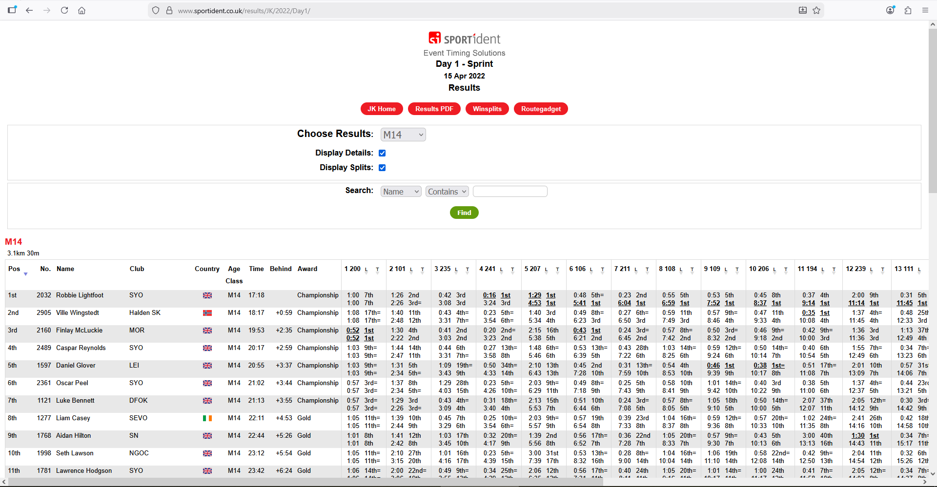
This is helpful to an orienteer who wants to see what their opponents are doing in races and how they compare, however it isn’t very intuitive and is therefore hard to understand or compare to certain people in an easily understandable manner.

Problems and a proposed solution
P they compare against the competition in their head.
S Program will predict the route ran by the participants, draw it on the orienteering map and show the runners moving across the map according to their times, this shows people speeding up and slowing The representation of data after a race is unimpressionable and crude which makes it hard for a runner to visualise how down compared to the other runners in a way that is easily understandable and visually appealing.

P Data is only presented in tables of each race which is further split into tables of each age category, and then each difficulty/route. This means that to see one’s improvement on every green route they have ran you need to find the link for each race and your specific category in that race and compare manually.
P You cannot compare people directly unless they appear in the exact same race as you.
S Store run data in a relational database which allows people to compare across races, routes, events and age categories easily.

Limitations
The program would predict the route taken by a runner based on terrain type and elevation change, certain runners may prefer taking unorthodox routes around courses according to their own strengths and, although they are a small minority, this would not be representative of them.
Fluctuations in elevation smaller than the resolution of the programs mapping would not be counted and therefore the algorithm could mistake small changes in elevation as flat ground.
The final result of runners represented as dots moving across the map would be an average based off of the start time and time every point is reached, this would not include potential breaks to check the map or small sprints or slows during the route, though this also isn’t represented in the current system, it is also a limitation with the system I am building.

More limitations that are real and because of nea

Feedback Response
Collapsed is a summary of what was written down by my peers in response to my presentation of my idea (each line of my response corresponds to a cell in a table they were asked to fill out, Idea, success criteria and feedback/comments respectively), after is comprised of questions that I have inferred from the response and my response to said questions.

(1) Adam al Khaja
Addresses orienteering routes, arranges stats allowing for comparison between runners.
Provide in depth detail of runner’s events.
Show where others did better. Club access to other data
Address the statistics that are hidden from the runners.

(2) Peter Gardiner
Orienteering tracker
Shows map route and who is faster where, terrain affected, access historical data.
Create a scientifically perfect route, client side? If people are very slow in a part leaders can warn runners for safety.

(3) Christopher Small
Take timing and split data, display that data on the route, and compare to others.
Adapt route prediction according to terrain.
Sounds good but difficult, also display numerical data, access levels are helpful for better management.

(4) Aiden Muthiah
Improving an existing system on recording orienteering stats. Strava-style route replay.
Can’t see specific route due to hardware, pathfinding used to analyse the map and predict an efficient route, consider elevation.
Algorithmically good. User comments on others runs? Good output. Club management & user login could allow for more functionality.

(5) Muhammad Annas
Software for runners to see the route, their own stats and then compare to other runners.
Takes into account different elevations and terrain types. Aids runner to improve their runs by analysing their runs and showing them their weaknesses.
Processes runs and outputs stats with relevant routes. It is a useful feature to compare to other runners and runs of similar course difficulty or route. Personalisation of data for runners? Potentially add the weather at the time of a race to be of consideration.

(6) Mrs V Medway
Track orienteering routes, timings and stats.
Replay feature to show contrasts to other participants. Highlight where runners can improve. Pathfinding and getting data from APIs to form weighted graphs.
Good idea and interesting to see. Think of all the stats.

- Will this address other statistics that are hidden from the runners?
  - As with the current system, there is no data that anyone has access to that is hidden, however while the data is provided, it isn’t very intuitive and is therefore hard to understand or otherwise benefit from. My goal is to take that seemingly garbled table of numbers and turn it into a visual representation of orienteers on a route that the runners can then benefit from by clearly seeing what needs improvement.
- Will all of the processing on the data be done client side?
  - Yes, all processing of data will be done client side, however some data will need to be pulled from various APIs such as terrain type in a location and that data will then be interpreted by the program to form a graph of the route and then calculate the computers predicted route. The only other data used by the program is that given by the dibber, the dibber records the time of each ‘event’ (start, finish, checkpoint punch etc.) and that will be then read into the program so that it can interpret these events and use them to make a visualisation of the runner moving across the route created by the program.
- Will the program still display important numerical data and how will the access levels work?
  - Yes, the numerical data is still important to be displayed to the runner as it is the exact values that make up their run. Access levels will hopefully work by allowing people to identify themselves as either runners or club owners (via a login system) that will then let them access either their own runs if they are just a runner, or the data of all runners under their club’s name if they log in as an owner.
- Will there be a social element to the system that, for example, contains user comments on other runs?
  - I think this is a fantastic idea and hopefully I will be able to implement features to this effect, however, this would also require a ‘friends’ system’ as it would be unfair to publish everyone’s results to everyone in case they would rather keep this private. Although, a friends’ system could be avoided if all users were public but they could choose to privatise certain data or not.
- Will there be a way to create personalised data for the runners?
  - This is a very good idea, personalised data past how a runner did on a route would absolutely help someone improve. I think this would be difficult to implement due to a lack of available data but certain personalised data would certainly be possible such as allowing a user to input some of their attributes (like weight or height) and the program could then estimate things like power output based on their route performance therefore providing the user extra useful data.
- How will all of the stats be collected and used/produced?
  - The location data will be taken from APIs, the run data will be read in using a proprietary USB device that comes as part of the dibber, the weighted graph is then calculated based on data from APIs, the run is constructed from the dibber data and plotted onto the map with the weighted graph made by the program. If I also make personalised data like Mo suggested then that will be entered by the user and calculated with relation to the route taken from the program.

From the feedback it seems

Broad aims and objectives-
- Exact criteria to fulfil
- Bullet points and explanations
- Also include what has been suggested from peers

Interview with primary user
User is Joshua Lockwood, a 16 year old orienteer and cross-country runner.
How do you track your orienteering?
On Strava and Garmin connect which is linked to a Garmin running watch
What do you want to track/compare but are unable to do with the current systems in place?
I can use Liveox or something similar but that only lets you compare with people who also upload their results. Moreover, only the biggest events are on there (JKs, National champs) so I cannot do anything for normal club events.
Are there any things that you want to be changed about the current systems?
Ability to be able to see what I did wrong (analysing the GPS overlayed on the map), also compare to other people to see how they did better than me (different route choices etc) so if they showed me where I ran and I could compare with other it would definitely further my orienteering.
What parts of the current orienteering systems do you want to be carried over onto a new system?
Well, I think the GPS overlay on the orienteering map is excellent, I also like the comparisons between your routes and others as you can learn from their route choices

Communication plan with primary user

I intend to rendezvous on a monthly basis with Josh and bring him my updated project for him to critique and potentially even use with the sport.

Research includes:

https://developers.google.com/maps/documentation/elevation/overview
https://wiki.openstreetmap.org/wiki/API
https://wiki.openstreetmap.org/wiki/Overpass_API
https://wiki.openstreetmap.org/wiki/Software_libraries#Web_maps
https://en.wikipedia.org/wiki/Object%E2%80%93relational_mapping
https://www.cs.yale.edu/homes/aspnes/pinewiki/ShortestPath.html
https://experience.arcgis.com/experience/20981dabcb14402687dccb437a4a78fb/
https://docs.os.uk/os-downloads/height-and-imagery/os-terrain-5#benefits
https://www.strava.com/
https://www.sportident.co.uk/
https://www.britishorienteering.org.uk/

