For me the biggest feasibility risk is doing the pathfinding algorithms to produce the predicted route since I have never done anything like this before. Therefore, as a feasibility prototype I will make a functioning Dijkstra implementation on a weighted graph that can then be added to with the input handling from mapping APIs and the output can also be changed to show the route on a map.
In order to ensure that this was possible, I made a prototype of Dijkstra’s algorithm that I could run on a weighted graph to learn about the algorithm and get an idea of whether this could be implemented as I would want.

Current System Investigation:
SI Timing
When you run a race you first sign up with the organiser to participate, then you arrive with running clothes, a compass and a dibber.
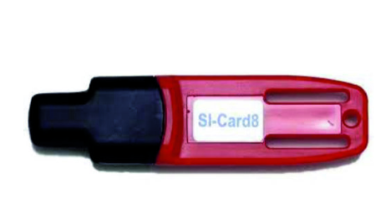
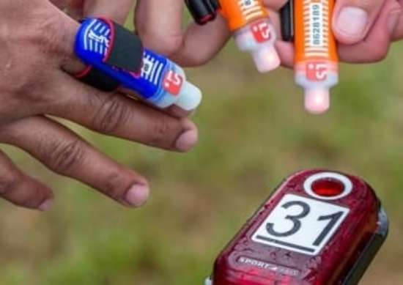
Dibbers and a control point: https://www.quantockorienteers.co.uk/info/competitors-resources/siac-electronic-timing
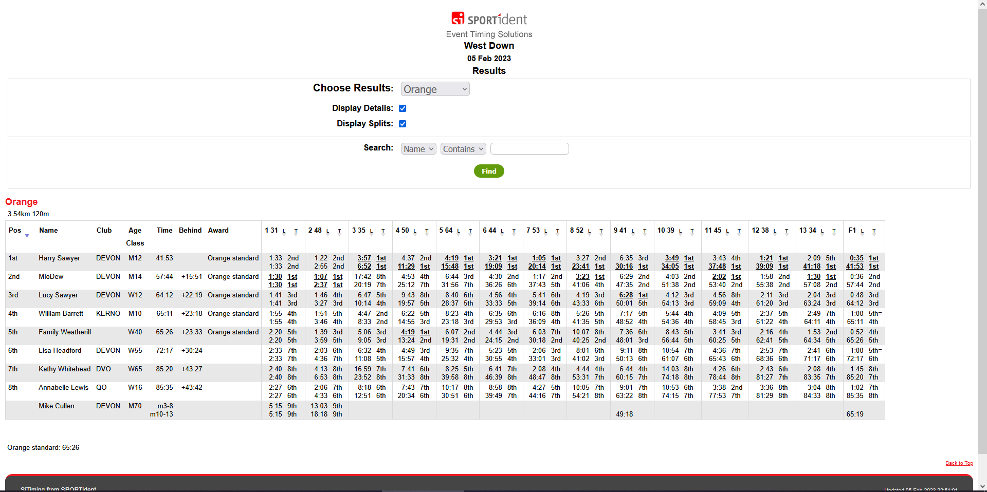
You then go about the race, scanning controls as you go until you scan the finish control. After a race you must go to the download tent where the organiser will read the data into the SiTiming app on their computer and it will be interpreted into a table that produces a final number or place that you get overall. The rest of your data is also placed in a table that you are free to access individually once the event results are uploaded.

The data shown gives a position on each control and the overall race along with other data like name, age, club and award given. This data can be accessed by finding the specific web page for the race and then clicking on that race so that it opens in the online results viewer provided by Sportident, the developers of the SiTiming software. This is great to see the numerical results for one race but is unimpressive due to the nature of plain text and numbers in a table and you are unable to compare your place directly against other runners or between races.
This system, however, does make it possible to access results from anywhere at any time since it is available online, it also allows you to search for a runner in a particular race by filtering or their full name which I can also see being very useful. I hope that when I make my software, it also allows me to search conveniently in races and be easy to access.

Interview with primary user
User is Joshua Lockwood, a 16 year old orienteer and cross-country runner.
How do you track your orienteering?
On Strava and Garmin connect which is linked to a Garmin running watch
What do you want to track/compare but are unable to do with the current systems in place?
I can use Liveox or something similar but that only lets you compare with people who also upload their results. Moreover, only the biggest events are on there (JKs, National champs) so I cannot do anything for normal club events.
Are there any things that you want to be changed about the current systems?
Ability to be able to see what I did wrong (analysing the GPS overlayed on the map), also compare to other people to see how they did better than me (different route choices etc) so if they showed me where I ran and I could compare with other it would definitely further my orienteering.
What parts of the current orienteering systems do you want to be carried over onto a new system?
Well, I think the GPS overlay on the orienteering map is excellent, I also like the comparisons between your routes and others as you can learn from their route choices

