**PROJECT 1 TITLE:AQM**

PHASE 1: AIR QUALITY MONITORING

SUBMITTED BY:SARAVANAN S

**PROBLEM STATEMENT**:

Inhaling pollutants for a long time causes damages in human health. Traditional air quality monitoring methods, such as building air quality monitoring stations, are typically expensive. This project is suitable for air quality monitoring in real time.

**ABSTRACT**

Air pollution is a growing issue these days. It is necessary to monitor air quality and keep it under control for a better future and healthy living for all. Here we propose an air quality as well as sound pollution monitoring system that allows us to monitor and check live air quality in particular areas through IOT. System uses air sensors to sense presence of harmful gases/compounds in the air and constantly transmit this data to microcontroller. Also system keeps measuring sound level and reports it to the online server over IOT. The sensors interact with microcontroller which processes this data and transmits it over internet. This allows authorities to monitor air pollution in different areas and take action against it. This project gives a proposal for addressing the issue of indoor air quality using the internet of things communication model. The description of the effects of low moderate levels of pollutants on the occupants on the indoor space is presented. A system, containing sensor networks and being internet of things enabled, is proposed, to facilitate in achieving efficient indoor air quality system. The system is designed to contain three major areas of functionality: first, the wireless sensor network that will provide the pollutant levels of the room. Second, this information is passed through a wireless access point and gets dumped on a server machine. Third, the server side stores and processes this data. The server side contains user interface and notification system functionalities.

**Keywords**: Air Pollution, MQ135 Sensor, IOT, Arduino Uno

**Problem Statement**

Air pollution is one of environmental issues that cannot be ignored. Inhaling pollutants for a long time causes damages in human health. Traditional air quality monitoring methods, such as building air quality monitoring stations, are typically expensive. This project is suitable for air quality monitoring in real time.Design a tool which will sense quality of air and display it in the form of percentage,Sense how much carbon mono-oxide(CO) is present in air and display in the form of percentage,Sense the temperature and display it in degree celcius.

**Problam solution:**

Not a single living thing can survive without air. Air is the most important element for living. According to the SDG (Sustainable Development Goals) by the UN (United Nations) there are seventeen goals to transform the world to clean, healthy and natural way to live in because at this time there are several problems in human life. The SDG says,Ensure healthy lives and promote well-being for all at all ages,Ensure access to affordable, reliable, sustainable and modern energy for all,Ensure sustainable consumption and production patterns,Take urgent action to combat climate change and its impacts,Conserve and sustainably use the oceans, seas and marine resources,Sustainably manage forests, combat desertification, halt and reverse land degradation, halt biodiversity loss.

**What is air quality monitoring:**

Ambient air monitoring is the systematic, long-term assessment of pollutant levels by measuring the quantity and types of certain pollutants in the surrounding, outdoor air.

**Design thinking:**

* Define specific objectives such as real-time air quality monitoring,data sharing,public awereness,and health impact.
* Plan the design and deployment of iot device to measure air quality data to the public.
* Design a web-based platform to display real-time air quality data to the public.
* Determine how to Iot device will send data-sharing platform.

**Content Diagram of Air Quality Monitoring System**

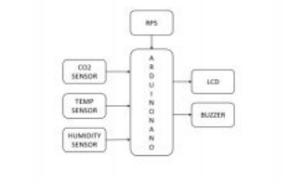

**Define specific objectives such as real-time air quality monitoring,data sharing,public awereness,and health impact.**

Real-time air quality refers to the measurement and reporting of air pollution levels as they occur in the present moment, rather than through historical data or forecasted estimates. We can gather this information through the use of [air quality monitoring equipment](https://www.pranaair.com/air-quality-monitor/). This equipment can measure the levels of various pollutants in the air and transmit that data in real-time to a central location or app. The data helps in alerting individuals and organizations to potential health hazards. It helps to inform decisions about when and where to take action to reduce pollution.

**Plan the design and deployment of iot device to measure air quality data to the public.**

Abstract—Air quality is getting worse worldwide, especially in cities with high population density and many industrial parks. Raising community awareness and applying science and technology are effective ways to mitigate the negative impacts of industrialization and pollution on the natural environment as well as public health. This work presents the design and deployment of an IoT-based air quality monitoring system, named the Environmental Monitoring System (EnMoS). LoRa (Long-Range) wireless communication technology and innovation sensors being used aim to facilitate the development of data communication network over a large area, improving sensing reliability, extending battery life as well as reducing total system costs. The air quality factors such as particulate matter (PM2.5 and PM10), carbon dioxide (CO2), air temperature and humidity, after being read from the sensors were uploaded to a real-time database server for Air Quality Index (AQI) calculation. In addition, for indicating conveniently obtained AQI values a web page is also developed to provide an interactive map along with corresponding charts. A case study on an actual LoRa network consisting of three sensing nodes and a gateway were conducted for validating the feasibility of the system. Index Terms—Air quality monitoring

**Design a web-based platform to display real-time air quality data to the public.**

IoT (Internet of Things) has become an integral part of our lives and it has already made an impact in various sectors, including the environment. Air pollution is a severe problem that has been affecting our planet for years. Therefore, there is a need for a reliable and efficient air pollution monitoring system to protect ourselves from its hazardous effects. An IoT-based air pollution monitoring system is an ideal solution that can provide real-time data and insights about the air quality in a particular area.

An IoT based air pollution monitoring system consists of several hardware and software components that work together to collect and process data. The hardware components include sensors, microcontrollers, and communication modules. The software components consist of a cloud platform, a mobile application, and a web-based dashboard.

Determine how to Iot device will send data-sharing platform.

*The IoT device's internet connection allows it to be managed and controlled remotely and enables a consistent exchange of the collected data. The data is then shared to other IoT devices or transmitted through a gateway to be analyzed either locally (i.e. edge computing) or on the cloud.

*The data collected by the sensors is then shared via the cloud and integrated with software. The software then analyzes and transmits the data to users via an app or website.

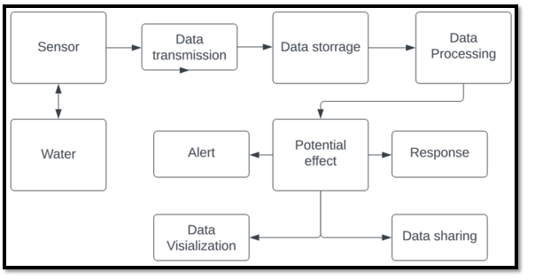

**Iot sensor’s:**

**Co2 sensor’s:**

A **carbon dioxide sensor** or **CO2 sensor** is an instrument for the measurement of [carbon dioxide](https://en.wikipedia.org/wiki/Carbon_dioxide) gas. The most common principles for CO2 sensors are infrared gas sensors ([NDIR](https://en.wikipedia.org/wiki/NDIR)) and chemical gas sensors. Measuring carbon dioxide is important in monitoring [indoor air quality](https://en.wikipedia.org/wiki/Indoor_air_quality),[[1]](https://en.wikipedia.org/wiki/Carbon_dioxide_sensor#cite_note-1) the function of the lungs in the form of a [capnograph](https://en.wikipedia.org/wiki/Capnograph" \o "Capnograph) device, and many industrial processes.

**Temp sensor’s:**

A temperature sensor is a device used to measure temperature. This can be air temperature, liquid temperature or the temperature of solid matter. There are different types of temperature sensors available and they each use different technologies and principles to take the temperature measurement.

**Humidity sensor’s**:

Humidity sensors work by detecting changes that alter electrical currents or temperature in the air. There are three basic types of humidity sensors: capacitive, resistive and thermal. All three types will monitor minute changes in the atmosphere in order to calculate the humidity in the air.

------------------------*-----------------------*------------------------*------------------------