

**Mawlana Bhashani Science and Technology University**

**Lab-Report**

Report No:02

Course code: ICT-3110

Course title: Operating System Lab

Date of Performance:01/09/2020

Date of Submission:10/09/2020

**Submitted by Submitted To**

Nazrul Islam

Assistant Professor

Dept. of ICT

MBSTU.

Name:Md Milon Ahmed

ID:IT-18034

3rd  year 1st semester

Session: 2017-2018

Dept. of ICT

MBSTU.

Experiment No:06

Experiment Name : Process Handling in Linux

Aim and Objective :

To understand and handle processes in Linux . How process work in Linux , how to manipulate and process and see all the running process , to store them in a local file and thus have the basic understanding of the whole thing

Commands :

ps aux :This command is used to see all the running process in Linux . Every process has a PID number or process id which uniquely identifies the process , the CPU and memory usages are also shown along with the start and running time .

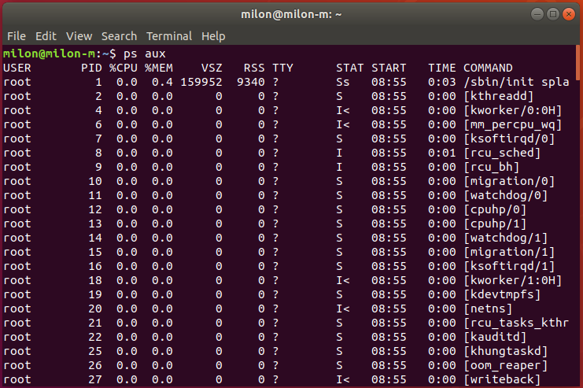

kill :This command is used to terminate running a process , hear the PID is put into use the syntax for killing a process is “ kill PID “

xkill:This is a GUI version of kill it does not require a PID to terminate a process , a process is terminated in this process by putting the mouse cursor over the process the left button down

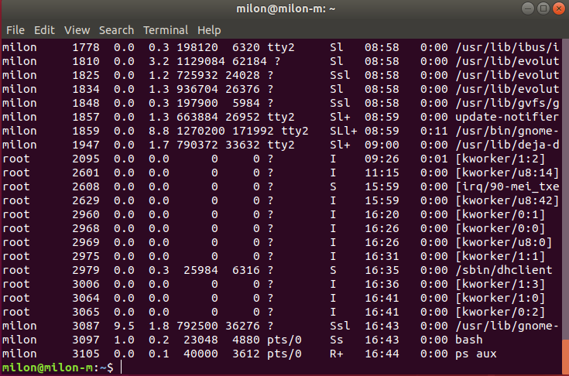

killall :This kill command does not require a PID but a process name has to be giver as it kills by name , this command is used when a session is to be killed

Here id 4519 process has been killed.

> and >> redirectors :

Redirectors are used when the result needs to be stored in a file . ‘>’ is used when the previous data in the file is not to be kept ,nano was used hear to see what is in a file

.

“>>” is used when the file needs to ne appended

The text1 file had data in it previously

After being modified

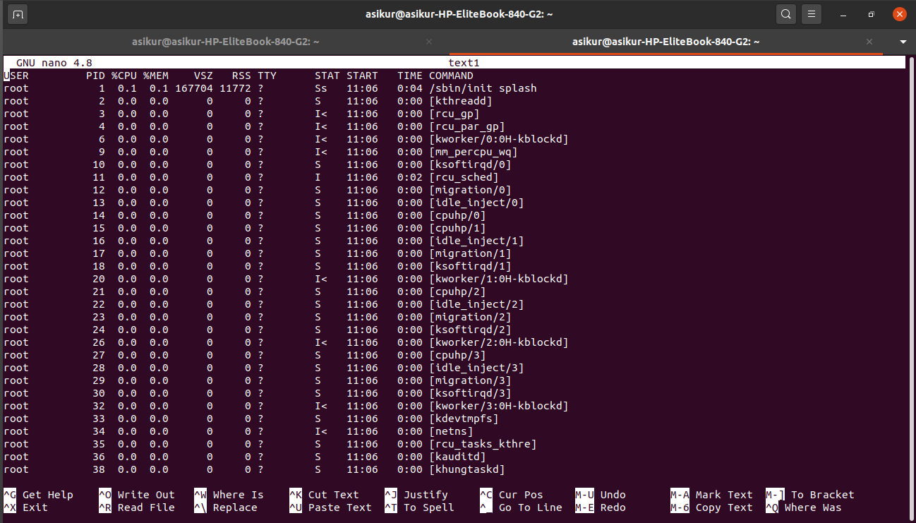

tee and pipes:

the tee command is used when it is both necessary to show the data in terminal and save the data to a file and the parameter needed to tee comes from pipes , it is represented by “|” this takes the result of a command and sends it to another , in this case it takes from ps aux and gives to tee

head data was saved in a file named text1 file we can see the data using nano

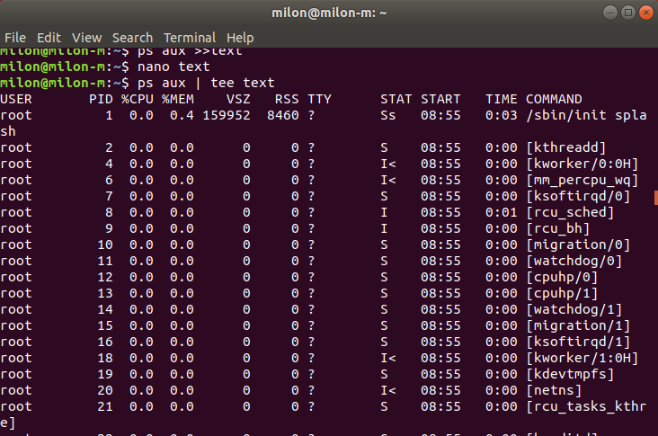

Discussion:

In this experiment we had a basic grasp of process in Linux operating system , how to kill them how to save there data in memory we also learnt about pipes.We learnt several methos to kill a process in linux both in GUI and command line , by using name and PID .