

Mawlana Bhashani Science and Technology University

Lab-Report

Report No:03
Course code: ICT-3110
Course title: Operating System Lab
Date of Performance:01/09/2020
Date of Submission:10/09/2020

Submitted by Submitted To
Name:Md Milon Ahmed
ID:IT-18034
3rd year 1st semester
Session: 2017-2018
Dept. of ICT
MBSTU.

Nazrul Islam
Assistant Professor
Dept. of ICT
MBSTU.

Connecting a database (Mysql) with linux

- Install Mysql on Ubuntu:

- sudo apt-get update
- sudo apt-get install mysql-server
- mysql_server_installation

Log into mysql by linux (Ubuntu)

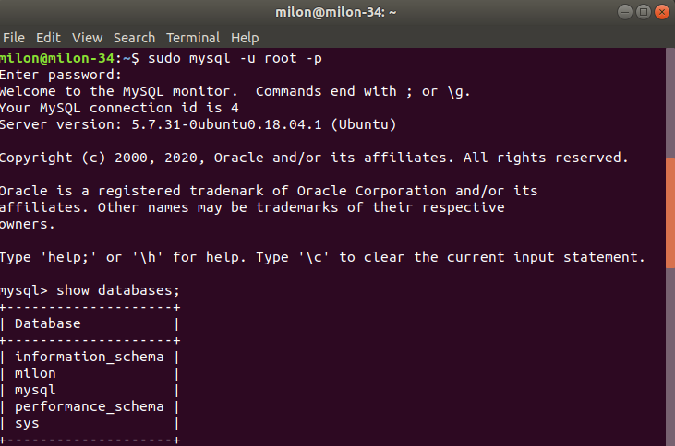

Use database ans data insert into database.

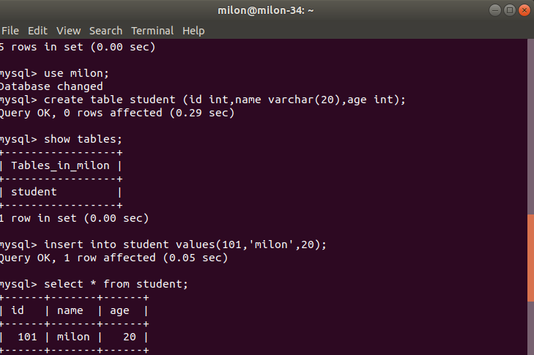

Show table data from database.

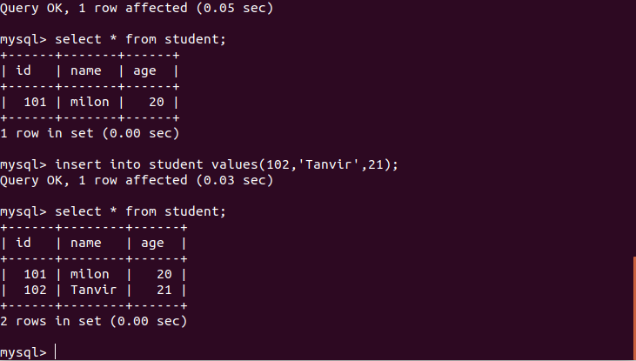
Conclusion :

In this lab we learnt how to install database in Linux bases operating systems . Using database is a convenient way of saving data in both research and technical fields ,
so it will be of great help in near future.

