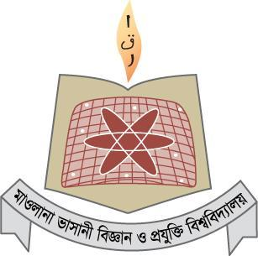

Mawlana Bhashani Science and Technology University

Lab-Report

Report No:04
Course code: ICT-3110
Course title: Operating System Lab
Date of Performance:01/09/2020
Date of Submission:10/09/2020

Submitted by Submitted To

Name:Md Milon Ahmed
ID:IT-18034
3rd year 1st semester
Session: 2017-2018
Dept. of ICT
MBSTU.

Nazrul Islam
Assistant Professor
Dept. of ICT
MBSTU.

File operation and permission

Objectives:
- File operation
- File permission
Filr Operation: To use the Linux terminal like a pro, we’ll need to know the basics of managing files and navigating directories.Differnet file operation is given below…

1) ls – List Files
The ls command lists the files in a directory. By default, ls lists files in the current directory.

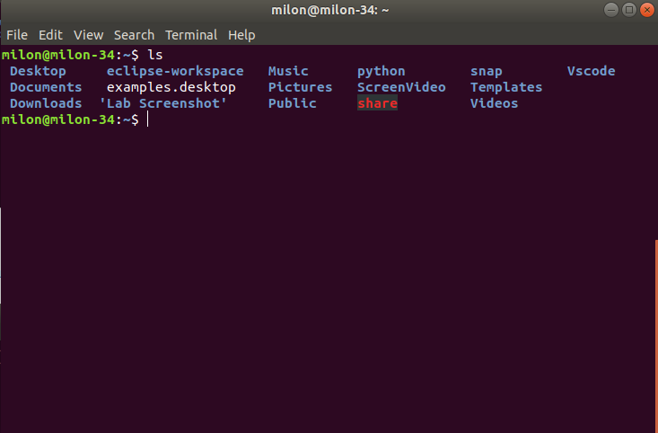
2. we can also list files recursively — that is, list all files in directories inside the current directory — with ls -R.

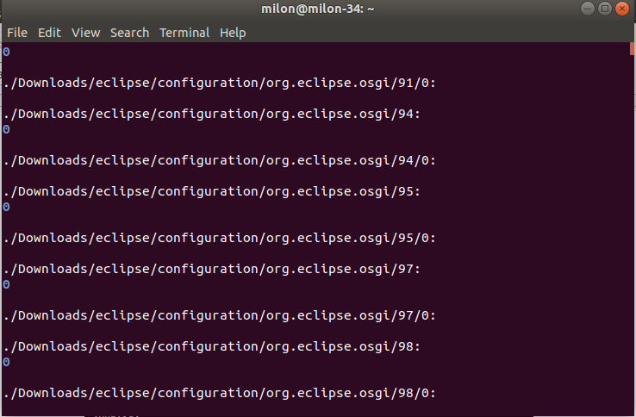

3. cd – Change Directory
The cd command changes to another directory. For example, cd Desktop will take you to your Desktop directory if you’re starting from your home directory.

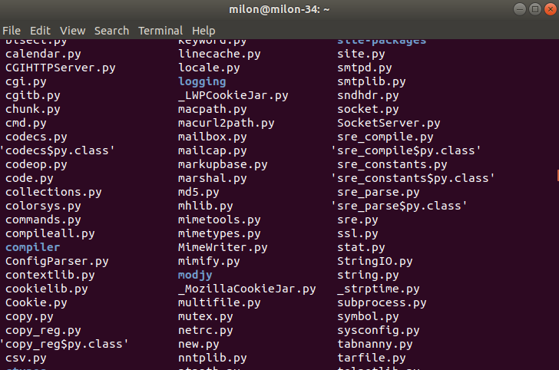

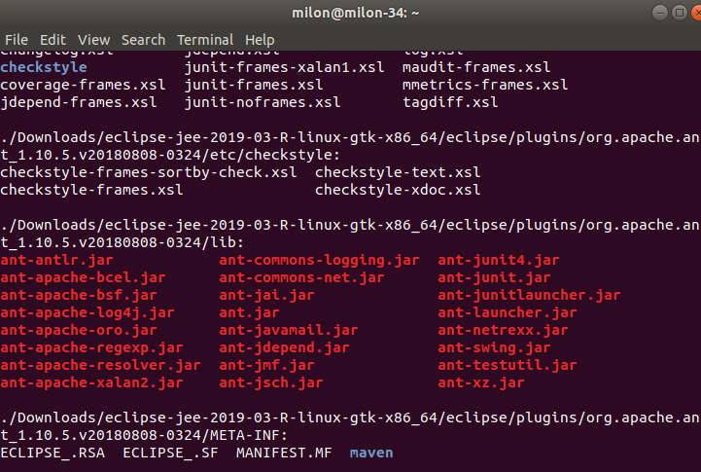

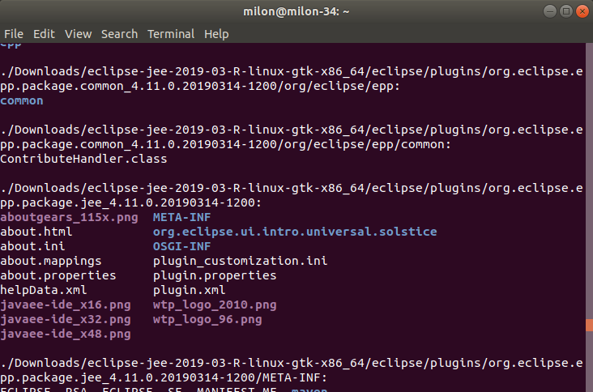
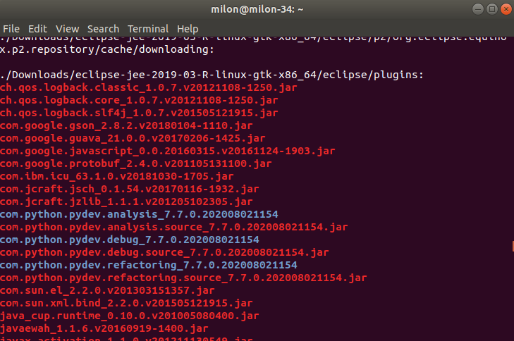
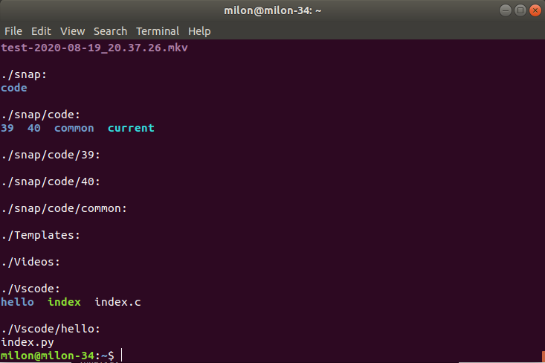
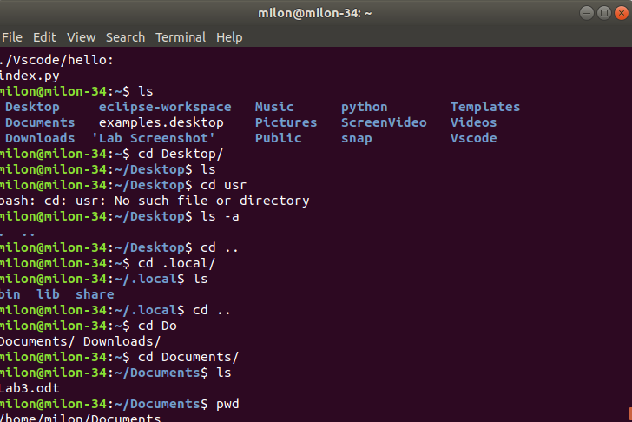
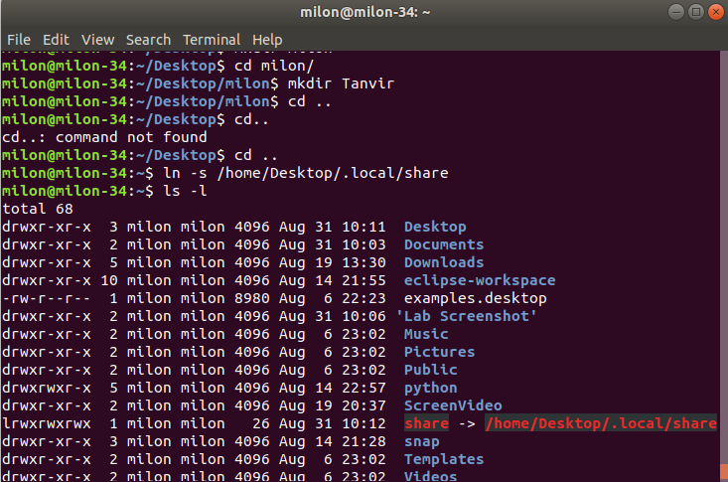
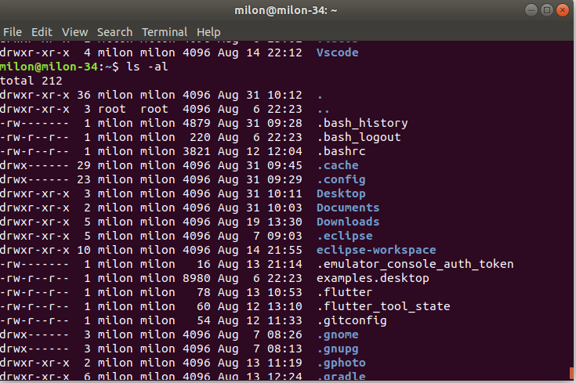
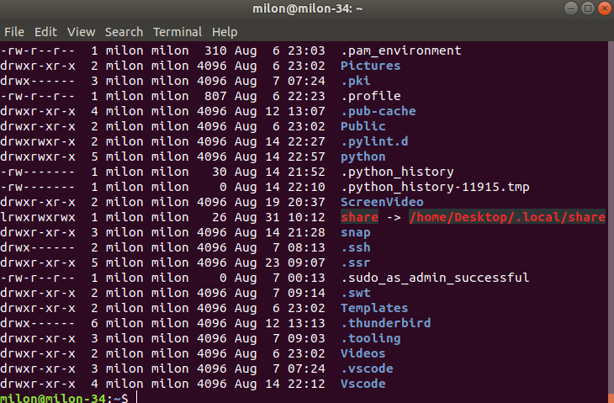

6) mkdir – Make Directories
The mkdir command makes a new directory. mkdir example will make a directory with the name “example” in the current directory.

Discussion :
This is one of the most important lab so far as we learnt about various kinds of users and operations and how to set permission for different users , how to add or remove different set of permissions for a or a set of users .

