CA3 Report

Overview
It has been observed that students are facing difficulties navigating their way around the campus and accessing significant information. There is often misinformation and the student spend most of the time trying to figure where to go or how to get the information that they need. Students get late or miss their classes, they don’t know their way around the labs, they cannot access any events that are interested in just to mention a few.

To solve the problem the team will design a Campus Companion application. The application aims at fulfilling all the student needs in one application by providing a map that gives directions to locations. It will provide relevant personalized timetables, events and societies that are available in the student’s specific campus and steps on how to join with locations included. The app also aims at providing the helpdesk page that allows students to request for information about anything they need including assistance in logging in issues

Target Users
The primary target users are the first-year students who need to be familiar with the campus. Also, first year students ne to familiarise with the university environment including co-curricular activities like societies and events. In addition, returning students will be significant users as they will want to know their timetables and the location of their classes. Also, they need updated updates on societies and the upcoming events.

Secondary users of the application include the academic staff members. They need the application to send students updates and to be aware the events available. Some academic staff members are the involved in event organizing and they would want to know how the students’ academic calendar is like to be able to organize an event that would accommodate the students’ needs of attendance.

The administration staff will also be significant secondary users of the application. They need the application to be able to update student profiles if there is need. The administration is also involved in events organization to ensure that events are approved, and the required equipment and venues are available for the events to take place without any obstructions.

System design: Inputs, Processes, Outputs (IPO)
The system will be designed to take in inputs to be processed and then produce outputs. The timetable is one aspect we plan on having as one section that takes inputs like the class times, module names and the location which will be processed to produce timetables for the student as per their area of studies.
The events page takes in inputs like names of events available and dates with locations which the system compares the current events to previous similar events checking the attendance of the previous events then prints or a display of events details.
The search box allows users to input whatever they are searching for then it assessed whether it already in the system or not and then the system will print and display similar patterns to the searched item.
The helpdesk is one feature that allows users to type whatever they want help with, and it gets sent to the database with the information that is requested and await the response from the administration. The user gets an acknowledgment response.

Architecture overview (client, data storage, optional auth, serverless functions if used)
The application will be designed using a scripted website with CSS styling. For the backend structured query language will be used to design the tables through Supabase application. For authentication purposes the application will use a Supabase driven authentication system for log in purposes. It will be designed in such a way that some information is only available to logged in users only. We will make use of buttons, functional links and labels for triggering certain events like submission and searching. There will be links connecting the pages.

Data design (conceptual): key entities and relationships; what you will NOT collect (data minimisation)
The system is created through specific entities which include profile, timetables, events, societies, location and helpdesk. This is a representation of the data that is needed for the system to function properly and efficiently.

In terms of relationships the student will create a profile which will be connected to all the database timetables. This will make users to access their personalised timetables. One timetable can be accessed by many students from the same class. Students can also sign up for events, societies and access the maps and then request for assistance from helpdesk. A society can host an event, and many societies can host many events.

In terms of data minimisation principles, the application does not collect sensitive data like the first name and last name for the students or their home addresses. Only necessary data will be collected for certain purposes. An example the modules the user is doing is collected only for the personalised timetables only and is used for that. The student names are only collected when the user is requesting for assistance through the help desk section and is used for just that.

Usability and UI design decisions (navigation, layout consistency, feedback/messages)
As a team we chose a blue-pink themed website. The colours were chosen because the colour blue represents calmness, trust and serenity whilst pink represents youthfulness and passion. Since the application is primarily targeted at students, we believe the chosen colours are the most befitting. The website will consist of at least five pages with the homepage, events, societies, helpdesk and timetables. In terms of navigation all pages will consist of the navigation bar and side-menu and quick links, which consists of home, help and sign in buttons for easier navigation through pages. For the helpdesk form the system will retain an error message if an incorrect email is entered. Also, after submitting a helpdesk ticket the system will tell the user that their ticket has been submitted for feedback purposes

Accessibility plan (WCAG-aligned decisions: headings, labels, keyboard navigation, focus states, contrast)
The design aims at providing effective features like reliable links, labels and buttons. Tables will be used to display timetables and grids to display events and societies. The application will support keyboard navigation. The main headings will be uniform throughout all the pages with larger text while normal readable text for the rest of the website to maintain consistency. Also, buttons will be different colours when hovering around and when being clicked on this helps the user to know which button to improve readability.
There will be interactive form provided like the search bar which allows users to type whatever they wish to search for without going through all the pages. We aim at including placeholders on text field which guide the users of what to type in. The same applies to the helpdesk forms which have placeholders to show the kind of input expected.

Privacy, security, and compliance (GDPR basics: lawful basis conceptually, minimisation, retention; risks + mitigations)

Privacy, Security and compliance will be greatly considered in the design process. The system will collect information like student ids, courses of study, visited events and societies and in app live location. Login activities will be also recorded for system improvement reasons. The system will not collect regular live location for users and unencrypted passwords. The information stored will be categorized in a way that it shows the sensitivity amount of information store for example the student id and location are highly sensitive. The password will be encrypted by supabase to ensure that no one can see the plain password inline with the GDPR policies

Deployment plan (conceptual)
The application will be deployed as a web-based platform which can be accessed by academic staff, students and administration staff and can be accessed through mobile phones, computers and tablets.
Appendix (wireframes, palette, diagrams, checklists)

WCAG-Checklist

HOME PAGE
1. SEARCH INPUT NEEDS A LABEL
- the search box only has placeholder text but no real label
- people using screen readers don't know what the search box is for
- fix: add an aria-label like "Search campus services"

2. SEARCH BUTTON NEEDS A DESCRIPTION
- the button just says "Search" but doesn't explain what it searches
- people using screen readers don't know what it's searching
- fix: add an aria-label like "Search campus services and events"

HELP DESK
1. REQUIRED FIELDS NOT MARKED
- the form doesn't show which fields you have to fill in
- people just try to submit without filling everything and get an error
- fix: put an asterisk (*) next to the fields that are required
- or add aria-required="true" in the code

2. SUBMIT BUTTON NEEDS A DESCRIPTION
- the button just says "submit" but doesn't explain what it's doing
- people using screen readers don't know what happens when they click it
- fix: make it say something like "submit your help desk ticket"

SETTINGS PAGE
1. CHECKBOXES HAVE NO LABELS
- the checkboxes (Large text, High Contrast Mode, Reduced Motion, Event Reminders,
Society Alerts, Helpdesk Updates) have no labels or aria-labels
- screen reader users can't tell what each checkbox does
- fix: add a <label> element for each checkbox or add aria-label="Toggle Large text" to each one

2. BUTTONS LACK DESCRIPTIONS
- buttons like "Sign Out", "Accessibility Help", "Notification Help", "Save Settings", "Restore Defaults" have no aria-labels
- screen readers just read the text but don't explain what they do
- fix: add aria-labels to buttons that need more context, like "Save your preferences" for the Save Settings button

3. SETTINGS SAVE WITHOUT CONFIRMATION
- when a user enables a setting (e.g. Large Text or High Contrast Mode) and clicks "Home", the change is automatically saved without clicking "Save Settings"
- users may not realise their changes were saved or may expect them to only apply after pressing "Save Settings"
- this creates confusion and reduces user control over their preferences

TIMETABLE PAGE
1. DAY SELECTION BUTTONS NEED LABELS
- the Monday, Tuesday, Wednesday, Thursday, Friday buttons have role="tab" and ariaselected states
- but they don't have aria-labels explaining what they do
- people using screen readers just hear "tab Monday" without context
- fix: add aria-label="View Monday's schedule" to each day button

SOCIETIES PAGE
1. "VIEW DETAILS" BUTTONS ARE NOT DESCRIPTIVE
- there are multiple "View Details" buttons for each society (Business Network Society, Campus Gamers Guild, etc.)
- but the buttons don't say which society they're for
- a screen reader user just hears "button: View Details" with no context about which society
- fix: change button text to "View details for Business Network Society" or add arialabel="View details for Business Network Society"

CAMPUS MAP PAGE
1. SEARCH INPUT HAS NO LABEL
- the search input only has placeholder text but no actual label
- screen reader users don't know what the search field is for
- fix: add a <label> element for the search input or add aria-label="Search campus map by building, service, or category"

2. CATEGORY FILTER BUTTONS HAVE NO STATES
- the buttons (All, Academic, Food, Study, Support, Recreation, Accessibility) don't have ariapressed or aria-selected states
- screen readers can't tell which category is currently selected
- fix: add aria-pressed="true/false" to each button or aria-selected="true/false"

3. MAP ITSELF IS NOT ACCESSIBLE
- the map (the visual with circles A, B, C marking locations) has no description for screen reader users
- people using screen readers can't understand what the map shows or how to interact with it
- fix: add role="img" and aria-label="Campus map showing building locations. Use the category filters or search to find locations." to the map container
- or provide a text-based list of locations as an alternative

Before:
After:

SUPABASE DATABASE

User tester 1:
User tester 2:
Name: Evan
I tested finding an event using the Events page by browsing and using the available options. The feature worked well overall, and I was able to find an event without any major issues.

User tester 3:
Name: Elliot
I tested finding a location using the campus map by using the search bar and category filters. I was able to navigate the map and locate the building successfully, and the feature worked well overall. The layout was clear and I did not experience any major issues while completing the task.

Netilfy Deployment Evidence

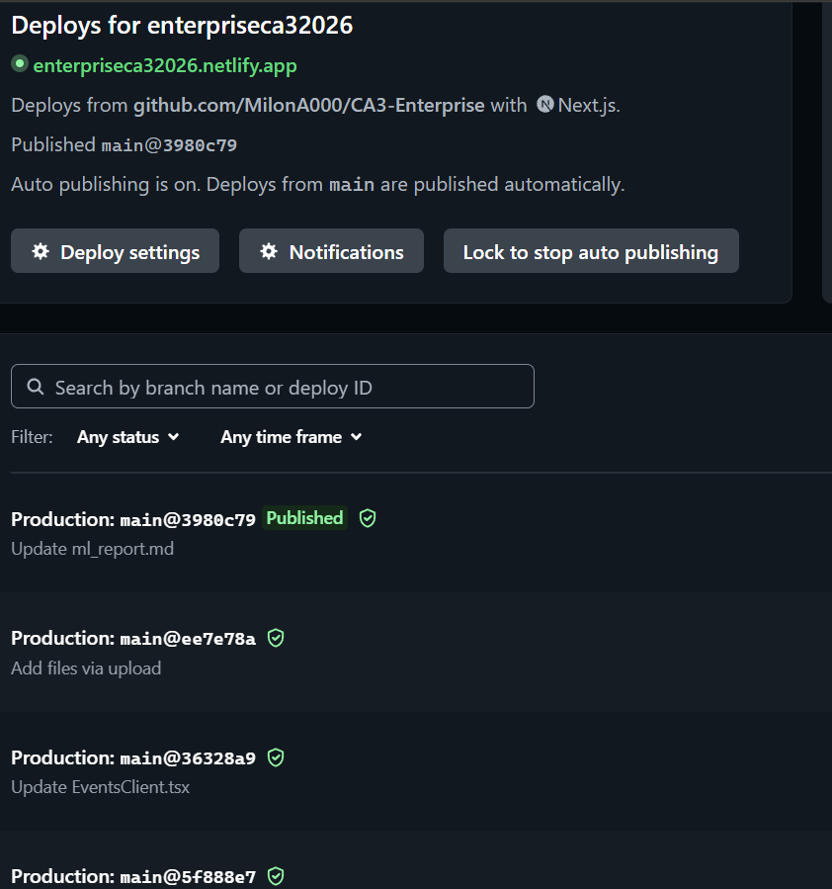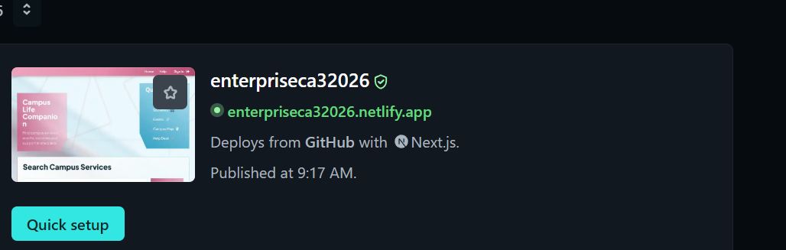

Colour Pallet

Wireframe

AI WAIVER:

Student Names: Joshua Lyons, Aseel Nawasrah, Andile
Ngwenya, Atalanta Madzikwa, Milon Manthei Loughlin

Group name/number: 18

Module: Nature of Enterprise Computing

Assessment: CA3 Design Report (Component 1)

Declaration: I confirm that We did not/will not use
generative AI (e.g., ChatGPT/Claude or other
AI tools) to produce any part of the design
report. I understand that genAI use in this
component results in a mark of 0 for this
component for the whole group.

Signature: Joshua Lyons, Aseel Nawasrah, Andile
Ngwenya, Atalanta Madzikwa, Milon Manthei Loughlin

Date: 01/05/2026

