

|  |  |
| --- | --- |
| **LEARNER** | Miloni Agarwal |
| **TRAINER** | Craig Reeves |
| **DATE** | 13/04/213022 |

**Week 1**

**Activity 1: Quantitative vs. Qualitative**

**Looking at the table above which of the column headers are Quantitative: and which are Quantitative?**

|  |  |  |  |  |  |  |
| --- | --- | --- | --- | --- | --- | --- |
| First Name | Last Name | Age | Company Name | Height in cm | Eye-colour | Number of Order |
| Aleshia | **Tomkiewicz** | **36** | **Alan D Rosenburg Cpa Pc** | **185** | **Brown** | **452** |
| Evan | **Zigomalas** | **30** | **Cap Gemini America** | **187** | **Green** | **1657** |
| France | **Andrade** | **31** | **Elliott, John W Esq** | **176** | **Blue** | **1414** |
| Ulysses | **Mcwalters** | **20** | **Mcmahan, Ben L** | **190** | **Brown** | **1935** |
| Tyisha | **Veness** | **29** | **Champagne Room** | **178** | **Brown** | **386** |
| Eric | **Rampy** | **68** | **Thompson, Michael C Esq** | **181** | **Green** | **221** |

|  |  |
| --- | --- |
| **Quantitative** | **Qualitative:** |
| **age** | **Eye-colour** |
| **Height** | **First Name** |
| **Number of orders** | **Last Name** |
|  | **Company Name** |
|  |  |
|  |  |

**Activity 2 : Sources of Data**

**Write a description of the following sources of data and include 2 examples of each, where they can be gathered from.**

**Primary Data :** Primary data is information collected through original or first-hand research.

For example, surveys and focus group discussions.

**Secondary Data :** Secondary data is information which has been collected in the past by someone else.

For example, researching the internet, newspaper articles and company reports.

**Tertiary Data :** Tertiary Data is based on a collection of primary and secondary Data.

Examples of tertiary Data textbooks dictionaries, encyclopedias, manuals, guidebooks and directories.

**Public or Open Data (What’s the difference?)**

**O**[**pen data**](https://portal0.cf.opendata.inter.sandbox-toronto.ca/) is the information that has been published on government-sanctioned portals. In the best case, this data is structured, machine-readable, open-licensed, and well maintained.

[**Public data**](https://www.google.com/publicdata/directory) is the data that exists everywhere else. This is information that’s freely available (but not really accessible) on the web. It is frequently unstructured and unruly, and its usage requirements are often vague.

**ACTIVITY 3: DATA GATHERING**

**You are in a start-up company, and you want to develop a product/service/video game (anything you’re interested in).**

**You want to reach out to your target market by creating a short survey (minimum 5 questions)**

**Think of the questions you want to ask and the format of how the users can answer (if it's a yes/no or 1-9 scale).**

**Under each question write why and what you hope to gain from the answers and why is it in that format.**

**I am planning to start a property letting services.**

1. **How will I get the properties from the Landlords?**
2. **What do I have different in my company to offer then the established players in the market?**
3. **What do I have in place to offer Tenants?**
4. **What should be fees?**
5. **How will Landlord or tenant trust me?**

**ACTIVITY 4 Databases**

**Name 4 different DBMS’s *Example MySQL***

1. Relational database – MySQL, Oracle Database
2. Object oriented database – MongoDB, NoSQL
3. Hierarchical database - The IBM Information Management System
4. Network database

**ACTIVITY 5 Databases**

**Do some research online and try to identify what you think the best database data type for the following forms of data might be.**

**A NUMBER (e.g. the number 1000) - Numeric**

**A SHORT PIECE OF TEXT (e.g. an email address) - Text - Varchar**

**A LONG SECTION OF TEXT (e.g. a short essay) - ntext**

**A DATE - DATE**

**A TIME - TIME**

**A YES/NO VALUE - Boolean**

**AN IMAGE - image**

**ACTIVITY 6 Databases Design (extended Task)**

**Use any tool you like to create an ERD based on something you are interested in.**

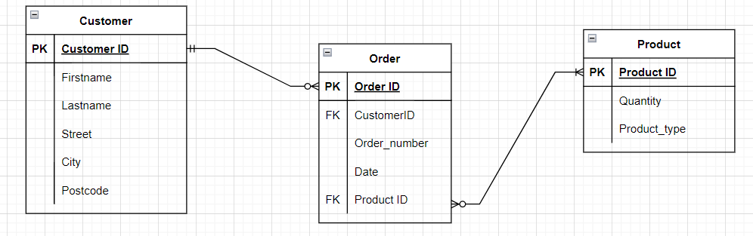

***<SREENSHOT>***

**ACTIVITY 8 <Extended Optional>**

**IN MySQL create the schema for your database.**

***Saved as week1_script on github:***

***https://github.com/Miloni1/Week1_Script/blob/main/Week1_Script.sql***