1c) x = [0, 2, 3, 4]

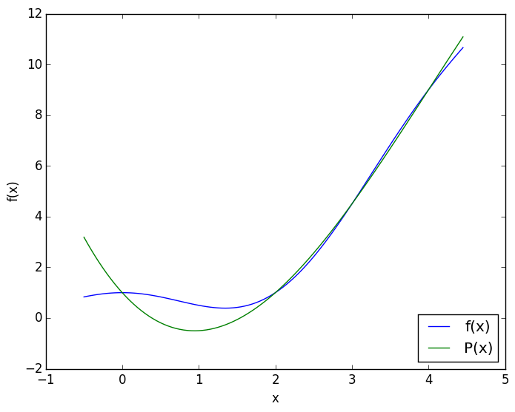

1d) x = [0, 1, 2.5, 4]

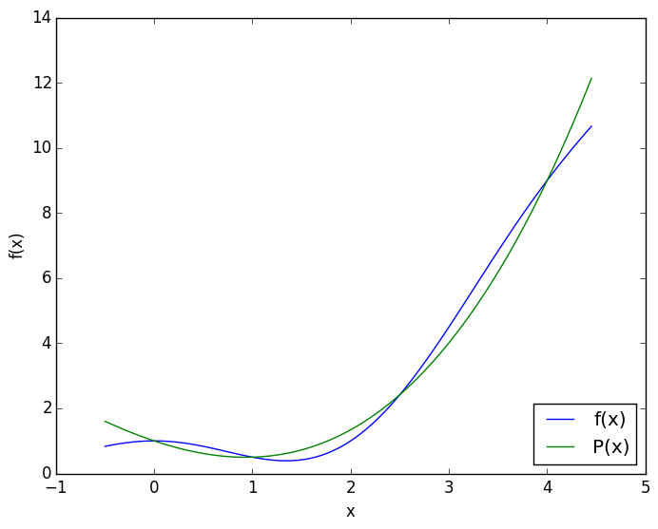

3a) i. Piecewise linear interpolation

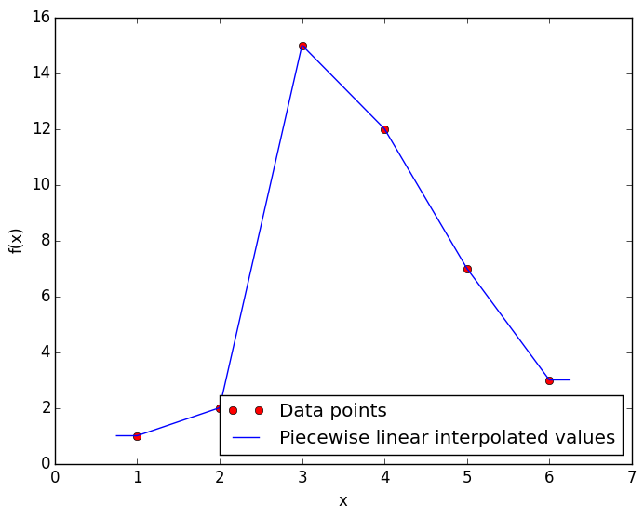

3a) ii. Lagrange polynomial interpolation

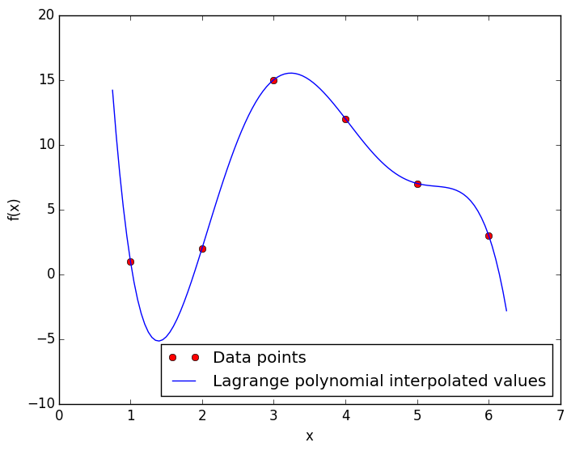

3a) iii. Spline interpolation

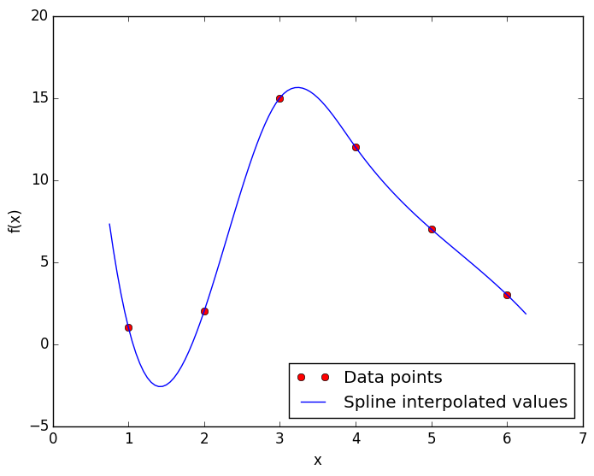

4d) Log-log plot of data and least squares approximation of data

