**Template version: 1.0**

UML

UML diagrams

diagram types

**UML company**

**www.uml.com**

**Document Number: 4**

**Version: 2.0**

**Release Date: 09.03.2021**

Document History

Author Name: UML Author

Author Contact: uml@diagram.com

Document Revision

|  |  |  |  |  |
| --- | --- | --- | --- | --- |
| Version Number | Release Date | Status | Change Description | Author |
| 2.0 | 09.03.2021 | Draft | UML diagrams change | Uemelko Diagramic |
|  |  |  |  |  |
|  |  |  |  |  |
|  |  |  |  |  |

Intellectual Property Rights

This document is exclusive property of UML company and all rights are reserved.

Table of Contents

1 Introduction 4

1.1References 4

Figure 1: Last Page 6

Table 1: Document references 4

# Introduction

## References

Referenced documents in creation of this document are listed in the Table 1.

|  |  |  |  |
| --- | --- | --- | --- |
| Document Reference | Document Title | Version | Filename |
| [1] | UML reference |  | umlDocFile |
| [2] |  |  |  |
| [3] |  |  |  |
| [4] |  |  |  |
| [5] |  |  |  |
| [6] |  |  |  |
| [7] |  |  |  |
| [8] |  |  |  |

Table 1: Document references

# This is md file with coded UML diagram

## title: UC3 Work in our App and Publish Docs in GIT weight: 3 layout: docs

## This is first uml

In this section we will explain the workflow on how you can work in our Webapp and publish docs in Git.
The workflow is outlined in the following UML diagram:

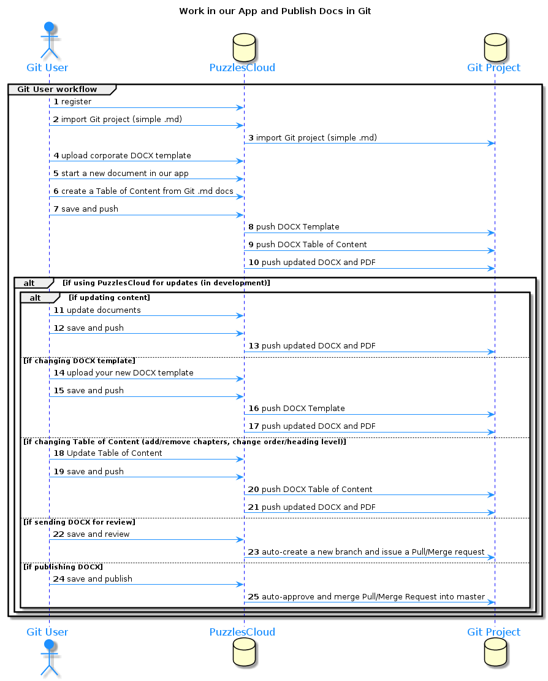

preview: <https://www.planttext.com/>
-->

## This is second UML diagram

**YOU CAN CHECK IT BELLOW**

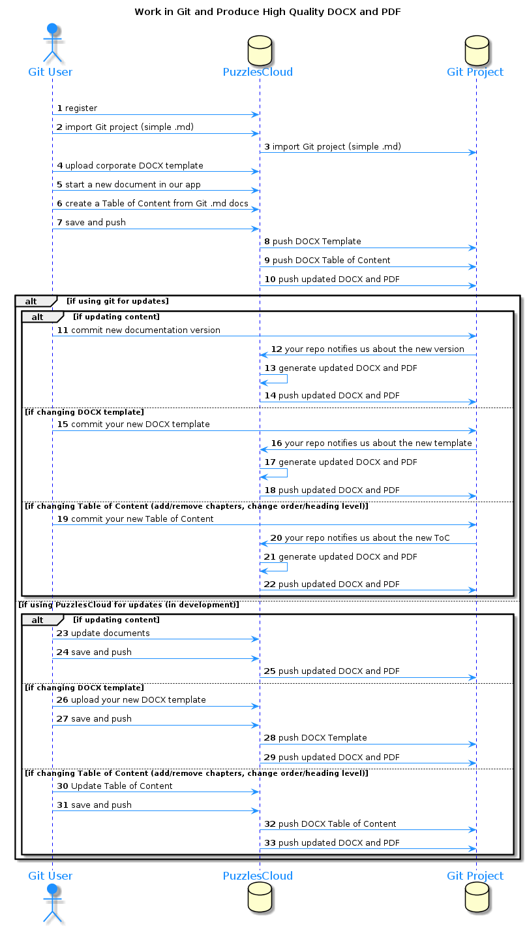



Figure 1: Last Page