Visoka škola strukovnih studija za informacione i komunikacione tehnologije

**Miloš Mićin Dokumentacija**

Smer: **Internet tehnologije** Modul: **Web programiranje** Predmet: **Web programiranje**

**PHP1**

Beograd, Mart 2015. godine.

**SADRŽAJ**

**1. Uvod**

**1.1 Korišćeni programski jezici**

**1.2 Opis funkcionalnosti**

**1.3 Template**

**1.4 Korišćeni CSS**

**2. Organizacija**

**2.1 Slike stranica i opisi funkcionalnosti**

**2.1.1 index.php**

**2.1.2 forma.php**

**2.1.3 logovanje.php**

**2.1.4 registracija.php**

**2.1.5 galerija.php**

**2.1.6 slike.php**

**2.1.7 admin.php**

**2.1.8 anketa.php**

**2.1.9 prikaz.php**

**2.1.10 milos.php**

**3. Kodovi**

**3.1 PHP**

**2.1.1 index.php**

**2.1.2 forma.php**

**2.1.3 logovanje.php**

**2.1.4 registracija.php**

**2.1.5 galerija.php**

**2.1.6 slike.php**

**2.1.7 admin.php**

**2.1.8 anketa.php**

**2.1.9 prikaz.php**

**2.1.10 milos.php**

**3.2 CSS**

**3.2.1 global.css**

**3.3 JavaScript / jQuery**

**3.3.1 ajax.js**

**3.3.2 telefoni.js**

**3.4 Baza Podataka**

**3.4.1 baza.sql**

**1. Uvod**

**1.1 Korišćeni programski jezici**

Za izradu ovog sajta koristio sam sledeće tehnologije:

HTML, CSS, PHP, JavaScript, AJAX i jQuery, SQL. Ceo kod je pisan u **Notepad++** text editoru.

**1.2 Template**

Template je uzet sa yourname.com sajta. On u sebi sadrži omot koji se sastoji iz headera, sadržaja i footera. Header se sastoji iz 3 diva. Div sa navigacijom, div sa naslovom i div koji u sebi sadrži sliku.

Sadržaj ima levi deo i desni deo. U levom delu se nalazi navigacija za telefone koja se pokreće AJAXom. Ispod se nalazi slika. U desnom delu se nalazi neki text.

Footer sadrži prava i stranu o autoru.

**1.3 Korišćeni CSS**

Korišćen je CSS sa sajta youtname.com.

**2. Organizacij**

2.1 Slike stranica i opisi funkcionalnosti

**2.1.1 index**

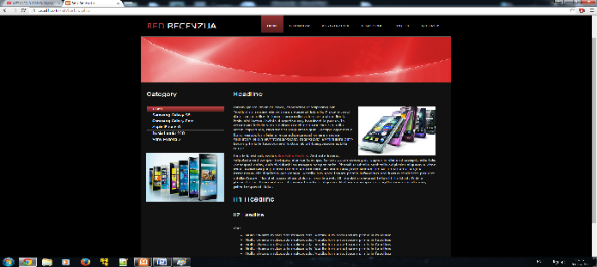

Ovo je sajt za recenzije mobilnih telefona. On u sebi sadrži meni sa aktivnim linkovima, koji se uzimaju iz baze. Unosom podataka putanje linka, naziv linka i broja roditelja(0 ako je meni, 1 ako je podmeni tog menija itd..) pravi se novi link. Jedino je home stranica u neku ruku statička zbog posebne clase CSSa.

U sadržaju sa leve strane postoji lista linkova kojima se odlazi na sadržaj željenog telefona. Na ovim linkovima se koristio AJAX koji ne učita novu stranicu, već samo promeni sadržaj, sa sve slikama i tekstom.

Ovi linkovi nisu dinamički. Nisam uspeo da pokrenem događaje preko baze podataka jednostavno nije funkcionisalo.

U fotter delu se nalazi sajt odakle je template skinut, strana o autoru i dokumentacija ovog sajta.

**2.1.2 forma**

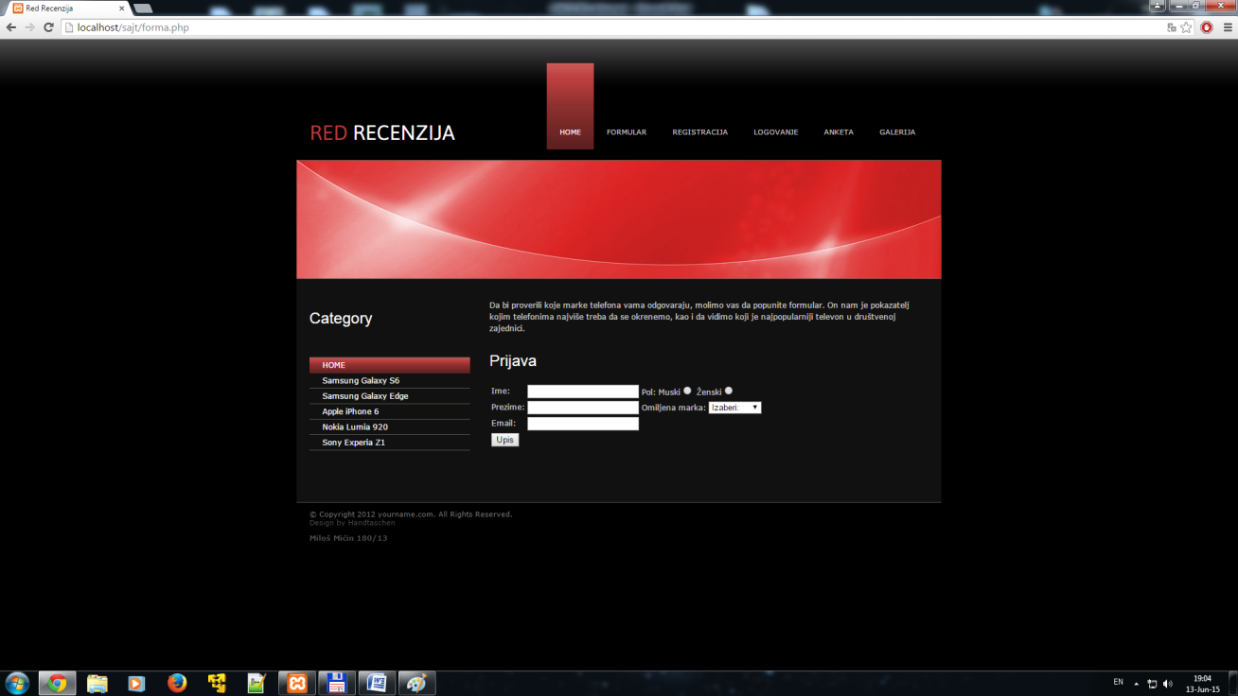

Forma sadrži u sebi formular koji je odrađennn regularnim izrazima i povezan sa bazom podataka. Po uspešnom unosu podataka pojavljuje se link za stranicu koja pokazuje unete podatke. Stranica se zove prikaz.php

**2.1.3 logovanje**

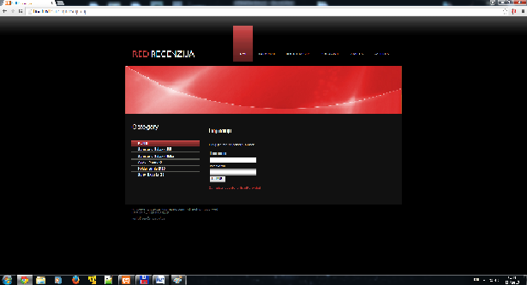

Stranica logovanje omogućava da pristupite anketi. Formular se sastoji iz 2 textualna polja to jest username i password. Takođe postoji i submit dugme.Ispod se nalazi link koji vodi na stranicu registracija, u slučaju da se kojisnik nije registrovao.

Na stranici logovanje su korišćene sesije. Uzimanjem podataka iz baze sesijom mozete ući uz postojeće podatke iz baze.

**2.1.4 registracija**

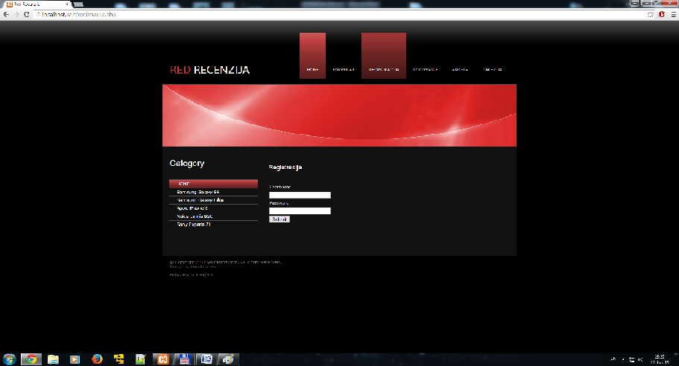

Stranica za registraciju sadrži formular koji se sastoji iz dva tekstualna prostora. Po kliku na Submit dugme podaci iz username i password polja se unose u bazu podataka koji se posle mogu dohvatiti sa stranice logovanje.php.

**2.1.5 galerija**

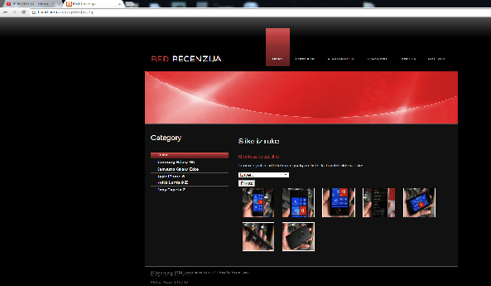

Ideja ove stranice je da prikazuje slike iz ruke telefona koji je korisnik izabrao sa padajuđe lise koja je predstavljena kao galerija. Na ovoj strani je koriscen jQuery koji prikaže sliku kad se klikne na nju. Na strani postoji i link koji administratoru sajta omogućava da lakše unosi slike u bazu i na ovoj strani da prikaže istu.

**2.1.6 slike**

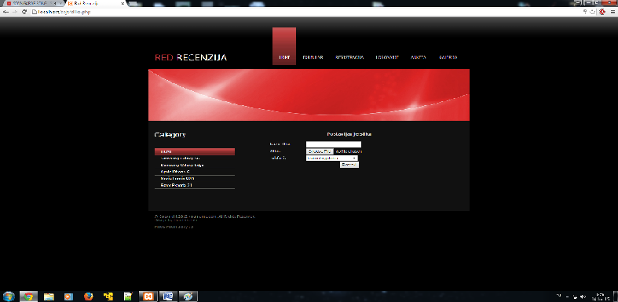

Na ovoj strani postoji formular. Koja se sastoji od tekstualnog prostora kojim se unosi ime slike. Postoji dugme za selektovanje fajla. Zatim tu je i padajuća lista koja poseduje određen broj galerija.

Kad admin odradi se opcije, submit dugmetom šalje podatke u bazu podataka i onda ih sa stranice galerija.php dohvata.

**2.1.7 admin**



Username i password za ovu stranu je **ADMIN.** Pomoću nje se ulazi na stranu slike.php. Korišćene su sesije radi zaštite.

**2.1.8 anketa**

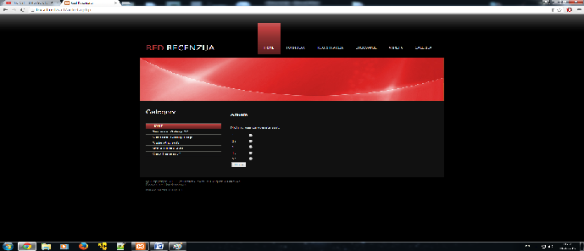

Na stranicu anketa.php se može ući samo ako imate nalog i ako ste se registrovali. Anketa služi samo za ocenu sajta koja se po završetku koriščenja submit dugmetom unosi u bazu. Podaci koji se mogu naći u toj bazi su broj ocena, zbir ocena i prosek ocena.

**2.1.9 prikaz**

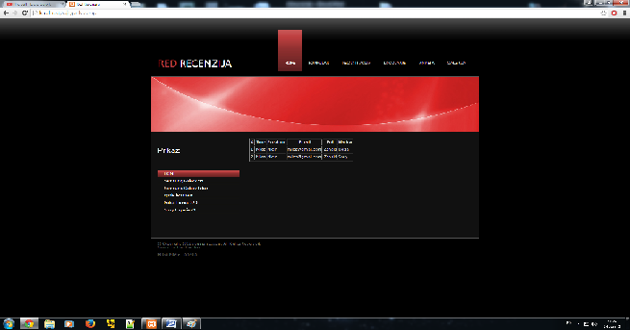

Prikaz.php postavlja tabelu u koju su upisani podaci koje je korisnik uneo u forma.php stranici, to jest dohvata podatke iz baze podataka koji su uneti u bazu pomoću formulara sa stranice forma.php.

**2.1.10 milos**

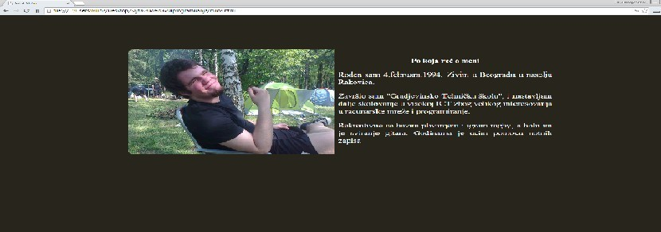

Strana o autoru.

**3. Kodovi**

**3.1 PHP**

**3.1.1 index.php**

<!DOCTYPE html PUBLIC "-//W3C//DTD XHTML 1.0 Strict//EN"

"http://www.w3.org/TR/xhtml1/DTD/xhtml1-strict.dtd">

<html xmlns="http://www.w3.org/1999/xhtml" xml:lang="en" >

<head>

<meta http-equiv="content-type" content="text/html; charset=utf-8" />

<meta name="author" content="bred<" />

<meta name="keywords" content="bred<" />

<meta name="description" content="bred<" />

<meta name="robots" content="all" />

<script type = "text/javascript" src = "ajax.js"></script>

<script type = "text/javascript" src = "telefoni.js"></script>

<title>Red Recenzija</title>

<style type="text/css" title="currentStyle" media="screen">

@import "./css/global.css";

</style>

<link href='http://fonts.googleapis.com/css?family=Asap:400,700' rel='stylesheet' type='text/css'>

</head>

<body>

<div id="wrapper">

<div id="top">

<h1 class="logo"><span class="green1">RED</span> RECENZIJA </h1>

<?php

include('konekcija.php');

$upit_link= "SELECT * FROM linkovi WHERE link_roditelj=0";

$rezultat_link = mysql_query($upit_link,$konekcija);

echo("<ul id='topnavi'>");

echo "<li class='active'><a href='index.php'>HOME</a></li>";

while($r=mysql_fetch_array($rezultat_link)){

echo "<li>

<a href=".$r['link_putanja'].">".$r['link_ime']."</a>";

echo "</li>";

}

echo "</ul>";

?>

</div>

<div id="header">

<img src="img/header.jpg" alt="" width="1000" height="183" />

</div>

<div id="main">

<div id="left-part">

<h1>Category</h1>

<ul id="subnavi">

<li class="active"><a href="index.php">HOME</a></li>

<li><a href="#" onclick = "telefon1(this.value);">Samsung Galaxy S6</a></li>

<li><a href="#" onclick = "telefon2(this.value);">Samsung Galaxy Edge</a></li>

<li><a href="#" onclick = "telefon3(this.value);">Apple iPhone 6</a></li>

<li><a href="#" onclick = "telefon4(this.value);">Nokia Lumia 920</a></li>

<li><a href="#" onclick = "telefon5(this.value);">Sony Experia Z1</a></li>

</ul>

<img src="img/telefon/telefon6.jpg" alt="" width="251" height="196" class="right"/>

</div>

<div id="right-part">

<h1>Headline</h1>

<p><img src="img/telefon/telefon.jpg" alt="" width="251" height="196" class="right" />Lorem ipsum dolor sit amet,

consectetur adipiscing elit. Vestibulum ornare elementum neque at lobortis.

Fusce ac orci diam. Ut ac tellus in lorem commodo vulputate a vitae ligula. Proin nisl lectus, lacinia id

egestas eu, hendrerit id purus. In accumsan felis in sem pulvinar condimentum eget sed odio. Etiam sapien

leo, tincidunt at vulputate quis, suscipit eget lacus. Nunc vestibulum felis ut eros adipiscing at ornare

magna vulputate. Nulla viverra malesuada malesuada. Vestibulum ante ipsum primis in faucibus orci luctus

et ultrices posuere cubilia Curae;</p>

<p>Mauris id est mi, varius <a href="#">dignissim lectus</a>. Sed ante lorem, vulputate sed tempor tristique, elementum quis

tortor. Etiam consequat, sapien id eleifend suscipit, odio felis consequat enim, quis tincidunt leo magna

semper ante. Phasellus ut felis eget felis adipiscing aliquam a vitae dolor. Pellentesque pulvinar condimentum

nibh, eu vulputate justo fermentum et. Ut sit amet augue fermentum elit dignissim accumsan. Vestibulum ante

ipsum primis in faucibus orci luctus et ultrices posuere cubilia Curae; Morbi et quam vitae dolor ornare

laoreet. Ut feugiat consequat tellus id tincidunt. Duis a placerat eros. Proin vel arcu at ipsum hendrerit

aliquam. Nullam quam ipsum, sagittis non vehicula non, pellentesque ut dolor.</p>

<h1>H1 Headline</h1>

<h2>H2 Headline</h2>

<p>List:</p>

<ul class="list">

<li>Nulla viverra malesuada malesuada. Vestibulum ante ipsum primis in faucibus</li>

<li>Nulla viverra malesuada malesuada. Vestibulum ante ipsum primis in faucibus</li>

<li>Nulla viverra malesuada malesuada. Vestibulum ante ipsum primis in faucibus</li>

<li>Nulla viverra malesuada malesuada. Vestibulum ante ipsum primis in faucibus</li>

<li>Nulla viverra malesuada malesuada. Vestibulum ante ipsum primis in faucibus</li>

</ul>

<p><a href="#">This</a> is a link. </p>

</div>

</div>

<div id="footer">

<p>© Copyright 2012 yourname.com. All Rights Reserved. <br />

<span class="darkgrey">Design by <a href="http://www.prontomoda.de/" target="_blank" title="Handtaschen">Handtaschen</a></span></p>

<a href = "milos.php"><b>Miloš Mićin 180/13</b></a>

</div>

</div>

<div style="margin: 1em 0 3em 0; text-align: center;">

</div>

</body>

</html>

**3.1.2 forma.php**

<!DOCTYPE html PUBLIC "-//W3C//DTD XHTML 1.0 Strict//EN"

"http://www.w3.org/TR/xhtml1/DTD/xhtml1-strict.dtd">

<html xmlns="http://www.w3.org/1999/xhtml" xml:lang="en" >

<head>

<meta http-equiv="content-type" content="text/html; charset=utf-8" />

<meta name="author" content="bred<" />

<meta name="keywords" content="bred<" />

<meta name="description" content="bred<" />

<meta name="robots" content="all" />

<script type = "text/javascript" src = "ajax.js"></script>

<script type = "text/javascript" src = "telefoni.js"></script>

<title>Red Recenzija</title>

<style type="text/css" title="currentStyle" media="screen">

@import "./css/global.css";

</style>

<link href='http://fonts.googleapis.com/css?family=Asap:400,700' rel='stylesheet' type='text/css'>

</head>

<body>

<div id="wrapper">

<div id="top">

<h1 class="logo"><span class="green1">RED</span> RECENZIJA</h1>

<?php

include('konekcija.php');

$upit= "SELECT * FROM linkovi WHERE link_roditelj=0";

$rezultat = mysql_query($upit,$konekcija);

echo("<ul id='topnavi'>");

echo "<li class='active'><a href='index.php'>HOME</a></li>";

while($r=mysql_fetch_array($rezultat)){

echo "<li>

<a href=".$r['link_putanja'].">".$r['link_ime']."</a>";

echo "</li>";

}

echo "</ul>";

?>

</div>

<div id="header">

<img src="img/header.jpg" alt="" width="1000" height="183" />

</div>

<div id="main">

<div id="left-part">

<p><h1>Category</h1></p>

<ul id="subnavi">

<li class="active"><a href="index.php">HOME</a></li>

<li><a href="#" onclick = "telefon1(this.value);">Samsung Galaxy S6</a></li>

<li><a href="#" onclick = "telefon2(this.value);">Samsung Galaxy Edge</a></li>

<li><a href="#" onclick = "telefon3(this.value);">Apple iPhone 6</a></li>

<li><a href="#" onclick = "telefon4(this.value);">Nokia Lumia 920</a></li>

<li><a href="#" onclick = "telefon5(this.value);">Sony Experia Z1</a></li>

</ul>

</div>

<div id="right-part">

<p>Da bi proverili koje marke telefona vama odgovaraju, molimo vas da popunite formular. On nam je pokazatelj

kojim telefonima najviše treba da se okrenemo, kao i da vidimo koji je najpopularniji televon u društvenoj zajednici.<p>

<?php

include('konekcija.php');

$upit_marke = "SELECT * FROM marka ORDER BY ime_marke";

$rezultat_marke = mysql_query($upit_marke, $konekcija);

if(!$rezultat_marke)

{

echo "Opcija omiljene marke nije selektovana!".mysql_error();

}

else

{

$marke = "";

while($r = mysql_fetch_array($rezultat_marke))

{

$marke .= "<option value = '".$r['id_marka']."'>".$r['ime_marke']."</option>";

}

}

?>

<div id = "form">

<form name = "forma" action = "forma.php" method = "POST">

<h1>Prijava</h1>

<table>

<tr>

<td>

Ime:

</td>

<td>

<input type = "text" name="tbIme" id = "tbIme"/>

</td>

<td>

Pol: Muski<input type = "radio" name = "rbPol" value = "M"/>

Ženski<input type = "radio" name = "rbPol" value = "Z"/>

</td>

</tr>

<tr>

<td>

Prezime:

</td>

<td>

<input type = "text" name="tbPrezime" id = "tbPrezime"/>

</td>

<td>

Omiljena marka: <select name = "ddlMarka">

<option value = "0">Izaberi:</option>

<?php print $marke; ?>

</select>

</td>

</tr>

<tr>

<td>

Email:

</td>

<td>

<input type = "text" name="tbMail" id = "tbMail"/>

</td>

</tr>

<tr>

<td>

<input type = "submit" class = "button" name = "btnUpis" value = "Upis"/>

</td>

</tr>

</table>

</form>

</div>

<?php

if(isset($_POST['btnUpis']))

{

$ime = $_POST['tbIme'];

$prezime = $_POST['tbPrezime'];

$mail = $_POST['tbMail'];

$pol = $_POST['rbPol'];

$marka = $_POST['ddlMarka'];

$reIme = "/^[A-Z][a-z]{2,10}$/";

$rePrezime = "/^[A-Z][a-z]{2,20}$/";

$reMail = "/^[a-zA-Z0-9\.\-]+@[a-zA-Z0-9\.\-]+$/";

if(!preg_match($reIme, $ime))

{

echo "Niste uneli pravilno ime!";

break;

}

else if(!preg_match($rePrezime, $prezime))

{

echo "Niste uneli pravilno prezime!";

}

else if(!preg_match($reMail, $mail))

{

echo "Niste uneli dobaro Email adresu!";

break;

}

else if(empty($pol))

{

echo "Unesite pol!";

break;

}

else if($marka == "0")

{

echo "Izaberite marku!";

break;

}

$upit = "INSERT INTO prijava VALUES('', '$ime', '$prezime', '$mail', '$pol', '$marka')";

$rezultat = mysql_query($upit, $konekcija);

if($rezultat)

{

echo "Uspešno ste uneli podatke!";

echo '<a href = "prikaz.php">Prikaz podataka</a>';

}

mysql_close($konekcija);

}

?>

<div>

</div>

</div>

</div>

<div id="footer">

<p>© Copyright 2012 yourname.com. All Rights Reserved. <br />

<span class="darkgrey">Design by <a href="http://www.prontomoda.de/" target="_blank" title="Handtaschen">Handtaschen</a></span></p>

<a href = "milos.php"><b>Miloš Mićin 180/13</b></a>

</div>

</div>

<div style="margin: 1em 0 3em 0; text-align: center;">

</div>

</body>

</html>

**3.1.3 logovanje.php**

<?php

@session_start();

include ('konekcija.php');

if(isset($_POST['btnRegistracija']))

{

$username = $_POST['username'];

$password = $_POST['password'];

$upit = "SELECT * FROM registracija WHERE username = '".$username."' AND password = '".$password."'";

$rezultat = mysql_query($upit, $konekcija);

if(mysql_num_rows($rezultat) != 0)

{

$red = mysql_fetch_array($rezultat);

$username = $red['username'];

$_SESSION['logovanje'] = $username;

header('Location:anketa.php');

}

}

?>

<!DOCTYPE html PUBLIC "-//W3C//DTD XHTML 1.0 Strict//EN"

"http://www.w3.org/TR/xhtml1/DTD/xhtml1-strict.dtd">

<html xmlns="http://www.w3.org/1999/xhtml" xml:lang="en" >

<head>

<meta http-equiv="content-type" content="text/html; charset=utf-8" />

<meta name="author" content="bred<" />

<meta name="keywords" content="bred<" />

<meta name="description" content="bred<" />

<meta name="robots" content="all" />

<script type = "text/javascript" src = "ajax.js"></script>

<script type = "text/javascript" src = "telefoni.js"></script>

<title>Red Recenzija</title>

<style type="text/css" title="currentStyle" media="screen">

@import "./css/global.css";

</style>

<link href='http://fonts.googleapis.com/css?family=Asap:400,700' rel='stylesheet' type='text/css'>

</head>

<body>

<div id="wrapper">

<div id="top">

<h1 class="logo"><span class="green1">RED</span> RECENZIJA</h1>

<?php

$upit_link= "SELECT * FROM linkovi WHERE link_roditelj=0";

$rezultat_link =

mysql_query($upit_link,$konekcija);

echo("<ul id='topnavi'>");

echo "<li class='active'><a href='index.php'>HOME</a></li>";

while($r=mysql_fetch_array($rezultat_link)){

echo "<li>

<a href=".$r['link_putanja'].">".$r['link_ime']."</a>";

echo "</li>";

}

echo "</ul>";

mysql_close($konekcija);

?>

</div>

<div id="header">

<img src="img/header.jpg" alt="" width="1000" height="183" />

</div>

<div id="main">

<div id="left-part">

<h1>Category</h1>

<ul id="subnavi">

<li class="active"><a href="index.php">HOME</a></li>

<li><a href="#" onclick = "telefon1(this.value);">Samsung Galaxy S6</a></li>

<li><a href="#" onclick = "telefon2(this.value);">Samsung Galaxy Edge</a></li>

<li><a href="#" onclick = "telefon3(this.value);">Apple iPhone 6</a></li>

<li><a href="#" onclick = "telefon4(this.value);">Nokia Lumia 920</a></li>

<li><a href="#" onclick = "telefon5(this.value);">Sony Experia Z1</a></li>

</ul>

</div>

<div id="right-part">

<p><h2>Logovanje</h2></p>

<p>Ulogujte se za pristup anketi.</p>

<form name = "registracija" method = "POST" action = "logovanje.php">

<table style = "margin:opx auto;">

<tr>

<td>Username</td>

</tr>

<tr>

<td><input type = "text" name = "username"></td>

</tr>

<tr>

<td>Password</td>

</tr>

<tr>

<td><input type = "password" name = "password"></td>

</tr>

<tr>

<td><input type = "submit" name = "btnRegistracija"></td>

</tr>

</table>

<p><a href = "registracija.php">Za registrovanje pritisnite ovde!</a></p>

</form>

</div>

</div>

<div id="footer">

<p>© Copyright 2012 yourname.com. All Rights Reserved. <br />

<span class="darkgrey">Design by <a href="http://www.prontomoda.de/" target="_blank" title="Handtaschen">Handtaschen</a></span></p>

<a href = "milos.php"><b>Miloš Mićin 180/13</b></a>

</div>

</div>

<div style="margin: 1em 0 3em 0; text-align: center;">

</div>

</body>

</h

**3.1.4 registracija.php**

<!DOCTYPE html PUBLIC "-//W3C//DTD XHTML 1.0 Strict//EN"

"http://www.w3.org/TR/xhtml1/DTD/xhtml1-strict.dtd">

<html xmlns="http://www.w3.org/1999/xhtml" xml:lang="en" >

<head>

<meta http-equiv="content-type" content="text/html; charset=utf-8" />

<meta name="author" content="bred<" />

<meta name="keywords" content="bred<" />

<meta name="description" content="bred<" />

<meta name="robots" content="all" />

<script type = "text/javascript" src = "ajax.js"></script>

<script type = "text/javascript" src = "telefoni.js"></script>

<title>Red Recenzija</title>

<style type="text/css" title="currentStyle" media="screen">

@import "./css/global.css";

</style>

<link href='http://fonts.googleapis.com/css?family=Asap:400,700' rel='stylesheet' type='text/css'>

</head>

<body>

<div id="wrapper">

<div id="top">

<h1 class="logo"><span class="green1">RED</span> RECENZIJA</h1>

<?php

include('konekcija.php');

$upit_link= "SELECT * FROM linkovi WHERE link_roditelj=0";

$rezultat_link = mysql_query($upit_link,$konekcija);

echo("<ul id='topnavi'>");

echo "<li class='active'><a href='index.php'>HOME</a></li>";

while($r=mysql_fetch_array($rezultat_link)){

echo "<li>

<a href=".$r['link_putanja'].">".$r['link_ime']."</a>";

echo "</li>";

}

echo "</ul>";

mysql_close($konekcija);

?>

</div>

<div id="header">

<img src="img/header.jpg" alt="" width="1000" height="183" />

</div>

<div id="main">

<div id="left-part">

<h1>Category</h1>

<ul id="subnavi">

<li class="active"><a href="index.php">HOME</a></li>

<li><a href="#" onclick = "telefon1(this.value);">Samsung Galaxy S6</a></li>

<li><a href="#" onclick = "telefon2(this.value);">Samsung Galaxy Edge</a></li>

<li><a href="#" onclick = "telefon3(this.value);">Apple iPhone 6</a></li>

<li><a href="#" onclick = "telefon4(this.value);">Nokia Lumia 920</a></li>

<li><a href="#" onclick = "telefon5(this.value);">Sony Experia Z1</a></li>

</ul>

</div>

<div id="right-part">

<p><h2>Registracija</h2></p>

<form name = "registracija" method = "POST" action = "registracija.php">

<table style = "margin:opx auto;">

<tr>

<td>Username</td>

</tr>

<tr>

<td><input type = "text" name = "username"></td>

</tr>

<tr>

<td>Password</td>

</tr>

<tr>

<td><input type = "password" name = "password"></td>

</tr>

<tr>

<td><input type = "submit" name = "btnRegistracija"></td>

</tr>

</table>

</form>

<?php

include('konekcija.php');

if(isset($_POST['btnRegistracija']))

{

$username = $_POST['username'];

$password = $_POST['password'];

$upit = "INSERT INTO registracija VALUES('', '$username', '$password')";

$rezultat = mysql_query($upit, $konekcija);

if($rezultat)

{

echo "Uspesno ste upisali podatke!";

header('Location:logovanje.php');

}

}

mysql_close($konekcija);

?>

</div>

</div>

<div id="footer">

<p>© Copyright 2012 yourname.com. All Rights Reserved. <br />

<span class="darkgrey">Design by <a href="http://www.prontomoda.de/" target="_blank" title="Handtaschen">Handtaschen</a></span></p>

<a href = "milos.php"><b>Miloš Mićin 180/13</b></a>

</div>

</div>

<div style="margin: 1em 0 3em 0; text-align: center;">

</div>

</body>

</html>

<div id = "sadrzaj">

<div id= "sadrzaj_levo">

**3.1.5 galerija.php**

<!DOCTYPE html PUBLIC "-//W3C//DTD XHTML 1.0 Strict//EN"

"http://www.w3.org/TR/xhtml1/DTD/xhtml1-strict.dtd">

<html xmlns="http://www.w3.org/1999/xhtml" xml:lang="en" >

<head>

<meta http-equiv="content-type" content="text/html; charset=utf-8" />

<meta name="author" content="bred<" />

<meta name="keywords" content="bred<" />

<meta name="description" content="bred<" />

<meta name="robots" content="all" />

<link rel="stylesheet" type="text/css" href="jquery.lightbox-0.5.css" media="screen" />

<title>Red Recenzija</title>

<script type = "text/javascript" src = "ajax.js"></script>

<script type = "text/javascript" src = "telefoni.js"></script>

<script type="text/javascript" src="jquery.js"></script>

<script type="text/javascript" src="jquery.lightbox-0.5.min.js"></script>

<script type="text/javascript">

$(document).ready(function(){

$('#galerija a').lightBox();

});

</script>

<style type="text/css" title="currentStyle" media="screen">

@import "./css/global.css";

</style>

<link href='http://fonts.googleapis.com/css?family=Asap:400,700' rel='stylesheet' type='text/css'>

</head>

<body>

<?php

include('konekcija.php');

?>

<div id="wrapper">

<div id="top">

<h1 class="logo"><span class="green1">RED</span> RECENZIJA </h1>

<?php

$upit_link= "SELECT * FROM linkovi WHERE link_roditelj=0";

$rezultat_link = mysql_query($upit_link,$konekcija);

echo("<ul id='topnavi'>");

echo "<li class='active'><a href='index.php'>HOME</a></li>";

while($r=mysql_fetch_array($rezultat_link)){

echo "<li>

<a href=".$r['link_putanja'].">".$r['link_ime']."</a>";

echo "</li>";

}

echo "</ul>";

?>

</div>

<div id="header">

<img src="img/header.jpg" alt="" width="1000" height="183" />

</div>

<div id="main">

<div id="left-part">

<h1>Category</h1>

<ul id="subnavi">

<li class="active"><a href="index.php">HOME</a></li>

<li><a href="#" onclick = "telefon1(this.value);">Samsung Galaxy S6</a></li>

<li><a href="#" onclick = "telefon2(this.value);">Samsung Galaxy Edge</a></li>

<li><a href="#" onclick = "telefon3(this.value);">Apple iPhone 6</a></li>

<li><a href="#" onclick = "telefon4(this.value);">Nokia Lumia 920</a></li>

<li><a href="#" onclick = "telefon5(this.value);">Sony Experia Z1</a></li>

</ul>

</div>

<div id="right-part">

<p><h1>Slike iz ruke</h1></p>

<p><a href = "slike.php">Kliknite za unost slike</a></p>

<form name = "galerija" action = "galerija.php" method = "POST";>

<p>Izaberite jedan od telefona iz padajuće liste da bi videli slike iz ruke.</p>

<p> <select name = "ddlGalerija">

<option value = "0">Izaberi...</option>

<?php

$query="SELECT * FROM galerija";

$rezultat=mysql_query($query,$konekcija);

while($red=mysql_fetch_array($rezultat))

{

print "<option value='{$red['id_galerija']}'>{$red['naziv_galerije']}</option>";

}

?>

</select></p>

<input type="submit" value="Prikaz" class="button" name="btnPrikaz" />

</form>

<div id="galerija">

<?php

if(isset ($_POST['btnPrikaz']))

{

$idGalerija=$_POST['ddlGalerija'];

$select_query="SELECT * FROM slika WHERE id_galerija=".$idGalerija;

$rezultat=mysql_query($select_query,$konekcija);

$slike=array();

$putanja_male=$dir_male.'galerija_'.$idGalerija;

$putanja_velike=$dir_velike.'galerija_'.$idGalerija;

while($red=mysql_fetch_array($rezultat))

{

$slike[]=$red;

}

$br = count($slike)/3;

$broj_redova=count($slike)%3;

if($broj_redova != 0)

{

$br++;

}

for($i=0,$k=0; $i<$br; $i++,$k+=3)

{

print "<div class='red_slika'>";

for($j=$k;$j<$k+3; $j++)

{

if(isset($slike[$j]))

{

print "<div class='img'>";

print "<a href='".$putanja_velike.$slike[$j]['fajl']."'>";

print "<img src='".$putanja_male.$slike[$j]['fajl']."'/></a>";

print "<div class='desc'>".$slike[$j]['naziv']."</div>";

print "</div>";

}

}

print "<div class='clearer'></div>";

print "</div>";

}

mysql_close($konekcija);

}

?>

</div>

</div>

</div>

<div id="footer">

<p>© Copyright 2012 yourname.com. All Rights Reserved. <br />

<span class="darkgrey">Design by <a href="http://www.prontomoda.de/" target="_blank" title="Handtaschen">Handtaschen</a></span></p>

<a href = "milos.php"><b>Miloš Mićin 180/13</b></a>

</div>

</div>

<div style="margin: 1em 0 3em 0; text-align: center;">

</div>

</body>

</html>

**3.1.6 slike.php**

<?php

@session_start();

if(isset($_SESSION['uloga']))

{

?>

<!DOCTYPE html PUBLIC "-//W3C//DTD XHTML 1.0 Strict//EN"

"http://www.w3.org/TR/xhtml1/DTD/xhtml1-strict.dtd">

<html xmlns="http://www.w3.org/1999/xhtml" xml:lang="en" >

<head>

<meta http-equiv="content-type" content="text/html; charset=utf-8" />

<meta name="author" content="bred<" />

<meta name="keywords" content="bred<" />

<meta name="description" content="bred<" />

<meta name="robots" content="all" />

<script type = "text/javascript" src = "ajax.js"></script>

<script type = "text/javascript" src = "telefoni.js"></script>

<title>Red Recenzija</title>

<style type="text/css" title="currentStyle" media="screen">

@import "./css/global.css";

</style>

<link href='http://fonts.googleapis.com/css?family=Asap:400,700' rel='stylesheet' type='text/css'>

</head>

<body>

<?php

include('konekcija.php');

include('fja.php');

?>

<div id="wrapper">

<div id="top">

<h1 class="logo"><span class="green1">RED</span> RECENZIJA </h1>

<?php

$upit_link= "SELECT * FROM linkovi WHERE link_roditelj=0";

$rezultat_link = mysql_query($upit_link,$konekcija);

echo("<ul id='topnavi'>");

echo "<li class='active'><a href='index.php'>HOME</a></li>";

while($r=mysql_fetch_array($rezultat_link)){

echo "<li>

<a href=".$r['link_putanja'].">".$r['link_ime']."</a>";

echo "</li>";

}

echo "</ul>";

?>

</div>

<div id="header">

<img src="img/header.jpg" alt="" width="1000" height="183" />

</div>

<div id="main">

<div id="left-part">

<h1>Category</h1>

<ul id="subnavi">

<li class="active"><a href="index.php">HOME</a></li>

<li><a href="#" onclick = "telefon1(this.value);">Samsung Galaxy S6</a></li>

<li><a href="#" onclick = "telefon2(this.value);">Samsung Galaxy Edge</a></li>

<li><a href="#" onclick = "telefon3(this.value);">Apple iPhone 6</a></li>

<li><a href="#" onclick = "telefon4(this.value);">Nokia Lumia 920</a></li>

<li><a href="#" onclick = "telefon5(this.value);">Sony Experia Z1</a></li>

</ul>

</div>

<div id="right-part">

<form name="form" method="POST" action="slike.php" enctype="multipart/form-data">

<table style="width:500px; margin:0 auto;">

<tr>

<th colspan="2"><h3>Postavljanje slika</h3></th>

</tr>

<tr>

<td>Naziv slike:</td>

<td>

<input type="text" class="styled" id="tbImeSlike" name="tbImeSlike" />

</td>

</tr>

<tr>

<td>Slika:</td>

<td>

<input type="file" class="styled" id="tbSlika" name="tbSlika" />

</td>

</tr>

<tr>

<td>Telefoni:</td>

<td>

<select name="ddlGalerija" id="ddlGalerija">

<option value='0'>Izaberite galeriju....</option>

<?php

$query="SELECT * FROM galerija";

$rezultat=mysql_query($query,$konekcija);

while($red=mysql_fetch_array($rezultat))

{

print "<option value='{$red['id_galerija']}'>{$red['naziv_galerije']}</option>";

}

?>

</select>

</td>

</tr>

<tr>

<td colspan="2" align="center">

<input type="submit" value="Postavi" class="button" name="btnPostavi" />

</td>

</tr>

</table>

</form>

<?php

if(isset($_POST['btnPostavi']))

{

$ime_slike=$_POST['tbImeSlike'];

$fajl=$_FILES['tbSlika'];

$idGalerija=$_POST['ddlGalerija'];

$greske=array();

if($fajl['type']=='image/jpg' || $fajl['type']=='image/jpeg')

{

$ime_fajla=$fajl['name'];

$tmp_name=$fajl['tmp_name'];

$galerija='galerija_'.$idGalerija;

if(move_uploaded_file($tmp_name,$dir_velike.$galerija.$ime_fajla))

{

malaslika($dir_velike.$galerija.$ime_fajla,$dir_male.$galerija.$ime_fajla,100,100);

if($konekcija)

{

$unos_query="INSERT INTO slika(id_galerija,naziv,fajl) VALUES($idGalerija,'$ime_slike','$ime_fajla')";

$rezultat=mysql_query($unos_query,$konekcija);

}

}

}

mysql_close($konekcija);

}

?>

</div>

</div>

<div id="footer">

<p>© Copyright 2012 yourname.com. All Rights Reserved. <br />

<span class="darkgrey">Design by <a href="http://www.prontomoda.de/" target="_blank" title="Handtaschen">Handtaschen</a></span></p>

<a href = "milos.php"><b>Miloš Mićin 180/13</b></a>

</div>

</div>

<div style="margin: 1em 0 3em 0; text-align: center;">

</div>

</body>

</html>

<?php

}

else

{

echo "<a href = 'admin.php'>Morate se ulogovati kao admin da bi usli na stranicu!</a>";

}

?>

**3.1.7 admin.php**

<?php

@session_start();

include ('konekcija.php');

if(isset($_POST['btnRegistracija']))

{

$username = $_POST['username'];

$password = $_POST['password'];

$upit = "SELECT * FROM admin WHERE admin_user = '".$username."' AND admin_pass = '".$password."'";

$rezultat = mysql_query($upit, $konekcija);

if(mysql_num_rows($rezultat) != 0)

{

$red = mysql_fetch_array($rezultat);

$uloga = $red['uloga'];

$_SESSION['uloga'] = $uloga;

header('Location:slike.php');

}

}

?>

<!DOCTYPE html PUBLIC "-//W3C//DTD XHTML 1.0 Strict//EN"

"http://www.w3.org/TR/xhtml1/DTD/xhtml1-strict.dtd">

<html xmlns="http://www.w3.org/1999/xhtml" xml:lang="en" >

<head>

<meta http-equiv="content-type" content="text/html; charset=utf-8" />

<meta name="author" content="bred<" />

<meta name="keywords" content="bred<" />

<meta name="description" content="bred<" />

<meta name="robots" content="all" />

<script type = "text/javascript" src = "ajax.js"></script>

<script type = "text/javascript" src = "telefoni.js"></script>

<title>Red Recenzija</title>

<style type="text/css" title="currentStyle" media="screen">

@import "./css/global.css";

</style>

<link href='http://fonts.googleapis.com/css?family=Asap:400,700' rel='stylesheet' type='text/css'>

</head>

<body>

<div id="wrapper">

<div id="top">

<h1 class="logo"><span class="green1">RED</span> RECENZIJA</h1>

<?php

$upit_link= "SELECT * FROM linkovi WHERE link_roditelj=0";

$rezultat_link = mysql_query($upit_link,$konekcija);

echo("<ul id='topnavi'>");

echo "<li class='active'><a href='index.php'>HOME</a></li>";

while($r=mysql_fetch_array($rezultat_link)){

echo "<li>

<a href=".$r['link_putanja'].">".$r['link_ime']."</a>";

echo "</li>";

}

echo "</ul>";

mysql_close($konekcija);

?>

</div>

<div id="header">

<img src="img/header.jpg" alt="" width="1000" height="183" />

</div>

<div id="main">

<div id="left-part">

<h1>Category</h1>

<ul id="subnavi">

<li class="active"><a href="index.php">HOME</a></li>

<li><a href="#" onclick = "telefon1(this.value);">Samsung Galaxy S6</a></li>

<li><a href="#" onclick = "telefon2(this.value);">Samsung Galaxy Edge</a></li>

<li><a href="#" onclick = "telefon3(this.value);">Apple iPhone 6</a></li>

<li><a href="#" onclick = "telefon4(this.value);">Nokia Lumia 920</a></li>

<li><a href="#" onclick = "telefon5(this.value);">Sony Experia Z1</a></li>

</ul>

</div>

<div id="right-part">

<p><h2>Admin LOG</h2></p>

<p>Morate se ulogovati kao administrator da bi mogli da nastavite dalje.</p>

<form name = "registracija" method = "POST" action = "admin.php">

<table style = "margin:opx auto;">

<tr>

<td>Username</td>

</tr>

<tr>

<td><input type = "text" name = "username"></td>

</tr>

<tr>

<td>Password</td>

</tr>

<tr>

<td><input type = "password" name = "password"></td>

</tr>

<tr>

<td><input type = "submit" name = "btnRegistracija"></td>

</tr>

</table>

</form>

</div>

</div>

<div id="footer">

<p>© Copyright 2012 yourname.com. All Rights Reserved. <br />

<span class="darkgrey">Design by <a href="http://www.prontomoda.de/" target="_blank" title="Handtaschen">Handtaschen</a></span></p>

<a href = "milos.php"><b>Miloš Mićin 180/13</b></a>

</div>

</div>

<div style="margin: 1em 0 3em 0; text-align: center;">

</div>

</body>

</html>

**3.1.8 anketa.php**

<?php

@session_start();

include ('konekcija.php');

if(isset($_POST['btnRegistracija']))

{

$username = $_POST['username'];

$password = $_POST['password'];

$upit = "SELECT * FROM admin WHERE admin_user = '".$username."' AND admin_pass = '".$password."'";

$rezultat = mysql_query($upit, $konekcija);

if(mysql_num_rows($rezultat) != 0)

{

$red = mysql_fetch_array($rezultat);

$uloga = $red['uloga'];

$_SESSION['uloga'] = $uloga;

header('Location:slike.php');

}

}

?>

<!DOCTYPE html PUBLIC "-//W3C//DTD XHTML 1.0 Strict//EN"

"http://www.w3.org/TR/xhtml1/DTD/xhtml1-strict.dtd">

<html xmlns="http://www.w3.org/1999/xhtml" xml:lang="en" >

<head>

<meta http-equiv="content-type" content="text/html; charset=utf-8" />

<meta name="author" content="bred<" />

<meta name="keywords" content="bred<" />

<meta name="description" content="bred<" />

<meta name="robots" content="all" />

<script type = "text/javascript" src = "ajax.js"></script>

<script type = "text/javascript" src = "telefoni.js"></script>

<title>Red Recenzija</title>

<style type="text/css" title="currentStyle" media="screen">

@import "./css/global.css";

</style>

<link href='http://fonts.googleapis.com/css?family=Asap:400,700' rel='stylesheet' type='text/css'>

</head>

<body>

<div id="wrapper">

<div id="top">

<h1 class="logo"><span class="green1">RED</span> RECENZIJA</h1>

<?php

$upit_link= "SELECT * FROM linkovi WHERE link_roditelj=0";

$rezultat_link = mysql_query($upit_link,$konekcija);

echo("<ul id='topnavi'>");

echo "<li class='active'><a href='index.php'>HOME</a></li>";

while($r=mysql_fetch_array($rezultat_link)){

echo "<li>

<a href=".$r['link_putanja'].">".$r['link_ime']."</a>";

echo "</li>";

}

echo "</ul>";

mysql_close($konekcija);

?>

</div>

<div id="header">

<img src="img/header.jpg" alt="" width="1000" height="183" />

</div>

<div id="main">

<div id="left-part">

<h1>Category</h1>

<ul id="subnavi">

<li class="active"><a href="index.php">HOME</a></li>

<li><a href="#" onclick = "telefon1(this.value);">Samsung Galaxy S6</a></li>

<li><a href="#" onclick = "telefon2(this.value);">Samsung Galaxy Edge</a></li>

<li><a href="#" onclick = "telefon3(this.value);">Apple iPhone 6</a></li>

<li><a href="#" onclick = "telefon4(this.value);">Nokia Lumia 920</a></li>

<li><a href="#" onclick = "telefon5(this.value);">Sony Experia Z1</a></li>

</ul>

</div>

<div id="right-part">

<p><h2>Admin LOG</h2></p>

<p>Morate se ulogovati kao administrator da bi mogli da nastavite dalje.</p>

<form name = "registracija" method = "POST" action = "admin.php">

<table style = "margin:opx auto;">

<tr>

<td>Username</td>

</tr>

<tr>

<td><input type = "text" name = "username"></td>

</tr>

<tr>

<td>Password</td>

</tr>

<tr>

<td><input type = "password" name = "password"></td>

</tr>

<tr>

<td><input type = "submit" name = "btnRegistracija"></td>

</tr>

</table>

</form>

</div>

</div>

<div id="footer">

<p>© Copyright 2012 yourname.com. All Rights Reserved. <br />

<span class="darkgrey">Design by <a href="http://www.prontomoda.de/" target="_blank" title="Handtaschen">Handtaschen</a></span></p>

<a href = "milos.php"><b>Miloš Mićin 180/13</b></a>

</div>

</div>

<div style="margin: 1em 0 3em 0; text-align: center;">

</div>

</body>

</html>

**3.1.9 prikaz.php**

<!DOCTYPE html PUBLIC "-//W3C//DTD XHTML 1.0 Strict//EN"

"http://www.w3.org/TR/xhtml1/DTD/xhtml1-strict.dtd">

<html xmlns="http://www.w3.org/1999/xhtml" xml:lang="en" >

<head>

<meta http-equiv="content-type" content="text/html; charset=utf-8" />

<meta name="author" content="bred<" />

<meta name="keywords" content="bred<" />

<meta name="description" content="bred<" />

<meta name="robots" content="all" />

<script type = "text/javascript" src = "ajax.js"></script>

<script type = "text/javascript" src = "telefoni.js"></script>

<title>Red Recenzija</title>

<style type="text/css" title="currentStyle" media="screen">

@import "./css/global.css";

</style>

<link href='http://fonts.googleapis.com/css?family=Asap:400,700' rel='stylesheet' type='text/css'>

</head>

<body>

<div id="wrapper">

<div id="top">

<h1 class="logo"><span class="green1">RED</span> RECENZIJA</h1>

<?php

include('konekcija.php');

$upit= "SELECT * FROM linkovi WHERE link_roditelj=0";

$rezultat = mysql_query($upit,$konekcija);

echo("<ul id='topnavi'>");

echo "<li class='active'><a href='index.php'>HOME</a></li>";

while($r=mysql_fetch_array($rezultat)){

echo "<li>

<a href=".$r['link_putanja'].">".$r['link_ime']."</a>";

echo "</li>";

}

echo "</ul>";

?>

</div>

<div id="header">

<img src="img/header.jpg" alt="" width="1000" height="183" />

</div>

<div id="main">

<div id="left-part">

<p><h1>Prikaz</h1></p>

<ul id="subnavi">

<li class="active"><a href="index.php">HOME</a></li>

<li><a href="#" onclick = "telefon1(this.value);">Samsung Galaxy S6</a></li>

<li><a href="#" onclick = "telefon2(this.value);">Samsung Galaxy Edge</a></li>

<li><a href="#" onclick = "telefon3(this.value);">Apple iPhone 6</a></li>

<li><a href="#" onclick = "telefon4(this.value);">Nokia Lumia 920</a></li>

<li><a href="#" onclick = "telefon5(this.value);">Sony Experia Z1</a></li>

</ul>

</div>

<div id="right-part">

<?php

$index = 1;

echo "<table border = '1'>";

echo "<tr><th>#</th><th>Ime</th><th>Prezime</th><th>Email</th><th>Pol</th><th>Marka</th></tr>";

$upit = "SELECT * FROM prijava";

$rezultat = mysql_query($upit, $konekcija);

while($niz = mysql_fetch_array($rezultat))

{

if($niz['pol'] == 'M')

{

$niz['pol'] = 'Muski';

}

else

{

$niz['pol'] = 'Zenski';

}

if($niz['marka'] == "1")

{

$niz['marka'] = "Apple";

}

else if($niz['marka'] == "2")

{

$niz['marka'] = "LG";

}

else if($niz['marka'] == "3")

{

$niz['marka'] = "Nokia";

}

else if($niz['marka'] == "4")

{

$niz['marka'] = "Samsung";

}

else if($niz['marka'] == "5")

{

$niz['marka'] = "Sony";

}

echo '<tr><td>'.$index.'</td><td>'.$niz['ime'].'</td><td>'.$niz['prezime'].'</td><td>'.$niz['mail'].'</td><td>'.$niz['pol'].'</td>

<td>'.$niz['marka'].'</td></tr>';

$index++;

}

echo "</table>";

mysql_close($konekcija);

?>

<div>

</div>

</div>

</div>

<div id="footer">

<p>© Copyright 2012 yourname.com. All Rights Reserved. <br />

<span class="darkgrey">Design by <a href="http://www.prontomoda.de/" target="_blank" title="Handtaschen">Handtaschen</a></span></p>

<a href = "milos.php"><b>Miloš Mićin 180/13</b></a>

</div>

</div>

<div style="margin: 1em 0 3em 0; text-align: center;">

</div>

</body>

</html>

**3.1.10 milos.php**

<!DOCTYPE html PUBLIC "-//W3C//DTD XHTML 1.0 Strict//EN"

"http://www.w3.org/TR/xhtml1/DTD/xhtml1-strict.dtd">

<html xmlns="http://www.w3.org/1999/xhtml" xml:lang="en" >

<head>

<title>Miloš Mićin</title>

<meta http-equiv="Content-Type" content="text/html; charset=utf-8">

<link rel="shortcut icon"href="slike/logo.png"/>

<style type="text/css" title="currentStyle" media="screen">

@import "./css/global.css";

</style>

</head>

<body id="ja_body">

<div id="ja_container">

<div id = "ja_slika">

<img src="img/ja.jpg" alt="" width="500" height="350" />

</div>

<div id="ja_levi">

<h2>Po koja reč o meni</h2>

<p> Rođen sam 4.februara.1994. Zivim u Beogradu u naselju Rakovica. </p>

<p> Završio sam "Gradjevinsko Tehničku školu", i nastavljam dalje

školovanje u visokoj ICT zbog velikog interesovanja u racunarske mreže i

programiranje.

</p>

<p>

Rekreativno se bavim plivanjem i igram ragby, a hobi mi je sviranje gitara. Godinama je

ucim pomocu notnih zapisa

</p>

</div>

</body>

</html>

3.2 css

3.2.1 global.css

body {

margin:0px;

padding:0px;

background-color:#000;

background-image:url('../img/bg-body.jpg');

background-repeat:repeat-x;

font-family:Verdana, Geneva, sans-serif;

font-size:12px;

color:#CCC;

}

#wrapper {

width:1000px;

margin:0 auto;

}

#top {

float:left;

width:960px;

padding:0px 20px 0px 20px;

height:151px;

border-bottom:1px solid #555555;

}

a {

color:#B73C3E;

text-decoration:none;

}

a:hover {

color:#B73C3E;

text-decoration:underline;

}

h1 {

float:none;

margin:0px;

padding:20px 0px 25px 0px;

font-family:Arial, Helvetica, sans-serif;

font-weight:normal;

font-size:24px;

color:#fff;

}

h2 {

float:none;

margin:0px;

padding:20px 0px 25px 0px;

font-family:Arial, Helvetica, sans-serif;

font-weight:normal;

font-size:18px;

color:#fff;

}

h1.logo {

float:left;

margin:90px 0px 0px 0px;

padding:0px;

font-family: 'Asap', sans-serif;

font-size:32px;

color:#fff;

}

span.green1 {

color:#B73C3E;

}

span.darkgrey {

color:#4f4f4f;

}

#topnavi {

float:right;

height:151px;

margin:0px;

padding:0px;

list-style-type:none;

}

#topnavi li {

float:left;

height:150px;

margin-top:1px;

background:0;

}

#topnavi li:hover {

float:left;

height:150px;

margin-top:1px;

background:url('../img/button-topnavi-hover.jpg');

background-repeat:repeat-x;

}

#topnavi li.active {

float:left;

height:150px;

margin-top:1px;

background:url('../img/button-topnavi-active.jpg');

background-repeat:repeat-x;

}

#topnavi li a {

display:block;

color:#CCC;

font-size:11px;

text-decoration:none;

padding:100px 20px 0px 20px;

}

#topnavi li a:hover {

display:block;

color:#FFF;

font-size:11px;

text-decoration:none;

padding:100px 20px 0px 20px;

}

#topnavi li.active a, #topnavi li:hover a {

display:block;

color:#FFF;

font-size:11px;

text-decoration:none;

padding:100px 20px 0px 20px;

}

#topnavi li.active a:hover {

display:block;

color:#FFF;

font-size:11px;

text-decoration:none;

padding:100px 20px 0px 20px;

}

#header {

float:left;

width:1000px;

height:183px;

border-bottom:1px solid #555555;

}

#header img {

float:left;

}

#main {

float:left;

width:960px;

background-color:#111;

padding:20px 20px 40px 20px;

line-height:18px;

border-bottom:1px solid #555555;

}

#left-part {

float:left;

width:249px;

margin:0px 30px 0px 0px;

}

#right-part {

float:left;

width:651px;

margin:0px 30px 0px 0px;

}

#subnavi {

float:left;

width:249px;

margin:14px 0px 40px 0px;

padding:0px;

list-style-type:none;

border-top:1px solid #555651;

}

#subnavi li {

float:left;

width:249px;

height:24px;

background-image:url('../img/subnavi-button.jpg');

background-repeat:repeat-x;

}

#subnavi li:hover {

float:left;

width:249px;

height:24px;

background-image:url('../img/subnavi-button-active.jpg');

background-repeat:repeat-x;

}

#subnavi li.active {

float:left;

width:249px;

height:24px;

background-image:url('../img/subnavi-button-active.jpg');

background-repeat:repeat-x;

}

#subnavi li a {

display:block;

line-height:24px;

color:#fff;

text-decoration:none;

padding-left:20px;

}

#subnavi li a:hover {

display:block;

line-height:24px;

color:#fff;

text-decoration:none;

padding-left:20px;

}

img.right {

float:right;

border:1px solid #CCC;

padding:1px;

margin:0px 0px 5px 10px;

}

ul.list {

list-style-type:square;

}

#footer {

float:left;

width:960px;

padding:0px 20px 0px 20px;

height:80px;

color:#7b7b7b;

font-size:11px;

}

#footer a {

color:#4f4f4f;

}

#form{

margin:5px 0 30px 0;

}

div.img

{

margin:2px;

height:auto;

width:auto;

float:left;

text-align:center;

}

div.img img

{

display:inline;

margin:3px;

border:1px solid #ffffff;

width:100px;

height:100px;

}

div.img a:hover img

{

border:1px solid #0000ff;

}

div.desc

{

text-align:center;

font-weight:normal;

width:120px;

margin:2px;

}

#ja_body{

background:none;

background-color:#232019;

}

#ja_container{

margin:7% auto;

width:1200px;

background:url('img/ja.jpg') no-repeat;

background-size:48%;

text-align:justify;

border-radius:10px;

}

#ja_levi{

margin:0 0 0 48%;

width:50%;

padding:1%;

color:#fff;

background:url('img/pozadina.png');

background-size:100%;

border-radius:7px;

}

#ja_levi h2{

text-align:center;

}

#ja_levi p{

font-size:1.6em;

}

#ja_slika{

float:left;

}

**3.3 JavaScript / jQuery**

**3.3.1 ajax.js**

function GetXmlHttpObject()

{

var xmlHttp = null;

try

{

xmlHttp = new XMLHttpRequest();

}

catch(e)

{

try

{

xmlHttp = new ActiveXObject("Msxml2.XMLHTTP");

}

catch(e)

{

xmlHttp = new ActiveXObject("Microsoft.XMLHTTP");

}

}

return xmlHttp;

}

**3.3.2 telefoni.js**

var xmlHttp = null;

function telefon1(str)

{

xmlHttp = GetXmlHttpObject();

var url = "telefon1.php";

url = url+"?text="+str;

xmlHttp.onreadystatechange = listaTelefona;

xmlHttp.open("GET",url,true);

xmlHttp.send(null);

}

function telefon2(str)

{

xmlHttp = GetXmlHttpObject();

var url = "telefon2.php";

url = url+"?text="+str;

xmlHttp.onreadystatechange = listaTelefona;

xmlHttp.open("GET",url,true);

xmlHttp.send(null);

}

function telefon3(str)

{

xmlHttp = GetXmlHttpObject();

var url = "telefon3.php";

url = url+"?text="+str;

xmlHttp.onreadystatechange = listaTelefona;

xmlHttp.open("GET",url,true);

xmlHttp.send(null);

}

function telefon4(str)

{

xmlHttp = GetXmlHttpObject();

var url = "telefon4.php";

url = url+"?text="+str;

xmlHttp.onreadystatechange = listaTelefona;

xmlHttp.open("GET",url,true);

xmlHttp.send(null);

}

function telefon5(str)

{

xmlHttp = GetXmlHttpObject();

var url = "telefon5.php";

url = url+"?text="+str;

xmlHttp.onreadystatechange = listaTelefona;

xmlHttp.open("GET",url,true);

xmlHttp.send(null);

}

function listaTelefona()

{

if(xmlHttp.readyState == 4)

{

document.getElementById("right-part").innerHTML = xmlHttp.responseText;

}

**3.4 Baza Podataka**

**3.3.2 baza.sql**

-- phpMyAdmin SQL Dump

-- version 4.2.11

-- http://www.phpmyadmin.net

--

-- Host: 127.0.0.1

-- Generation Time: Jun 14, 2015 at 02:25 PM

-- Server version: 5.6.21

-- PHP Version: 5.5.19

SET SQL_MODE = "NO_AUTO_VALUE_ON_ZERO";

SET time_zone = "+00:00";

/*!40101 SET @OLD_CHARACTER_SET_CLIENT=@@CHARACTER_SET_CLIENT */;

/*!40101 SET @OLD_CHARACTER_SET_RESULTS=@@CHARACTER_SET_RESULTS */;

/*!40101 SET @OLD_COLLATION_CONNECTION=@@COLLATION_CONNECTION */;

/*!40101 SET NAMES utf8 */;

--

-- Database: `baza`

--

-- --------------------------------------------------------

--

-- Table structure for table `admin`

--

CREATE TABLE IF NOT EXISTS `admin` (

`id_admin` int(10) NOT NULL,

`admin_user` varchar(255) CHARACTER SET utf8 COLLATE utf8_unicode_ci NOT NULL,

`admin_pass` varchar(255) CHARACTER SET utf8 COLLATE utf8_unicode_ci NOT NULL,

`uloga` varchar(20) CHARACTER SET utf8 COLLATE utf8_unicode_ci NOT NULL

) ENGINE=InnoDB AUTO_INCREMENT=2 DEFAULT CHARSET=utf8mb4 COLLATE=utf8mb4_unicode_ci;

--

-- Dumping data for table `admin`

--

INSERT INTO `admin` (`id_admin`, `admin_user`, `admin_pass`, `uloga`) VALUES

(1, 'admin', 'admin', 'admin');

-- --------------------------------------------------------

--

-- Table structure for table `anketa`

--

CREATE TABLE IF NOT EXISTS `anketa` (

`id_anketa` int(10) NOT NULL,

`broj_ocena` int(10) NOT NULL,

`zbir_ocena` int(10) NOT NULL,

`$prosek` int(10) NOT NULL

) ENGINE=InnoDB AUTO_INCREMENT=2 DEFAULT CHARSET=utf8mb4 COLLATE=utf8mb4_unicode_ci;

--

-- Dumping data for table `anketa`

--

INSERT INTO `anketa` (`id_anketa`, `broj_ocena`, `zbir_ocena`, `$prosek`) VALUES

(1, 1, 3, 3);

-- --------------------------------------------------------

--

-- Table structure for table `galerija`

--

CREATE TABLE IF NOT EXISTS `galerija` (

`id_galerija` int(10) NOT NULL,

`naziv_galerije` varchar(255) CHARACTER SET utf8 COLLATE utf8_unicode_ci NOT NULL

) ENGINE=InnoDB AUTO_INCREMENT=6 DEFAULT CHARSET=utf8mb4 COLLATE=utf8mb4_unicode_ci;

--

-- Dumping data for table `galerija`

--

INSERT INTO `galerija` (`id_galerija`, `naziv_galerije`) VALUES

(1, 'Samsung Galaxy S6'),

(2, 'Samsung Galaxy Edge'),

(3, 'Apple iPhone 6'),

(4, 'Nokia Lumia 920'),

(5, 'Sony Experya Z1');

-- --------------------------------------------------------

--

-- Table structure for table `linkovi`

--

CREATE TABLE IF NOT EXISTS `linkovi` (

`id_link` int(5) NOT NULL,

`link_ime` varchar(50) CHARACTER SET utf8 COLLATE utf8_unicode_ci NOT NULL,

`link_putanja` varchar(100) CHARACTER SET utf8 COLLATE utf8_unicode_ci NOT NULL,

`link_roditelj` int(10) NOT NULL

) ENGINE=InnoDB AUTO_INCREMENT=6 DEFAULT CHARSET=utf8mb4 COLLATE=utf8mb4_unicode_ci;

--

-- Dumping data for table `linkovi`

--

INSERT INTO `linkovi` (`id_link`, `link_ime`, `link_putanja`, `link_roditelj`) VALUES

(1, 'FORMULAR', 'forma.php', 0),

(2, 'REGISTRACIJA', 'registracija.php', 0),

(3, 'LOGOVANJE', 'logovanje.php', 0),

(4, 'ANKETA', 'anketa.php', 0),

(5, 'GALERIJA', 'galerija.php', 0);

-- --------------------------------------------------------

--

-- Table structure for table `linkovi2`

--

CREATE TABLE IF NOT EXISTS `linkovi2` (

`id_link2` int(10) NOT NULL,

`link2_ime` varchar(100) COLLATE utf8mb4_unicode_ci NOT NULL,

`link2_putanja` varchar(100) COLLATE utf8mb4_unicode_ci NOT NULL,

`link2_dogadjaj` varchar(100) COLLATE utf8mb4_unicode_ci NOT NULL,

`link2_roditelj` int(5) NOT NULL

) ENGINE=InnoDB AUTO_INCREMENT=6 DEFAULT CHARSET=utf8mb4 COLLATE=utf8mb4_unicode_ci;

--

-- Dumping data for table `linkovi2`

--

INSERT INTO `linkovi2` (`id_link2`, `link2_ime`, `link2_putanja`, `link2_dogadjaj`, `link2_roditelj`) VALUES

(1, 'Samsung Galaxy S6', '#', '"telefon1(this.value);"', 0),

(2, 'Samsung Galaxy Edge', '#', 'telefon2(this.value);', 0),

(3, 'Apple iPhone 6', '#', 'telefon3(this.value);', 0),

(4, 'Nokia Lumia 920', '#', 'telefon4(this.value);', 0),

(5, 'Sony Experia Z1', '#', 'telefon5(this.value);', 0);

-- --------------------------------------------------------

--

-- Table structure for table `marka`

--

CREATE TABLE IF NOT EXISTS `marka` (

`id_marka` int(5) NOT NULL,

`ime_marke` varchar(20) CHARACTER SET utf8 COLLATE utf8_unicode_ci NOT NULL

) ENGINE=InnoDB AUTO_INCREMENT=6 DEFAULT CHARSET=utf8mb4 COLLATE=utf8mb4_unicode_ci;

--

-- Dumping data for table `marka`

--

INSERT INTO `marka` (`id_marka`, `ime_marke`) VALUES

(1, 'Apple'),

(2, 'LG'),

(3, 'Nokia'),

(4, 'Samsung'),

(5, 'Sony');

-- --------------------------------------------------------

--

-- Table structure for table `prijava`

--

CREATE TABLE IF NOT EXISTS `prijava` (

`id_forma` int(5) NOT NULL,

`ime` varchar(20) CHARACTER SET utf8 COLLATE utf8_unicode_ci NOT NULL,

`prezime` varchar(20) CHARACTER SET utf8 COLLATE utf8_unicode_ci NOT NULL,

`mail` varchar(50) CHARACTER SET utf8 COLLATE utf8_unicode_ci NOT NULL,

`pol` int(1) NOT NULL,

`marka` varchar(30) CHARACTER SET utf8 COLLATE utf8_unicode_ci NOT NULL

) ENGINE=InnoDB AUTO_INCREMENT=3 DEFAULT CHARSET=utf8mb4 COLLATE=utf8mb4_unicode_ci;

--

-- Dumping data for table `prijava`

--

INSERT INTO `prijava` (`id_forma`, `ime`, `prezime`, `mail`, `pol`, `marka`) VALUES

(1, 'Milos', 'Micin', 'milos@gmail.com', 0, '3'),

(2, 'Milos', 'Micin', 'milos@gmail.com', 0, '5');

-- --------------------------------------------------------

--

-- Table structure for table `registracija`

--

CREATE TABLE IF NOT EXISTS `registracija` (

`id_registracija` int(10) NOT NULL,

`username` varchar(30) CHARACTER SET utf8 COLLATE utf8_unicode_ci NOT NULL,

`password` varchar(255) CHARACTER SET utf8 COLLATE utf8_unicode_ci NOT NULL

) ENGINE=InnoDB AUTO_INCREMENT=3 DEFAULT CHARSET=utf8mb4 COLLATE=utf8mb4_unicode_ci;

--

-- Dumping data for table `registracija`

--

INSERT INTO `registracija` (`id_registracija`, `username`, `password`) VALUES

(1, 'milos', 'milos'),

(2, 'milos', 'milos');

-- --------------------------------------------------------

--

-- Table structure for table `slika`

--

CREATE TABLE IF NOT EXISTS `slika` (

`id_slike` int(10) NOT NULL,

`id_galerija` int(10) NOT NULL,

`naziv` varchar(255) CHARACTER SET utf8 COLLATE utf8_unicode_ci NOT NULL,

`fajl` varchar(255) CHARACTER SET utf8 COLLATE utf8_unicode_ci NOT NULL

) ENGINE=InnoDB AUTO_INCREMENT=40 DEFAULT CHARSET=utf8mb4 COLLATE=utf8mb4_unicode_ci;

--

-- Dumping data for table `slika`

--

INSERT INTO `slika` (`id_slike`, `id_galerija`, `naziv`, `fajl`) VALUES

(1, 1, '', '1.jpg'),

(2, 1, '', '4.jpg'),

(3, 1, '', '9.jpg'),

(4, 1, '', '13.jpg'),

(5, 1, '', '26.jpg'),

(6, 1, '', '28.jpg'),

(7, 1, '', '30.jpg'),

(8, 1, '', '34.jpg'),

(9, 2, '', '1 (1).jpg'),

(10, 2, '', '3.jpg'),

(11, 2, '', '5.jpg'),

(12, 2, '', '14.jpg'),

(13, 2, '', '26.jpg'),

(14, 2, '', '30.jpg'),

(15, 2, '', '31.jpg'),

(16, 2, '', '38.jpg'),

(17, 3, '', '1.jpg'),

(18, 3, '', '13.jpg'),

(19, 3, '', '21.jpg'),

(20, 3, '', '25.jpg'),

(21, 3, '', '52.jpg'),

(22, 3, '', '56.jpg'),

(23, 3, '', '57.jpg'),

(24, 3, '', '64.jpg'),

(25, 4, '', '1 (1).jpg'),

(26, 4, '', '2.jpg'),

(27, 4, '', '3.jpg'),

(28, 4, '', '10.jpg'),

(29, 4, '', '14.jpg'),

(30, 4, '', '17.jpg'),

(31, 4, '', '18.jpg'),

(32, 5, '', '1.jpg'),

(33, 5, '', '2.jpg'),

(34, 5, '', '3.jpg'),

(35, 5, '', '4.jpg'),

(36, 5, '', '5.jpg'),

(37, 5, '', '9.jpg'),

(38, 5, '', '12.jpg'),

(39, 5, '', '13.jpg');

--

-- Indexes for dumped tables

--

--

-- Indexes for table `admin`

--

ALTER TABLE `admin`

ADD PRIMARY KEY (`id_admin`);

--

-- Indexes for table `anketa`

--

ALTER TABLE `anketa`

ADD PRIMARY KEY (`id_anketa`);

--

-- Indexes for table `galerija`

--

ALTER TABLE `galerija`

ADD PRIMARY KEY (`id_galerija`);

--

-- Indexes for table `linkovi`

--

ALTER TABLE `linkovi`

ADD PRIMARY KEY (`id_link`);

--

-- Indexes for table `linkovi2`

--

ALTER TABLE `linkovi2`

ADD PRIMARY KEY (`id_link2`);

--

-- Indexes for table `marka`

--

ALTER TABLE `marka`

ADD PRIMARY KEY (`id_marka`);

--

-- Indexes for table `prijava`

--

ALTER TABLE `prijava`

ADD PRIMARY KEY (`id_forma`);

--

-- Indexes for table `registracija`

--

ALTER TABLE `registracija`

ADD PRIMARY KEY (`id_registracija`);

--

-- Indexes for table `slika`

--

ALTER TABLE `slika`

ADD PRIMARY KEY (`id_slike`);

--

-- AUTO_INCREMENT for dumped tables

--

--

-- AUTO_INCREMENT for table `admin`

--

ALTER TABLE `admin`

MODIFY `id_admin` int(10) NOT NULL AUTO_INCREMENT,AUTO_INCREMENT=2;

--

-- AUTO_INCREMENT for table `anketa`

--

ALTER TABLE `anketa`

MODIFY `id_anketa` int(10) NOT NULL AUTO_INCREMENT,AUTO_INCREMENT=2;

--

-- AUTO_INCREMENT for table `galerija`

--

ALTER TABLE `galerija`

MODIFY `id_galerija` int(10) NOT NULL AUTO_INCREMENT,AUTO_INCREMENT=6;

--

-- AUTO_INCREMENT for table `linkovi`

--

ALTER TABLE `linkovi`

MODIFY `id_link` int(5) NOT NULL AUTO_INCREMENT,AUTO_INCREMENT=6;

--

-- AUTO_INCREMENT for table `linkovi2`

--

ALTER TABLE `linkovi2`

MODIFY `id_link2` int(10) NOT NULL AUTO_INCREMENT,AUTO_INCREMENT=6;

--

-- AUTO_INCREMENT for table `marka`

--

ALTER TABLE `marka`

MODIFY `id_marka` int(5) NOT NULL AUTO_INCREMENT,AUTO_INCREMENT=6;

--

-- AUTO_INCREMENT for table `prijava`

--

ALTER TABLE `prijava`

MODIFY `id_forma` int(5) NOT NULL AUTO_INCREMENT,AUTO_INCREMENT=3;

--

-- AUTO_INCREMENT for table `registracija`

--

ALTER TABLE `registracija`

MODIFY `id_registracija` int(10) NOT NULL AUTO_INCREMENT,AUTO_INCREMENT=3;

--

-- AUTO_INCREMENT for table `slika`

--

ALTER TABLE `slika`

MODIFY `id_slike` int(10) NOT NULL AUTO_INCREMENT,AUTO_INCREMENT=40;

/*!40101 SET CHARACTER_SET_CLIENT=@OLD_CHARACTER_SET_CLIENT */;

/*!40101 SET CHARACTER_SET_RESULTS=@OLD_CHARACTER_SET_RESULTS */;

/*!40101 SET COLLATION_CONNECTION=@OLD_COLLATION_CONNECTION */;