**1.Einleitung eines Fragebogens:**

**1.1.WHAT IS A QUESTIONNAIRE?**

Questionnaires are written in many different ways, to be used in many

different situations and with many different data-gathering media.

Structured interviews are carried out using a range of different data

collection media. Interviewers can be used to ask questions face to face

with the respondent or subject; interviews can be carried out by telephone;

questionnaires can be left with subjects to complete themselves;  
questionnaires can be mailed to subjects; or questionnaires can be  
accessed by subjects through the Internet. It is likely that, in the nottoo-  
distant future, questionnaires will be accessed by respondents  
through their television sets. Each of these media has its own opportunities  
and problems, but the general principles of questionnaire  
construction and writing apply to all of them.

**1.2.STANDARDIZED SURVEYS**

Many market research companies now use standardized and often

branded approaches for some of the more common research requirements

– advertising tracking, advertising pre-testing, brand positioning,

customer satisfaction – which use standard questionnaires or questionnaire

formats. This reduces the need for the researcher to determine

and decide on the questions to be asked. However, using standard

techniques does not remove the need for the researcher to be aware of

the principles of questionnaire design. Standardized surveys are often

written with a particular research universe or product sector in mind

and need to be adapted for other populations and product sectors. A

technique designed for researching fast-moving consumer goods may

need considerable alteration for the retail or financial sector.

Many standardized approaches allow some flexibility, often in the

way of additional questions that can be added to the end of the standardized

interview. The questionnaire writer therefore needs to know

what questions can be asked, how to ask them and how to assess their

value, given that they follow the standard questions.

All researchers therefore need to know how to write a questionnaire.

**2.Datenerfassung eines Fragebogens**

**2.1.Objectives in writing a questionnaire**

**2.1.1.INTRODUCTION**

This chapter considers what the researcher is trying to achieve with the

questionnaire. Later chapters will then look at how this can be achieved.

The role of the questionnaire is to elicit the information that is

required to enable the researcher to answer the objectives of the survey.

To do this the questionnaire must not only collect the data required, but

collect the data in the most accurate way possible.

Collecting accurate data means getting the most accurate responses,

so a key objective in writing the questionnaire is to help the respondents

to provide them. The questionnaire’s role does not stop there,

though. There are other stakeholders whose interests must also be met.

Before any questions can be asked, though, the sample must be

defined, and the sampling method and the data collection medium

must be determined. These are all crucial stages in designing a survey

that is appropriate to answering the objectives, and although outside

the scope of this book, all will have an influence on the way in which the

questionnaire is written.  
After the interviews have been carried out and the data collected,

they will need to be analysed. How the data are to be collated and

analysed will have an influence on how the questionnaire is written  
and laid out, as well as determining some of the questions that will

need to be asked for analysis purposes. Ascreening questionnaire for a

focus group of eight people will not have to make the same allowances

for data input to an analysis program that a survey of 1,000 people

must make, nor ensure that all likely cross-analyses are anticipated and

the appropriate questions asked.

**2.1.2.Relating the questionnaire to the research objectives**

The first task therefore is to determine what the questions are that need

to be asked. These will be a function both of the research objectives and

of the survey design to be used. Thus it may be clear from the information

needs of the study that certain questions must be asked, eg

whether or not a car is owned, the number and ages of children in the

family, whether or not the respondent ever buys pasta sauce. The  
research technique to be used may also require that certain types of

question are asked, eg a paired comparison product test will almost

certainly require questions to compare the respondent’s preference

between the products, or an advertising awareness study will require

questions about advertising recall.

**2.1.3.COLLECTING UNBIASED AND ACCURATE DATA**

Clearly, the data collected should be as accurate as possible. However,

complete accuracy is almost impossible to obtain in surveys where

respondents are asked to report their behaviour or their attitudes.

Many problems arise because of problems within the questionnaire

itself. These can include:

■ ambiguity in the question;

■ order effects between questions;

■ order effects within a question;

■ inadequate response codes;

■ wrong questions asked because of poor routeing.

Some of the problems outside of the direct control of the researcher in

trying to collect accurate and unbiased data include:

■ questions asked inaccurately by the interviewer;

■ failure of the respondent to understand the question;  
■ failure of the interviewer to record the reply accurately or completely;

■ failure of the questionnaire to record the reply accurately or completely;

■ inattention to the interview because of respondent boredom and

fatigue;

■ mistakes made by the interviewer because of boredom and fatigue;

■ desire by the respondent to answer a different question to the one

asked;

■ inaccuracy of memory regarding behaviour;

■ inaccuracy of memory regarding time periods (telescoping);

■ asking respondents to describe attitudes on subjects for which they

hold no conscious attitude;

■ respondents lying as an act of defiance;

■ respondents wishing to impress the interviewer;

■ respondents not willing to admit their attitudes or behaviour either

consciously or subconsciously;

■ respondents trying to influence the outcome of the study and giving

answers that they believe will lead to a particular conclusion.

**3.Medien zur Datenerfassung:  
3.1.The data collection media  
3.1.1.INTRODUCTION**

The researcher has an array of different ways in which to collect the

data, and it is an array that continues to grow. They can, however, be

broadly divided into two categories: interviewer-administered; and

self-completion.

Each of the types of data collection media provides its own opportunities

in terms of questionnaire construction, but equally each has its

own drawbacks.

**3.1.2.INTERVIEWER-ADMINISTERED INTERVIEWS**

The key benefits of having an interviewer administer the questionnaire

are:

■ Queries about the meaning of a question can be dealt with.

■ A misunderstood question may be corrected.

■ Respondents can be encouraged to provide deeper responses to

open questions.

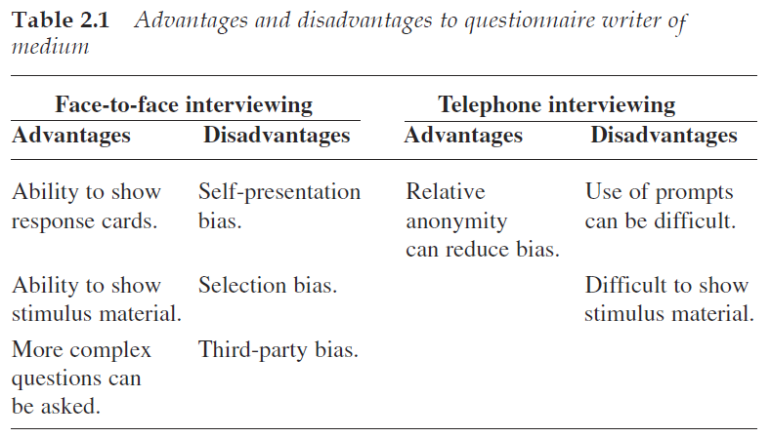

**Face-to-face CAPI**

CAPI (computer-assisted personal interviewing) is the use of a

portable computer that provides the questions and pre-codes on the

screen.

Whichever type of computer is used, it can either provide the interviewer

with a questionnaire and means of recording responses, or allow

the respondent to participate in the interview through self-completion

of part or all of the questionnaire. Either way, it brings a number of

advantages for the questionnaire writer. Principal amongst these is the

ability to include complex routeing between questions, which could

cause problems for interviewers if given as a written instruction. Thus,

the question that is asked of the respondent can be determined by a  
combination of answers from a number of previous questions. Such

complex routeing would have resulted in a significant level of error if

the interviewer had had to determine which question was to be asked.

**Telephone-administered questionnaires**

**Advantages of telephone interviewing**

Most of the advantages enjoyed by telephone interviewing are to the

benefit of the survey design rather than to the questionnaire design.

Thus there are efficiencies in cost and speed, particularly where the

sample is geographically dispersed, or where, as often happens in  
business-to-business surveys, the respondents are prepared to talk on

the telephone but not to have someone visit them.

One advantage for data accuracy is that the telephone as a medium

gives more anonymity to the respondents in respect of their relationship

to the interviewer.

It is also the experience of many

researchers that respondents are more prepared to discuss sensitive

subjects such as health on the telephone than face to face with an interviewer.

Fuller responses are achieved to open questions, and they are

more likely to be honest because the interviewer is not physically present

with the respondent. Telephone interviewing thus becomes the

medium of choice for interviews where there is a need for an interviewer-

administered interview, coupled with a sensitive subject matter.

Computer-assisted telephone interviewing (CATI) brings many of

the same advantages to this medium as CAPI does to face-to-face

interviewing. These include an ability to include complex routeing

and calculations within the interview, and the automatic randomization

or rotation of question order and of prompt lists within questions.

**Disadvantages of telephone interviewing**

From the point of view of the questionnaire writer, telephone interviewing

has a number of disadvantages.

First, there is limited ability to show material such as prompt lists or

stimuli. (The inability to show prompt lists is not as much of a problem

as might be imagined. Where the list is short it can be read out by the

interviewer and remembered by the respondents.

When it is straightforward for the respondents to understand, they

can hold the question and answer in their head until the time comes for

them to respond. It is important that the interviewer reaches the end of

the options before the respondent answers, so that the complete list of

possible responses is read out.

For longer lists of response options, or repeated lists such as scales,

respondents can be asked to write them down.)

The inability to show material such as concepts or advertising is a

drawback to telephone interviewing. Radio ads or the soundtrack from

television ads can be played over the telephone as a prompt for recognition.

Care must be taken to distinguish responses that arise because

of the quality of the recording as heard by the respondent, which can  
be variable, from those relating to content. Other ways must be sought,

though, for visual material.

It is possible to mail material to respondents for them to look at during

the interview. This creates a lengthy and more expensive process.

**3.1.3.SELF-COMPLETION SURVEYS**

Self-completion methods, whether paper based or electronic, can benefit

from the complete absence of an interviewer from the process. This

removes a major source of potential bias in the responses, and makes it

easier for respondents to be honest about sensitive subjects.

However, self-completion studies can also suffer from there being

no interviewer to identify when a respondent has misunderstood, or to

ask for clarification where there are inconsistencies, or to probe for

fuller answers.

From the aspect of the survey design, self-completion questionnaires

are often considerably cheaper per interview to administer than

interviewer-administered ones, although this is not always the case.

Against that must be balanced the difficulties of achieving a representative

sample when there is such a high degree of self-selection as is

typical with self-completion studies, and particularly when there is a

low response rate.

**Paper questionnaires**

Paper self-completion questionnaires are typically sent by mail to people

who qualify or are thought to qualify as eligible for the study.

**Advantages of paper questionnaires**

With a paper self-completion questionnaire, respondents have time to

consider their answers. They can leave the questionnaire whilst they

think about an issue, or whilst they go away to check something or

look up some information. With little time pressure on them, they can

write lengthy and full answers to open questions if they wish to do so.

Descriptive material can be included for evaluation. Written

descriptions and pictures of new concepts, products or ideas can be

included, and again the respondents have the time to read and digest  
these before giving their responses. For photographs and drawings, as

well as written material, a level of production quality can be achieved

that is appropriate to the study.

**Disadvantages of paper questionnaires**

With a paper self-completion questionnaire, it is impossible to stop

respondents from reading through all of the questions before responding.

Frequently the question sequence is carefully chosen by the questionnaire

writer in order to reveal certain pieces of information at a specific

point in the interview. That is impossible with this type of questionnaire.

Certain measures cannot therefore be taken. It is not possible to ask

a spontaneous brand awareness question if the questionnaire includes

brand names in any of the other questions. Respondents may have read

through the questionnaire and will have been prompted by mentions

of a brand before completing the spontaneous awareness question.

Having time to consider answers, whilst often an advantage, is not

always what the questionnaire writer wants. With attitudinal and

image questions, it is often the first reaction that is sought, rather than

a considered response. An instruction in the question for respondents

to give their first reaction cannot be enforced, nor encouraged in the

way that an interviewer can, either face to face or by telephone.

Where prompt material has been sent to the respondents for their

reaction, it is difficult to retrieve all of it. This can present a security

concern if the material is commercially sensitive.

**Web-based self-completion**

There are several different ways of carrying out surveys using the

Internet. The questionnaire can either be delivered by e-mail or

accessed via a Web page. The main approaches are summarized by

Bradley (1999) as follows:

■ Open Web – a Web site open to anyone who visits it.

■ Closed Web – respondents are invited to visit a Web site to complete

a questionnaire.

■ Hidden Web – the questionnaire appears to a visitor only when triggered

by some mechanism (eg date, visitor number, interest in a

specific page). This includes pop-up surveys.

■ E-mail URL embedded – a respondent is invited by e-mail to the  
survey site, and the e-mail contains a URL or Web address on which

respondents click.

■ Simple e-mail – an e-mail with questions contained in it.

■ E-mail attachment – the questionnaire is sent as an attachment to an

e-mail.

The last two of these, the simple e-mail and e-mail attachment, are

rarely used in commercial research for a variety of practical reasons.

Attachments require respondents to download the questionnaire, complete

it and then return it. This requires a lot of cooperation and has

been shown to lead to low response rates. Questionnaires embedded

within e-mails can have their layout distorted, depending on the e-mail

software with which it is opened. This can lead to the questionnaire

being incomprehensible to the recipient. Both of these routes also suffer

from the inability to include complex routeing.

Most practitioners now use questionnaires hosted on a Web site to

which respondents are invited or routed in some way. This book will

therefore concentrate on the Web-based questionnaire.

As noted above, the invitation to the Web site or questionnaire can

be delivered in a number of ways:

■ It can be delivered by e-mail to people on a panel or to a mailing list

of customers or people who might qualify for the survey.

■ Pop-ups can be used to direct respondents to the questionnaire

whilst they are visiting another site. (These are particularly useful

where the objectives of the survey relate to the site being visited,

such as evaluating the site.)

■ Invitations can be posted as banner ads on other sites (eg ISP home

pages) or respondents can be directed to the site following a recruitment

interview by telephone or face to face.

**Advantages of Web-based self-completion**

There are many different ways of capturing a sample online. There are

also many issues regarding how representative such samples are of a

population that contains people other than those with Internet access.

These issues are outside the scope of this book and are well covered

elsewhere.

Web-based questionnaires have the same strength as paper selfcompletion

questionnaires in that, in theory at least, respondents can  
complete the questionnaire in their own time, going away from it if

they are interrupted, and returning to it later. In practice, there is little

evidence that respondents leave a questionnaire whilst they think

about it and return later.

In terms of data collection, the major differences between online surveys

and other forms of data collection are the same as between postal

self-completion and interviewer-administered surveys. Any advantages

are those that come from being technology driven (Ilieva, Baron

and Healey, 2002).

Some of the differences between online and other forms of data

collection are given by Taylor (2000) as:

■ It is a visual medium, allowing images, messages and longer lists of

response options. (One survey of motorists has a list of more than

90 different car makes and models for respondents to code their

vehicle against. This level of detail would not be possible in any

other medium.)

■ It captures the unedited voice of the consumer, so that open-ended

responses can be richer, longer and more revealing.

■ It may be more effective in addressing sensitive issues (medical

issues, in particular, may be more easily discussed).

■ Scales may elicit different response patterns – it has been the experience

both of Taylor and of other researchers that the extremes of

scales are used less often.

■ More ‘Don’t knows’ may be generated, which is likely to be a function

of the ‘Don’t know’ code appearing as a response option.

In addition to online surveys being more effective with sensitive issues,

evidence from Kellner (2004) and Basi (1999) supports the view that

because there is no interviewer there is less social desirability bias and

the respondents answer more honestly (see Chapter 10). This means

that data on ‘threatening’ questions, where respondents feel a need to

appear to be socially acceptable, are likely to represent better how the

survey population really feels, although this is not yet proven (Sparrow

and Curtice, 2004). It also helps to achieve high response rates to questions

regarding household income, for example.

The distribution of usage of the points on rating scales has been

shown to be different, with less use of the extreme points than is found

with face-to-face or telephone interviewing. However, Cobanoglu,  
Warde and Moreo (2001) have shown that mean scores for data collected

via a Web-based questionnaire are the same as for other self-completion

methods, postal and fax surveys. This supports the view that using a

Web-based questionnaire should be seen as an alternative method of

administering a self-completion survey.

Most studies of how people respond to Web-based questionnaires

have found that they are completed more quickly than their equivalent

telephone or face-to-face administered versions. Being quicker can help

to make it a more pleasurable experience for respondents.

The presentation of the questionnaire can also help to make its

completion pleasurable. With a little flair and imagination, Web questionnaires

can be designed to have visual appeal, an equivalent level of

which is often too costly to achieve with paper questionnaires. In addition

to the page design, techniques such as showing icons to represent

each brand can be used for respondents to move around the screen and

drop into the appropriate response box. By involving the respondents

more, the interview is more likely to keep their attention and continue

to provide good-quality data through to the end of the questionnaire.

Demonstration of material can also be achieved with a Web-based

survey in many of the same ways as with CAPI surveys. Television

advertisements can be shown, although the quality with which they

are seen will depend on the specification of the equipment that the

respondent is using to view it. High-quality representation of still

images can be achieved, so that pack designs can be shown either for

new or for existing products. There is software available that allows the

respondent to rotate the pack representation in three dimensions and

even to change elements of it such as colour or text. This kind of technique

allows much more interaction in the interview, again involving

the respondents and maintaining their interest.

One of the disadvantages of paper self-completion questionnaires is

that the respondents can look ahead. With Web-based questionnaires

the questions are presented in the sequence that the researcher wants

them to be. Generally, Web-based questionnaires will allow respondents

to go back over questions already answered in order either to

check or to change previous answers. However, it is unlikely that

respondents will go completely through the interview and then go

back to the beginning and change all of their answers.

As with other electronic questionnaires, CATI and CAPI, the Webbased

questionnaire can change the order of questions between  
respondents; rotate or randomize response lists; customize response

lists against previous answers; cope with complex routeing; and carry

out calculations within the interview.

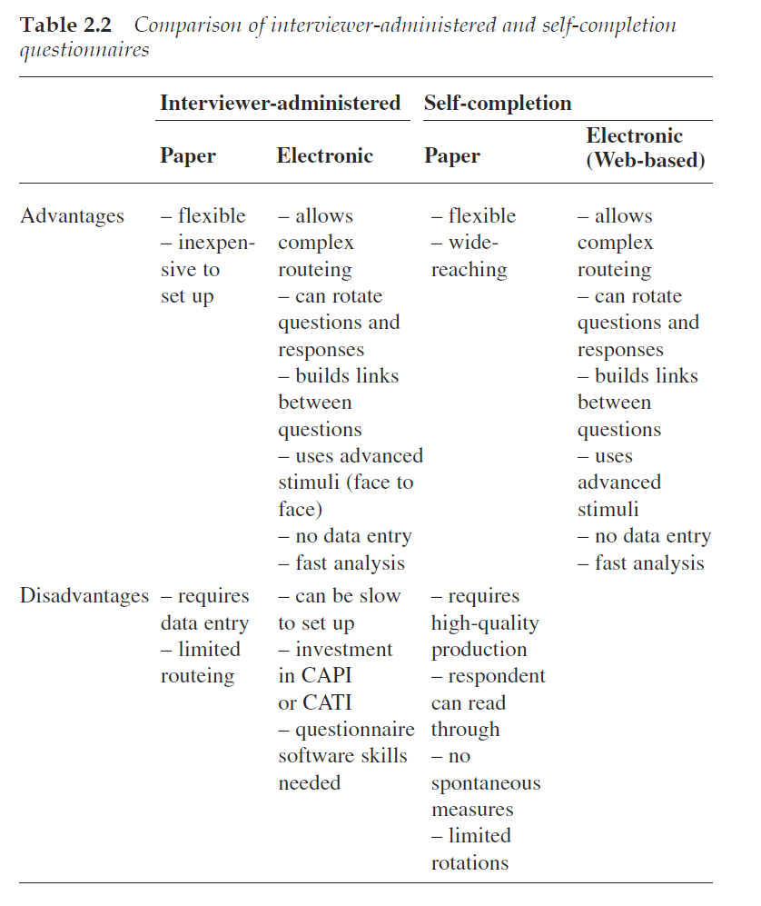

**Disadvantages of Web-based self-completion**

As with all self-completion media, a major disadvantage is not having an

interviewer on hand to clarify questions or to repair misunderstandings.  
It might be thought that an issue with Web-based questionnaires

would be the difficulty of recording open-ended verbatim responses.

Most respondents are not accomplished typists, and it might be expected

that questions that require responses to be typed in verbatim would

be poorly completed, and be at best completed perfunctorily and in

abbreviated fashion. However, experience has shown that, whilst this

is undoubtedly an issue with some respondents, the overall level of

detail to which this type of question is completed is high. The ability of

respondents to take their time and think about their answer appears to

more than cancel out any typing difficulties, and responses are generally

as complete as for interviewer-administered questionnaires.

Web-based surveys have other disadvantages compared to face-toface

surveys, such as the inability to touch or smell stimuli, but these

tend to be issues of survey design rather than questionnaire design.

**4.Struktur eines Fragebogens:**

**4.1.Planning the Questionnaire**

**4.1.1.MAIN QUESTIONNAIRE**

Once into the main questionnaire, the writer must consider the order

in which the various topics are presented to the respondents. As a rule,

it is better to work from the most general topics through to the most specific.

Thus, the interview might start with questions about the respondent’s

behaviour in the market in general, before proceeding through to

specific questions about the client’s product and then to reaction to a

new proposition for the client’s product.

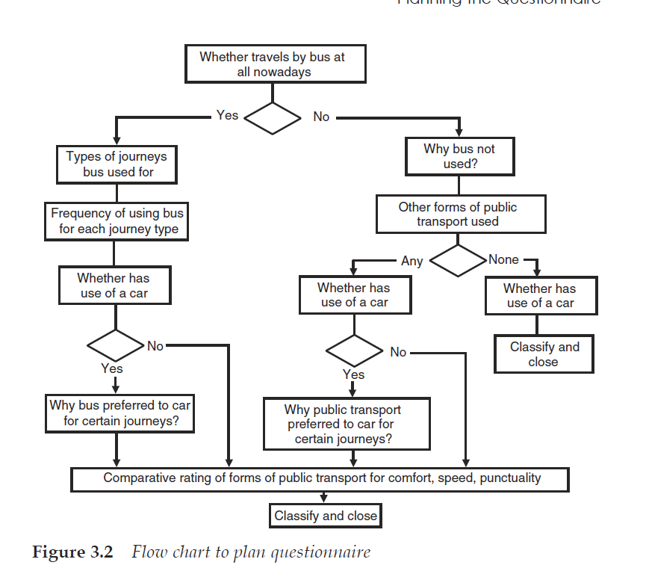

**5.Einleitung eines Fragebogens:**

**5.1.Types of question and data**

**5.1.1.INTRODUCTION**

Questions can be asked and data recorded in many ways. Different types

of questions are appropriate for different purposes and different

types of data can be used and analysed differently. It is important for

the questionnaire writer to understand the range of question types

available because the choice of question type will determine the information

that is elicited. It is also important to understand the different types

of data that will be generated, because that will determine the types of

analysis that can be carried out. The questionnaire writer should thus

be thinking about how the data are to be analysed at the time that the

questions are being formulated so that the information collected can be

analysed in the way that is required.

**5.1.2.QUESTION TYPES**

Any question in an interview can be classified in a number of different

ways:

■ open or closed, depending whether or not the answer can come

only from a finite number of possible responses;

■ spontaneous or prompted, depending on whether respondents are

asked to reply in their own words or given a number of options

from which to choose a response;

■ open-ended or pre-coded, depending on whether the answer is

recorded verbatim or against one or more of a number of predetermined

answers.

**OPEN AND CLOSED QUESTIONS**

An open question is one where the range of possible answers is not

suggested in the question and which respondents are expected to

answer in their own words. An open question may expect a short

answer, as in ‘Which brand of breakfast cereal did you eat today?’,

where the anticipated answer would simply be a brand name, or it may

expect respondents to talk as long as possible using their own words in

order to give fully their answer, as in ‘Why do you eat that brand of

breakfast cereal more than any other?’ Open questions always seek a

spontaneous, that is unprompted, response. In conversation, one person

trying to start another person talking about a topic would use an

open question.

The responses may be recorded verbatim as an open-ended question

(‘Why do you eat…?’) or, with interviewer-administered surveys, a list  
of the most commonly given responses may be provided that can be

coded (‘Which brand did you eat…?’).

Closed questions, on the other hand, tend, in conversation, to bring

it to a stop. This is because there is a predictable and usually small set

of answers to a closed question that the respondent can give. Any question

that simply requires the answer ‘yes’ or ‘no’ is a closed question,

and not helpful to opening out a conversation. An evening spent with

a new acquaintance with both of you asking only closed questions

would be very dull indeed.

In a research interview, closed questions also include any question

where the respondent is asked to choose from a number of alternative

answers. Thus any prompted question is a closed question.

Examples of closed questions are:

■ ‘Have you drunk any beer in the last 24 hours?’

■ ‘Are you aged under 25?’

■ ‘Which of these brands of tinned meat do you buy most often?’

■ ‘Which of the phrases on this card best indicates how likely you are

to buy this product?’

The examples above are all closed questions, the first two because they

can only be answered ‘yes’ or ‘no’, and the last two because there is a

frame of possible responses from which the respondent is asked to

choose.

Closed, and therefore pre-coded, questions are popular with

researchers and interviewers alike because there is a set of answers

known beforehand that can be listed on the questionnaire. With a

paper questionnaire the interviewer only has to circle the appropriate

code and that code can easily be entered into the data file by those

responsible for data entry. With an electronic questionnaire, either the

interviewer or the respondent only has to check the appropriate box

and the data are automatically recorded and stored, ready for analysis.

This type of question is usually easy to administer and cheap to process.

A questionnaire that measures behaviour is likely to consist mostly

of closed questions (‘Which of these brands…?’, ‘When did you

last…?’, ‘How many did you buy?’), whereas one exploring attitudes is

likely to have a higher proportion of open questions. From the point of

view of maintaining the involvement of the respondent, the interview

should consist of a mixture of both types of question.  
**SPONTANEOUS QUESTIONS**

A spontaneous question is any question for which the respondent is

not given a repertoire of possible answers from which to choose. All

open-ended questions are by their nature spontaneous, but not all

spontaneous questions need be open-ended.

Spontaneous questions will be used when the questionnaire writer

does not know what the range of responses is likely to be, or wants to

collect the response in the respondent’s own words. These will then be

open-ended questions with the response recorded verbatim for later

coding.

The decision whether or not to make a spontaneous question

open-ended depends on whether it is important to record the

response verbatim and whether the full range, or at least the majority,

of likely responses is known.

One of the difficulties with spontaneous questions is that the

amount of effort that respondents are prepared to make with spontaneous

questions varies depending on how interested they are in the

subject and on the medium of the interview.  
**Common uses of spontaneous questions**

Spontaneous open questions are frequently used in market research to

measure awareness and attitudes, for example:

■ brand awareness;

■ awareness of brands seen advertised;

■ recall of brands or products used or bought;

■ advertising content recall;

■ attitudes towards a product, or activity or situation;

■ likes and dislikes of a product or concept.

The first three in this list would normally be pre-coded on an interviewer-

administered questionnaire, where the interviewers can easily

code the response without prompting the respondents.

With spontaneous questions we are trying to determine what is at

the forefront of people’s minds, which they can easily access. We interpret

this as saliency in the case of brands, or as importance in the case

of attitudes. Spontaneous questions are not a good measure of the  
brands people have heard of, nor of behaviour, nor of all the full range

of attitudes or emotions. Prompted questions usually elicit more complete

and accurate responses in terms of behaviour.

Spontaneous brand awareness

Spontaneous brand awareness is a measure of which brands are the

most salient in the respondents’ minds. It would be the result of the following

or similar questioning: ‘Which brands of breakfast cereal have

you heard of?’ ‘Please tell me all the brands of washing powder that

you can think of.’ The objective here is to obtain every brand that the

respondent can think of, and so probes asking for ‘What else?’ or ‘Any

more?’ will be used extensively in interviewer-administered interviews.

The list of possible brands will usually be given as pre-codes on

the questionnaire for the interviewer to record responses.

Frequently the first brand mentioned will be recorded separately, to

give a measure of ‘top of mind awareness’. With CAPI and CATI questionnaires,

the order in which brands are mentioned can be recorded

automatically.

With self-completion questionnaires (including Web-based), spontaneous

questions must be recorded as open-ended responses to avoid

prompting the respondents. With paper self-completion questionnaires,

it is not possible to obtain spontaneous awareness if any brands are mentioned

anywhere in the questionnaire. Respondents will read through

the questionnaire and will be prompted by any brand names that appear.

Sometimes we wish to know precisely how respondents give a

brand name. Then, in any data collection medium, the responses will

be recorded verbatim. The researcher can then determine whether it is

the brand, sub-brand or variant that is mentioned, or what combination

of these. This is particularly used in advertising research where it

can be important to know precisely what level of branding is being

communicated.

Spontaneous brand awareness can be used to demonstrate how the

effort that respondents are prepared to make varies according to where

the interview takes place. It has been demonstrated on numerous occasions

that the average number of brands that are given spontaneously in

face-to-face street interviews is significantly lower than with face-to-face

in-home interviews. Not only is the average number lower in the street,

but the distribution of the brands mentioned is also different. In the

street, where less effort is made, the dominant brands in a market will  
end to be mentioned. Their spontaneous brand awareness figures may

be similar to those obtained from in-home interviews. The smaller and

newer brands get lower prompted awareness levels from street interviews,

or in any type of interview where the respondent is prepared to

make less effort.

Spontaneous advertising awareness

When evaluating the effect of an advertising campaign, spontaneous

advertising awareness is usually a key measure. Exactly how this is

measured, though, differs between researchers.

One way is to ask spontaneous brand awareness first, followed by a

spontaneous awareness of brands seen advertised, followed by content

recall of the advertising claimed to have been seen. All questions

require spontaneous responses; the first two are likely to be pre-coded

with a list of brands, and the third question will be open-ended:

‘Which brands of breakfast cereal have you heard of?’

‘Which brands of breakfast cereal have you seen or heard advertising

for recently?’

‘What did the advertising say, or what was it about?’

Repeat the last question for all brands for which advertising has

been seen.

An alternative approach is not to ask brand awareness first, but to ask

the respondent to recall spontaneously any advertising for any brand

in the category:

‘Please describe to me any advertising that you have seen recently

for a breakfast cereal. What did it say? What was it about?’

‘What brand was that for?’

Repeat until the respondent can recall no more advertising.

‘Please tell me any other brands of breakfast cereal that you have

seen advertising for.’

Proponents of this approach argue that, by leading with the brand

recall in the first approach, the best-known brands score well as

respondents assume that they have seen advertising for them, whether

or not they have actually been advertising. By leading with advertising

content recall, without mentioning any brands, the second approach

attains a truer measure of memorability of the advertising.  
Spontaneous attitudinal questions

Spontaneous questions regarding attitudes can be either open-ended

or pre-coded. Typical spontaneous attitudinal questions are:

■ ‘What, if anything, do you like about…?’

■ ‘What, if anything, do you dislike about…?’

■ ‘How do you feel about…?’

■ ‘Please describe to me your feelings about…?’

The responses to these questions would most likely be recorded verbatim

as open-ended answers. This enables the capture of the full range

of answers in the code frame, which may include some that were not

anticipated. This also allows the researcher to see the precise language

used by respondents to describe their feelings and attitudes.

Preliminary qualitative research may have been carried out so that

the full range of attitudes held on the issue in question has been

determined. The study may be a repeat of a previous one in which the

attitudes were defined. In these cases summaries of the main attitudes

may be pre-coded on interviewer-administered questionnaires, in

order to save the time and expense of coding the responses at the analysis

stage. With any kind of self-completion questionnaire pre-coding

is not a possibility if the attitudes are to be expressed spontaneously.  
**PROMPTED QUESTIONS**

Spontaneous responses rarely tell the researcher the complete picture

regarding what the respondent knows or feels, but only what is frontof-

mind. However, most people find it difficult to articulate everything

that they know or feel about a subject, or they forget that they

know something, or they have given one answer and aren’t prepared

to make any further effort to think of additional answers. Prompting

with a set of options tells the researcher what people know or recognize,

rather than what is front-of-mind, if we are measuring awareness

or recognition.

Alternatively, prompting helps people to recall actions and

behaviour, and to express their answers in the framework desired by

the researcher.  
For prompted awareness questions that follow a spontaneous question

on the same issue it may sometimes be helpful to include the

phrase ‘… including any that you have already mentioned’. Whether

or not this phrase is included, the analysis should always re-record any

answers mentioned spontaneously on to the prompted recognition

answer for each respondent.

With self-completion paper questionnaires it is not possible to ask

both spontaneous and prompted questions on the same subject.

Because respondents can read through the complete interview before

answering questions, any lists or sets of answers that appear in the

questionnaire can act as a prompt to any question.  
**OPEN-ENDED QUESTIONS**

An open-ended question is an open question where the response is

recorded verbatim. An open-ended question is nearly always also an

open question. (It would be wasteful to record yes–no answers verbatim.)

Open-ended questions are also known as ‘unstructured’ or

‘free-response’ questions.  
Probing

With most open questions it is important to extract from respondents

as much information as they can provide. The first reason they give for

having bought that brand may be the same for all brands and will not

discriminate. Although it is the first that comes to mind, it may not be

the one in which the researcher is most interested. First responses given

to open questions are often very bland, and non-directional probing is

required to try to fill out the answer.

Probing is very different from prompting, and the two must not be

confused. In prompting, respondents are given a number of possible

answers from which to choose, or are given clues to the answers through

visual or picture prompts. Probing makes no suggestions regarding

answers to the respondent.

**Dichotomous questions**

The simplest of closed questions are dichotomous questions, which have

only two possible answers.

**Multiple choice**

Closed questions with more than one possible answer are known as

multiple choice (or multi-chotomous) questions.

**‘Don’t know’ responses**

Questionnaire writers are often unsure as to whether they should include

a ‘Don’t know’ response to pre-coded questions. With intervieweradministered

questionnaires, it is argued, the inclusion of ‘Don’t know’

legitimizes it as a response and gives the interviewer permission to

accept it and not to probe for a fuller answer. If it is not on the questionnaire,

the interviewer will be more likely to probe for a response

that is on the pre-code list before having to write in that the respondent

is unable or unwilling to answer the question.

‘Don’t know’ can be a legitimate response to many

**5.Ableitung der Erkenntnisse auf die möglichen Tools:**

|  |  |  |  |
| --- | --- | --- | --- |
|  | PowerPoint | Google Formulare | Microsoft Forms |
| Usersicht | | | |
| Verfügbarkeit (Lokal, Online) | Lokal | Online  (Drucken möglich) | Online (Drucken möglich) |
| Fragen vor bzw. auch nach dem Senden bearbeiten | nein | wählbar | wählbar |
| Hilfsmedien wie Bild, Ton, Video | ja | ja | ja |
| Software Kompatibilität (niedrig, mittel, hoch) | mittel | hoch | hoch |
| Unternehmenssicht | | | |
| Individualisierbarkeit (niedrich, mittel, hoch) | hoch | hoch | mittel |
| Verfügbarkeit (Lokal, Online) | Lokal | Online (Drucken möglich) | Online (Drucken möglich) |
| Wiederherstellbarkeit (schwer, mittel, leicht) | mittel | leicht | leicht |
| Erlernbarkeit, Handling (schwer, mittel, leicht) | mittel | leicht | leicht |
| Software Kompatibilität (niedrig, mittel, hoch) | mittel | hoch | hoch |
| Übersichtlichkeit bei der Bearbeitung (niedrig, mittel, hoch) | niedrig | hoch | hoch |
| Wartbarkeit und Modifizierbarkeit (schwer, mittel, leicht) | schwer | leicht | leicht |
| Hilfsdiagramm (Flussdiagramm, Baumdiagramm) (notwendig, möglich) | notwendig | möglich | möglich |
| Anzahl der Methoden der Fragen (niedrig, mittel, hoch) | hoch | hoch | hoch |
| Übertragbarkeit und Auswerung der Daten (niedrig, mittel, hoch) | mittel | hoch | hoch |

(Brance 2018)

Literaturverzeichnis

Brance, Ian (2018): Questionnaire design: How to plan, structure and write survey material for effective market researc.