Homeworks 1&2 by Miloš Jakovljević 89221057

Homework1

Sequence analysis
Open the sequence.fa file in Biopython and do the following:
Determine the sequence length
Determine the sequence GC content
Translate the sequence into amino acid sequence
Determine the length of the amino acid sequence
Save the translated sequence into a properly formatted FASTA/FA file
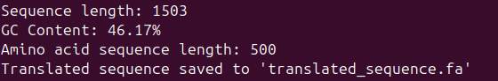

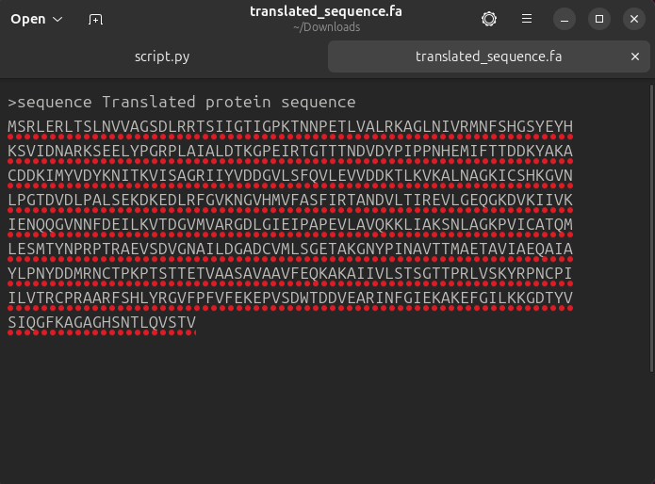

BLAST analysis
Download the reference genome for Saccharomyces cerevisiae (refSeq ID GCF_000146045.2). Once the reference genome has been downloaded do the following:
Perform the BLAST analysis of the translated sequence against the downloaded reference using the correct BLAST algorithm
Once the alignment is done, open the result file and answer the following questions:
What is the E-value for the top ranking alignment?
What is the length of the top ranking alignment?
What is the genomic position (start and end) of the top ranking alignment?
Based on the genomic position and the reference genome annotation, what is the name of the gene our sequence has aligned to?
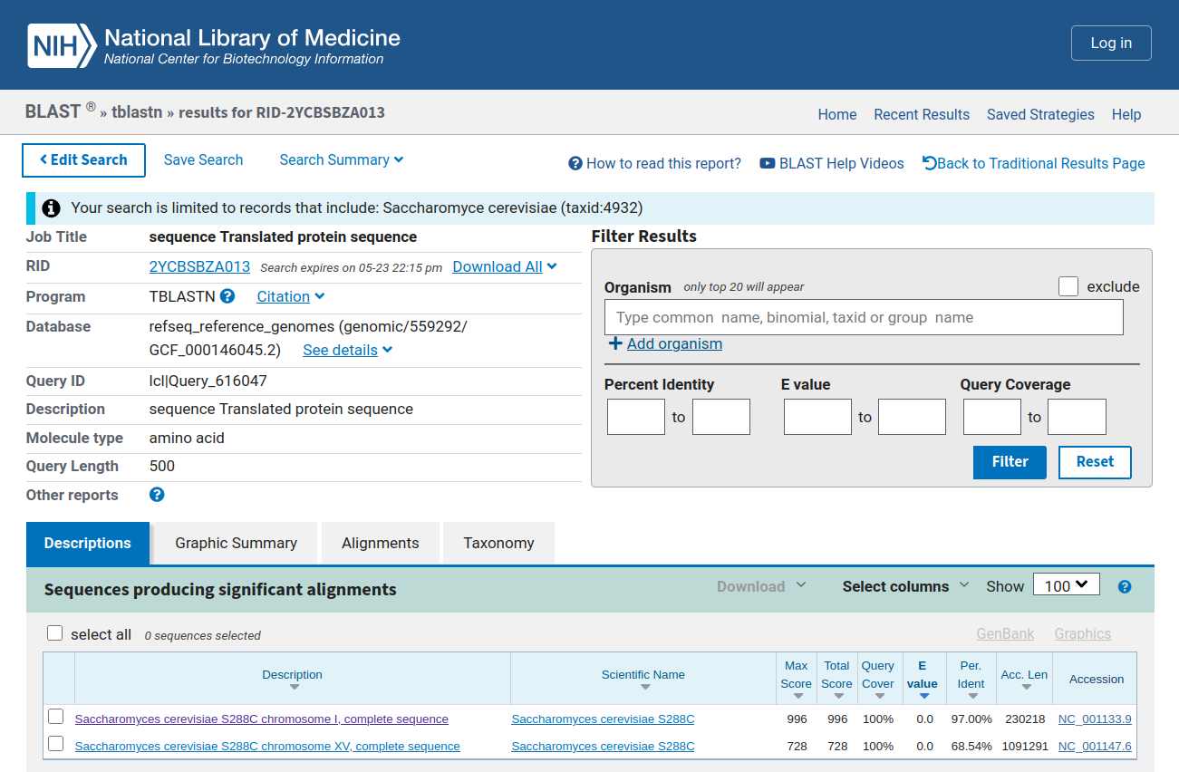
-E-value for the top ranking alignment: 0.0
-Length of the top ranking alignment: 230218
-Genomic position (start and end) of the top ranking alignment: 71786 - 73285
-Name of the gene our sequence has aligned to:
CDC19 pyruvate kinase

Homework2

-Part 1:

conda install -c bioconda orthofinder
mkdir orthofinder_project
cd orthofinder_project
mkdir proteomes

Downloaded:

Schizosaccharomyces_pombe.ASM294v2.pep.all.fa.gz
Candida_albicans.GCA000182965v3.pep.all.fa.gz
Neurospora_crassa.NC12.pep.all.fa.gz
Saccharomyces_cerevisiae.R64-1-1.pep.all.fa.gz

Since they are all in the same folder:
gunzip *.fa.gz

-Part 2:

for f in proteomes/*.fa; do python3 primary_transcript.py "$f"; done
orthofinder -f path/to/proteomes

-Part 3:

Species | Total Genes | Genes in Orthogroups | % in Orthogroups
Saccharomyces cerevisiae | 6600 | 4972 | 75.3%
Schizosaccharomyces pombe | 5146 | 4248 | 82.5%
Candida albicans | 6221 | 5013 | 80.6%
Neurospora crassa | 10813 | 7190 | 66.5%

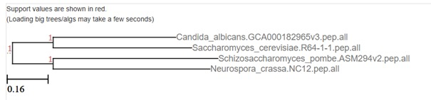

-Part 4:

- The closest relatives are Candida albicans and Saccharomyces cerevisiae, because they form a sister group in the species tree.

-Neurospora crassa appears most distant from the other species in the tree, which is expected due to its position in the Pezizomycotina (filamentous fungi).

-OrthoFinder performed well, assigning 66–83% of genes to orthogroups. Most unassigned genes, especially in N. crassa, may represent lineage-specific or poorly conserved genes, or those lacking detectable orthologs due to divergence.

