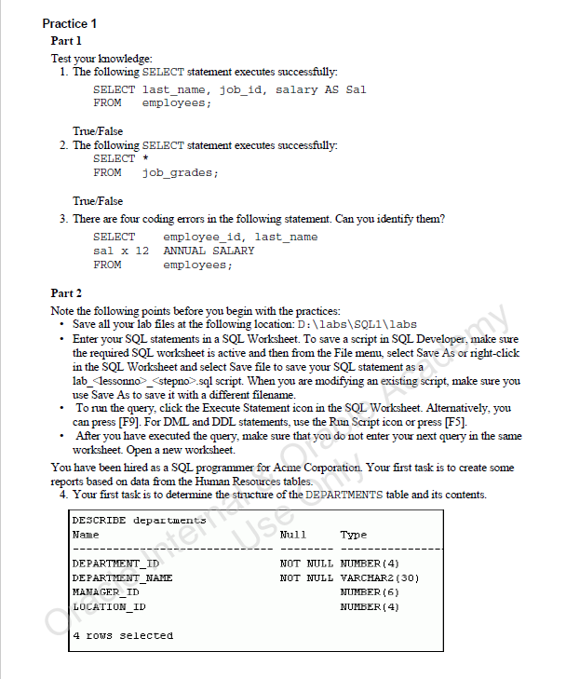

***TRUE***

***TRUE***

***SELECT employee_id, last_name,  
salary * 12 “ANNUAL SALARY”  
FROM employees;***



***DESCRIBE departments***

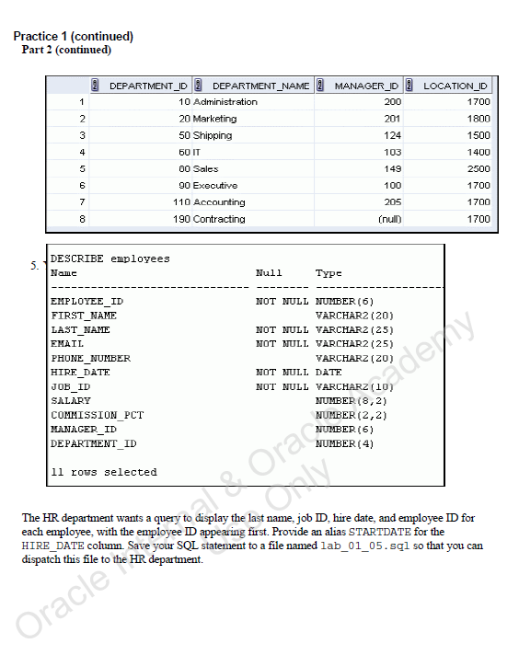

***SELECT *  
FROM departments;***



***SELECT employee_id, last_name, job_id, hire_date AS startdate  
FROM employees;  
  
SAVE lab_01_05.sql***

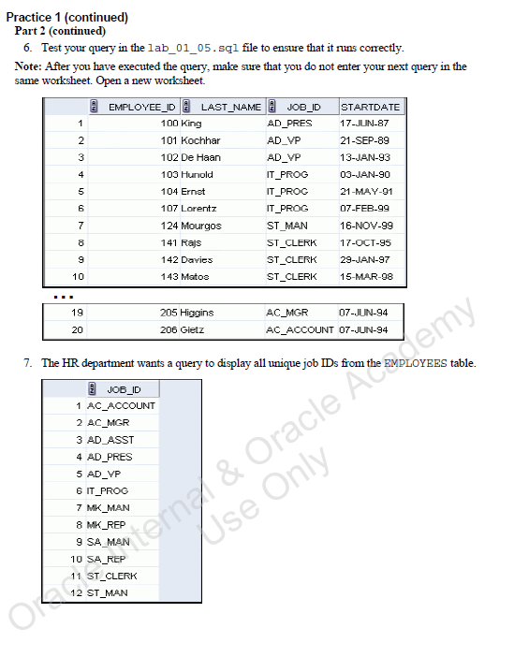

***START lab_01_05.sql***



***SELECT DISTINCT job_id  
FROM employees;***

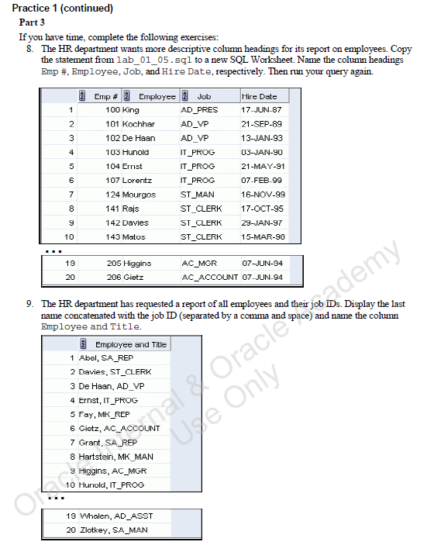

***SELECT employee_id AS "Emp #", last_name AS "Employee", job_id AS "Job", hire_date AS "Hire Date"  
FROM employees;***



***SELECT last_name || ', ' || job_id AS "Employee and Title"  
FROM employees ORDER BY last_name;***

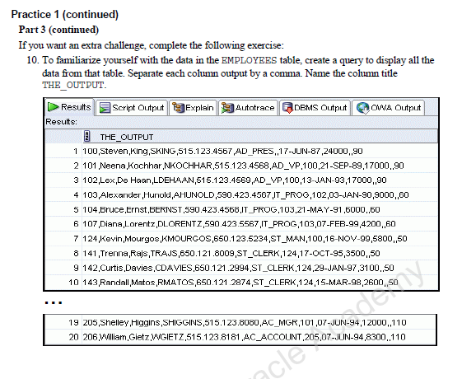

***SELECT employee_id || ',' || first_name || ',' || last_name || ',' || email || ',' || phone_number || ',' || hire_date || ',' || job_id || ',' || salary || ',' || commission_pct || ',' || manager_id || ',' || department_id the_output  
FROM employees;***