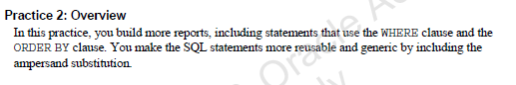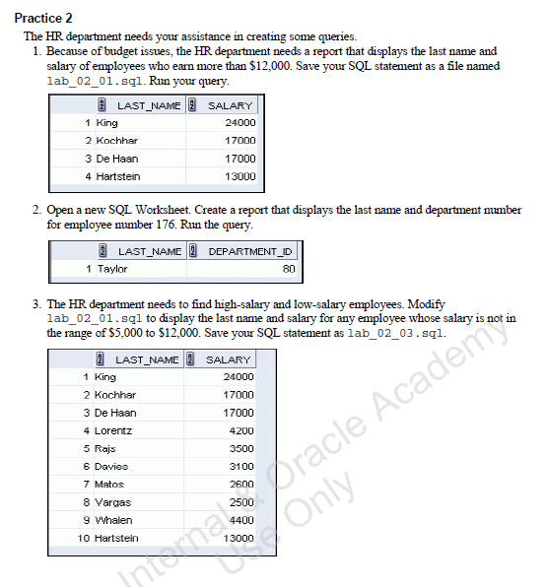

***SELECT last_name, salary  
FROM employees  
WHERE salary > 12000;  
  
SAVE lab_02_01.sql***

***SELECT last_name, department_id  
FROM employees  
WHERE employee_id = 176;***



***EDIT lab_02_01.sql  
  
SELECT last_name, salary  
FROM employees  
WHERE salary NOT BETWEEN 5000 AND 12000;  
  
SAVE lab_02_03.sql***

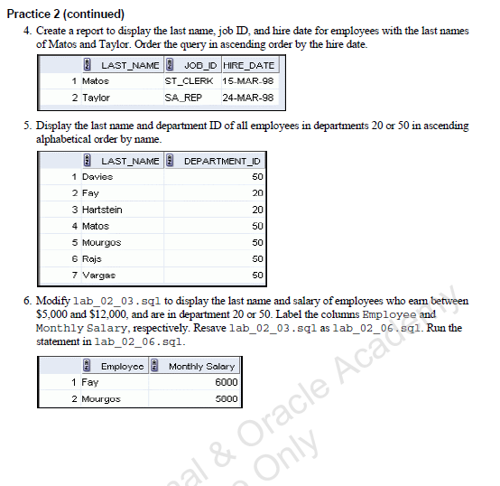

***SELECT last_name, job_id, hire_date  
FROM employees  
WHERE last_name = ‘Matos’ OR last_name = ‘Taylor’  
ORDER BY hire_date;***



***SELECT last_name, department_id  
FROM employees  
WHERE department_id = 20 OR department_id = 50  
ORDER BY last_name;***



***EDIT lab_02_03.sql  
  
SELECT last_name AS "Employee", salary AS "Monthly Salary"  
FROM employees  
WHERE (salary > 5000 AND salary < 12000) AND (department_id = 20 OR department_id = 50);  
  
SAVE lab_02_06.sql***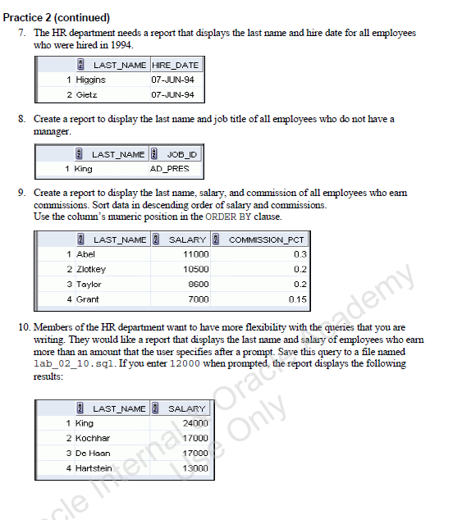

***SELECT last_name, hire_date  
FROM employees  
WHERE hire_date LIKE '%94';***



***SELECT last_name, job_id, manager_id  
FROM employees  
WHERE manager_id IS NULL;***



***SELECT last_name, salary, commission_pct  
FROM employees  
WHERE commission_pct IS NOT NULL  
ORDER BY 2 DESC, 3 DESC;***



***SELECT last_name, salary  
FROM employees  
WHERE salary > &salary_input;   
  
SAVE lab_02_10.sql***

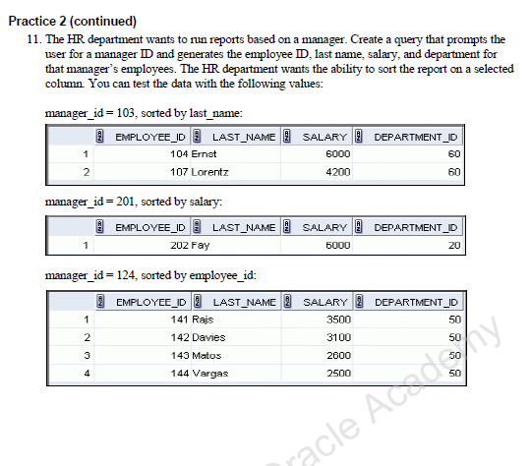

***SELECT employee_id, last_name, salary, department_id  
FROM employees  
WHERE manager_id = '&manager_input'  
ORDER BY &orderby_input;***