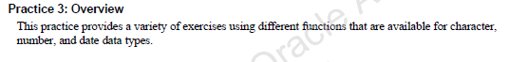

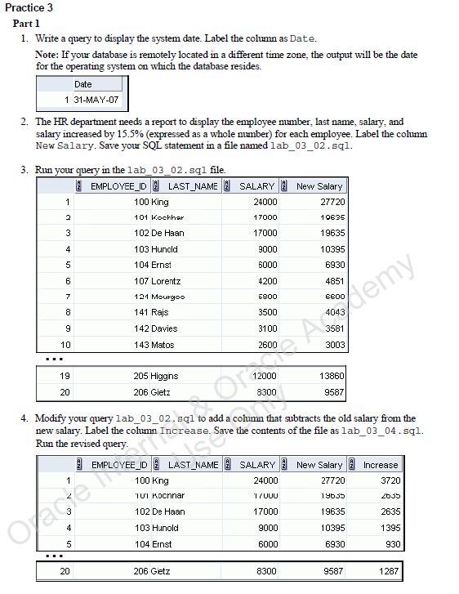

***SELECT TO_CHAR(SYSDATE)  
FROM dual;***



***SELECT employee_id, last_name, salary, ROUND(salary * 1.155) AS “New Salary”  
FROM employees;***

***SAVE lab_03_02.sql***

***START lab_03_02.sql***



***EDIT lab_03_02.sql***

***SELECT employee_id, last_name, salary, ROUND(salary * 0.155) AS “New Salary”, ROUND(((salary * 1.155) - salary)) AS “Increase”  
FROM employees;***

***SAVE lab_03_04.sql***

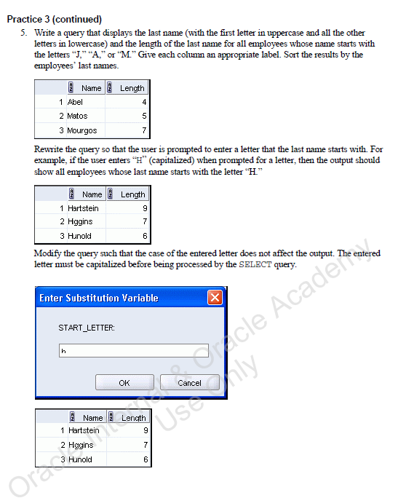

***SELECT INITCAP(last_name) AS "Name", LENGTH(last_name) AS "Length"  
FROM employees  
WHERE (SUBSTR(last_name, 0, 1) = 'J') OR (SUBSTR(last_name, 0, 1) = 'A') OR (SUBSTR(last_name, 0, 1) = 'M');***

***SELECT INITCAP(last_name) AS "Name", LENGTH(last_name) AS "Length"  
FROM employees  
WHERE SUBSTR(last_name,0,1) IN(‘A’,’M’,’J’);***

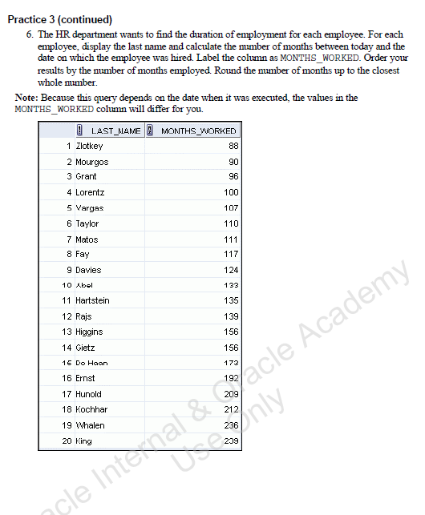

***SELECT last_name, (SYSDATE - hire_date) / 30 AS months_worked  
FROM employees;***

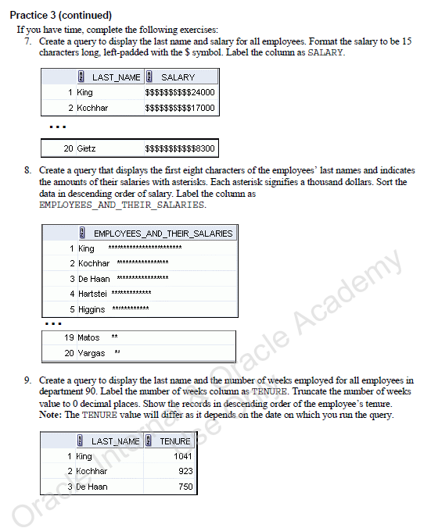

***SELECT last_name, LPAD(salary, 15, '$') AS salary  
FROM employees;***



***SELECT SUBSTR(last_name, 0, 7) || ' ' || LPAD('*', ROUND(salary / 1000) - 1, '*') AS employees_and_their_salaries.***

***FROM employees;***



***SELECT last_name, TRUNC((SYSDATE - hire_date) / 7) AS tenure  
FROM employees  
WHERE department_id = 90  
ORDER BY 2 DESC;***