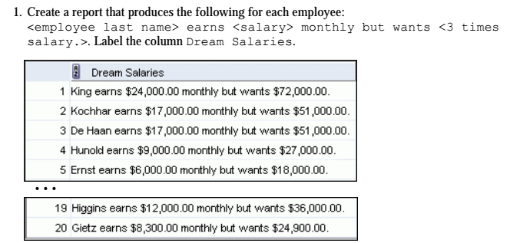

**SELECT** LAST_NAME || ' earns ' || TO_CHAR(SALARY, ‘$99,999.00’) || ' but wants $' || (SALARY * 3) || '.' AS “Dream Salaries”

**FROM** EMPLOYEES;

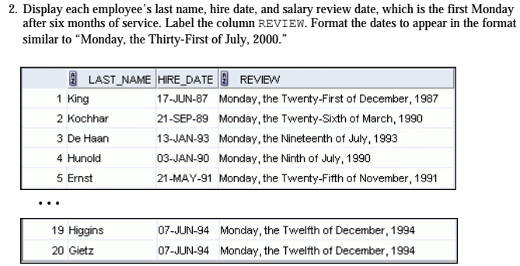

**SELECT** LAST_NAME, HIRE_DATE, *to_char*(*next_day*(*ADD_MONTHS*(HIRE_DATE, 6), 'monday'), 'DAY", the" fmDdspth "of" Month "," YYYY') **AS** review

**FROM** EMPLOYEES;

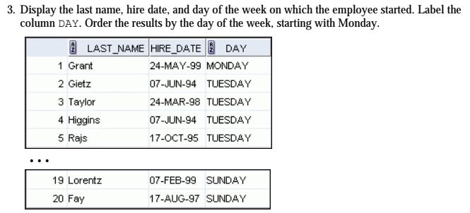

**SELECT** LAST_NAME, HIRE_DATE, *to_char*(HIRE_DATE, 'DAY') **AS day**

**FROM** EMPLOYEES

**ORDER BY** *to_char*(HIRE_DATE, 'D');

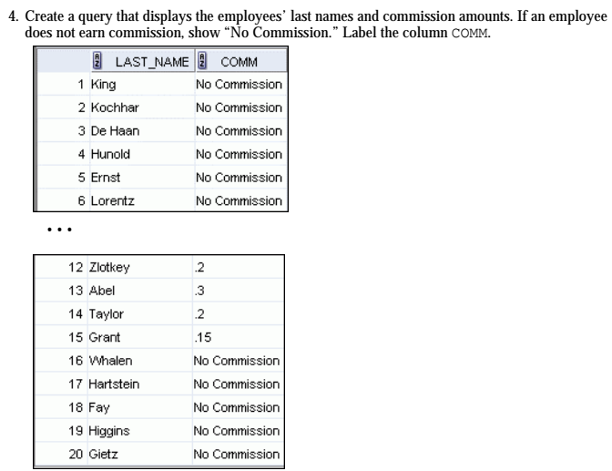

**SELECT** LAST_NAME, *NVL*(*to_char*(COMMISSION_PCT), 'No Commission') **AS** comm

**FROM** EMPLOYEES;

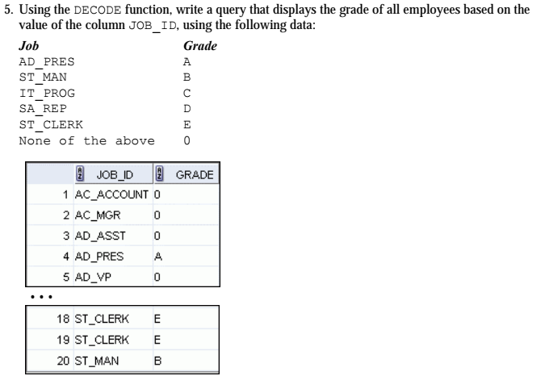

**SELECT** JOB_ID, *DECODE*( JOB_ID, 'AD_PRES', 'A', 'ST_MAN', 'B', 'IT_PROG', 'C', 'SA_REP', 'D', 'ST_CLERK', 'E', '0')

**FROM** EMPLOYEES;

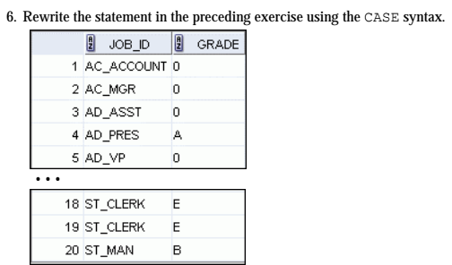

**SELECT** JOB_ID, **CASE** JOB_ID **WHEN** 'AD_PRES' **THEN** 'A'

**WHEN** 'ST_MAN' **THEN** 'B'

**WHEN** 'IT_PROG' **THEN** 'C'

**WHEN** 'SA_REP' **THEN** 'D'

**WHEN** 'ST_CLERK' **THEN** 'E'

**ELSE** '0'

**END**

**FROM** EMPLOYEES;